GIT = It is a cloud server Version Control managent tool, The main purpose of this tool Is used to integrate the source code from anywhere .

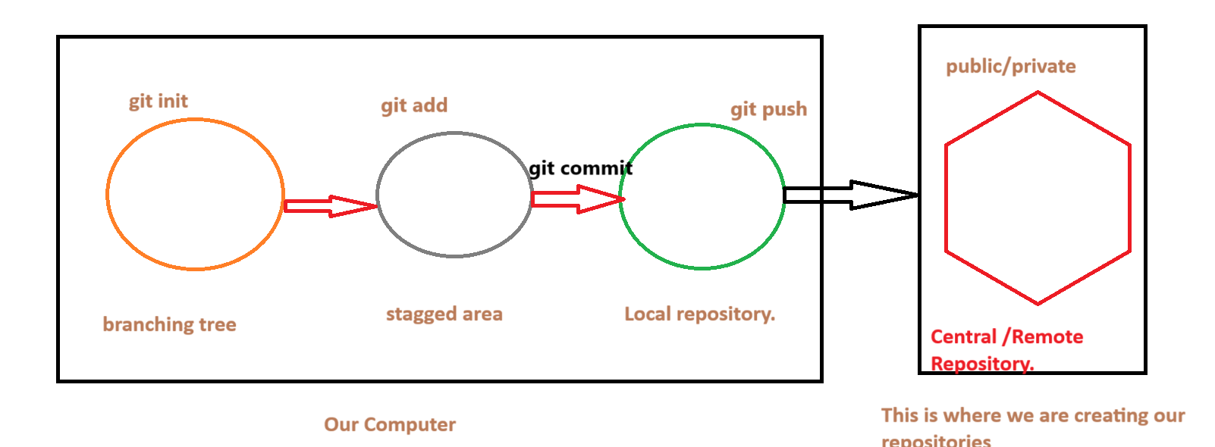  
  
🡪 Totally we have 3 types of Version control system available   
 1) SVN . 2)GIT 3)BITBUCKET.  
  
GIT :  
 🡪 GIT HUB is a cloud platform which is used to maintain source code repository.  
🡪 It will be monitored acess to the source code,  
 why , when , where, who ,what [modification]  
 we can able to check the source code in the GIT.  
🡪Working Tree : In our system we can consider our folders as a working tree whenever we have given a command git bash here by opening command prompt and by the help of git init,  
  
we can able to connect to the working tree after that by adding it will come to stagged area.  
  
🡪 Working tree mean simple project tree [git init]  
  
🡺 when ever our all files come into unstagged area ours is ready to push the source code to the repository.  
🡪 Now this file is to commit.  
🡪 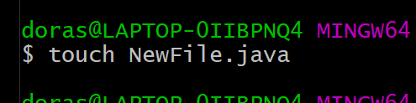  
  
here touch file will represent to help to create a new file.  
 🡪 git restore will work on the current status of the file…  
  
  
------------------------------------------------------------------🡪 Git clone is a command which we can used to download the file repository from the git.  
if use the command git clone   
 git clone repositoryname.  
  
🡪 Automatically whatever the file is there it is automatically restore all the data from the git account repository,