Paleta de cores

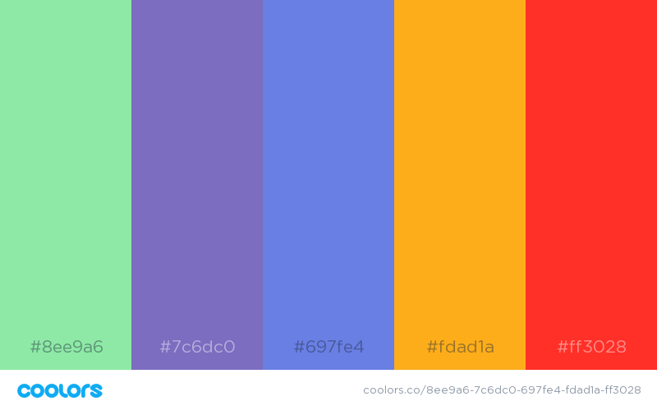

https://coolors.co/8ee9a6-7c6dc0-697fe4-fdad1a-ff3028