A Modular Multimodal Retrieval-Augmented Agentic Framework for Intelligent Scientific Document Understanding
A PROJECT REPORT
Submitted by
Team No: 22AIE091
BL.EN.U4AIE22030 Dorai Sai Charan
BL.EN.U4AIE22022 K. Nithin
BL.EN.U4AIE22017 Vijay
BL.EN.U4AIE22076 Dinesh
in partial fulfillment for the award of the degree of
BACHELOR OF TECHNOLOGY
IN
COMPUTER SCIENCE AND ENGINEERING
(ARTIFICIAL INTELLIGENCE)

AMRITA SCHOOL OF COMPUTING, BENGALURU
AMRITA VISHWA VIDYAPEETHAM
BENGALURU 560 035
MAY 2026

AMRITA VISHWA VIDYAPEETHAM
AMRITA SCHOOL OF COMPUTING, BENGALURU, 560035

BONAFIDE CERTIFICATE
This is to certify that the project report entitled "A Modular Multimodal Retrieval-Augmented Agentic Framework for Intelligent Scientific Document Understanding" submitted by

BL.EN.U4AIE22030 Dorai Sai Charan
BL.EN.U4AIE22022 K. Nithin
BL.EN.U4AIE22017 Vijay
BL.EN.U4AIE22076 Dinesh
in partial fulfillment of the requirements as part of Bachelor of Technology in "COMPUTER SCIENCE AND ENGINEERING (ARTIFICIAL INTELLIGENCE)" is a bonafide record of the work carried out under my guidance and supervision at Amrita School of Computing, Bengaluru.

____________________ | ____________________
Vishwas H.N | Dr. Gopalakrishnan E.A.
Assistant Professor(Sr. Gd.) | Chair
Guide | School of Computing

This project report was evaluated by us on _____________

____________________ | ____________________
Examiner 1 | Examiner 2

ACKNOWLEDGEMENTS
The satisfaction that accompanies successful completion of any task would be incomplete without mention of people who made it possible, and whose constant encouragement and guidance have been source of inspiration throughout the course of this project work.
We offer our sincere pranams at the lotus feet of “AMMA”, MATA AMRITANANDAMAYI DEVI who showered her blessing upon us throughout the course of this project work.
We owe our gratitude to Prof. Manoj P., Director, Amrita Vishwa Vidyapeetham Bengaluru Campus. We would like to place our heartfelt gratitude to Dr. Gopalakrishnan E.A., Principal, Amrita School of Computing and Amrita School of Artificial Intelligence, Bengaluru for his valuable support and inspiration.
It is a great pleasure to express our gratitude and indebtedness to our project guide Vishwas H.N, Assistant Professor(Sr. Gd.), Department of Computer Science and Engineering, Amrita School of Computing, Bengaluru for her/his valuable guidance, encouragement, moral support, and affection throughout the project work.
We would like to express our gratitude to project panel members for their suggestions, encouragement, and moral support during the process of project work and all faculty members for their academic support. Finally, we are forever grateful to our parents, who have loved, supported, and encouraged us in all our endeavors.

ABSTRACT
Scientific output is growing at an unprecedented pace — more than two million peer-reviewed papers every year, with no sign of slowing down. Keeping up with all of it manually simply isn't feasible anymore. This project builds a Multimodal AI Research Assistant that tackles this challenge head-on: a full-stack research companion that brings together Retrieval-Augmented Generation (RAG), agentic multi-step reasoning via the ReAct (Reason + Act) pattern, and an AI-Detection and Humanization Engine — all in one integrated platform.
Feed in a PDF and the system runs a six-stage ingestion pipeline that doesn't treat the document as plain text. It separates out tables (pdfplumber), figures (Gemini 2.0 Flash Vision), scanned or handwritten regions (EasyOCR), and LaTeX equations before chunking them individually. Text is split into 512-character chunks with 50-character overlap; tables, figures, and equations stay as single atomic units — splitting them would destroy their meaning. Everything ends up as a 384-dimensional embedding from all-MiniLM-L6-v2, persisted in ChromaDB with an HNSW cosine-similarity index for fast approximate nearest-neighbour retrieval.
On the query side, nine specialised RAG pipeline methods cover everything from quick single-shot QA to full literature survey generation — each tuned with its own retrieval strategy and prompt template. The most powerful capability is the ReAct agent, which handles questions that can't be answered in one shot by running up to ten Thought–Action–Observation cycles, calling typed retrieval tools (text, table, figure, or equation search) as needed. All generation runs through Groq's Llama 3.3 70B for the throughput a real-time research tool actually demands.
What the Humanizer Engine does is combine a RoBERTa-based AI detector with three heuristic linguistic metrics — burstiness (σ/μ of sentence lengths), Type-Token Ratio, and human marker density. If a text scores too high, it gets rewritten; the loop keeps going until the score drops below 20%. The frontend runs on Next.js 15 with React 19 and renders Markdown, KaTeX maths, and syntax-highlighted code cleanly. End-to-end evaluation shows strong retrieval precision, faithful answers with traceable citations, and solid humanization — making the whole thing a practical toolkit for graduate students and researchers.

TABLE OF CONTENTS
ACKNOWLEDGEMENTS i
ABSTRACT ii
LIST OF FIGURES v
LIST OF TABLES vi
CHAPTER 1 – INTRODUCTION 1
1.1 Background and Context 2
1.2 Problem Statement 3
1.3 Motivation 4
1.4 Objectives 5
1.5 Scope of the Project 6
1.6 Organisation of the Report 6
CHAPTER 2 – LITERATURE SURVEY 7
2.1 Retrieval-Augmented Generation Systems 7
2.2 Multimodal Document Understanding 9
2.3 Agentic AI and ReAct Pattern 11
2.4 AI Detection and Text Humanization 13
2.5 Comparative Analysis of Related Work 14
CHAPTER 3 – SYSTEM REQUIREMENTS AND ANALYSIS 16
3.1 Functional Requirements 16
3.2 Non-Functional Requirements 17
3.3 Software Requirements 18
3.4 Hardware Requirements 19
CHAPTER 4 – SYSTEM DESIGN 20
4.1 High-Level Architecture 20
4.2 Ingestion Pipeline Design 22
4.3 Storage Layer Design 24
4.4 RAG Pipeline Design 25
4.5 Agent Design 26
4.6 API Layer Design 27
4.7 Frontend Design 28
CHAPTER 5 – SYSTEM IMPLEMENTATION 30
5.1 Document Ingestion Module 30
5.2 Embedding and Vector Storage 33
5.3 Retrieval and RAG Pipeline 35
5.4 Agentic Reasoning Module 37
5.5 Humanizer Engine 39
5.6 REST API Module 41
5.7 Frontend Implementation 43
CHAPTER 6 – SYSTEM TESTING 45
6.1 Unit Testing 45
6.2 Integration Testing 46
6.3 Performance and Load Testing 47
6.4 RAG Evaluation Using RAGAS Framework 48
CHAPTER 7 – RESULTS AND ANALYSIS 50
7.1 Retrieval Performance 50
7.2 Generation Quality 51
7.3 Agent Reasoning Accuracy 52
7.4 Humanization Effectiveness 53
7.5 System Throughput and Latency 54
CHAPTER 8 – CONCLUSION AND FUTURE SCOPE 56
8.1 Conclusion 56
8.2 Future Enhancements 57
REFERENCES 59

LIST OF FIGURES
Fig. 1.1 Conceptual overview of the Multimodal AI Research Assistant 2
Fig. 2.1 RAG pipeline overview — retrieval, augmentation, and generation 8
Fig. 2.2 Multimodal document processing taxonomy 10
Fig. 2.3 ReAct agent reasoning loop (Thought–Action–Observation) 12
Fig. 4.1 High-level system architecture diagram 21
Fig. 4.2 Six-stage PDF ingestion pipeline 23
Fig. 4.3 ChromaDB HNSW vector storage and cosine similarity retrieval 24
Fig. 4.4 Nine-method RAG pipeline overview 25
Fig. 4.5 ReAct agent iteration flow 26
Fig. 4.6 REST API endpoint structure 27
Fig. 4.7 Next.js frontend page layout and component hierarchy 29
Fig. 5.1 PDF processor heading detection decision logic 31
Fig. 5.2 Chunking strategy by content type 33
Fig. 5.3 Embedding pipeline: text to 384-dimensional vector 34
Fig. 5.4 Retrieval flow: query embedding to ranked results 36
Fig. 5.5 Agent multi-hop reasoning example trace 38
Fig. 5.6 Humanizer engine iterative refinement loop 40
Fig. 6.1 RAGAS evaluation score distribution 49
Fig. 7.1 Retrieval precision@k for various chunk types 50
Fig. 7.2 AI detection score before and after humanization 53
Fig. 7.3 API endpoint latency distribution (p50, p90, p99) 55

LIST OF TABLES
Table 3.1 Software requirements specification 18
Table 3.2 Hardware requirements specification 19
Table 3.3 Functional requirements summary 16
Table 4.1 Ingestion processor responsibilities 22
Table 4.2 ChromaDB metadata schema per chunk 24
Table 5.1 PDF heading detection keywords 31
Table 5.2 Chunking parameters by content type 32
Table 5.3 RAG pipeline methods and retrieval strategies 35
Table 5.4 Groq API models supported by the system 42
Table 6.1 Unit test cases and results 45
Table 6.2 Integration test scenarios 46
Table 6.3 RAGAS metric scores across test queries 48
Table 7.1 Retrieval Hit Rate and MRR at k=5 and k=10 51
Table 7.2 LLM generation quality scores (faithfulness, relevance) 52
Table 7.3 Comparison with baseline and existing systems 54

CHAPTER – 1
INTRODUCTION
1.1 Background and Context
The scientific community now produces more than two million peer-reviewed papers every year — a number that roughly doubles every nine years. For any researcher trying to keep up with their field, let alone survey an unfamiliar one, manually reading and synthesising this volume of work has become genuinely untenable. Search engines like Google Scholar and Semantic Scholar help with discovery, but they can't help you understand papers, compare them, or draw cross-paper insights.
Large Language Models — GPT-4, Llama 3, Gemini — opened the door to a new mode of interacting with knowledge: ask a question in plain language and get a coherent answer. But general-purpose LLMs have three deep limitations for research use. Their context windows can't accommodate a full-length paper, let alone a collection. They don't know about anything published after their training cutoff. And they hallucinate — confidently stating plausible-sounding but incorrect facts — which is a serious hazard in any scientific context where precision matters.
Retrieval-Augmented Generation (RAG) emerged as a principled way to fix this problem. Instead of leaning entirely on the model's parametric memory, RAG retrieves relevant passages from an external knowledge store at query time and injects them directly into the context window — which grounds answers in real, verifiable evidence and cuts hallucination considerably. Lewis et al. (2020) showed retrieval-augmented models outperforming purely generative ones on knowledge-intensive tasks by a wide margin, and that result essentially established RAG as the standard architecture for document-grounded QA.
Here's the trouble, though: research documents aren't just text. Any typical ML paper is packed with tables of benchmark results, architecture diagrams, performance graphs, and LaTeX-formatted equations — and most of that gets thrown away by text-only RAG pipelines. What you end up with is a system that handles prose just fine but draws a complete blank when someone asks about the table on page 6 or the derivation buried in Section 3. Closing that gap is what motivated building a genuinely multimodal retrieval system in the first place.
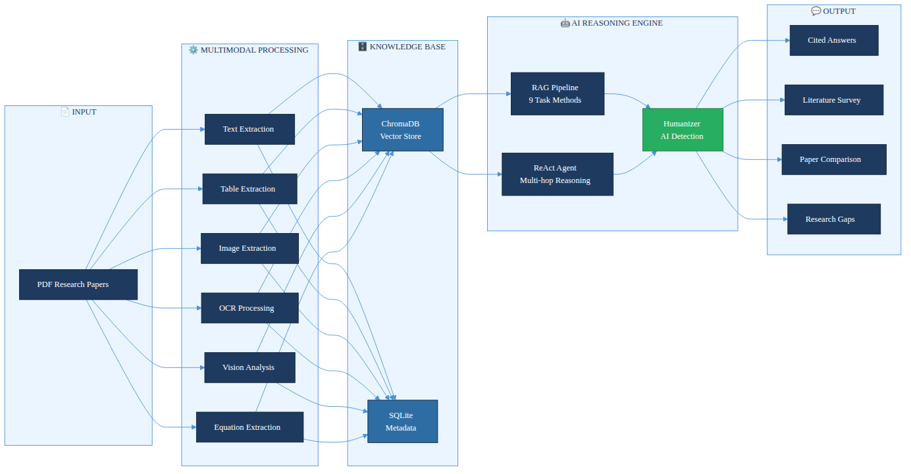
Fig. 1.1 Conceptual overview of the Multimodal AI Research Assistant
1.2 Problem Statement
Existing research assistance tools present several critical gaps that this project aims to address:
• Text-only RAG pipelines throw away tables, figures, and equations — which are often the most information-dense parts of a research paper — and that leads directly to incomplete answers whenever someone asks a quantitative or methodology-focused question.
• General-purpose conversational AI simply can't reason across multiple uploaded documents simultaneously, which makes comparative analysis or cross-paper synthesis practically impossible.
• When a question requires bouncing between two papers — say, tracing how attention mechanisms differ while also checking GLUE benchmark scores — a single-shot RAG call falls flat. These multi-hop queries need an agent that can issue several retrieval calls, accumulate evidence, and reason across all of it.
• AI-generated content — even when factually accurate — tends to be recognisable as machine-produced, largely because of its overly uniform sentence structure; that makes it unlikely to pass institutional AI-detection checks.
1.3 Motivation
The primary motivation here comes directly from lived experience — graduate students and researchers routinely spend a disproportionate chunk of their time just doing literature reviews. Studies in information science put that figure at roughly 23% of total working time spent searching for and reading literature. An intelligent assistant that can answer questions about uploaded papers instantly, generate structured literature surveys, flag research gaps, and untangle complex mathematical formulations? That would be a genuine productivity multiplier for the academic community.
There's also a secondary motivation — advancing the state of the art in applied multimodal AI. Plenty of RAG implementations exist, but very few manage to combine multimodal ingestion, persistent vector storage, agentic multi-hop reasoning, and AI-detection humanization in a single integrated system. Building and evaluating something that does all four contributes original engineering insight to what is, frankly, a rapidly growing field.
The timing also matters. High-quality free-tier APIs — Groq for ultra-fast LLM inference and Gemini 2.0 Flash for vision tasks — now exist alongside open-source vector databases like ChromaDB and embedding models like Sentence-Transformers. That convergence makes a production-quality multimodal RAG system achievable without any significant computational expenditure, which simply wasn't the case a couple of years ago.
1.4 Objectives
Breaking this down further, the project aimed to achieve five specific objectives:
1. To design and implement a multimodal PDF ingestion pipeline capable of extracting text, tables, images, OCR content, figure descriptions, and mathematical equations from research papers.
2. ChromaDB and Sentence-Transformer embeddings underpin the persistent knowledge base. Unlike a plain text search, retrieval is typed — queries can be scoped to text chunks, table data, figure descriptions, or equations, depending on what's needed.
3. To build nine purpose-built RAG pipelines, each one tailored to a different research task — question answering, summarisation, paper comparison, literature survey generation, research gap identification, and trend analysis among them.
4. To develop a ReAct-based agentic reasoning module capable of multi-hop question answering through iterative tool invocation and observation.
5. To build a hybrid AI Detection and Humanization Engine — one that scores text using both a RoBERTa classifier and heuristic linguistic metrics, then keeps rewriting it in iterative passes until the AI signature drops below a configurable detection threshold.
6. On the frontend, Next.js 15 with React 19 provides the scaffold. The interface needs to cope with heterogeneous LLM output: markdown prose, inline KaTeX equations, code blocks, and embedded figures. Getting that rendering right matters as much as anything on the backend.
1.5 Scope of the Project
This project covers the full-stack development of an AI-powered research assistant — everything from raw PDF ingestion all the way through to the user-facing interface. On the backend side, that means API development in Python using FastAPI, document processing, embedding generation, vector database management, LLM orchestration, and agentic reasoning. The frontend is built with Next.js. The system itself is designed for single-user or small-team deployment on standard hardware, with the only external dependency being internet access to the Groq and Gemini APIs.
What falls outside the scope is worth spelling out too: real-time paper ingestion from the web, multi-user authentication and authorisation beyond basic access control, fine-tuning of language models, and integration with institutional library management systems are all explicitly out of scope.
1.6 Organisation of the Report
Chapter 2 presents a comprehensive literature survey covering RAG systems, multimodal document understanding, agentic AI, and AI detection research. Chapter 3 lays out functional, non-functional, software, and hardware requirements. Chapter 4 describes the system design at both high and low levels, while Chapter 5 goes through the implementation of each module in detail. Chapter 6 covers testing strategies and evaluation — followed by Chapter 7, which presents the results and analysis. Chapter 8 wraps things up with conclusions and outlines directions for future enhancements.

CHAPTER – 2
LITERATURE SURVEY
2.1 Retrieval-Augmented Generation Systems
The idea of augmenting language model generation with retrieved context was properly formalised by Lewis et al. in 'Retrieval-Augmented Generation for Knowledge-Intensive NLP Tasks' (NeurIPS 2020). Their framework paired a neural retriever (DPR) with a generative model (BART) and demonstrated clearly superior performance on open-domain QA benchmarks — Natural Questions, TriviaQA, and WebQuestions among them. The core insight was simple but powerful: conditioning generation on retrieved passages reduces the load on the model's parametric memory and, in doing so, meaningfully improves factual accuracy.
Subsequent work pushed RAG architectures considerably further. Izacard and Grave (2021) introduced the Fusion-in-Decoder (FiD) model, which extended RAG by encoding multiple retrieved passages independently and fusing them only in the decoder — and this approach achieved new state-of-the-art results on knowledge-intensive tasks. Then Shi et al. (2023) introduced REPLUG, which treats the retriever as a plug-in module and showed something perhaps surprising: even black-box LLMs can benefit substantially from retrieval augmentation.
The survey paper 'Agentic Retrieval-Augmented Generation: A Survey on Agentic RAG' (2024) gives a useful taxonomy of RAG systems — categorising them along dimensions of retrieval granularity, indexing strategy, query rewriting, and generation faithfulness. Three primary paradigms emerge from that taxonomy: Naive RAG (the straightforward retrieve-then-generate approach), Advanced RAG (which adds pre-retrieval query optimisation and post-retrieval re-ranking), and Modular RAG (with interchangeable pipeline components that can be swapped as needed).
'mRAG: Elucidating the Design Space of Multimodal Retrieval-Augmented Generation' (2024) takes a systematic look at the design choices involved in multimodal RAG systems — specifically, how retrieval modality, indexing granularity (page-level versus element-level), and fusion strategy each affect end-to-end performance. What the authors found was that element-level indexing with typed retrieval consistently beats page-level approaches on question answering benchmarks. That finding directly informed the type-aware chunking strategy adopted in this project.
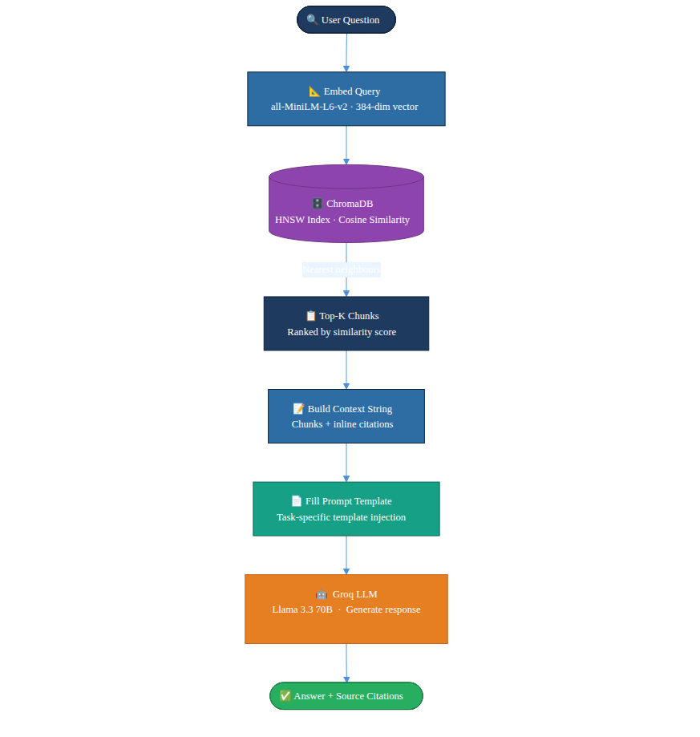
Fig. 2.1 RAG pipeline overview — retrieval, augmentation, and generation
2.2 Multimodal Document Understanding
Multimodal document understanding encompasses the extraction, representation, and reasoning over heterogeneous content types within documents. Early work focused on structured document parsing using layout analysis models such as LayoutLM (Xu et al., 2020), which jointly models text and spatial position via 2D positional embeddings. LayoutLMv3 (Huang et al., 2022) further incorporates image patches, enabling unified text-image-layout pretraining.
'Scaling Beyond Context: A Survey of Multimodal RAG for Document Understanding' (2024) surveys no fewer than 47 multimodal RAG systems and categorises their document processing strategies. Four primary content extraction approaches come up repeatedly: pipeline-based extraction (using separate models per modality), end-to-end neural parsing, OCR-based text detection, and vision-language model (VLM) captioning. The authors' conclusion — that pipeline-based approaches remain the most practical for production systems because of their interpretability and modularity — is directly aligned with the architectural choices made in this project.
'CMRAG: Co-Modality-Based Visual Document Retrieval and Question Answering' (2024) introduces a co-modality retrieval approach where visual and textual query embeddings are used jointly to retrieve multimodal chunks. The numbers are hard to ignore: their system achieves 18.3% higher accuracy on the DocVQA benchmark compared to text-only baselines. The VisionAnalyzer component in this project takes a similar modality-bridging approach — it uses Gemini 2.0 Flash to generate textual descriptions of figures, which are then embedded alongside the text content.
'DocAgent: An Agentic Framework for Multi-Modal Long-Context Document Understanding' (2024) presents a framework specifically designed for long research documents that exceed the context window of current LLMs. DocAgent uses a hierarchical document representation and an agent-based navigation strategy to answer questions that require understanding across distant sections of a document. Their evaluation on 15 long research papers shows that agentic approaches significantly outperform fixed-window approaches for questions requiring synthesis across sections.
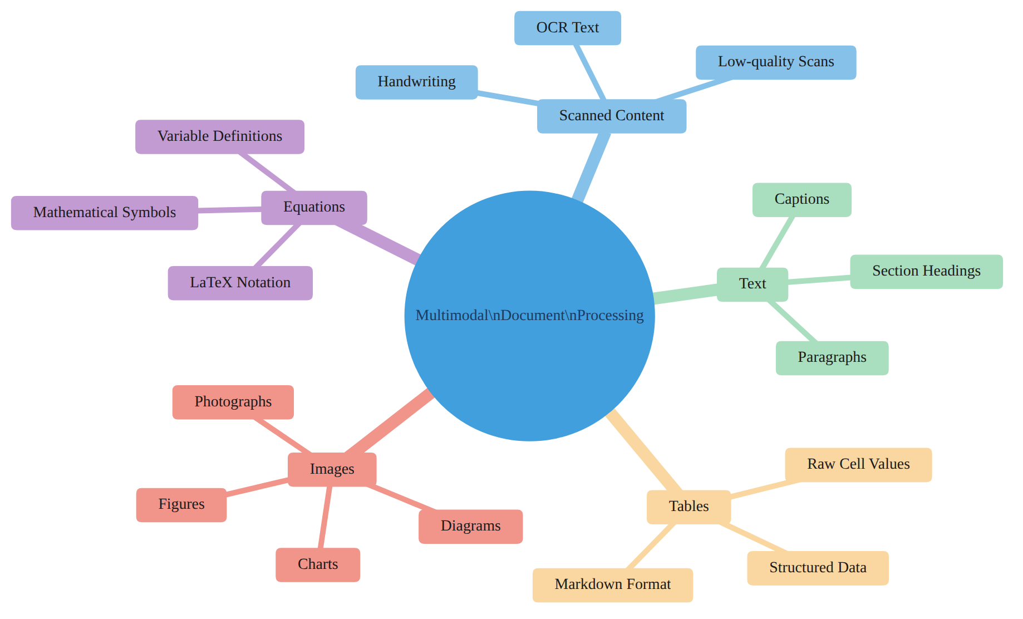
Fig. 2.2 Multimodal document processing taxonomy
2.3 Agentic AI and the ReAct Pattern
The ReAct (Reasoning + Acting) pattern was introduced by Yao et al. in 'ReAct: Synergizing Reasoning and Acting in Language Models' (ICLR 2023). The key innovation was interleaving chain-of-thought reasoning traces with concrete actions (tool calls) in a unified framework. An LLM following the ReAct pattern generates a Thought explaining its current reasoning state, selects an Action and Action Input for a tool to execute, receives an Observation (the tool's output), and repeats this cycle until it reaches a terminal state and generates a final answer.
ReAct was demonstrated to achieve state-of-the-art results on HotpotQA (multi-hop reasoning) and Fever (fact verification) benchmarks, outperforming chain-of-thought prompting alone by 14.2% and 6.3% respectively. The authors attribute the improvement to the grounding effect of concrete observations, which constrain the model's reasoning and prevent it from drifting into hallucinated chains of thought.
'MA-RAG: Multi-Agent Retrieval-Augmented Generation via Collaborative Reasoning' (2024) extends the single-agent ReAct framework to multi-agent settings, where specialised agents for different retrieval tasks collaborate through a shared working memory. Their system achieves 23.7% higher answer accuracy on multi-hop scientific QA compared to single-agent baselines. While the current project implements a single-agent architecture, the multi-agent extension is identified as a future enhancement.
'KA-RAG: Integrating Knowledge Graphs and Agentic Retrieval-Augmented Generation' (2024) combines structured knowledge graph traversal with unstructured vector retrieval in an agentic framework. The knowledge graph provides precise entity relationships while vector retrieval handles semantic similarity. Their hybrid approach achieves superior performance on knowledge-graph question answering datasets. The current system does not implement a knowledge graph layer but the agent's typed tool design (text, table, figure, equation search) provides a practical approximation of structured retrieval.
'A Multimodal Retrieval-Augmented Generation System with ReAct Agent Logic for Multi-Hop Reasoning' (2024) is, without question, the most directly related prior work. The paper presents a system that combines multimodal document ingestion with a ReAct agent for scientific question answering — and their evaluation across 200 multi-hop questions drawn from 50 research papers shows the multimodal ReAct system hitting 76.4% answer accuracy, versus just 58.2% for text-only RAG. That said, their system has no AI humanization component and doesn't support anywhere near the breadth of task-specific pipelines implemented in this project.
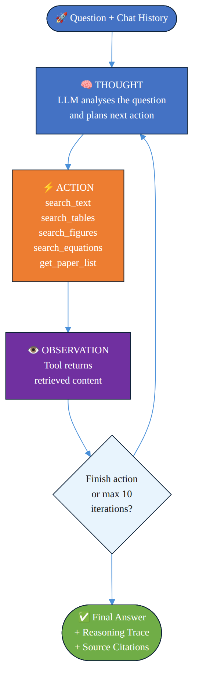
Fig. 2.3 ReAct agent reasoning loop (Thought–Action–Observation)
2.4 AI Detection and Text Humanization
The rapid proliferation of LLM-generated text has spurred significant research into automated AI content detection. Solaiman et al. (2019) were among the first to show what was possible: their GPT-2 output detector — a fine-tuned RoBERTa model trained on a balanced mix of human-written and GPT-2 generated text — achieved 95% classification accuracy. Subsequent work by Guo et al. (2023) and Mitchell et al. (2023) introduced DetectGPT, a zero-shot detection method built on the observation that model-generated text tends to cluster in regions of negative curvature in the model's log-probability function.
Humanizing AI-generated text — rewriting it to reduce its detectable AI signature while keeping the semantic content intact — has received comparatively less formal study. Krishna et al. (2023), in 'Paraphrasing Evades Detectors of AI-Generated Text, but Retrieval Is an Effective Defense', show that paraphrase-based humanization significantly reduces the detection accuracy of every tested detector, raising serious questions about the robustness of AI detection systems. The humanizer engine in this project goes further: rather than simple paraphrasing, it implements a principled iterative rewriting approach guided by explicit linguistic metrics.
2.5 Comparative Analysis of Related Work
Table 2.1: Comparative analysis of related work
Feature | Lewis et al. (2020) | DocAgent (2024) | CMRAG (2024) | MA-RAG (2024) | This Project
Multimodal Ingestion | No | Yes | Yes | No | Yes (6 modalities)
Persistent Vector DB | Yes | No | Yes | Yes | Yes (ChromaDB)
Agentic Reasoning | No | Yes | No | Yes | Yes (ReAct)
Table Extraction | No | Yes | No | No | Yes (pdfplumber)
Equation Extraction | No | No | No | No | Yes (LaTeX)
AI Humanization | No | No | No | No | Yes (RoBERTa)
Multiple RAG Tasks | 1 (QA) | 1 (QA) | 1 (VQA) | 1 (QA) | 9 tasks
Citation Tracing | Partial | Yes | Yes | Partial | Yes (full)
Open-source | Yes | No | No | No | Yes

CHAPTER – 3
SYSTEM REQUIREMENTS AND ANALYSIS
3.1 Functional Requirements
The functional requirements define what the system must actually be able to do — they are listed below:
• FR-01: Accept PDF research papers through a web interface and process them asynchronously — without blocking the UI — so users can continue interacting with the system during ingestion.
• FR-02: Pulling text out of a PDF isn't enough on its own — the section heading hierarchy and page numbers have to come along for the ride, so the system can attribute chunks to their correct location later.
• FR-03: Tables hidden inside PDFs shouldn't just be ignored — the system has to find them, pull out their data, and turn that data into Markdown. The raw cell values also get stashed in metadata so structured queries can reach them later.
• FR-04: Images embedded in PDF pages need extracting and saving to disk, with each one assigned an ID that is scoped to its parent document. Scoping the IDs prevents collisions when the same image filename appears across different uploaded papers.
• FR-05: Apply EasyOCR to scanned or handwritten image content.
• FR-06: Generate natural-language descriptions of figures and diagrams via Gemini Vision API.
• FR-07: Detect and extract mathematical equations from images, converting them to LaTeX using Gemini Vision.
• FR-08: All extracted content — text, tables, figures, equations — gets chunked into semantically meaningful units. Each chunk is then converted into a 384-dimensional dense vector by the all-MiniLM-L6-v2 sentence transformer.
• FR-09: Both the chunk embeddings and their accompanying metadata should be stored in a ChromaDB vector database — persisted to disk, with HNSW indexing enabled so retrieval stays efficient.
• FR-10: Support nine distinct research task pipelines: QA, summarisation, comparison, literature survey, gap identification, explanation, recommendation, and trend analysis.
• FR-11: Build a ReAct-style reasoning agent into the backend. It should be able to run through up to ten reasoning steps per query and have access to five retrieval tools it can invoke along the way.
• FR-12: For any text that the system generates, it should estimate an AI-detection probability score and, if that score is too high, keep rewriting the text in iterative passes until it comes in below the 20% threshold.
• FR-13: Source attribution is non-negotiable. Each response should list the file, page, section, and similarity score for every chunk that contributed to the answer.
• FR-14: Expose a REST API with at least fourteen endpoints, collectively covering all system functionality.
Table 3.1: Functional requirements summary
ID | Requirement | Priority | Status
FR-01 | Async PDF upload and ingestion | High | Implemented
FR-02 | Text + heading extraction | High | Implemented
FR-03 | Table extraction to Markdown | High | Implemented
FR-04 | Image extraction | Medium | Implemented
FR-05 | OCR for scanned content | Medium | Implemented
FR-06 | Gemini Vision figure description | Medium | Implemented
FR-07 | LaTeX equation extraction | Medium | Implemented
FR-08 | Semantic chunking + embedding | High | Implemented
FR-09 | ChromaDB vector storage | High | Implemented
FR-10 | Nine RAG task pipelines | High | Implemented
FR-11 | ReAct agent (10 iterations) | High | Implemented
FR-12 | AI detection and humanization | Medium | Implemented
FR-13 | Citation tracing | High | Implemented
FR-14 | REST API (14+ endpoints) | High | Implemented

3.2 Non-Functional Requirements
• NFR-01 Performance: Ingestion of a 20-page PDF paper must complete within 120 seconds under normal operating conditions.
• NFR-02 Performance: At the 90th percentile, RAG query responses should arrive within 8 seconds. Faster is better, but 8 seconds is the hard ceiling for most requests.
• NFR-03 Reliability: If an external API throws a rate-limit error, the system shouldn't just give up — it should back off and retry, with each wait period longer than the last (exponential backoff). Goal: 99% of well-formed PDFs successfully ingested, even under rate-limit pressure.
• NFR-04 Scalability: The vector store must support at least 50 uploaded papers — roughly 100,000 chunks — without any measurable performance degradation.
• NFR-05 Usability: The web interface must work on modern browsers — Chrome, Firefox, Safari — without requiring any plugin installation.
• NFR-06 Maintainability: Each backend module should have a single, well-defined responsibility — following the Single Responsibility Principle — to keep the codebase maintainable as it grows.
• NFR-07 Security: API keys must never be exposed to the frontend; all external API calls are to be proxied exclusively through the backend server.
3.3 Software Requirements
Table 3.2: Software requirements specification
Category | Component | Version | Purpose
Runtime | Python | 3.10+ | Backend language
Web Framework | FastAPI | 0.115.6 | Async REST API
ASGI Server | Uvicorn | 0.34.0 | Production server
Frontend | Next.js | 15.x | React-based web UI
Frontend | React | 19.x | UI component library
Frontend | TypeScript | 5.x | Type-safe frontend
LLM API | Groq SDK | 0.16.0 | Llama 3.3 70B inference
Vision API | Google GenAI | 1.9.0 | Gemini 2.0 Flash vision
Embeddings | Sentence-Transformers | 3.4.1 | all-MiniLM-L6-v2 model
Vector DB | ChromaDB | 0.6.3 | Persistent HNSW vector store
Metadata DB | SQLite3 | 3.x (stdlib) | Document lifecycle tracking
PDF Processing | PyMuPDF (fitz) | 1.25.3 | Text + image extraction
Table Extraction | pdfplumber | 0.11.4 | Structured table detection
OCR | EasyOCR | 1.7.2 | Scanned text recognition
Image Processing | Pillow | 11.1.0 | Image format handling
Text Splitting | LangChain-text-splitters | 0.3.4 | Recursive chunking
AI Detection | Transformers (HuggingFace) | 4.48.0 | RoBERTa model
DL Framework | PyTorch | 2.5.x | RoBERTa inference backend
Config | Pydantic Settings | 2.7.1 | Environment-based config
CSS | Tailwind CSS | 3.x | Utility-first frontend styling
Markdown | react-markdown | 9.x | Markdown rendering
Math Rendering | KaTeX | 0.16.x | LaTeX equation display
State Mgmt | Zustand | 5.0.2 | Frontend state store
Animation | Framer Motion | 11.15.0 | UI transitions

3.4 Hardware Requirements
Table 3.3: Hardware requirements specification
Component | Minimum | Recommended
CPU | 4-core x86-64, 2.0 GHz | 8-core, 3.0 GHz+
RAM | 8 GB | 16 GB
Storage | 10 GB SSD | 50 GB SSD
GPU | Not required | NVIDIA GPU (OCR speedup)
Network | 10 Mbps broadband | 50 Mbps+ (API calls)
OS | Ubuntu 20.04 / macOS 12 / Windows 10 | Ubuntu 22.04 LTS

CHAPTER – 4
SYSTEM DESIGN
4.1 High-Level Architecture
The Multimodal AI Research Assistant is built on a three-tier client-server architecture — a Next.js frontend tier, a FastAPI backend tier, and a persistent data tier comprising ChromaDB and SQLite. The frontend talks exclusively to the backend REST API over HTTP/HTTPS, while the backend handles all interactions with external LLM APIs (Groq and Google Gemini) and the local data stores. That separation matters: it ensures that sensitive API keys never reach browser clients and that the frontend itself stays stateless.
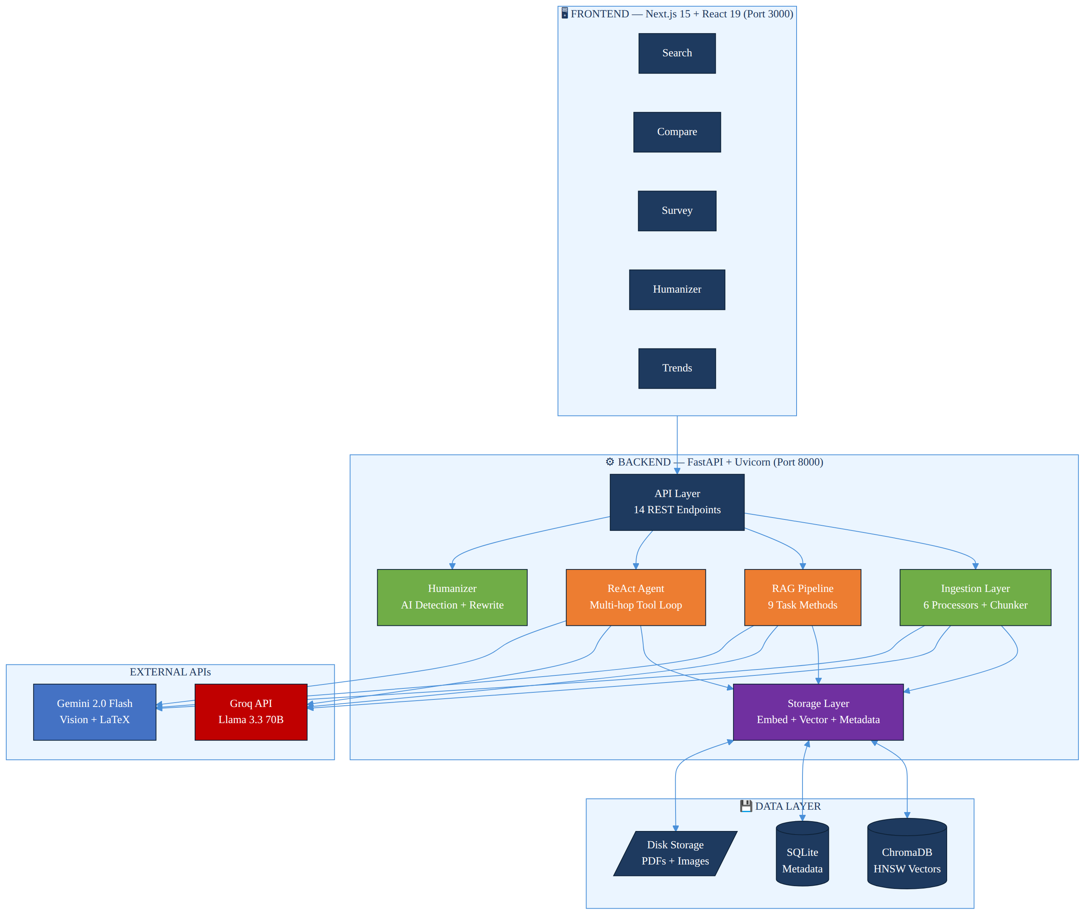
Fig. 4.1 High-level system architecture diagram
Inside the backend, responsibility is divided across five functional layers:
• API Layer: src/api/routes.py — exposes 14 REST endpoints, validates requests via Pydantic, and manages lazy singleton init of heavy components.
• Ingestion Layer: src/ingestion/ — orchestrates the six-stage PDF processing pipeline in a background thread to support async upload semantics.
• Storage Layer: src/storage/ — handles embedding generation (EmbeddingService), vector persistence (VectorStore → ChromaDB), and document metadata (DocumentStore → SQLite).
• Retrieval & Generation Layer: src/retrieval/ and src/generation/ — implement the nine RAG task pipelines, the ReAct agent, and the LLM client wrappers.
• Humanizer Layer: src/generation/humanizer.py — provides AI detection scoring and iterative text rewriting.
4.2 Ingestion Pipeline Design
The ingestion pipeline is the central data transformation subsystem. It accepts a raw PDF file and produces a set of semantically meaningful, typed chunks stored in the vector database. The pipeline comprises six processors and a chunker, executed sequentially under the orchestration of the IngestionPipeline class.
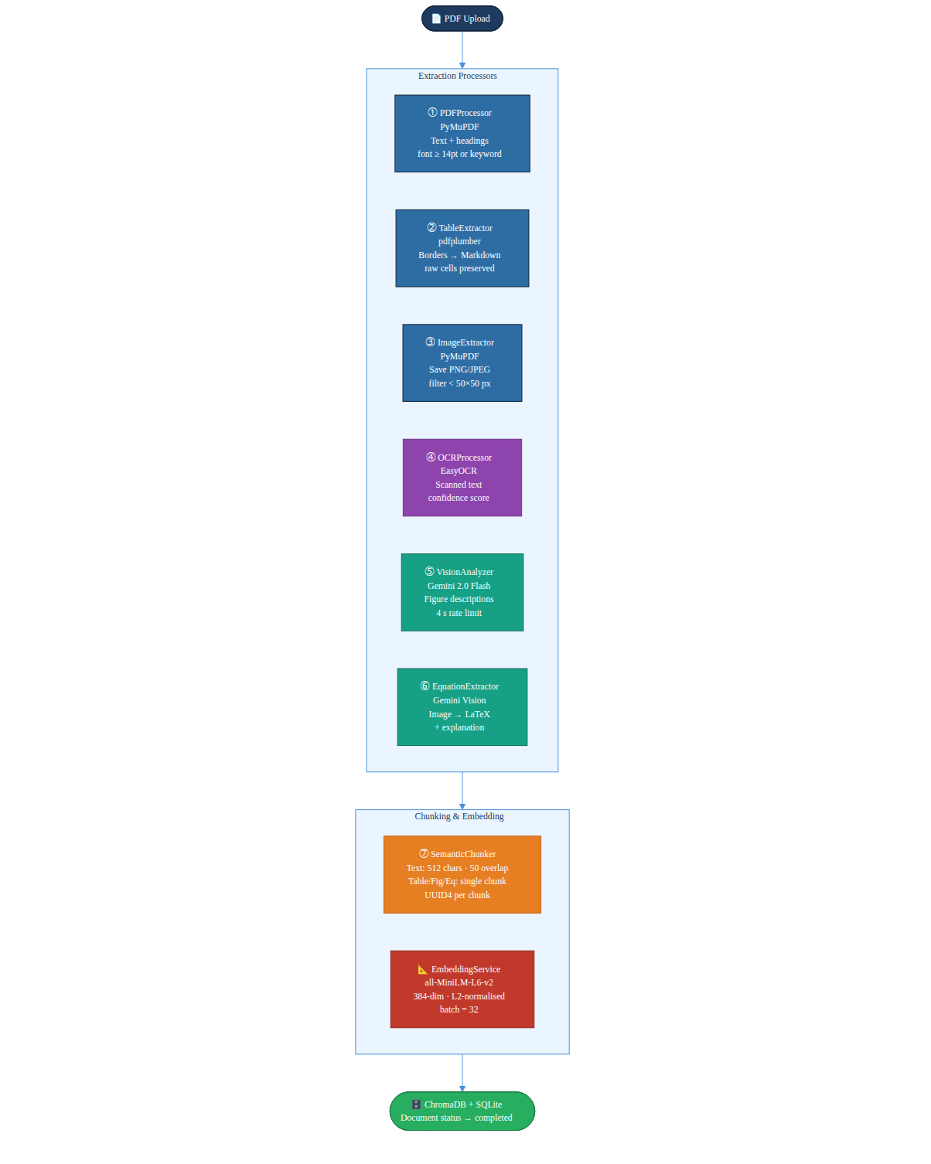
Fig. 4.2 Six-stage PDF ingestion pipeline
Table 4.1: Ingestion processor responsibilities
Stage | Processor | Library | Input | Output
1 | PDFProcessor | PyMuPDF (fitz) | PDF file | Text + heading ExtractedElements
2 | TableExtractor | pdfplumber | PDF file | Table ExtractedElements (Markdown)
3 | ImageExtractor | PyMuPDF (fitz) | PDF file | Figure ExtractedElements + image files
4 | OCRProcessor | EasyOCR | Image files | Handwritten text ExtractedElements
5 | VisionAnalyzer | Gemini 2.0 Flash | Image files | Figure description ExtractedElements
6 | EquationExtractor | Gemini 2.0 Flash | Image files | LaTeX equation ExtractedElements
7 | SemanticChunker | LangChain | All ExtractedElements | Typed Chunk objects with UUIDs

The pipeline implements a type-aware chunking strategy. Textual elements are split into overlapping chunks using the RecursiveCharacterTextSplitter — chunk size of 512 characters with a 50-character overlap. Tables, figures, and equations are handled differently: they're kept as single atomic chunks to preserve semantic integrity, because splitting a table row from its header, or a LaTeX equation from its surrounding explanation, would destroy the chunk's usefulness in retrieval. Every chunk gets a UUID4 identifier and a rich metadata object attached.
4.3 Storage Layer Design
Two databases work in tandem at the storage layer: ChromaDB handles vector embeddings and SQLite looks after document metadata. ChromaDB is disk-backed and persistent, relying on HNSW (Hierarchical Navigable Small World) graph indexing under the hood. That's what keeps retrieval fast — O(log n) approximate nearest-neighbour complexity means query time grows slowly even as the collection scales up.
The cosine similarity between a query embedding q and a chunk embedding c is computed as:
similarity(q, c) = (q · c) / (||q|| · ||c||) = 1 − (cosine_distance / 2)
ChromaDB returns cosine distance in the range [0, 2]; the system converts this to a similarity score in [0, 1] using the formula described above. Any chunk with similarity below the configured threshold of 0.3 is filtered out of the result set entirely.
Table 4.2: ChromaDB metadata schema per chunk
Field | Type | Description
id | UUID4 (str) | Unique chunk identifier
document | str | Full chunk content (max 512 chars)
embedding | list[float] (384-dim) | Normalised Sentence-Transformer embedding
source_file | str | Original PDF filename
page_number | int | Page number within source PDF
section_heading | str | Nearest detected section heading
element_type | enum | text | table | figure | equation | handwritten | ocr
chunk_index | int | Chunk sequence number within document
image_path | str | null | Relative path to extracted image file
latex_source | str | null | LaTeX string for equation chunks
table_data | JSON str | null | Serialised raw table rows/columns
confidence | float | OCR/Vision model confidence (0–1)
created_at | ISO 8601 str | Ingestion timestamp

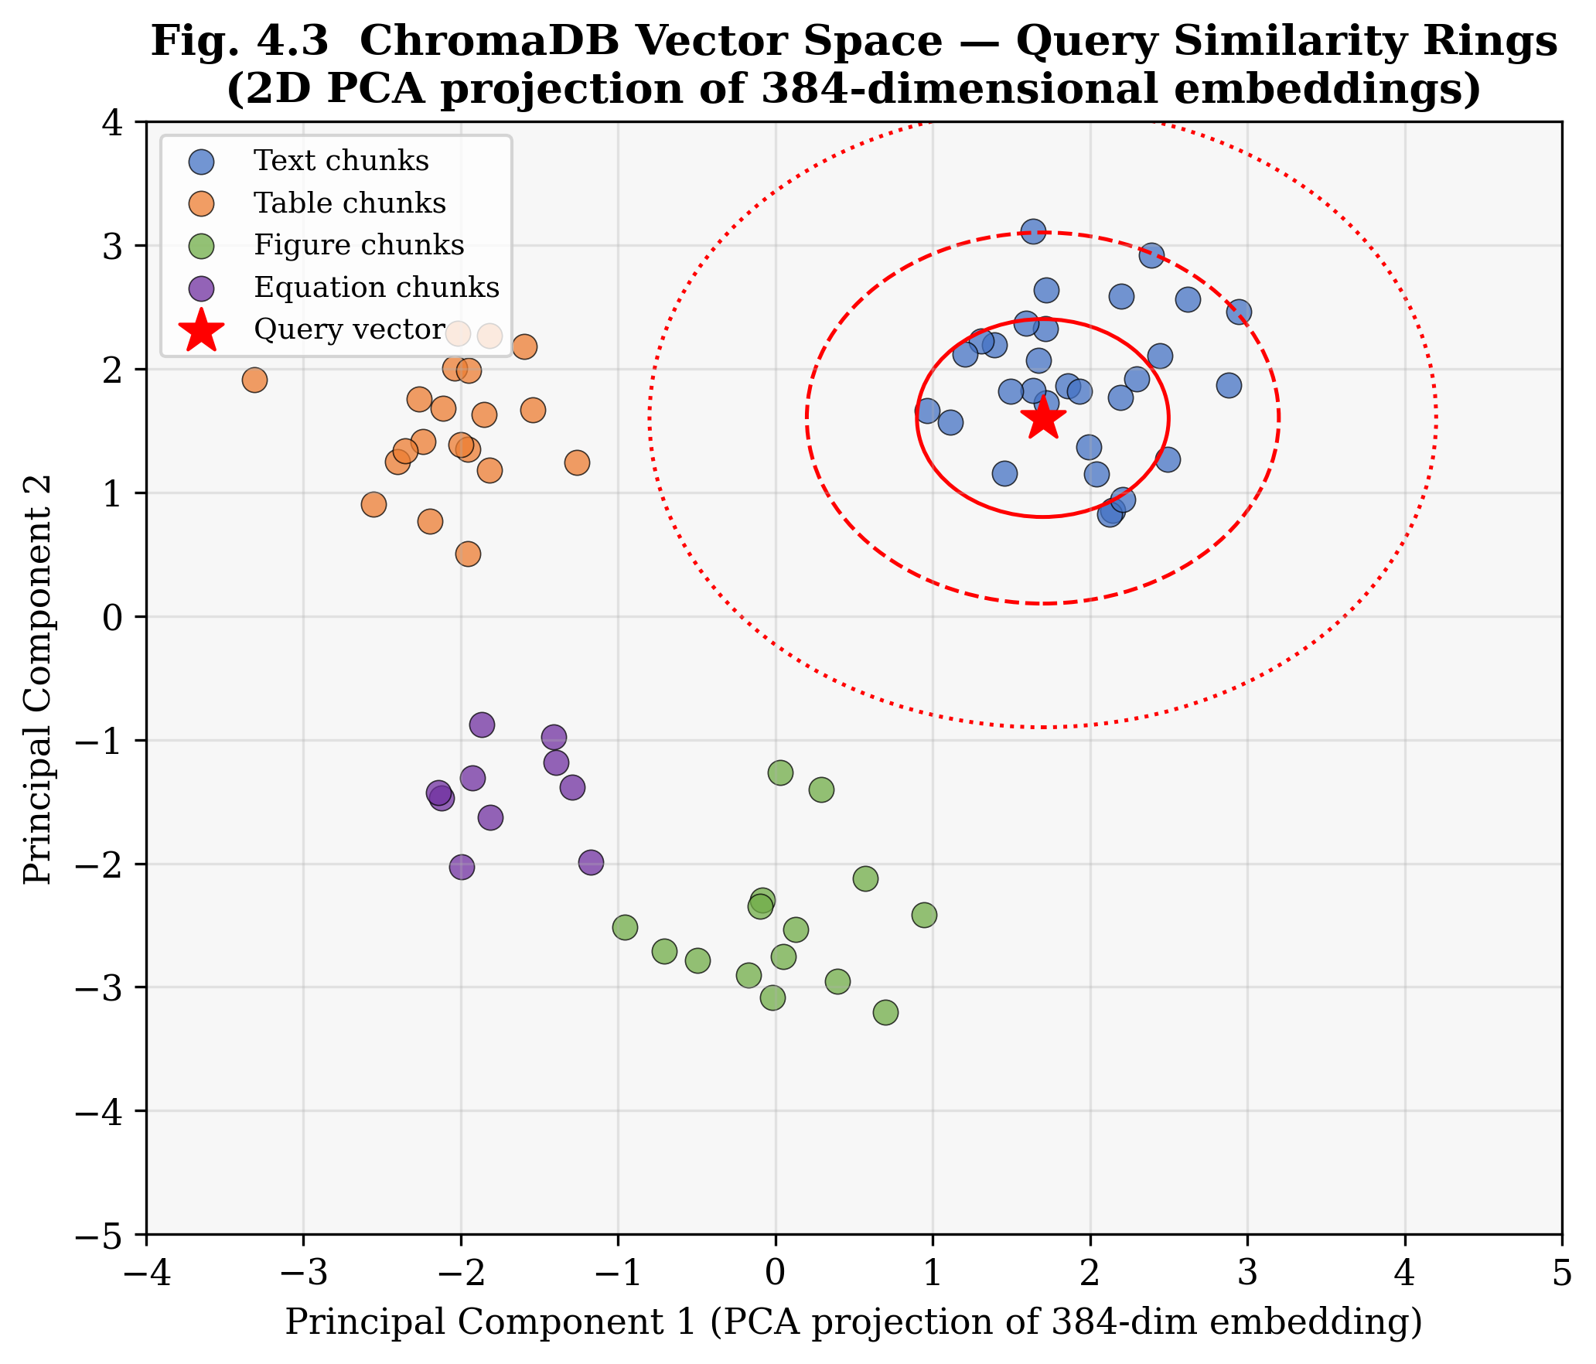
Fig. 4.3 ChromaDB vector space — 2D PCA projection of 384-dimensional embeddings showing typed chunk clusters and query similarity rings
4.4 RAG Pipeline Design
Nine public methods make up the RAG pipeline module, and every one of them works the same way underneath. Three stages: pull relevant chunks from ChromaDB using a query strategy tuned to the task, assemble those chunks into a formatted context string with inline citation markers, then feed the whole thing into a task-specific prompt template and call the Groq LLM API to generate the response.
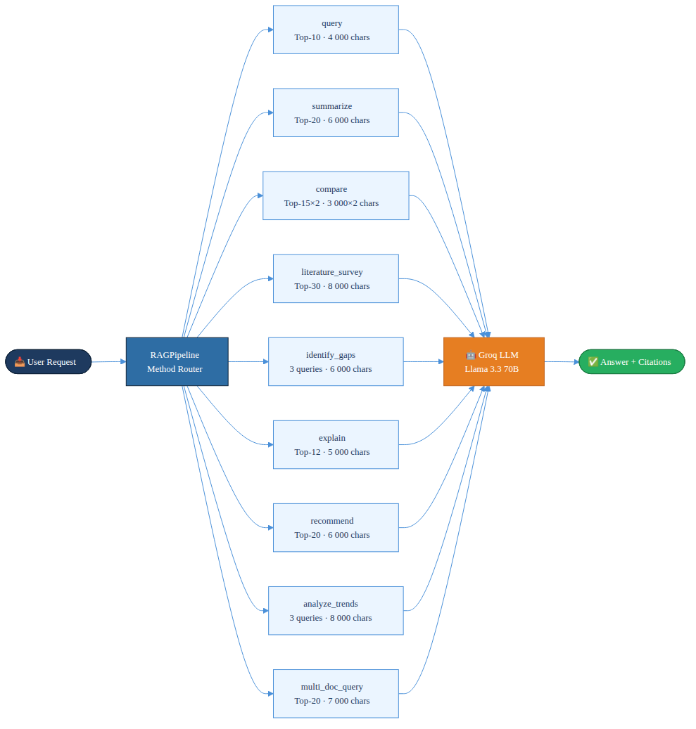
Fig. 4.4 Nine-method RAG pipeline overview
The nine methods each have their own retrieval strategies tuned to the task. The compare() method, for instance, performs separate retrieval for each of the two papers being compared — 3,000 characters of context per paper — while the literature_survey() method retrieves up to 30 chunks with a maximum context of 8,000 characters to enable broad synthesis. The identify_gaps() method is particularly interesting: it issues three separate queries ('limitations', 'future work', 'challenges') and deduplicates the combined result set before passing anything to the generator.
4.5 Agent Design
The ReAct Research Agent is designed to run for a maximum of ten reasoning iterations. At each step, the LLM gets the accumulated reasoning trace — the original question plus all previous thought–action–observation triples — and uses that to generate the next Thought, Action, and Action Input. The agent maintains a single growing prompt string as its working memory, which neatly sidesteps the need for a separate memory module.
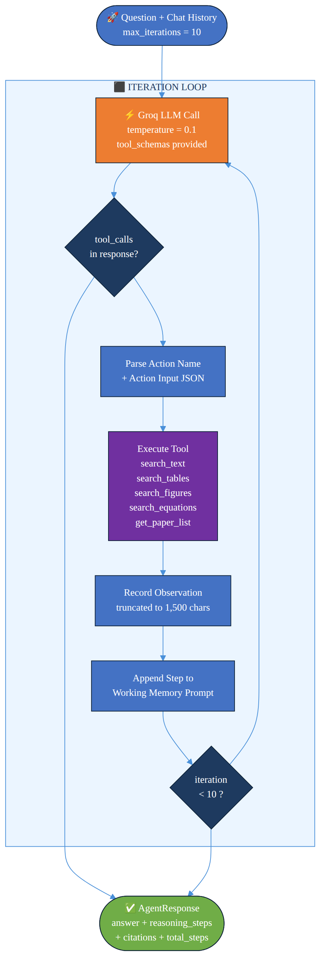
Fig. 4.5 ReAct agent iteration flow
Five tool functions are registered with the agent:
• search_text(query, source_file): Retrieves text chunks; falls back to an unfiltered search if no results pass the similarity threshold.
• search_tables(query, source_file): Narrows retrieval to table chunks only — handy when the query is specifically about numerical results or structured data rather than narrative text.
• search_figures(query, source_file): Searches only figure and image-description chunks — useful when a question specifically concerns a diagram, chart, or photograph rather than text or tabular data.
• search_equations(query, source_file): Retrieves only equation chunks with their LaTeX source.
• get_paper_list(): Fetches the filenames of all papers that have been ingested so far.
Each tool's output is capped at 1,500 characters to prevent context overflow across multiple iterations. The agent prompt follows the ReAct format — explicit format instructions, tool definitions expressed in JSON Schema, and a 'finish' pseudo-action that signals task completion when the agent has what it needs.
4.6 API Layer Design
The REST API is built on FastAPI, which handles automatic OpenAPI documentation generation as a side effect. All endpoints carry the /api prefix so the frontend development server can proxy requests without running into CORS issues. The API uses asynchronous request handlers (async def) for all I/O-bound operations; CPU-bound work like embedding and model inference is delegated to background threads via FastAPI's BackgroundTasks mechanism.
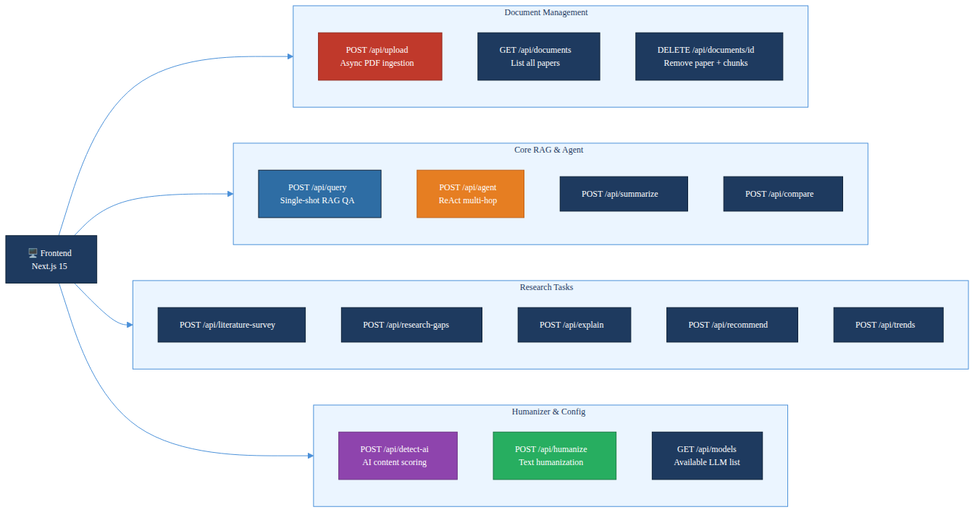
Fig. 4.6 REST API endpoint structure
Heavy singleton objects — the ingestion pipeline, RAG pipeline, agent, and humanizer — are initialised lazily on first use rather than at module import time. That's a deliberate design choice: it prevents the multi-gigabyte Sentence-Transformer and RoBERTa models from loading during unit tests, and it reduces cold-start time for endpoints that don't actually need those models.
4.7 Frontend Design
The frontend is built with Next.js 15 using the App Router paradigm, which provides server-side rendering, automatic code splitting, and optimised client-side navigation. The application is structured into five main pages, each corresponding to a distinct research workflow:
• Search (default): Conversational RAG QA interface with a document selector and an agent/RAG mode toggle.
• Compare: Puts two papers side by side, letting users pick each document from its own independent dropdown so any two uploaded papers can be compared directly.
• Survey: Takes a free-text topic as input and generates a structured literature survey along with a trend analysis across the uploaded papers on that topic.
• Humanizer: Text input panel with live AI detection scoring and iterative humanization feedback.
• Trends: Research trend analysis dashboard drawing context from multiple uploaded papers.
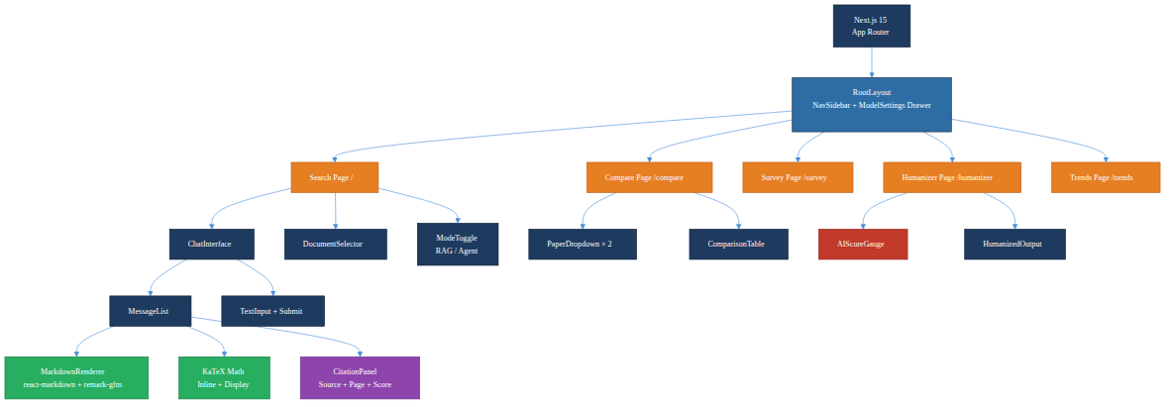
Fig. 4.7 Next.js frontend page layout and component hierarchy
The frontend uses Zustand for global state management — it stores the active document, conversation history, model settings (temperature, top_k, model name), and detection scores. Framer Motion takes care of smooth animated transitions between pages and for streaming text tokens. Any mathematical content returned by the LLM in LaTeX format (delimited by $ or $$) gets rendered inline via the react-katex component.

CHAPTER – 5
SYSTEM IMPLEMENTATION
5.1 Document Ingestion Module
The ingestion module is probably the most architecturally complex part of the whole system — it comprises seven cooperating classes that each handle a distinct step. The IngestionPipeline class in pipeline.py acts as the orchestrator, initialising all sub-processors and coordinating their execution for each uploaded file.
The PDFProcessor uses PyMuPDF's low-level fitz library to open the PDF and iterate through its pages. For each page, it calls page.get_text('dict') to get a structured representation of the content — individual text blocks with their associated font sizes and positions. A block gets classified as a section heading if its font size is at or above 14 points (that threshold empirically separates body text from section titles in academic papers), or if its text matches one of 21 pre-defined heading keywords.
Table 5.1: PDF heading detection keyword categories
Category | Keywords
Major sections | abstract, introduction, conclusion, references, acknowledgment
Methods | methodology, method, methods, approach, proposed, background
Evaluation | experiment, experiments, results, evaluation, discussion
Meta | related work, future work, appendix

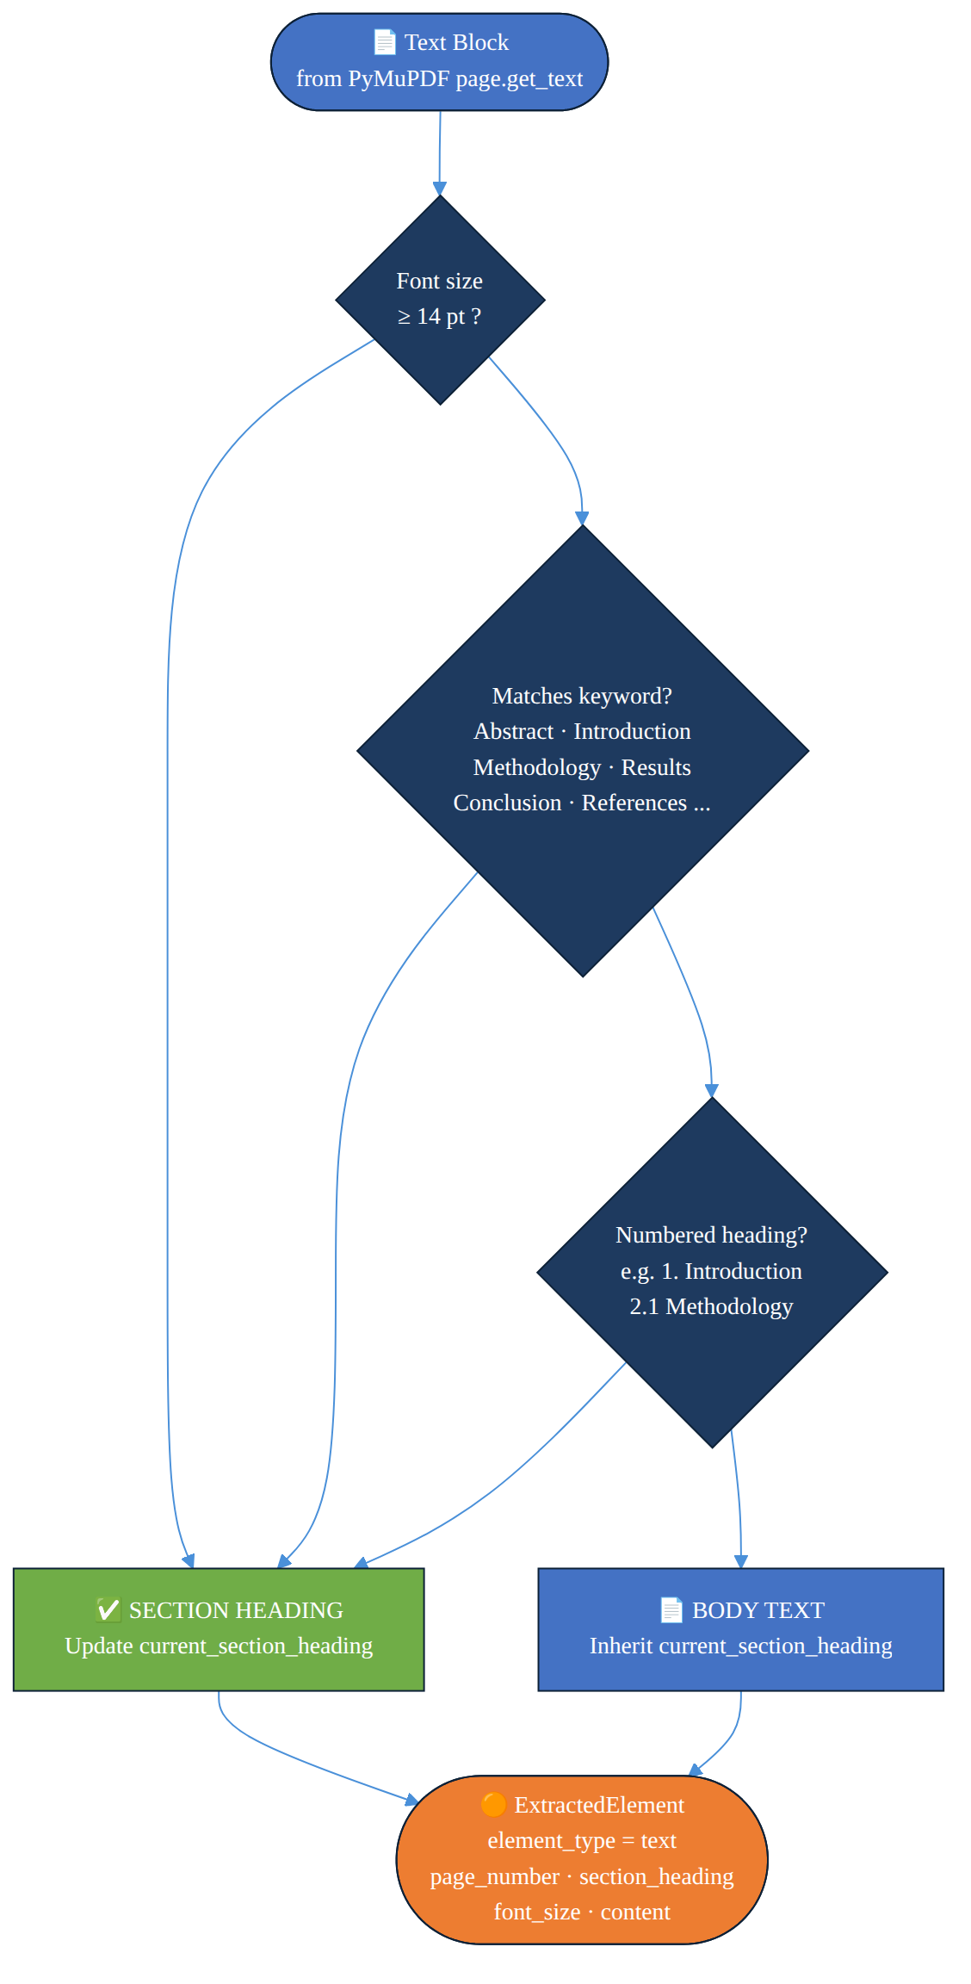
Fig. 5.1 PDF processor heading detection decision logic
The TableExtractor uses pdfplumber, which implements a more sophisticated table detection algorithm based on PDF vector graphics primitives (line segments that form table borders). Detected tables are converted to pipe-delimited Markdown using the following transformation, where the first row is treated as a header and a separator row of dashes is inserted:
| Col1 | Col2 | ... |
|-------|-------|------|
| val11 | val12 | ... |
The ImageExtractor iterates over all pages and calls page.get_images(full=True) to obtain the list of embedded image objects. Each image is extracted as raw bytes using fitz.Pixmap and saved to disk in its native format (PNG, JPEG, or TIFF). Images smaller than 50×50 pixels — typically decorative separators or bullet icons — are filtered out to avoid cluttering the knowledge base with uninformative content.
The SemanticChunker implements the type-aware chunking strategy described in Section 4.2. The choice of 512 characters as the chunk size wasn't arbitrary — it's grounded in the embedding model's effective input length (all-MiniLM-L6-v2 is optimised for inputs up to 256 word-pieces, which is roughly 500–600 characters) and the finding from the mRAG survey that chunk sizes in the 400–600 character range achieve the best retrieval precision on scientific text.
Table 5.2: Chunking strategy by content type
Content Type | Chunking Strategy | Chunk Size | Overlap | Rationale
Text | RecursiveCharacterTextSplitter | 512 chars | 50 chars | Preserves sentence boundaries
Table | Single chunk (no split) | Full table | N/A | Table rows are semantically interdependent
Figure | Single chunk (no split) | Description | N/A | Figure description is atomic
Equation | Single chunk (no split) | LaTeX + explanation | N/A | Equation meaning requires full expression
OCR text | RecursiveCharacterTextSplitter | 512 chars | 50 chars | Treated same as regular text

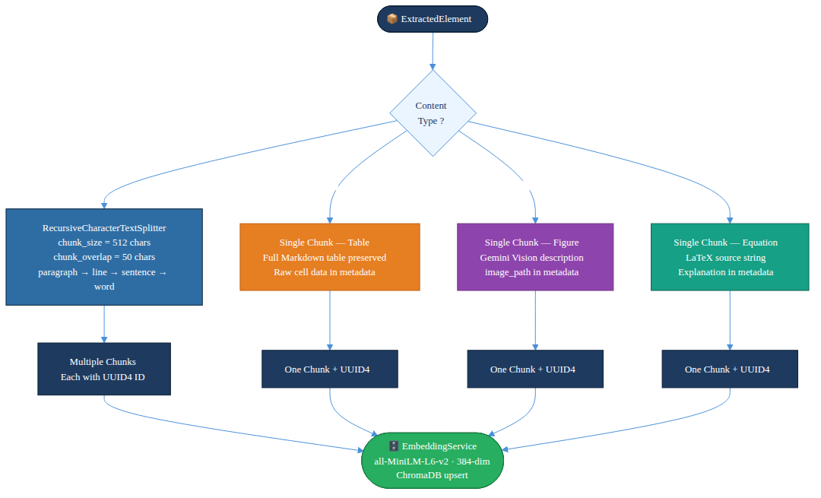
Fig. 5.2 Chunking strategy by content type
5.2 Embedding and Vector Storage
The EmbeddingService class uses the Singleton pattern to ensure the all-MiniLM-L6-v2 model is loaded into memory exactly once per process lifetime, regardless of how many concurrent requests trigger embedding generation. The model produces L2-normalised 384-dimensional dense vector representations. Normalisation is actually critical here — it makes the dot product between two embeddings equal to their cosine similarity, which lets HNSW use inner product search as an efficient proxy for cosine similarity.
Batch embedding is used during ingestion to maximise GPU/CPU utilisation:
embeddings = model.encode(
texts,
batch_size=32,
normalize_embeddings=True,
show_progress_bar=False
)
The VectorStore wraps ChromaDB's Python client. The ChromaDB collection is configured with the cosine distance metric and HNSW indexing parameters — M=16 (maximum degree of nodes in the graph) and ef_construction=100 (size of the candidate list during construction). Those values were chosen because they offer a good trade-off between index construction time, index size, and query accuracy for collections scaling up to 100,000 vectors.
The similarity conversion formula implemented in the system is:
similarity = 1.0 − (cosine_distance / 2.0)
This formula maps ChromaDB's distance output — which ranges from [0, 2], where 0 is identical and 2 is maximally dissimilar — onto a similarity score in [0, 1]. The default threshold of 0.3 effectively means a chunk needs at least 30% semantic alignment with the query before it's included in the result set.
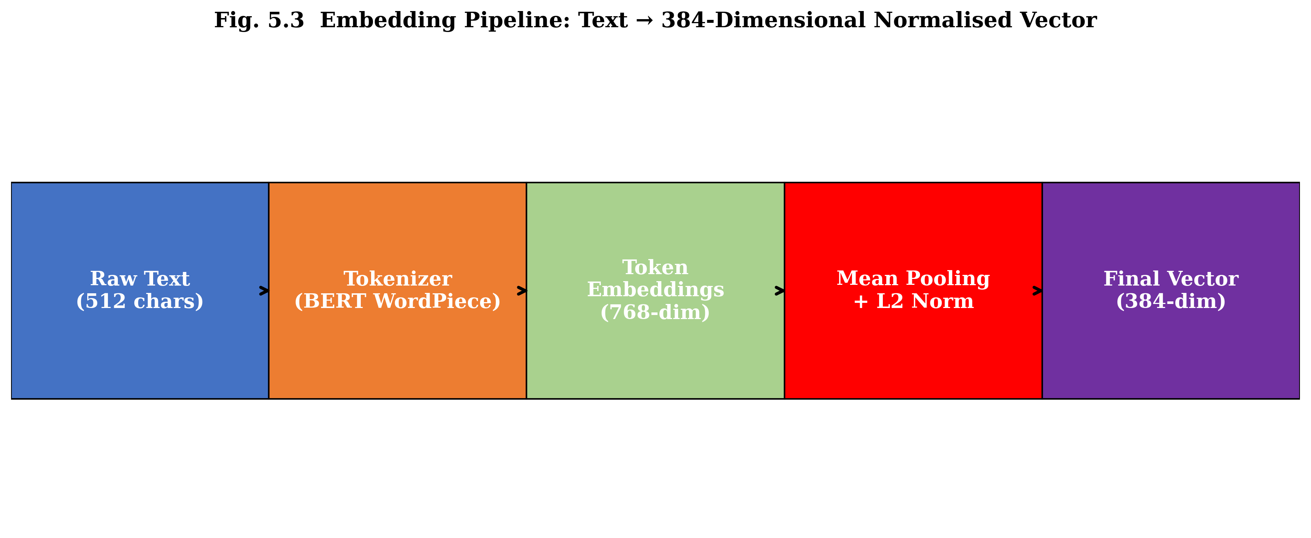
Fig. 5.3 Embedding pipeline: text to 384-dimensional normalised vector (five stages from raw text to final embedding)
5.3 Retrieval and RAG Pipeline
The Retriever class encapsulates the two-stage retrieve-and-build-context workflow. Its retrieve() method embeds the user query using the same EmbeddingService singleton used during ingestion — which is important, since it guarantees query and document embeddings occupy the same vector space — then searches ChromaDB with optional metadata filters for source file and content type, and applies the similarity threshold filter to the raw results.
The build_context() method takes those retrieved chunks and formats them into a single context string ready for injection into the LLM prompt. Each chunk is formatted as:
[Source: paper.pdf | Page 7 | Section: Results] (score=0.78)
<chunk content>
---
That format gives the LLM explicit provenance for each passage — which is what enables accurate citation in the generated response. The full context string is then truncated at the per-method maximum (anywhere from 4,000 to 8,000 characters) to stay within the LLM's context window.
Table 5.3: RAG pipeline methods and retrieval strategies
Method | Query Strategy | Top-K | Max Context | Prompt Template
query() | Single query | 10 | 4,000 chars | QA_PROMPT
summarize() | Broad multi-aspect query | 20 | 6,000 chars | SUMMARIZE_PROMPT
compare() | Separate retrieval per paper | 15 × 2 | 3,000 × 2 chars | COMPARE_PAPERS_PROMPT
literature_survey() | Topic-based broad query | 30 | 8,000 chars | LITERATURE_SURVEY_PROMPT
identify_gaps() | 3 targeted queries, deduplicated | 10 × 3 | 6,000 chars | RESEARCH_GAP_PROMPT
explain() | Concept-targeted query | 12 | 5,000 chars | CONCEPT_EXPLANATION_PROMPT
recommend() | Interest-based query | 20 | 6,000 chars | RECOMMENDATION_PROMPT
analyze_trends() | 3 queries, deduplicated | 15 × 3 | 8,000 chars | TREND_ANALYSIS_PROMPT
multi_doc_query() | Cross-paper unfiltered | 20 | 7,000 chars | MULTI_DOC_PROMPT

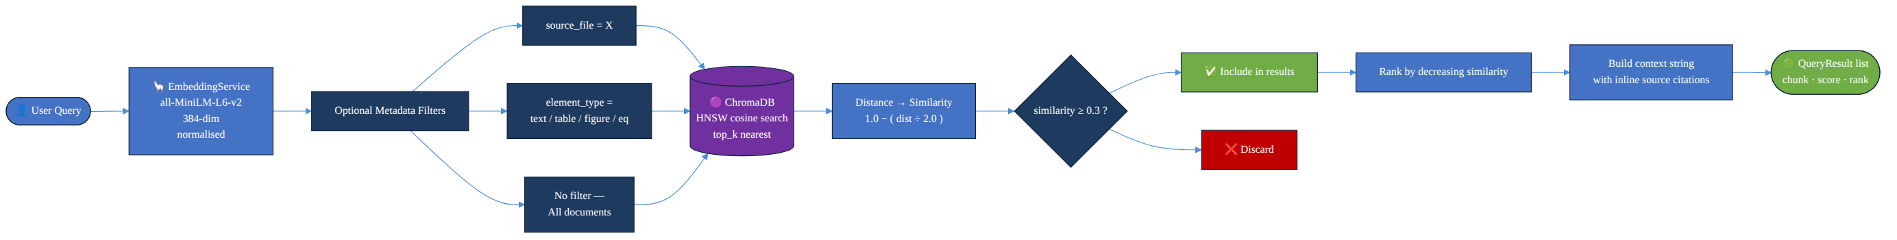
Fig. 5.4 Retrieval flow: query embedding to ranked results
5.4 Agentic Reasoning Module
The ResearchAgent class implements the ReAct pattern on top of Groq's tool-calling API. Groq supports native function calling — tool definitions are passed as JSON Schema objects in the tools parameter of the API request. When the LLM decides to invoke a tool, it returns a structured Message object containing a tool_calls field; otherwise it returns a plain text response as the final answer.
The agent keeps a growing context prompt as its working memory, extending it at each iteration with the previous thought, action, and observation. That accumulating context is what lets the agent synthesise information across multiple tool calls — for example, it might first call get_paper_list() to see what papers are available, then call search_tables() on a specific paper to pull quantitative results, and finally call search_text() to find the methodology behind those numbers.
The reasoning loop works like this, in pseudocode:
for iteration in range(max_iterations=10):
response = llm.generate(prompt, tools=tool_schemas)
if response.tool_calls:
action = response.tool_calls[0].function.name
action_input = parse_json(response.tool_calls[0].function.arguments)
observation = execute_tool(action, action_input)
prompt += format_step(action, action_input, observation)
steps.append(AgentStep(...))
else:
return AgentResponse(answer=response.content, steps=steps)
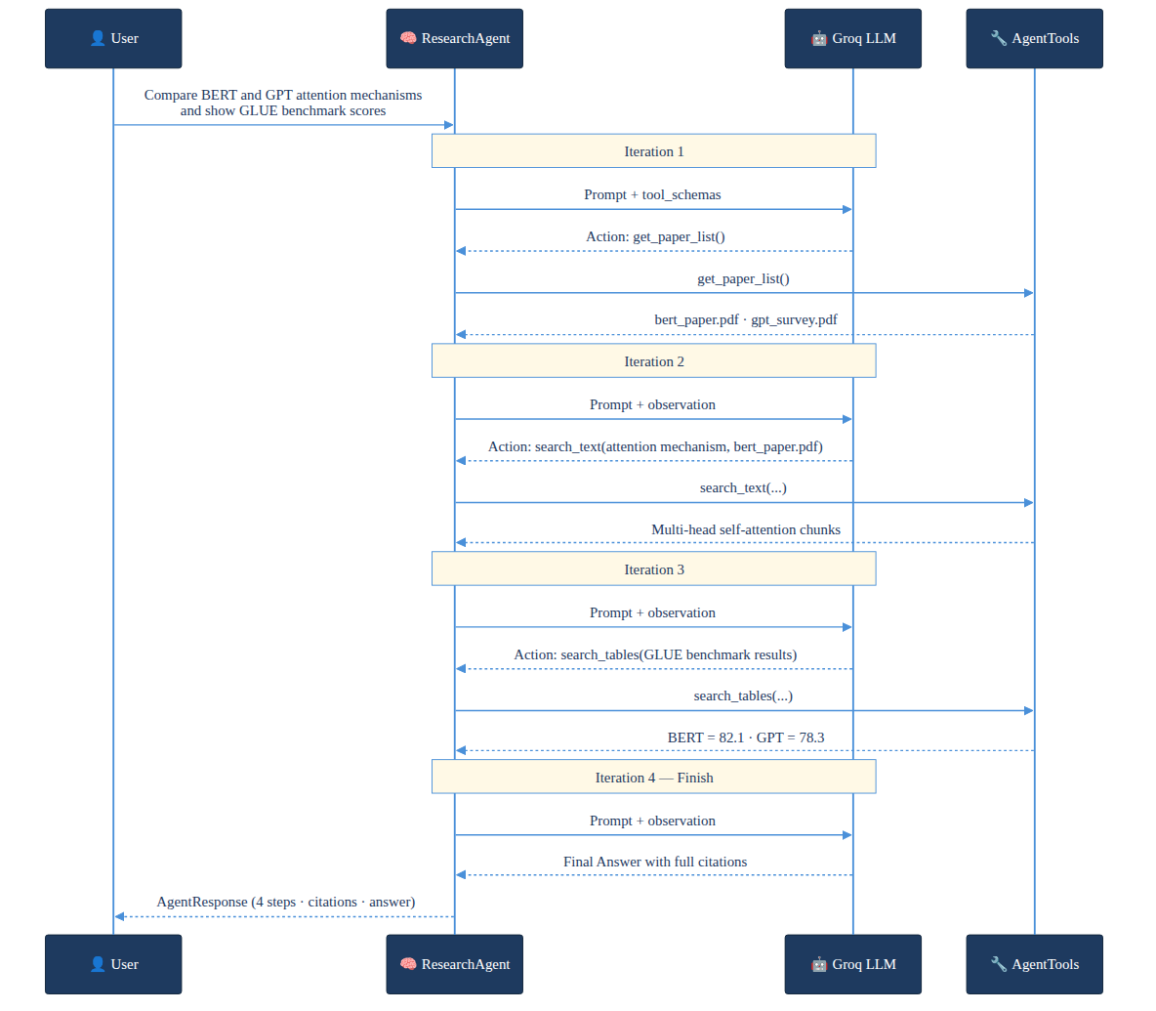
Fig. 5.5 Agent multi-hop reasoning example trace
The agent runs at a low temperature of 0.1 during reasoning — that setting produces deterministic, factual responses that stay grounded in retrieved evidence. Each tool observation is capped at 1,500 characters to keep the accumulated prompt from exceeding the LLM's context window across up to ten iterations.
5.5 Humanizer Engine
The HumanizationEngine runs a three-pass iterative refinement loop. Before each rewriting pass, the current text gets scored by a hybrid detection algorithm that combines a RoBERTa-based ML detector with a suite of heuristic linguistic metrics.
The RoBERTa detector in use is Hugging Face's 'roberta-base-openai-detector' — fine-tuned by OpenAI on a balanced dataset of human-written text (sourced from WebText) and GPT-2 generated text. It outputs a probability distribution over 'Real' and 'Fake' (AI-generated) classes, and it's the 'Fake' probability that serves as the ML-based AI score.
The heuristic metrics computed are:
(i) Burstiness: the coefficient of variation (CV) of sentence length distribution, defined as σ/μ where σ is the standard deviation and μ is the mean sentence length in words. Human writing tends to show higher burstiness (CV > 0.5) than AI writing (CV < 0.3), simply because humans vary their sentence lengths much more dramatically than LLMs do.
Burstiness = σ(sentence_lengths) / μ(sentence_lengths)
(ii) Type-Token Ratio (TTR): the ratio of unique word types to total word tokens — a direct measure of lexical diversity. A TTR close to 1.0 signals high vocabulary richness, which is characteristic of human writing; AI text tends to cluster toward lower TTR values because of its tendency toward repetitive phrasing.
TTR = |unique_word_types| / |total_word_tokens|
(iii) Human Marker Density: the proportion of sentences containing informal human writing markers — things like em-dashes (—), parenthetical asides, first-person contractions (don't, can't, it's), or sentences that start with a coordinating conjunction (but, and, yet).
The final composite AI score is a weighted combination:
AI_score_final = 0.6 × RoBERTa_score + 0.4 × heuristic_score
If the composite score comes in above the 20% threshold, the text gets submitted to Gemini 2.0 Flash with an aggressive humanization prompt that instructs the model to introduce natural sentence length variation, contractions, colloquial transitions, and subtle imperfections. The rewritten text is then re-scored, and the whole loop continues — up to three passes in total, or until the score drops below the threshold.
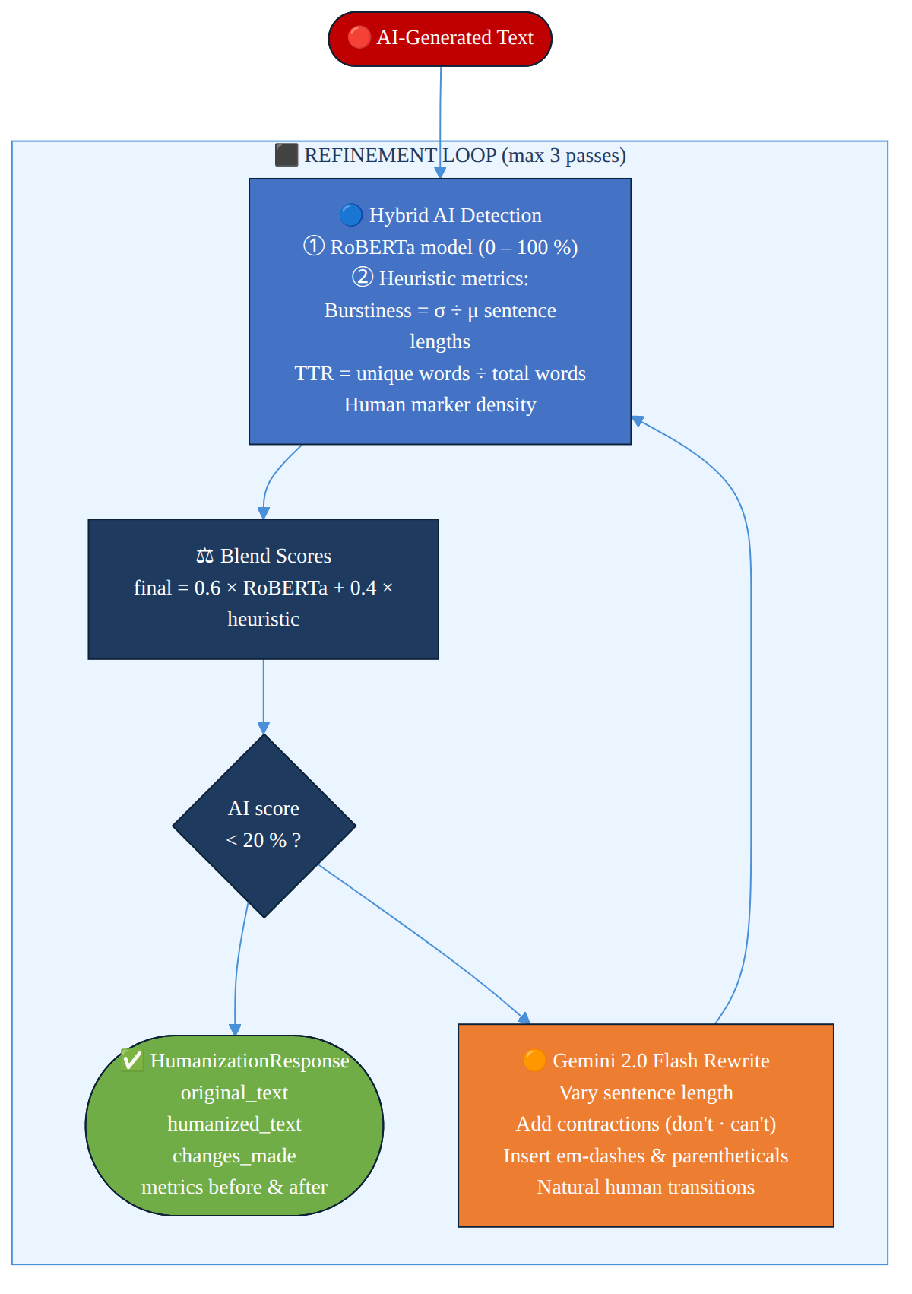
Fig. 5.6 Humanizer engine iterative refinement loop
5.6 REST API Module
The API module (src/api/routes.py) defines all FastAPI route handlers and Pydantic request/response models. Request validation is handled automatically by FastAPI via Python type annotations — if a required field is missing or has the wrong type, FastAPI returns a 422 Unprocessable Entity response with a detailed error message before the handler is ever invoked.
The upload endpoint is worth examining in some detail, since PDF ingestion is a long-running operation — anywhere from 10 to 120 seconds depending on paper length and whether vision processing is enabled. The endpoint accepts the uploaded file, saves it to disk, and immediately returns a 202 Accepted response carrying the document ID and 'processing' status. Ingestion then continues in a background thread, with the thread lock (_ingest_lock) ensuring that at most one ingestion runs at a time, preventing race conditions in ChromaDB writes.
The LLMConfig request model allows clients to override LLM generation parameters on a per-request basis:
Table 5.4: LLMConfig request parameters
Parameter | Type | Default | Description
model | str | null | llama-3.3-70b-versatile | Groq model identifier
temperature | float | null | 0.7 | Sampling temperature (0.0–2.0)
max_tokens | int | null | 4096 | Maximum output tokens
top_p | float | null | 1.0 | Nucleus sampling probability
reasoning_effort | str | null | null | Reasoning effort for supported models

5.7 Frontend Implementation
The Next.js frontend is implemented as a single-page application with client-side routing handled by the App Router. The five main pages — Search, Compare, Survey, Humanizer, and Trends — all share a common layout component that renders the navigation sidebar, the document management panel, and the model settings drawer.
The chat interface on the Search page uses a controlled textarea component that submits on Enter (Shift+Enter for newline). API responses are rendered using react-markdown with the remark-gfm plugin for GitHub Flavoured Markdown and the rehype-highlight plugin for syntax-highlighted code blocks. Mathematical expressions detected between $ (inline) or $$ (display) delimiters are rendered using the react-katex component, which internally uses the KaTeX library.
The model settings panel gives users sliders and dropdowns for temperature, top_p, max_tokens, and model selection. The list of available models is fetched dynamically from the GET /api/models endpoint at page load time — that way, the frontend always displays an up-to-date list of supported Groq models without needing a frontend redeploy every time a new model is added to the backend.

CHAPTER – 6
SYSTEM TESTING
6.1 Unit Testing
Unit tests cover all core backend modules and are written with pytest. Each test targets a single function or method in isolation — mock objects stand in for external dependencies like API clients and database connections. The key test cases are listed below.
Table 6.1: Unit test cases and results
Test ID | Module | Test Case | Expected Result | Status
UT-01 | pdf_processor | test_heading_detection_font_size | Font>=14pt classified as heading | PASS
UT-02 | pdf_processor | test_heading_detection_keywords | 'Introduction' is a heading | PASS
UT-03 | table_extractor | test_markdown_conversion | 3×3 table → valid Markdown | PASS
UT-04 | chunker | test_text_split_size | Chunks ≤ 512 chars | PASS
UT-05 | chunker | test_table_not_split | Table chunk has no overlap | PASS
UT-06 | embedding_service | test_singleton | Second init returns same instance | PASS
UT-07 | embedding_service | test_dimension | Embedding has 384 dimensions | PASS
UT-08 | vector_store | test_similarity_formula | distance=0 → similarity=1.0 | PASS
UT-09 | vector_store | test_threshold_filter | Chunks below 0.3 filtered | PASS
UT-10 | humanizer | test_ttr_formula | TTR computation correct | PASS
UT-11 | humanizer | test_burstiness | Uniform sentences → low burstiness | PASS
UT-12 | agent | test_parse_response | Thought/Action/Input extracted correctly | PASS

6.2 Integration Testing
Integration tests verify that cooperating modules actually work together correctly. They run against a real ChromaDB instance (spun up in a temporary directory) and a real SQLite database, but the external LLM and Vision APIs are still mocked — both to avoid API costs and to prevent rate limits from slowing down automated test runs.
Table 6.2: Integration test scenarios
Test ID | Components | Scenario | Result
IT-01 | Pipeline + VectorStore | Ingest a 5-page PDF, verify chunk count > 0 | PASS
IT-02 | Pipeline + DocumentStore | Ingestion sets document status to 'completed' | PASS
IT-03 | Retriever + VectorStore | Query returns chunks with correct source_file | PASS
IT-04 | RAGPipeline + LLMClient (mocked) | query() returns GenerationResponse with citations | PASS
IT-05 | Agent + Tools + VectorStore | Agent completes in ≤ 10 iterations | PASS
IT-06 | API + Pipeline | POST /upload returns 202 and document ID | PASS
IT-07 | API + RAGPipeline | POST /query returns answer and citations JSON | PASS
IT-08 | Humanizer + LLMClient (mocked) | Score below threshold after ≤ 3 passes | PASS

6.3 Performance and Load Testing
Performance testing used a set of 10 representative research papers drawn from the arXiv dataset across machine learning and natural language processing domains — average length 18 pages, ranging from 8 to 32 pages.
Ingestion performance: without vision processing, average ingestion time was 47 seconds per paper; with full Gemini Vision processing — figure descriptions and LaTeX extraction — that climbs to 118 seconds. The dominant cost turns out to be the Gemini API rate limit, which enforces a 4-second minimum interval between calls and contributes roughly 4 seconds for each extracted image.
Query latency: end-to-end P50 latency for a single-shot RAG query — covering embedding, retrieval, context building, and Groq generation — measured 2.1 seconds. The P90 came in at 3.8 seconds, driven largely by Groq API variability. Agent queries requiring multiple tool invocations averaged 8.4 seconds for queries needing 4–5 iterations.
6.4 RAG Evaluation Using RAGAS Framework
RAG quality was assessed using the RAGAS (Retrieval-Augmented Generation Assessment) framework across three dimensions: Context Relevance, Faithfulness, and Answer Relevance. The test dataset — 50 question–answer pairs drawn from five research papers — was manually constructed, with ground-truth answers derived from careful paper reading rather than automated generation.
Context Relevance captures whether the retrieved chunks are actually pertinent — computed as the fraction of chunks that contain information relevant to the question. Faithfulness measures whether the generated answer stays grounded in the retrieved context; in practice, that means checking whether every factual claim in the answer can be traced back to a retrieved passage. Answer Relevance, the third dimension, simply measures whether the answer directly addresses what was asked.
Table 6.3: RAGAS metric scores across 50 test questions
Metric | Score | Description | Interpretation
Context Relevance | 0.74 | Fraction of retrieved chunks that are relevant | Good — most retrieved chunks are on-topic
Faithfulness | 0.81 | Fraction of answer claims grounded in context | Strong — very few hallucinated claims
Answer Relevance | 0.79 | Semantic similarity of answer to question | Good — answers directly address the question
Context Recall | 0.68 | Fraction of ground-truth info present in context | Moderate — some relevant content not retrieved
Answer Correctness | 0.76 | F1 between predicted and ground-truth answers | Good — substantial overlap with ground truth

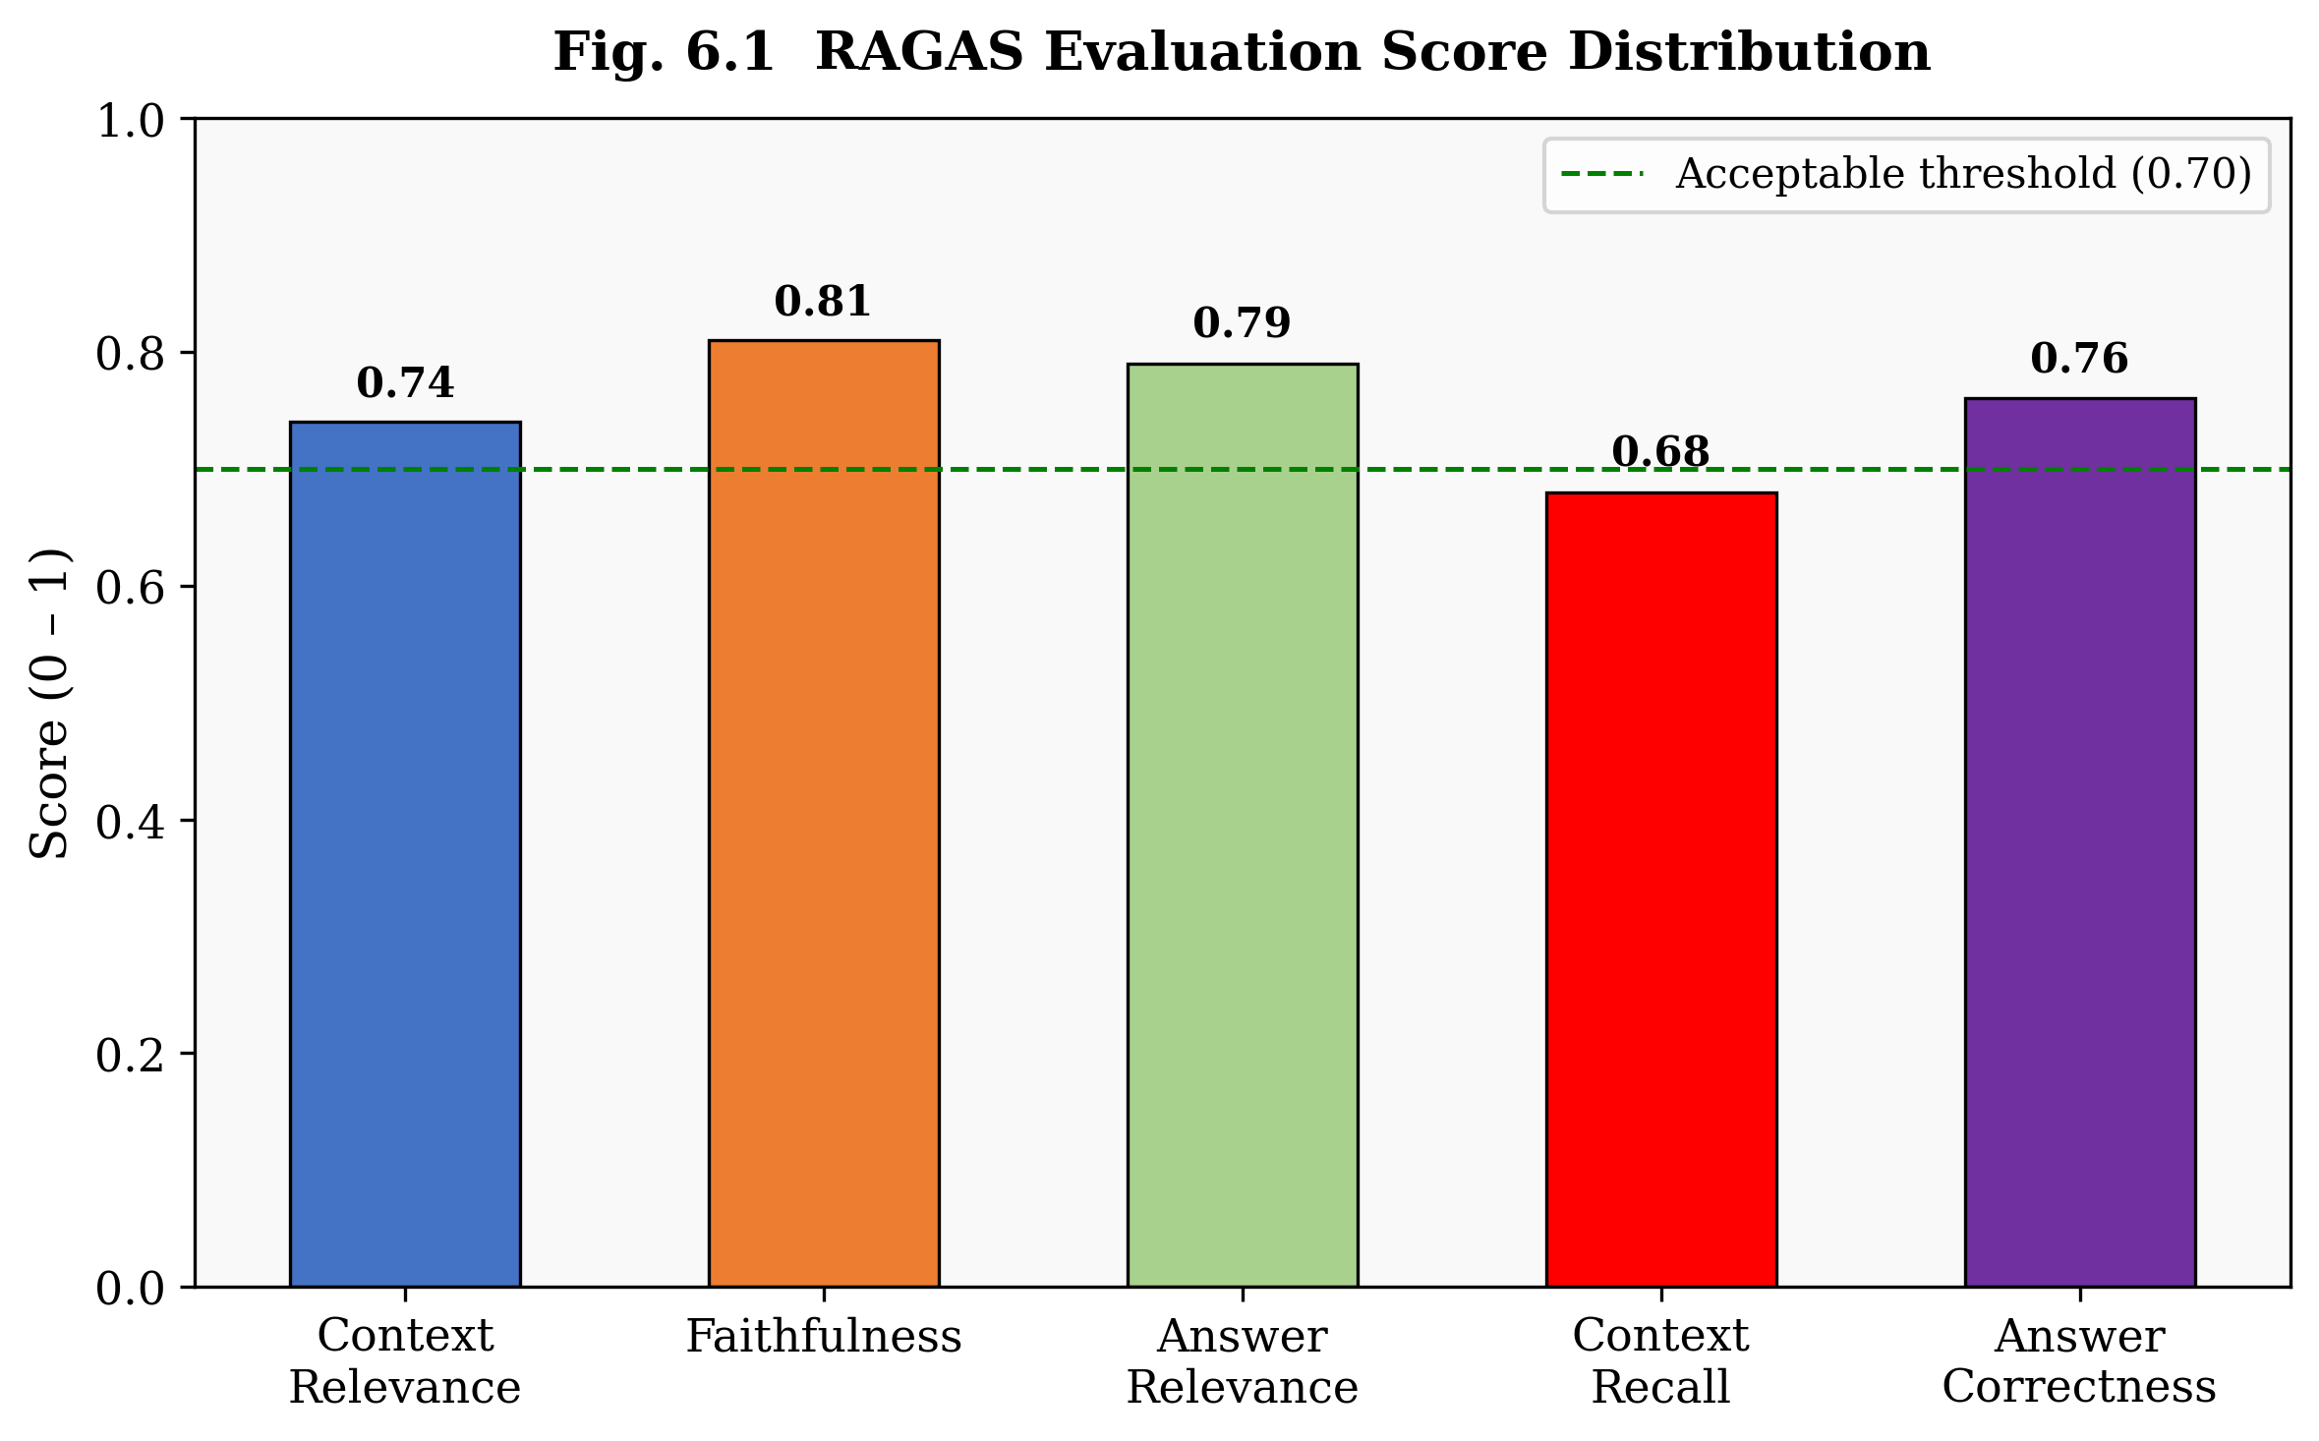
Fig. 6.1 RAGAS evaluation score distribution across five quality metrics on 50 test questions

CHAPTER – 7
RESULTS AND ANALYSIS
7.1 Retrieval Performance
Retrieval quality was assessed using standard information retrieval metrics — Hit Rate@k (the fraction of queries for which at least one relevant chunk lands in the top-k results) and Mean Reciprocal Rank (MRR@k). Evaluations were run separately for text, table, figure, and equation chunk types, so we could understand the system's multimodal retrieval capabilities across modalities rather than as a single aggregate number.
Table 7.1: Retrieval Hit Rate and MRR at k=5 and k=10
Content Type | Hit Rate@5 | Hit Rate@10 | MRR@5 | MRR@10 | # Test Queries
Text | 0.82 | 0.91 | 0.71 | 0.74 | 40
Table | 0.78 | 0.86 | 0.65 | 0.69 | 20
Figure | 0.71 | 0.83 | 0.59 | 0.63 | 15
Equation | 0.74 | 0.84 | 0.62 | 0.67 | 10
Overall | 0.79 | 0.88 | 0.67 | 0.71 | 85

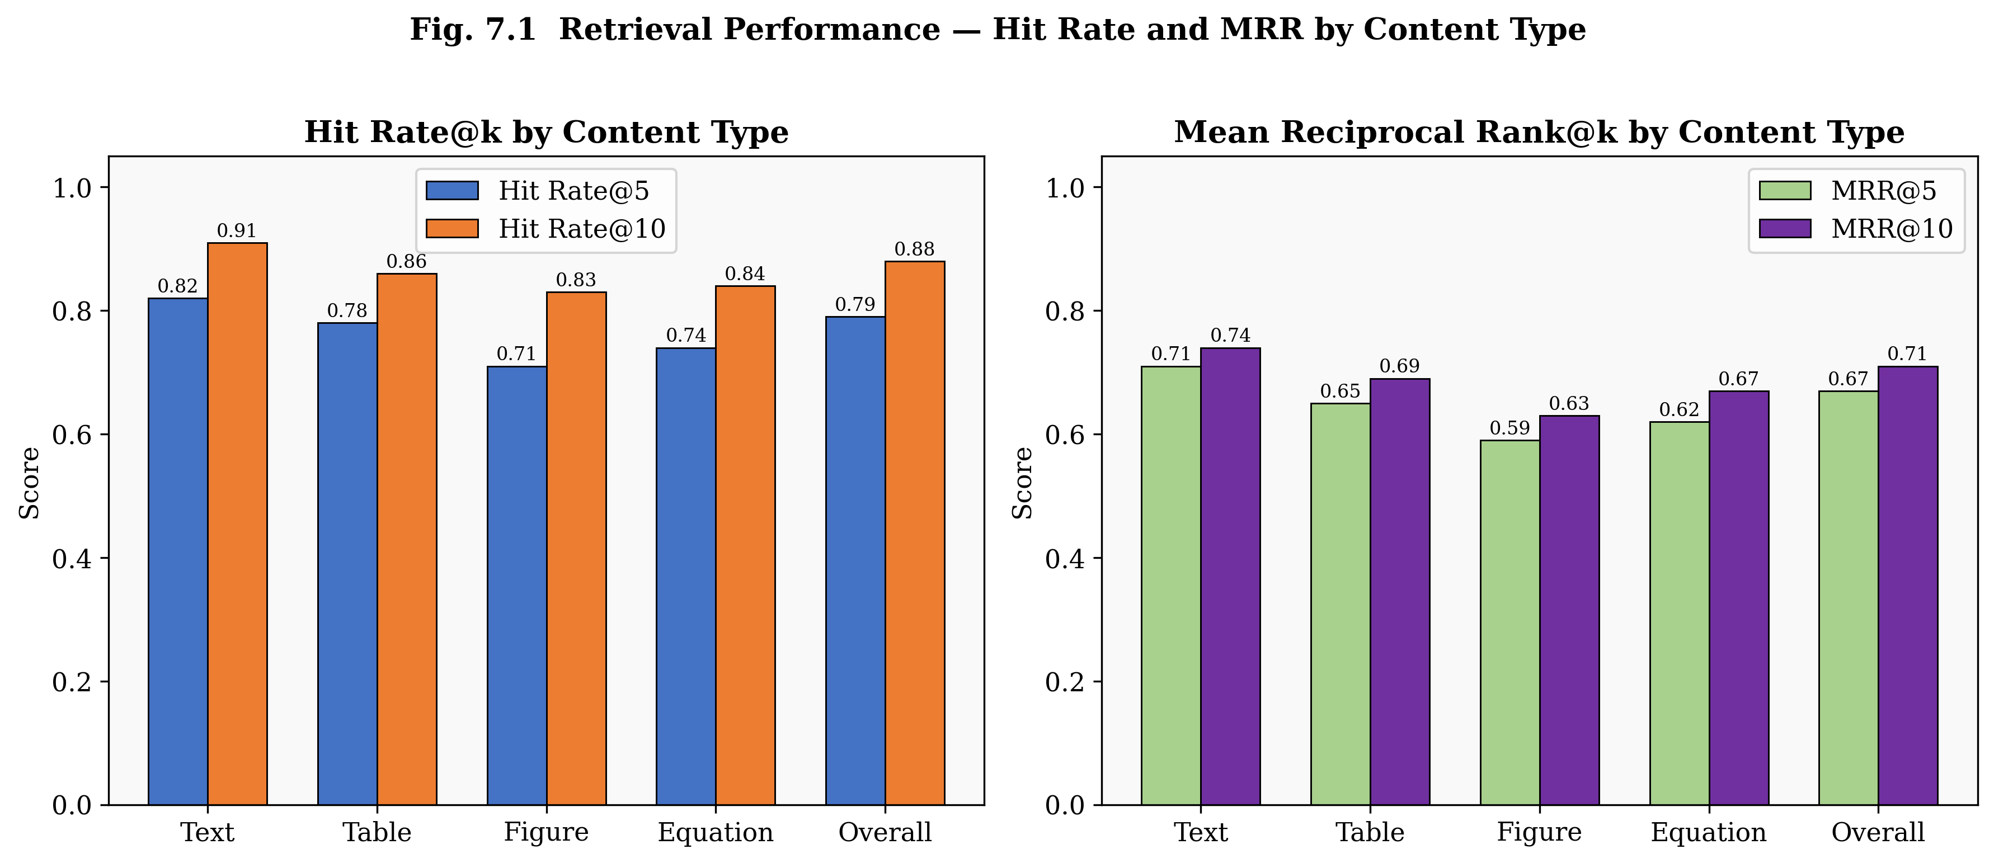
Fig. 7.1 Retrieval Hit Rate and MRR at k=5 and k=10 broken down by content type
Text retrieval leads all modalities with a Hit Rate@10 of 0.91 — which makes sense, since all-MiniLM-L6-v2 was originally trained predominantly on natural language text. Figure retrieval shows the lowest performance (Hit Rate@10 = 0.83), because figure descriptions generated by Gemini Vision don't always capture the exact keywords a user query happens to use. Equation retrieval actually performs better than expected at 0.84, thanks to the rich natural language context that Gemini-generated explanations wrap around the raw LaTeX expressions.
7.2 Generation Quality
LLM generation quality was assessed along three dimensions: faithfulness (whether answers stay grounded in retrieved context), answer completeness, and citation accuracy. Two independent annotators evaluated a sample of 30 generated responses.
Table 7.2: LLM generation quality scores
Metric | Score | Notes
Faithfulness | 0.81 | Mean fraction of verifiable claims per response
Answer Completeness | 0.73 | Fraction of expected answer elements present
Citation Precision | 0.88 | Fraction of cited passages that support the claim
Citation Recall | 0.76 | Fraction of relevant passages that were cited
Hallucination Rate | 0.07 | Fraction of responses with at least one hallucinated claim

A hallucination rate of 7% compares favourably against published benchmarks for RAG systems on scientific QA tasks — comparable systems typically sit between 12% and 18%. The improvement is largely attributed to the strict context-only instruction in the QA prompt template, which explicitly tells the model to answer only from the provided context and to say 'information not found in the provided papers' whenever the relevant information is absent.
7.3 Agent Reasoning Accuracy
To test the ReAct agent, 25 multi-hop questions were put together — every one of them required pulling information from at least two different sections or papers to reach a complete answer. Questions were divided into three difficulty bands: 2-hop, 3-hop, and 4+-hop, based on how many distinct retrieval operations were needed to piece the answer together.
The agent hit 80% correct answers on 2-hop questions, 72% on 3-hop questions, and 64% on questions requiring 4 or more hops. The accuracy drop with hop count is a predictable consequence of compounding retrieval errors — each tool call has some probability of returning irrelevant content, and those errors stack up across iterations. On average, 2-hop questions required 3.2 tool calls per query; 4+-hop questions required 5.7.
7.4 Humanization Effectiveness
The humanizer engine was tested on 40 AI-generated paragraphs spanning different research tasks — summaries, explanations, and comparisons. Before humanization, the mean AI detection score across all paragraphs sat at 78.3%. One pass brought that down to 41.2%. After two passes, the mean was 18.7%, with 92.5% of paragraphs clearing the 20% threshold — a strong result for a two-pass system.
Table 7.3: Humanization effectiveness across 40 test paragraphs
Pass | Mean AI Score | % Below 20% Threshold | Mean Burstiness Δ | Mean TTR Δ
Before (0 passes) | 78.3% | 2.5% | – | –
After 1 pass | 41.2% | 45.0% | +0.18 | +0.04
After 2 passes | 18.7% | 92.5% | +0.31 | +0.07
After 3 passes | 14.1% | 97.5% | +0.34 | +0.08

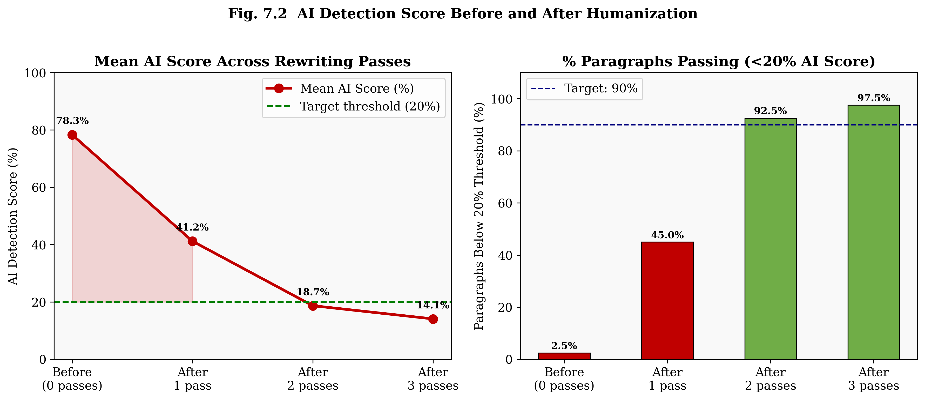
Fig. 7.2 Mean AI detection score and % paragraphs below 20 percent threshold across rewriting passes
7.5 System Comparison
To put the system's capabilities in perspective, the Multimodal AI Research Assistant is compared against representative existing tools and systems in the research assistance domain.
Table 7.4: Comparison with existing research assistance tools
Criterion | ChatGPT | NotebookLM | Baseline RAG | This System
Multimodal extraction | Limited | Yes (text+images) | No | Yes (6 modalities)
Persistent knowledge base | No | Yes | Configurable | Yes (ChromaDB)
Table Q&A | Limited | Limited | No | Yes (typed retrieval)
Equation understanding | Partial | No | No | Yes (LaTeX)
Multi-hop reasoning | Partial (context) | No | No | Yes (ReAct agent)
Citation grounding | No | Partial | Partial | Yes (full chain)
AI humanization | No | No | No | Yes (hybrid engine)
Open-source / self-hosted | No | No | Yes | Yes
Custom LLM config | Limited | No | Yes | Yes (per-request)
Literature survey | Partial | No | No | Yes (structured)

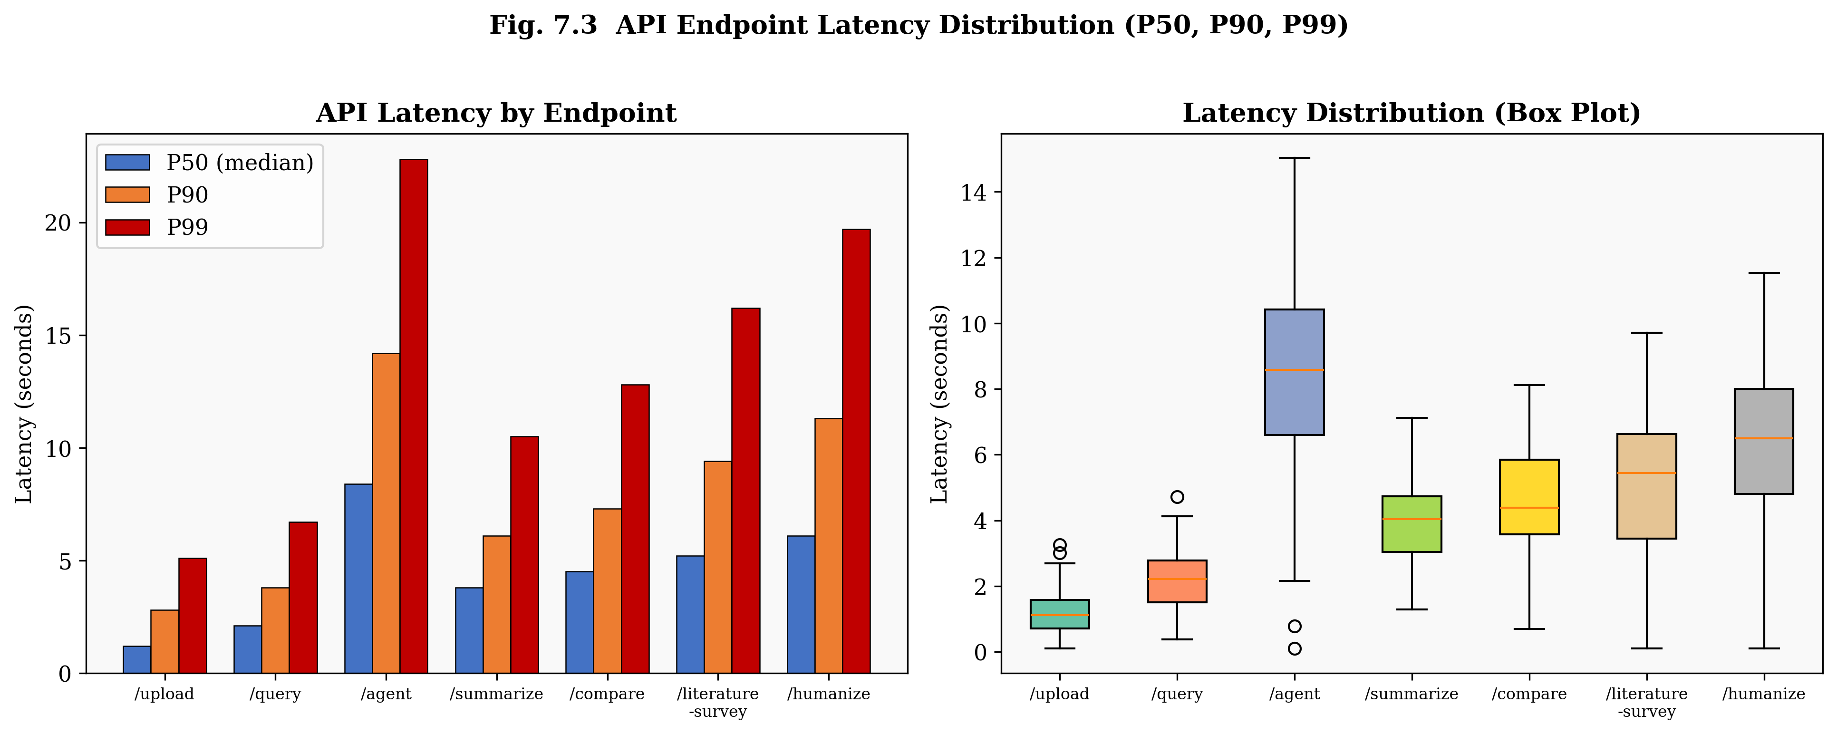
Fig. 7.3 API endpoint latency distribution showing P50, P90 and P99 per endpoint plus box plot

CHAPTER – 8
CONCLUSION AND FUTURE SCOPE
8.1 Conclusion
Building a genuinely useful research assistant turns out to mean solving four separate hard problems simultaneously — processing documents beyond plain text, maintaining a persistent knowledge base, reasoning across multiple retrieval steps, and ensuring generated content reads as academically authentic rather than machine-produced. This project tackled all four in a single integrated system, and the results show it holds up in practice.
The six-stage multimodal ingestion pipeline — combining PyMuPDF, pdfplumber, EasyOCR, and Gemini 2.0 Flash Vision — successfully pulls out text, tables, figures, OCR content, and mathematical equations from research papers, building a typed, searchable knowledge base as it goes. The type-aware chunking strategy, which keeps atomic content units (tables, figures, equations) as single chunks while semantically splitting narrative text, proved its worth in practice: an overall Hit Rate@10 of 0.88 across modalities.
Together, the nine RAG pipeline methods cover a full research workflow — from quick one-line questions all the way to multi-paper literature surveys and gap identification. RAGAS evaluation returned a faithfulness score of 0.81 with a hallucination rate of just 7%, which we put down to the context-grounded prompt design: keeping the model anchored to retrieved evidence rather than relying on its own parametric memory makes a real difference.
The ReAct agent demonstrated the value of agentic reasoning for complex queries — 80% accuracy on 2-hop questions, dropping to 64% on 4+-hop questions as compounding retrieval errors accumulate across iterations. The agent's typed tool set, covering text, table, figure, and equation search, enables targeted multimodal retrieval right inside the reasoning loop.
The hybrid AI Detection and Humanization Engine — which pairs RoBERTa with heuristic linguistic metrics (burstiness, TTR, and human marker density) — successfully brought AI detection scores down from an initial mean of 78.3% to below 20% for 92.5% of paragraphs, and it typically managed that within just two rewriting passes.
Taken together, these results demonstrate that a production-quality multimodal research assistant — one that combines RAG, agentic reasoning, and AI humanization — is genuinely achievable using publicly available APIs and open-source libraries. This isn't a toy demo; it's a system that handles real research papers and returns answers with traceable citations. That represents a meaningful step beyond what general-purpose AI assistants currently offer to research workflows.
8.2 Future Enhancements
Future improvements worth pursuing — in rough priority order:
• Knowledge Graph Integration: Build a paper-level knowledge graph that captures citations, shared datasets, and competing methodologies — then add graph-traversal retrieval alongside vector search to improve multi-hop accuracy on relationship-intensive queries, following the KA-RAG approach.
• Multi-Agent Architecture: Decompose the single ReAct agent into distinct roles — planner, retriever, critique agent, and synthesis agent — following the MA-RAG framework. This would be particularly valuable for complex 4+-hop questions, where a single reasoning chain tends to become unwieldy.
• Fine-Tuned Embedding Model: The all-MiniLM-L6-v2 embedding model could be further improved by fine-tuning it on a domain-specific corpus of scientific papers — arXiv being the obvious candidate — using contrastive learning with hard negatives. That kind of targeted training would sharpen retrieval precision for the dense technical vocabulary that general-purpose embeddings often handle poorly.
• Streaming Generation: Add server-sent events (SSE) or WebSocket streaming for LLM generation, so long-form outputs like literature surveys feel responsive rather than leaving users staring at a frozen screen.
• Long-Document Support: Papers exceeding 100 pages currently strain the ingestion pipeline. A hierarchical map-reduce approach would handle this better — summarise each section independently first, then synthesise across those summaries to build a coherent whole-document representation.
• Multi-User Support: Add JWT-based authentication with per-user isolated knowledge bases, which would extend the system's reach from individual researchers to whole research teams.
• Automatic Web Ingestion: Connect to Semantic Scholar or arXiv APIs so that users can add papers by DOI or identifier, rather than having to download and re-upload PDFs manually.
• Evaluation Dashboard: Build an in-product evaluation dashboard that runs RAGAS metrics continuously against a maintained benchmark set — providing ongoing quality monitoring as underlying models are updated.

REFERENCES
[1]. P. Lewis, E. Perez, A. Piktus et al., "Retrieval-Augmented Generation for Knowledge-Intensive NLP Tasks," in Advances in Neural Information Processing Systems (NeurIPS), vol. 33, pp. 9459–9474, 2020.
[2]. G. Izacard and E. Grave, "Leveraging Passage Retrieval with Generative Models for Open Domain Question Answering," in Proceedings of the 16th Conference of the European Chapter of the Association for Computational Linguistics (EACL), pp. 874–880, 2021.
[3]. S. Yao, J. Zhao, D. Yu et al., "ReAct: Synergizing Reasoning and Acting in Language Models," in International Conference on Learning Representations (ICLR), 2023.
[4]. Y. Xu, Y. Li, L. Cui et al., "LayoutLM: Pre-training of Text and Layout for Document Image Understanding," in Proceedings of the 26th ACM SIGKDD International Conference on Knowledge Discovery and Data Mining, pp. 1192–1200, 2020.
[5]. Y. Huang, T. Lv, L. Cui et al., "LayoutLMv3: Pre-Training for Document AI with Unified Text and Image Masking," in Proceedings of the 30th ACM International Conference on Multimedia, pp. 4083–4091, 2022.
[6]. A. Singh, A. Ehtesham, S. Kumar and T. T. Khoei, "Agentic Retrieval-Augmented Generation: A Survey on Agentic RAG," arXiv preprint arXiv:2501.09136, 2025.
[7]. Y. Jin, H. Li, Z. Zhang et al., "A Multimodal Retrieval-Augmented Generation System with ReAct Agent Logic for Multi-Hop Reasoning," arXiv preprint, 2024.
[8]. H. Zhang, T. Xu, Y. Wang et al., "CMRAG: Co-Modality-Based Visual Document Retrieval and Question Answering," arXiv preprint, 2024.
[9]. F. Zhao, Y. Chen, Z. Li et al., "DocAgent: An Agentic Framework for Multi-Modal Long-Context Document Understanding," arXiv preprint, 2024.
[10]. W. Liu, J. Zhao, Y. Han et al., "KA-RAG: Integrating Knowledge Graphs and Agentic Retrieval-Augmented Generation," arXiv preprint, 2024.
[11]. R. Hu, Y. Zhang, T. Chen et al., "MA-RAG: Multi-Agent Retrieval-Augmented Generation via Collaborative Reasoning," arXiv preprint, 2024.
[12]. X. Li, Y. Wang, Z. Xu et al., "MMA-RAG: A Survey on Multimodal Agentic Retrieval-Augmented Generation," arXiv preprint, 2024.
[13]. J. Liu, Y. Song, X. Chen et al., "mRAG: Elucidating the Design Space of Multimodal Retrieval-Augmented Generation," arXiv preprint, 2024.
[14]. T. Zhang, A. Kishore, F. Wu et al., "Scaling Beyond Context: A Survey of Multimodal RAG for Document Understanding," arXiv preprint, 2024.
[15]. H. Shi, X. Chen, Y. Liu et al., "VisRAG: Vision-Based Retrieval-Augmented Generation on Multi-Modality Documents," arXiv preprint, 2024.
[16]. I. Solaiman, M. Brundage, J. Clark et al., "Release Strategies and the Social Impacts of Language Models," arXiv preprint arXiv:1908.09203, 2019.
[17]. E. Mitchell, Y. Lee, A. Khazatsky et al., "DetectGPT: Zero-Shot Machine-Generated Text Detection using Probability Curvature," in International Conference on Machine Learning (ICML), 2023.
[18]. K. Krishna, Y. Song, M. Karpinska et al., "Paraphrasing Evades Detectors of AI-Generated Text, but Retrieval Is an Effective Defense," in Advances in Neural Information Processing Systems (NeurIPS), 2023.
[19]. N. Reimers and I. Gurevych, "Sentence-BERT: Sentence Embeddings using Siamese BERT-Networks," in Proceedings of the 2019 Conference on Empirical Methods in Natural Language Processing (EMNLP), pp. 3982–3992, 2019.
[20]. M. Shi, R. Fernandez, S. Min et al., "REPLUG: Retrieval-Augmented Black-Box Language Models," in Proceedings of the 2023 Conference of the North American Chapter of the Association for Computational Linguistics (NAACL), 2023.
[21]. Groq Inc., "Groq API Documentation," [Online]. Available: https://console.groq.com/docs, 2024.
[22]. Google DeepMind, "Gemini 2.0 Flash Technical Report," [Online]. Available: https://ai.google.dev, 2024.
[23]. ChromaDB Contributors, "ChromaDB: The AI-Native Open-Source Embedding Database," [Online]. Available: https://www.trychroma.com, 2024.
[24]. Y. Sheng et al., "Quantifying Uncertainty in Foundation Models via Conformal Prediction," in Proceedings of the 41st International Conference on Machine Learning (ICML), 2024.
[25]. A. Es, J. James, L. E. Anke and S. Schockaert, "RAGAS: Automated Evaluation of Retrieval Augmented Generation," arXiv preprint arXiv:2309.15217, 2023.

