Question Six (25)
- Provide interpretation for the following graph with results from SPSS 5 marks
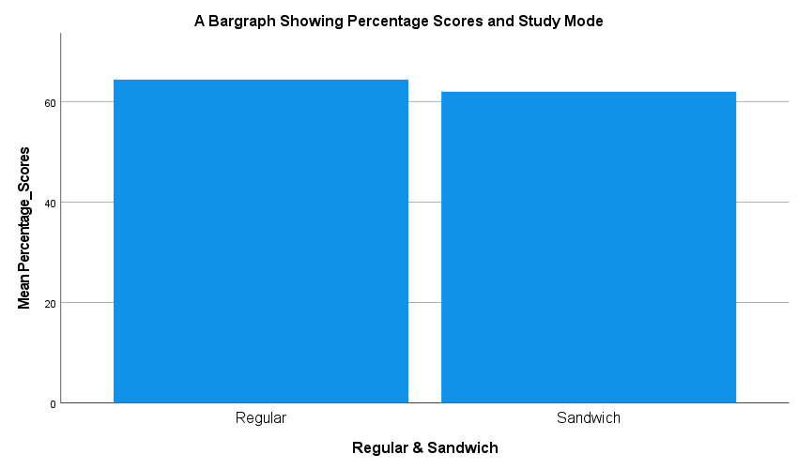

- Provide interpretation for the following graph with results from SPSS 5 marks
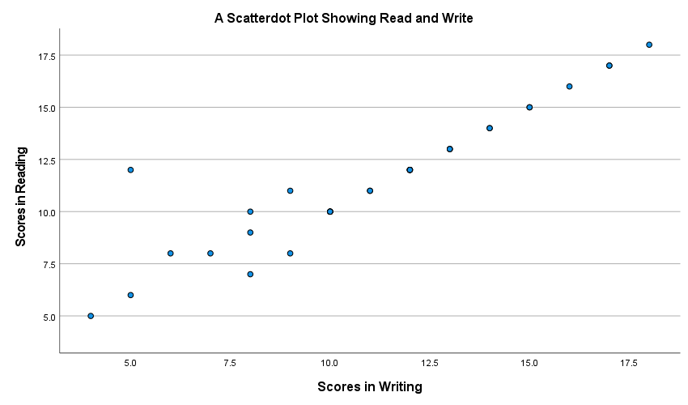

- Provide interpretation for the following table with results from SPSS 7.5 marks
Descriptive Statistics
 | N | Mean | Std. Deviation
Scores in Reading | 33 | 11.55 | 3.153
Scores in Writing | 33 | 11.09 | 3.600
Valid N (listwise) | 33

- Provide interpretation for the following table with results from SPSS 7.5 marks
Descriptive Statistics
 | N | Mean | Std. Deviation
Age_in_Years | 30 | 41.70 | 9.560
Percentage Scores | 30 | 63.20 | 11.909
Valid N (listwise) | 30

