Lola’s Learning

Game Design Document

**Executive Summary:**

* Overview: The main character, Lola, has to wander through classrooms and answer questions to proceed to the next room. All the classrooms are the same, except they slowly deteriorate into a horror-looking room. It is almost as if the character is going through a nightmare. If Lola gets a question right, she proceeds to the next question. If she gets the question wrong, the nightmare becomes more visible and she will eventually have to run away from a monster in the final level.
* Story of Game: Lola is a student in the school system who is trying her best to escape Failure (the final monster that chases you.) She answers questions, but in the end, failure always sneaks its way around the corner.
* Related Games: Baldy’s Basics
* The World: A school classroom and a hallway that slowly becomes more and more sinister.

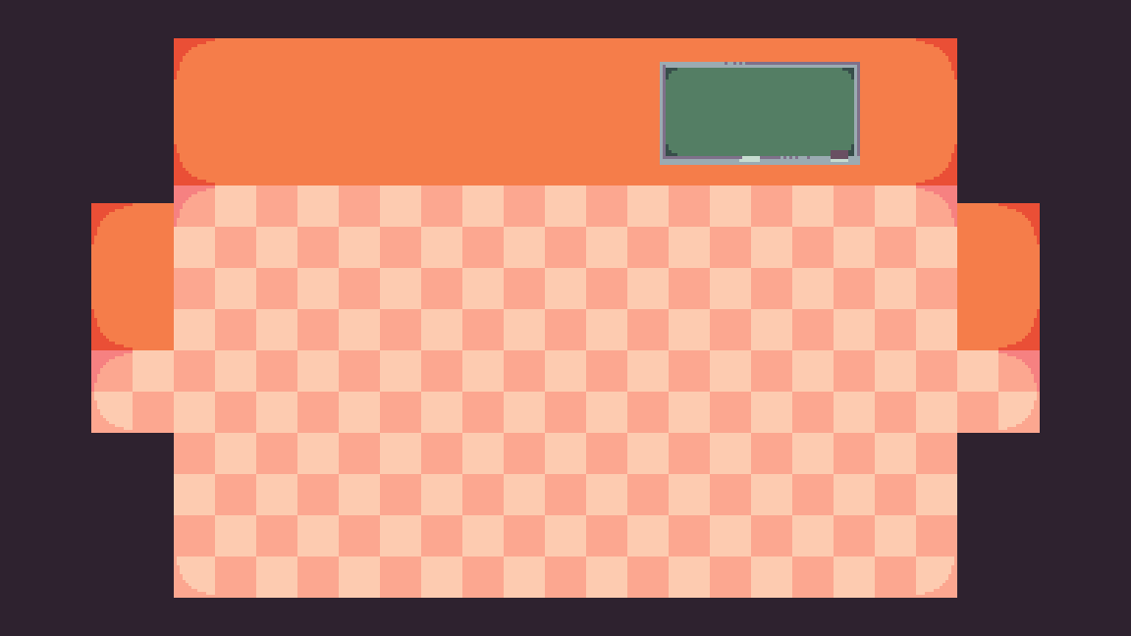

* Main Character: Lola
* Enemies: The final monster, Failure
* Main Game Mechanics: Moving with the arrow keys or WASD keys, pressing “E” to activate question prompt, clicking on answers, running away from the monster in a scrolling game, opening doors by answering questions, etc
* Character Goals: Answer the questions right, escape from this nightmare
* Game Win: Escape the monster, avoid getting hit and lowering your grade
* Game Loss: Get eaten by the nightmare monster and getting a 0% grade

**User Interface Mock-up(s):**

* Flowchart

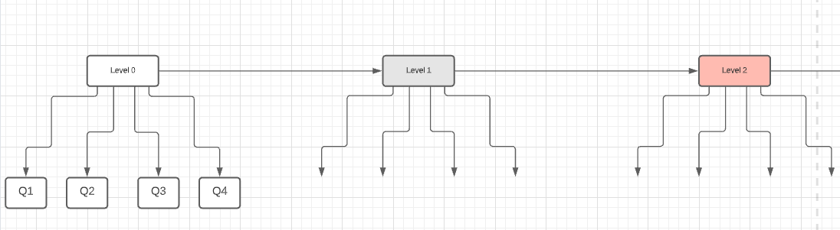

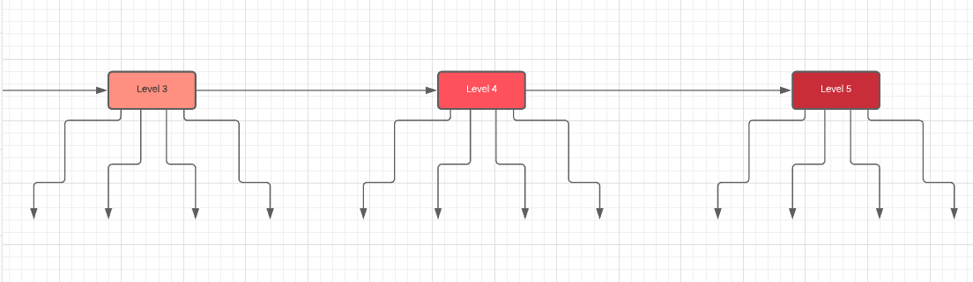

* Character design:



**Controls:**

* ARROW KEYS and WASD to move
* E to interact
* MOUSE to interact with buttons

**Levels Details:**

* Level 0 (Tutorial):
* Subject: Math
* Questions:
  + **0.1:** 1 + 1
  + **0.2:** 2 * 3
  + **0.3:** 6^2
  + **0.4:** 120 + 2 * 2
* Level 1:
* Subject: Art
* Questions:
  + **1.1:** Which one is the cylinder?
  + **1.2:** What is blue and red mixed together?
  + **1.3:** Who painted the painting in the room? (There should be a button where the player can exit the question screen so they can look around the room)
  + **1.4:** What will be the best selling painting in the year 3040?
* Level 2:
* Subject: English
* Questions:
  + **2.1:** Find the mistake in the following sentences: “You’re grades are getting lower and lower.”
  + **2.2:** “Your a failure.”
  + **2.3:** “You’re a disapointment.”
  + **2.4:** “You will never succeed.”
* Level 3:
* Subject: Science
* Questions:
  + **3.1:** How many legs does a spider have?
  + **3.2:** Which of these is not a blood type?
  + **3.3:** Which part of your brain generates fear?
  + **3.4:** What happens after you die?
* Level 4:
* Subject: Physical Educations
* Questions:
  + **4.1:** What would you do if something is chasing you? (the only answer choice is run)
  + Once the player clicks on “run”, implements Scrolling game where you run from monster
* Level 5:
* Scrolling Game
* Run from monster

**Score System:**

The score will be called ‘Grade’ in the game. Your grade will start at 100%. The grade will only be deducted if the player gets a question wrong. Otherwise the grade will remain the same. If you get a question wrong 10 points will be deducted.

**Developer Roles:**

* Doreen Ansah:
  + Sound Engineer
  + Level Designer
  + Game Designer
  + Programmer
* Amanda De Rosa:
  + Head Programmer
  + Art Director
  + Level Designer
  + Game Director
* Emma Florent:
  + Sound Engineer
  + Level Designer
  + Game Designer
  + Programmer

**Schedule of Releases:**

* 11/16: Prototype (initial draft)
  + Accomplishments:
    - The three of us worked on the level design
    - Discussed the story of the game
* 11/23: First playable (look and gameplay integrated)
  + Accomplishments:
    - Amanda worked on the animation of the main character.
    - Amanda programmed the main character to not walk through objects.
* 11/30: Pre-Alpha (all characters and levels integrated)
  + Accomplishments:
    - Amanda worked on the interaction with the desk to open the door to enter the hallway.
    - ⅛ of the sprites/backdrops have been added as of now.
    - Doreen and Emma worked on the final level.
    - Doreen implemented a scrolling game
    - Emma worked on the main menu screen and the icons to switch between worlds
    - Amanda implemented a way to spawn in the questions and to remove the questions
* 12/07: Alpha (will be shared for testing)
  + Accomplishments:
* 12/13: Gold Master (final version)
  + Accomplishments:

**Game Art** (created by Amanda’s friend, stepepson)

Lola's Game Art © 2021 by stepepson is licensed under CC BY-NC 4.0 [](http://creativecommons.org/licenses/by-nc/4.0/?ref=chooser-v1)



