# Git

An Easy Beginner’s Guide to Git

## Installing Git

<https://git-scm.com/book/en/v2/Getting-Started-Installing-Git>

git –version

## Creating a Local Git Repository

cd ~/Desktop/git-demo-example

git init

## Committing Files to the Local Repository

We will have to add the files into the local repository in order to be able to start tracking the files and changes we make. This process of adding a file to a local repository is called committing.

It is a two step process in order for us to commit the code to the local repository. We will need to first add the file into a staging area and then commit.

To add only a single file to the staging area, you can use git add fruit.py

To add multiple files, use this: git add fruit.py veggies.py

If you have many files or are too lazy to type out your file names, you may use git add . to add all files that are in the folder.

To commit the file, we will use git commit -m “My First Commit”

git add .

git commit -m “Changed pumpkin from veggie to fruit”

## Review All Commits Made

git log --pretty=oneline

git log — author=Julia

## Ignoring Files in Commits

Create .gitignore file with this command in the terminal: touch .gitignore

Open up .gitignore and add the names of the files that you don’t want to be tracked.

## Git Branches

In your terminal, if you type git status , you can see that you’re on the master branch.

By default, you will always be working off the master branch in Git. The two commits we made earlier were on the master branch. We have the ability to create a new branch (for example test) where we can test new code out without messing with the code in the master branch.

Let’s create a new branch called test.

git branch test

We will need to move from the master branch to the test branch if we want to commit code to the test branch. To do so, use the following command:

git checkout test

If you type git branch again, notice that we are now on the test branch.

## Merging branches

Before merging the two branches, you can take a look at what has changed between the branches by using git diff test master . Test is your source branch and master is your target branch.

To perform the merge, you will have to move back to the master branch and then use the merge function like this:

git checkout master

git merge test

## Create a Remote Repository to Share with Others

There are several websites for hosting Git projects, but for the purpose of these exercises, I will be using a website called Github.com. It’s free to sign up! If you don’t already have an account, register on https://github.com/. On the homepage, click Start a Project and create a repository.

git remote add origin [repository url]

## Moving Code Between Local and Remote Repository

git push -u origin master

git pull origin master

## Cloning a Remote Repositor

git clone <https://github.com/julia-git/Git-for-Beginners>

# CSS, Flex layout

[Pseudo-classes - CSS: Cascading Style Sheets | MDN](https://developer.mozilla.org/en-US/docs/Web/CSS/Pseudo-classes)

[CSS Flexbox Layout Guide | CSS-Tricks](https://css-tricks.com/snippets/css/a-guide-to-flexbox/)

[CSS Selectors Reference](https://www.w3schools.com/cssref/css_selectors.php)

# DOM(#3)

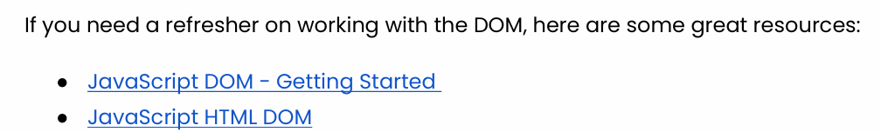

[JavaScript DOM Tutorial](https://www.javascripttutorial.net/javascript-dom/)

[JavaScript HTML DOM](https://www.w3schools.com/js/js_htmldom.asp)

# Types of Functions in JavaScript

[Regular vs Arrow Function. Define your functions in many ways. | by Suprabha Supi | Geek Culture | Medium](https://medium.com/geekculture/regular-vs-arrow-function-1f8140fbcece)

# Template Literals

# JavaScript Reduce

[Array.prototype.reduce() - JavaScript | MDN](https://developer.mozilla.org/en-US/docs/Web/JavaScript/Reference/Global_Objects/Array/reduce)

[JavaScript Array reduce() Method](https://www.javascripttutorial.net/javascript-array-reduce/)

# JS Filter

[Array.prototype.filter() - JavaScript | MDN](https://developer.mozilla.org/en-US/docs/Web/JavaScript/Reference/Global_Objects/Array/filter)

[JavaScript Array filter() Method](https://www.javascripttutorial.net/javascript-array-filter/)

# JavaScript HTML DOM EventListener

[JavaScript DOM EventListener](https://www.w3schools.com/js/js_htmldom_eventlistener.asp)

# Destructing and spread

