**NextJS**

**Special Files**

page.tsx

layout.tsx

template.tsx

not-found.tsx

loading.tsx

error.tsx

---------------

default.tsx

**React 18 – Client and Server Components**

**Routing Conventions**

**Dynamic route**

**Catch-all Segments**

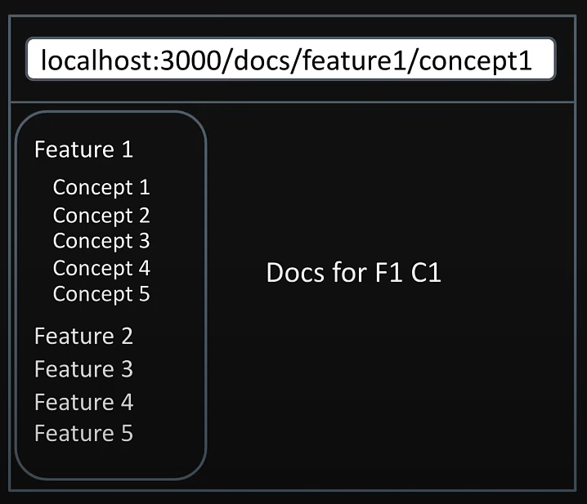

**404 Not found page**

**File colocation**

**Private Folders**

**Route Groups**

/auth/login → /login

**Layout**

**Nested layout**

**Routing metadata**

export *const* metadata = {

  title: 'Next.js',

  description: 'Generated by Next.js',

}

export *const* generateMetadata = ({ *params* }*:* Props)*:* Metadata *=>* {

    return {

        title: `Product ${params.productId}`

    }

}

**Title metadata**

**Navigation**

"use client";

*import* { useRouter } from "next/navigation";

        router.push("/");

        router.replace("/");

        router.back();

        router.forward();

**Templates**

**Loading**

**Error handling**

It will fall back to the most inner error.tsx

Layout.tsx will fallback the error to outside it folder

**Parallel Routes**

**Unmatched Routes**

**Conditional Routes**