Logical Volume Management Cheat Sheet
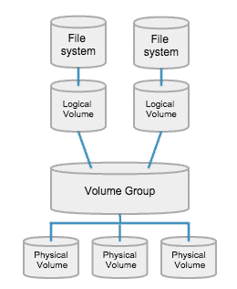
Run all commands as root with sudo. Example: sudo lvs
pvs : Show short details of physical volumes
vgs : Show short details of volume groups
lvs : Show short details of logical volumes
For the purpose of this cheat sheet I will use “vgname” in place of what your volume group name is, so ensure you replace vgname anywhere in this document with YOUR volume group name. To see what Volume Groups your system has, run vgs in the terminal. I will also use /dev/sdxx as a device name. Replace this with the partition you are planning to use on your new drive. You can confirm this with sudo fdisk -l
To find where your physical volume path is, run lvdisplay and look for the LV Path in the list. We will use this path with the lvextend command later.

To extend partitions to a new drive
Create empty LVM partition on new drive with fdisk or gparted.
Create Physical Volume on new disk with pvcreate /dev/sdxx
You can verify the new partition name with sudo pvs which should have a blank entry under VG.
Extend your Volume Group to the new disk with vgextend vgname /dev/sdxx
Extend your logical volume and resize the partition inside with lvextend -l +100%FREE -r /dev/vgname/root

On the previous command, you can change the +100%FREE to any value depending on how much space you want the new logical volume to take on the new drive. You could say +50%FREE, or, if you want to extend if by a specific size, use lvextend -L +10G -r /dev/vgname/root where the +10G extends it by 10 Gigabytes. You can also use +500M for 500 Megabytes and so on. Note that if you specify sizes, the command changes from lower-case -l to upper-case -L after lvextend.
If all was successful, you have now extended your space to the new drive. Congrats!
-DorianDotSlash

