ETLV101bis_Car_com_DSRC_45mn CAR COMMUNICATION name :

Dedicated short-range communications
A/ Read the following article. Find a translation for the phrases listed from a) to m)
Dedicated short-range communications are one-way or two-way short- to medium-range wireless communication channels specifically designed for automotive use and a corresponding set of protocols and standards .In October 1999, the United States Federal Communications Commission (FCC) allocated in the USA 75MHz of spectrum in the 5.9GHz band for DSRC to be used by Intelligent Transportation Systems ITS . Also, in Europe in August 2008 the European Telecommunications Standards Institute (ETSI) has allocated 30 MHz of spectrum in the 5.9GHz band for ITS.
Currently its main use in Europe and Japan is in electronic toll collection. DSRC systems in Europe, Japan and U.S. are not, at present, compatible.
Other possible applications are:
- Emergency warning system for vehicles systeme urgence pour véhicule pour prevenir d’un danger
- Adaptive Cruise Control regulateur de vitesse adatative
- Forward Collision Warning detecteur de collission avant
- Intersection collision avoidance detecteur de collision d’intersection
- Approaching emergency vehicle warning detecteur d’approche urgence
- Vehicle safety inspection
- Transit or emergency vehicle signal priority
- Electronic parking payments
- Commercial vehicle clearance
- In-vehicle signing
- Probe data collection
- Highway-rail intersection warning
- Electronic toll collection
Other short range wireless protocols are IEEE 802.11, Bluetooth and CALM.

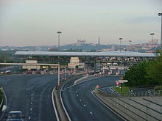
B/ Read the following article twice without taking any notes, then answer the questions below the article.

What is Vehicle-to-Vehicle (V2V) Communication All About?
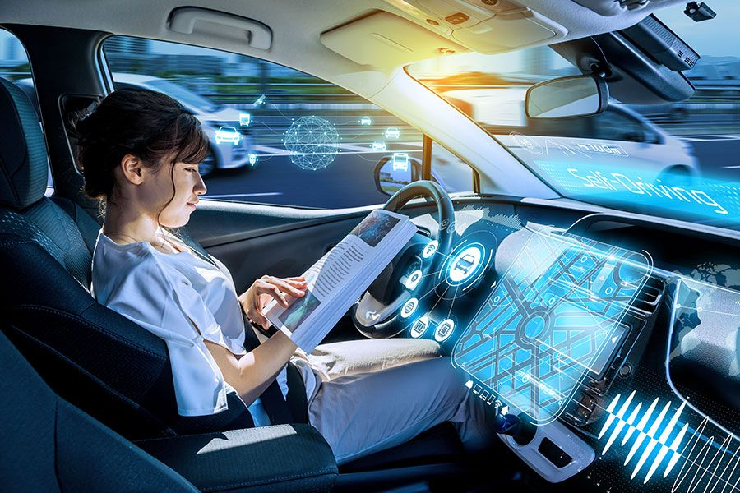
What is vehicle-to-vehicle communication? Right now, it’s limited to drivers flashing high beams (“cop ahead”), flicking on a turn signal (“might turn, might change my mind”) or throwing up a middle finger (infinite meanings). But in the very near future, vehicles will be in constant communication with each other without drivers being involved at all. This will even further expedite the capabilities and intelligence of our quickly-growing autonomous vehicle technologies.
How does V2V communication work ?
Vehicle-to-vehicle (V2V) communication works with DSRC (Dedicated Short Range Communications), which is a type of Wi-Fi that sends brief messages up to 10 times a second over short distances, about 1,000 feet. On a busy highway, vehicles might send automated messages to each other communicating things like “Road is slippery,” or “Ambulance coming!” or “Traveling 63 mph, road clear.”
This technology already exists. In Japan, certain Toyota models have V2V communication built in that conveys a few simple data points: location, speed, and heading. Soon, it’ll be widespread in the United States, too, as new cars and light trucks may be required to include V2V technology by 2023. Navigant Research predicts “that by 2025, more than 20 million vehicles will be sold annually with DSRC-based V2V in North America and nearly 70 million globally.”
The technology might already be outdated, however. While carmakers work to install DSRC capabilities in new cars, others are asking, “Why can’t we just use our phones?” An app called Nexar has a V2V communication function that sends traffic alerts to other, nearby phones running the app.
The pros of V2V communication
It could prevent crashes. The vast majority of car crashes are caused by human error. The U.S. Department of Transportation says car-to-car communication can help, as it has the potential “to significantly reduce many of the most deadly types of crashes through real time advisories alerting drivers to imminent hazards.”
It could ease traffic congestion. Imagine if all the individual data points from millions of cars were sent to a central hub. With so much real-time traffic data, transportation managers could adjust traffic light timing and redirect traffic to make rush hour flow more smoothly. Not only that, but each individual car could use the technology to maintain a consistent following distance. Imagine law abiding, organized highways, instead of hundreds of drivers jockeying for position, changing in and out of lanes.
It could improve fuel efficiency. A fleet of trucks equipped with vehicle-to-vehicle technology can do something called platooning: driving in close formation, like a flock of geese, to reduce drag and save gas. Platooning results in fuel consumption savings of up to 5 percent for the lead truck and up to 10 percent for the trucks following in formation, tests have found.
The drawbacks of V2V communication
Drivers should be concerned about their privacy. V2V data can reveal all kinds of things about you: where you’re going and when, as well as your driving habits. Who has access to this data? And how might they use it? “We have learned the hard way that both the government and private companies will go to great lengths to track vehicles—just look at the proliferation of Automated License Plate Readers (ALPR),” the Electronic Frontier Foundation warns.
Liability could get complicated. Imagine you’re zipping along the highway and your car, using V2V communication, tells you the road ahead is perfectly clear. Then — screeeech! — you smash into the back of a truck stuck in a traffic jam. Is the crash your fault? Or is the malfunctioning V2V tech to blame?
Hacking could cause chaos.The proliferation of V2V communication, whether in human-piloted or driverless cars, gives malicious hackers a new opportunity. DSRC-enabled cars are vulnerable to at least six types of attacks, one security firm warns.
Until car-to-car communication becomes a reality for everyone, the best thing you can do to protect yourself is make sure you carry dependable car insurance.

Now write a summary of the article (60 words). It will be easier if you answer th:e following questions and follow the structure of the text (try not to consult the text again!)

1. What is vehicle-to-vehicle communication?
2. How does V2V communication work?
3. The pros of V2V communication
4. The drawbacks of V2V communication

Send to ingwyn@gmail.com

