Send to: ingwyn@gmail.com NAMES:
I/ Match the equivalents, complete the table. You are going to hear all these words in the video.

a) Dedicated • • 1) voyage h) Pass on • • 8) mener
b) Range • • 2) aire de repos i) Relevant • • 9) Prévenir / signaler
c) Relay race • • 3) ordinateur portable j) Signal • • 10) rencontrer
d) Laptop • • 4) course de relais k) Lead • • 11) Améliorer
e) Spread • • 5) automatique / dédié l) Encounter • • 12) faire passer
f) Journey • • 6) diffuser m) Improve• • 13) pertinent
g) Roadside station • 7) portée / rayon d’action

a | b | c | d | e | f | g | h | i | j
5 | 7 | 4 | 3 | 6 | 1 | 2 | 12 | 13 | 9

k | l | m
8 | 10 | 11

II/ Listen to the video (from 0.00 to 1.12) and fill the blanks ( Most of the words appeared in the list above)
WRITE YOUR ANSWERS IN RED!!!
Seven big car _manufacture_ are working to _improve_ vehicle to vehicle communication technology with _dedicated_ short range communications or dsrc. This technology makes real time communication possible between a car and _Roadside station_ and from one vehicle to another. For example, if a car _Encounters _ a critical situation it can pass the _ Relevant _ information on automatically to all _Road user_ in the area.
Expert Christopher Wilson Explains: DSRC; Dedicated _Short Rouge_ communication. This is a modified version of a _Wireless_ LAN. What you have in your _Laptop_ and maybe in your home today. It’s been _Modified_ specifically for vehicle applications. We see this as a _Transportation_ internet. And who knew what the __ would be for ten years ago? We’re now starting a new _Journey_ into a new internet. And who knows where it’s gonna _? I don’t think anybody’s even got the thinnest _.

III/ Global comprehension (video from 1.12 to the end)

- Find out in the Internet what a WLAN stands for and explain briefly what it is.

- Can this technology be used only by private cars?
- What can emergency vehicles do thanks to this technology?
- [0130] According to the expert, what is this technology primarily for?
- [0140] What do they expect to send?
- [0144] What do they expect to get?
- [0146] What could you pay thanks to DSRC?
- [0148] What else could you do while sitting at the gas station?
- [0154] How many roles can each vehicle take? Mention them!
- [0200] What is the chain of information compared to?

IV/ Here is a picture explaining DSCR technology. Explain the document in French and show that you have understood everything.

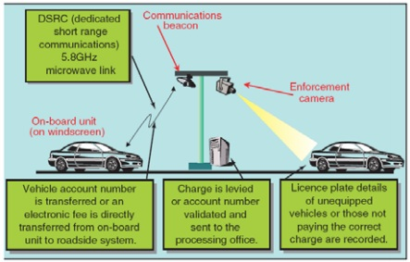

Send to: ingwyn@gmail.com

