Why Thanksgiving is an American Celebration of Immigration
A/ 1. What do you know about Thanksgiving?

2. Watch the video and comment: https://www.youtube.com/watch?v=jGc34FeFqH0&feature=youtu.be

B/ Look at the painting.
  - How is the “first Thanksgiving” depicted here?
……………………………………………………………………………………………………………………………………………………………………………………………………………
  - Focus on people’s actions.
………………………………………………………………………………………………………………………………………………………………………………………………………………
  - Compare with what you know.
……………………………………………………………………………………………………………………………………………………………………………………………………………

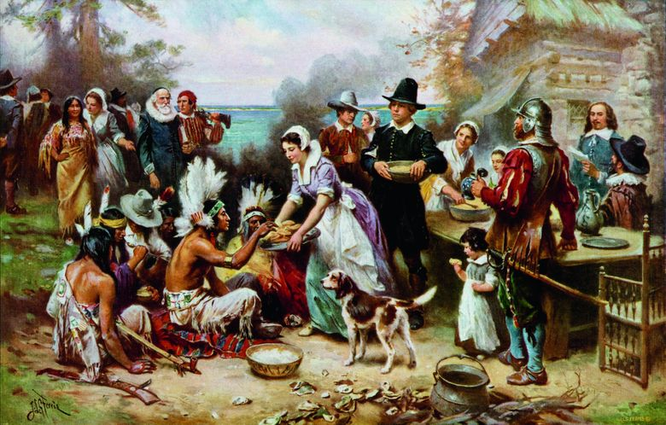
© Droits réservés
The First Thanksgiving 1621, J.L.G Ferris, circa 1912-1915
C/ The text :

1. Match the following words with their English equivalents :
Nouns :

- un abri
- un point d’appui
- un festin
- une dinde
- l’heure du repas
- la bonne volonté
- une pénurie
- un conte
- le sérieux
- un territoire

- a feast
- a foothold
- goodwill
- gravitas
- mealtime
- a shelter
- a shortage
- a soil
- a tale
- a turkey

Adjectives : fondamental(e), par excellence inadéquat(e)

- inadequate
- quintessential

Verbs : illustrer se disputer se passer de fuir

- to argue
- to exemplify
- to flee
- to forgo

A long time ago, refugees fleeing their home country’s hostile political environment headed west over the Atlantic Ocean in search of a better life. They arrived on a rock, unprepared for the challenges that come with moving to a new land: a shortage of food and inadequate shelter. A group of Americans took pity on these refugees, sharing their soil and helping them gain a foothold on it. In an act of goodwill and diplomacy the immigrants hosted the Americans for a large shared feast. The Americans were called the Wampanoag: the immigrants, the Pilgrims. Their meal has since become celebrated in the most quintessential American tradition, Thanksgiving.
Anyone who would argue that America is losing its sense of tradition to diversity would do well to remember the origins of the holiday, the fact that it was a meal where one group of people welcomed another as friends and neighbors, that its celebration lasted three days, and that turkey wouldn’t become the main course for another 230 years. It’s a celebration that has and will continue to evolve.
Our modern, cozy version of Thanksgiving seems to have forgone its historical gravitas for the mythology of a children’s tale. In other words, it exemplifies the American tendency to forget the people who were not only indigenous to this land, but who welcomed new arrivals and shared their “home”.
By Michael Barron, theculturetrip.com, 25 November 2016

Read the first paragraph.
  - When does the scene take place?
  - Describe in your own words what happened.
Winters are very harsh in North America and the Europeans lacked food (there was a shortage of food). The indigenous/antochtonous people helped them.
  - Identify the two groups and describe them*.
The white people came from Europe (at the beginning mainly from England and Holland),
They were called the “puritans” because they SDddddddddddddddddddddddddddddddddddddddddddddd>>dddwz<qé
  - How do people usually refer to them?
………………………………………………………………………………………………………………………………………………………………………………………………………………

3. What is the author’s opinion about Thanksgiving, past and present?
Americans seem to have forgetten the true meaning

D/ REMEMBER To seem
- Présent
The tradition seems to evolve with each generation.
seems to → to seem to evolve → Base verbale with each generation.
Cette tradition semble évoluer.
- Faire un lien entre le passé et le présent
Thanksgiving seems to have forgone its historical gravitas.
seems to → to seem to have → Have forgone → Participe passé
Thanksgiving semble avoir perdu son sens d’origine.
- Insister sur une action en cours
In the painting, the people seem to be enjoying themselves.
seem to → to seem to be → Be enjoying→ V-ing
Dans le tableau, les gens semblent s’amuser

EXERCISE: Translate into English:
  - Il ne réagit pas, il semble dormir.
He doen’t react, he seem to sleep
  - Elle semble avoir oublié mon nom.
She seem to have forgotten my name
  - Steven semble préférer les pizzas aux tacos.
Steven seem to prefere the tacos pizza

