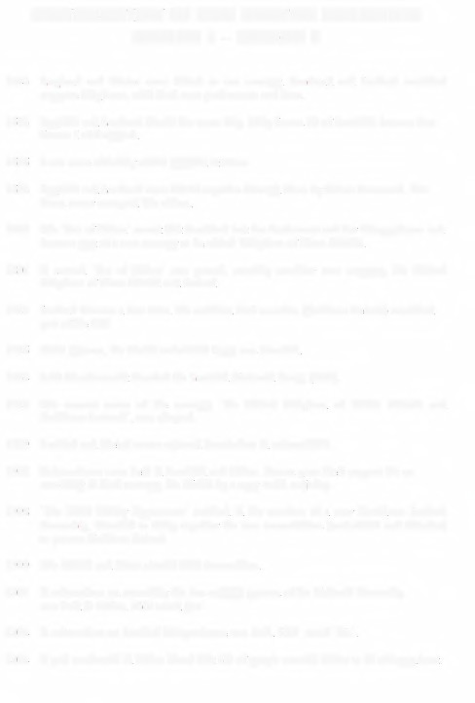
DEVOLUTION IN THE UNITED KINGDOM GROUP 1

1543 | England and Wales were united as one country. Scotland and Ireland remained  separate kingdoms, with their _{0,,111} parliaments and laws.
1603 | England and Scotland shared the sarne king. King James VI of Scotland became also ………………. of ……………….
1606 | Scots were officially called English citizens.
1652 | England and Scotland were united together through force by Oliver Cromwell.The ………………. never accepted this action.
1707 | The 'Act of Union' meant that Scotland lost her Parliament and her independence and became part of a new country to be called 'Kingdom of Great Britain'.
1801 | A second 'Act of Union' was passed, creating ……………….………………., the 'United Kingdom of Great Britain and Ireland'.
1921 | Ireland became a free state. Six northern Irish counties (Northern Ireland) remained part of the UK.
1925 | ……………….……………….the Welsh nationalist Party was founded.
1934 | John Maccormackfounded the Scottish National Party (SNP).
1927 | The current name of the country, 'the United Kingdom of ………………. and ……………….………………., was adopted.
1979 | Scottish and Welsh voters rejected devolution in referendums.
1997 | Referendums were held in Scotland and Wales. Voters gave their support for an ………………. in their country, the Welsh by a very small majority.
1998 | 'The Good Friday Agreement' resulted in the creation of a new Northern Ireland Assembly, intended to bring together the two communities (nationalist and unionist) to govern Northern Ireland.
1999 | The ………………. and ………………. elected their Assemblies.
2011 | A referendum on extending the law-making powers of the National Assembly was held in Wales. 63% voted'yes'.
2014 | A referendum on Scottish independence was held. 55% voted '……………….'.
2014 | A poll conducted in \Vales found that 3% of people wanted Wales to be independent.

