TM62ws_AUSTRALIA_webquest

 | 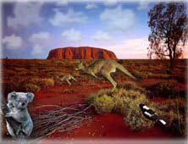

For this webquest, you may click on the links in blue to help you find the answers to the questions.
EQUATOR
NORTH AMERICA

AUSTRALIA
1. Complete the map
AFRICA
SOUTH POLE
SOUTH POLE
EUROPE
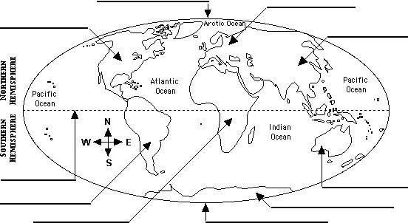
NORTH POLE
ANTARCTICA
ASIA
l
AFRICA – ANTARCTICA – ASIA – AUSTRALIA – EQUATOR – EUROPE – NORTH AMERICA – NORTH POLE –
SOUTH AMERICA – SOUTH POLE

- Which hemisphere is Australia in? …………………………………………………………………….
- So, when it’s winter in France, it’s ………………………………………… in Australia.

2. Complete the map of Australia.

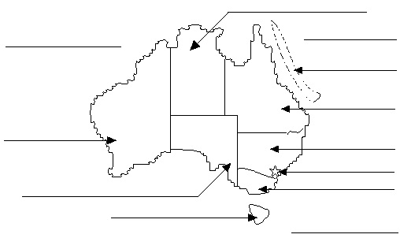 | Coral Sea  Great Barrier Reef  Indian Ocean Victoria –  New South Wales  Northern Territory  Queensland Tasmania  Tasman Sea –  Western Australia  South Australia

- Australia is composed of 6 states and … territories.
- What is the capital city of Australia ? ………………………………….………………………………
- Which are the largest cities?……………………………………….……………………………………
…………………………………………………………………………..……………………………………
- How many people are there in Australia ? …………………………………………………………..……………………………………………………
- What is the nickname of Australia ? Why ?
…………………………………………………………………………..…………………………………….
3. (Colour the Australian flag.) Optional ! You may copy/paste a flag from the Internet.
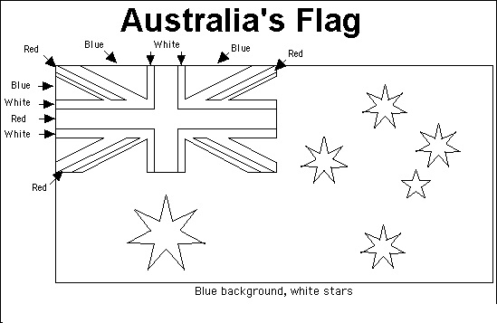

- Why is there the British flag on the upper left corner ?
………………………………………………………….………………………………………………………
- What do the 5 stars represent ? Why ?
…………………………………………………………………………………………………………………..
…………………………………………………………………………………………………………………..
- What does the Commonwealth star symbolize ? …………………………………………………………………………………………………………………...
……………………………………………………………………………………………………………………
4. What is the currency in Australia ?
In France, we pay in euros ; In Australia, they pay in ……………………………………………………..
5. Government in Australia. Page 1 - Page 2
- Who is the « Head of State » of Australia ?
Qui est “Head of State de Australie.
- Who represents her when she is not here ?
Qui représente elle quand elle est pas là.
- Who is the Head of the Government ?
Qui est à la tête de ce gouvernement
!!!!! The hyperlinks appearing on questions 6,7,8 and 9 have been deactivated. Make your own research on the Internet (in English of course! All answers must be brief, don’t copy/paste 10 pages from Wikipedia!)
6. The Aborigines.
- Who are they ? qui sont ils
- Look at the Aboriginal flag : 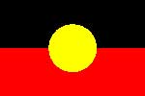
The black represents ………………………………………………………………………………………………..
The red represents ………………………………………………………………………………………………….
The yellow represents ………………………………………………………………………………………………
- What’s a « didgeridoo » ? ………………………………………………………………………………………….
- What was a boomerang used for ? ………………………………………………………………………………
7. Ayers Rock.
- What’s the Aboriginal name of it ? ……………………………………………………………………
- Why is it so important for the Aborigines ? ……………………………………………………………
……………………………………………………………………………………………………………………
- How high, how old and how long is it ?
8. The Flying doctors.
- Who are they ? What do they do ?.
9. Alice Spring School of the Air.
- What is it ? ………………………………………………………………………………………………………….
…………………………………………………………………………………………………………………………..
10. The animals.
- Write the names of these Australian animals. (+ Page 2)
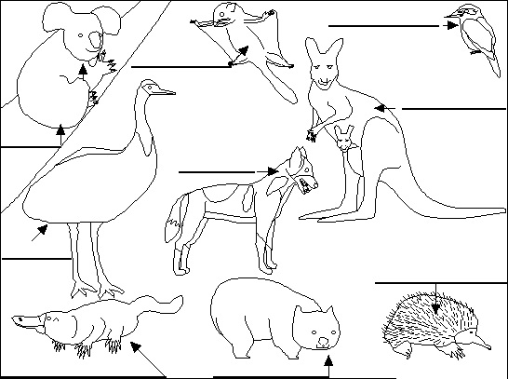  Duck-billed platypus  Wombat  Kookaburra  Sugar glider  Dingo  Kangaroo  Koala  Emu  Echidna | Dingo  Emu  Duck-billed platypus  Echidna  Koala  Kangaroo  Kookaburra  Sugar glider  Wombat -
- What are « dingoes » ? ………………………………………………………………………………………….
- Where do they live ? …………………………………………………………………………………………….
- What do they eat ? ………………………………………………………………………………………………
- Choose an Australian animal, click on it to get information and write a few lines about it.
…………………………………………………………………………………………………………………
…………………………………………………………………………………………………………………

11. Geography and tourism.
- What is the « outback » ? ………………………………………………………………………………………….
- What is there in the outback ? ……………………………………………………………………………………
- What can you see in Sydney ? ………………………………………………………………………………………….………………………
…………………………………………………………………………………………………………………
- What’s the most famous scenic place near Cairns ?
……………………………………………………………………………………………..…………………….
12. Language. Page 1 -
The Australians speak English but some words or expressions can be different : it’s the Australian slang.
Can you find the Australian slang words for these English words ?
ENGLISH / AUSTRALIAN | AUSTRALIAN / ENGLISH
friend =  good day or hello =  work =  woman =  Australian =  a guy = | arvo =  bickies =  hoon =  Oz =  sticky beak =  durry =
13. Sport.
The Australians are very sporty. What sports do they practise ?
S

