Inhaltsverzeichnis

**1 Only Backtracking (only walls), no routing** 1

**Zerotofour** 1

**eight** 2

**2 Backtracking only routing (no walls)** 3

**Zerotofour** 3

**eight** 5

**3 Backtracking (walls) with weighting by routing and resampling** 6

**Zerotofour** 6

**eight** 7

**4 Backtracking (room concept)** 8

**Zerotofour** 8

**Backtracking (walls) with weighting by routing and resampling** 10

**Zerotofour** 10

## **1 Only Backtracking (only walls), no routing**

No reinitializing/readjusting of particles when floor changes

### **Zerotofour**

0.2 step correction

Run time (whole): 203s

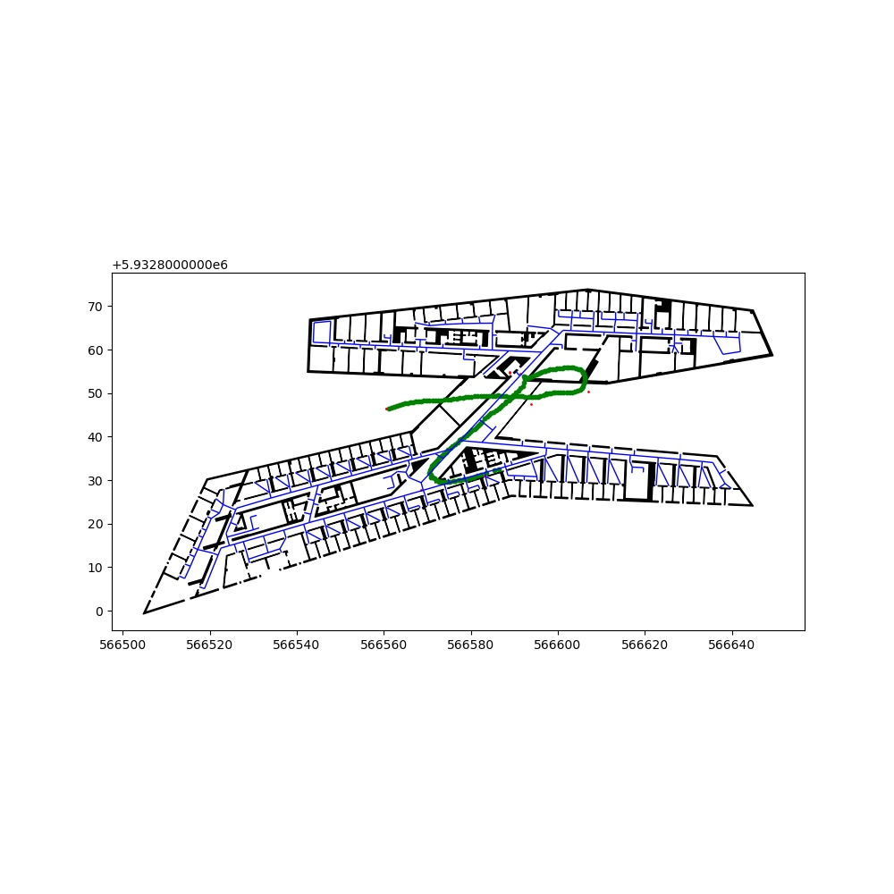

0.1 step correction

Run time (whole): 184s

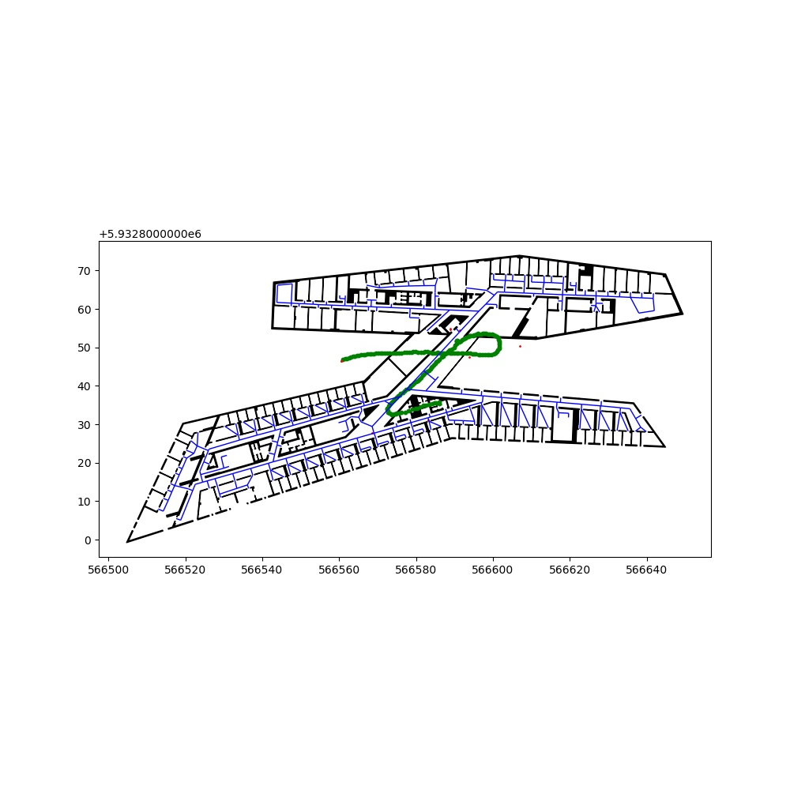

0 step correction

Run time (whole): 162s

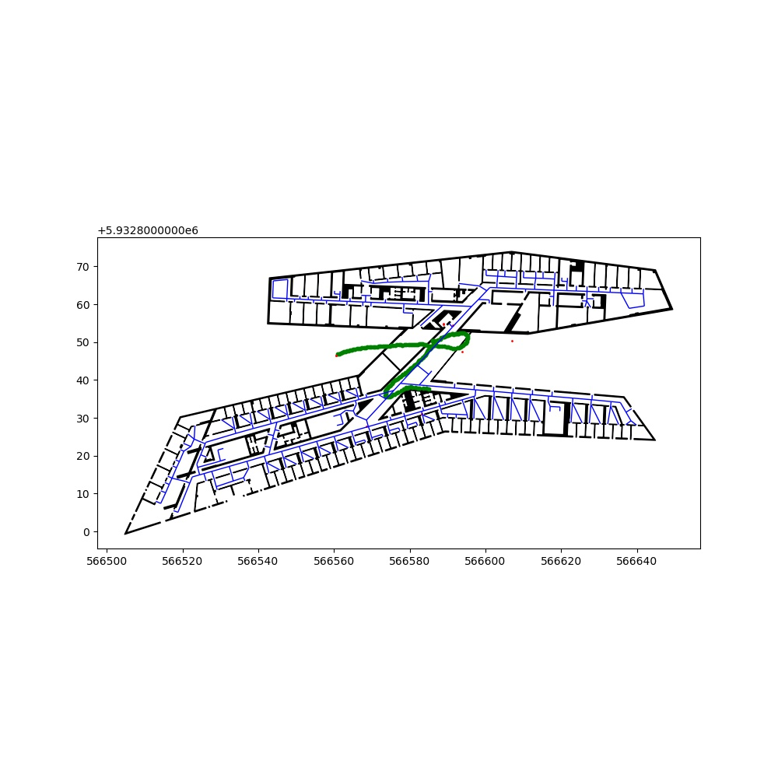

### **eight**

0.1 step correction

Run time (whole): 436s

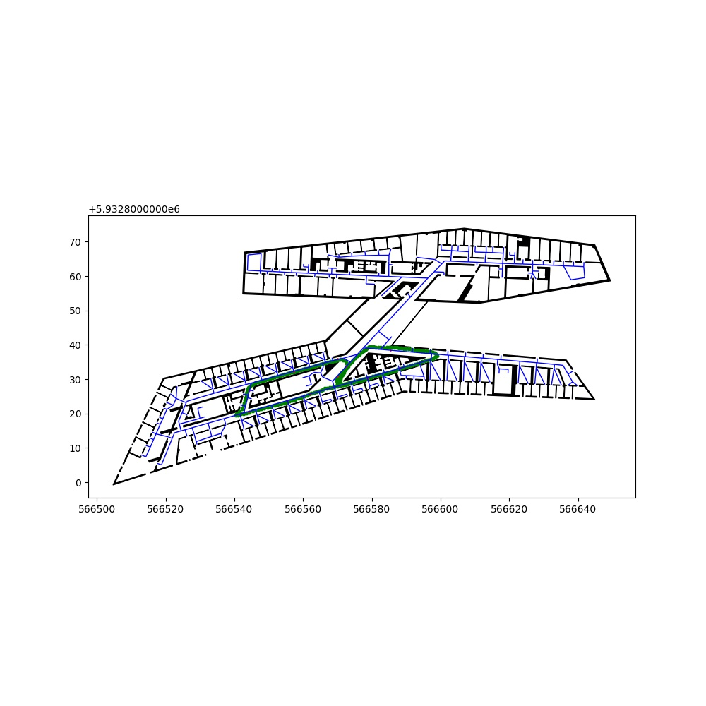

0.0 step correction

Run time (whole): 495s

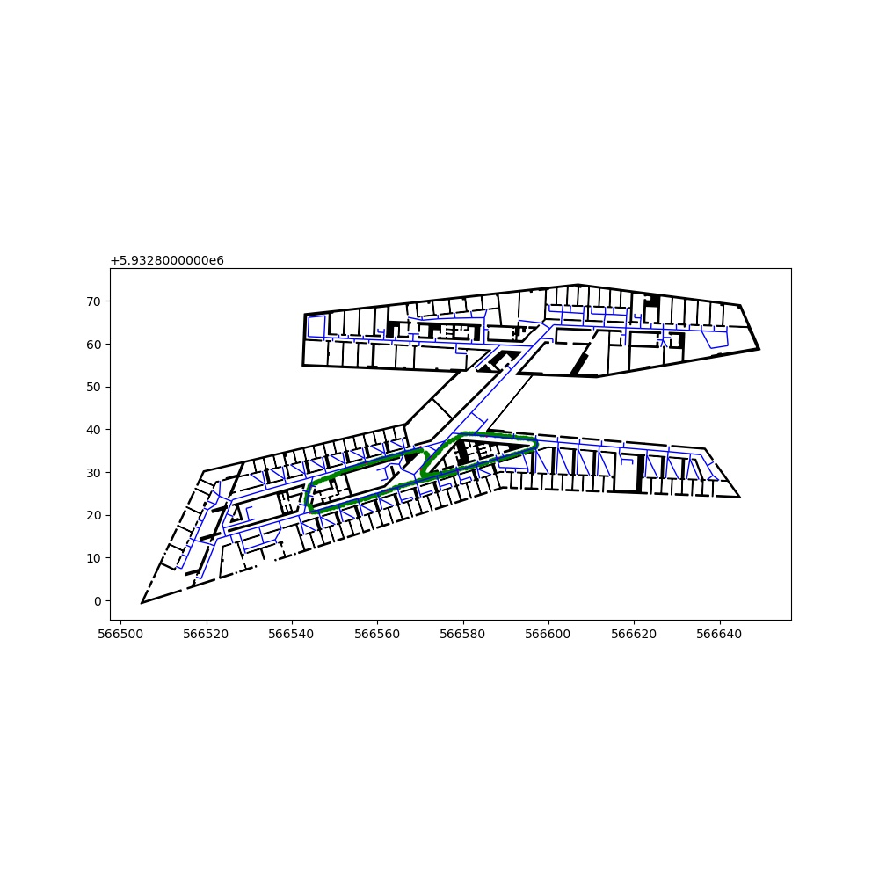

## **2 Backtracking only routing (no walls)**

No reinitializing/readjusting of particles when floor changes

### **Zerotofour**

0.2 step correction

2m routing edge distance threshold

Run time (whole): 147s

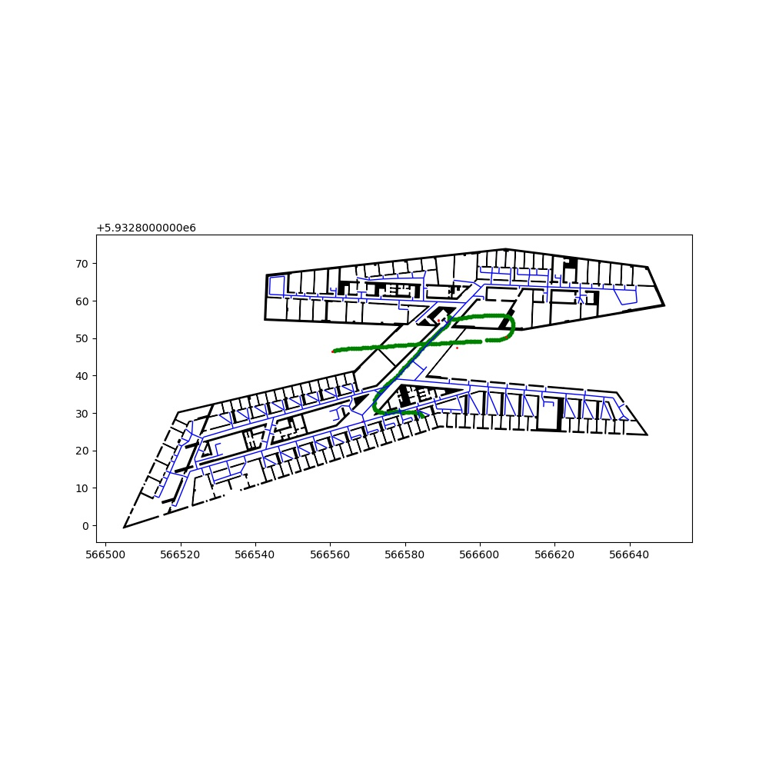

0.1 step correction

2m routing edge distance threshold

Run time (whole): 180s

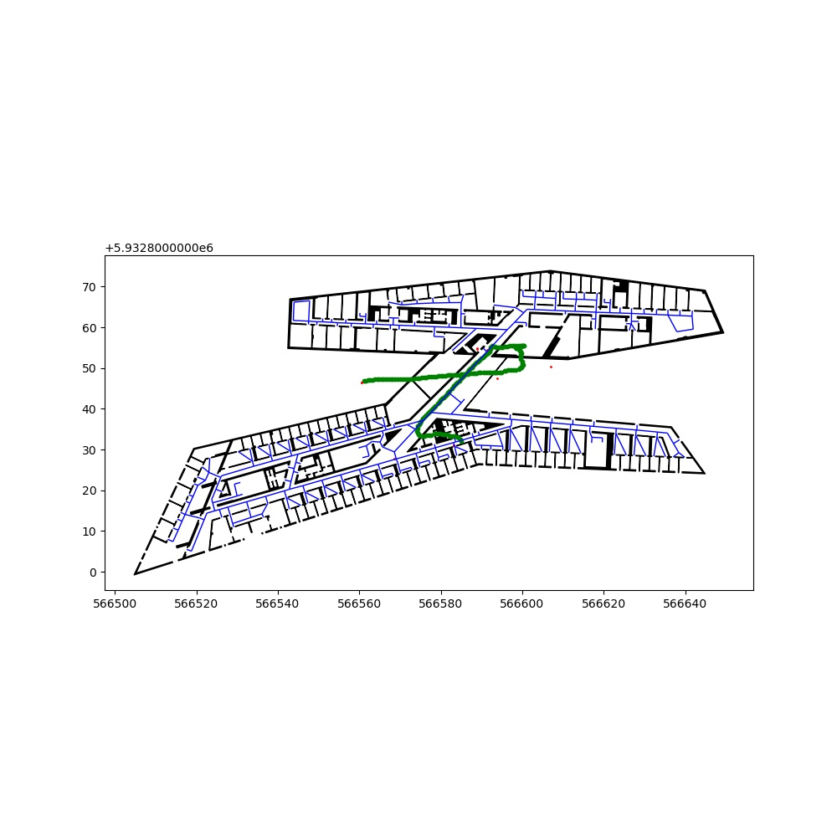

0 step correction

2m routing edge distance threshold

Run time (whole): 149s

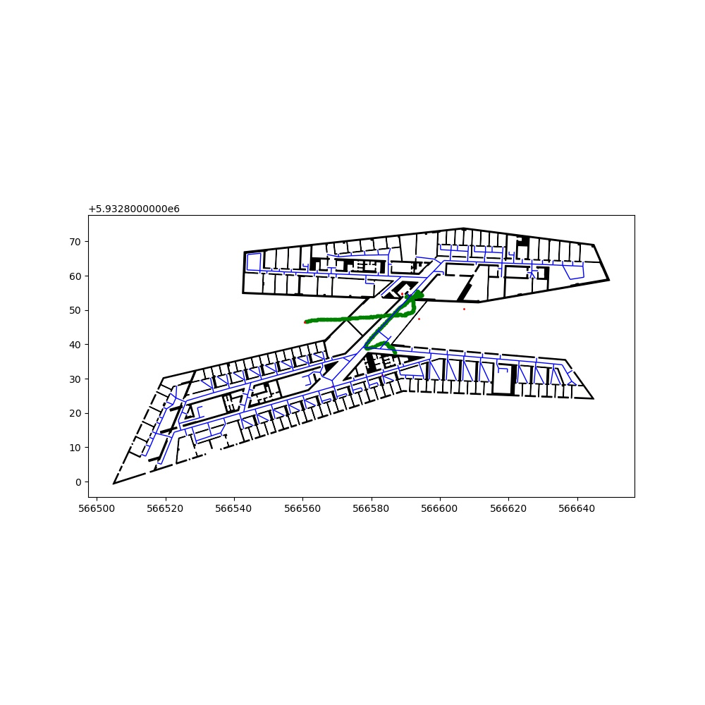

### **eight**

0.1 step correction

2m routing edge distance threshold

Run time (whole): 233s

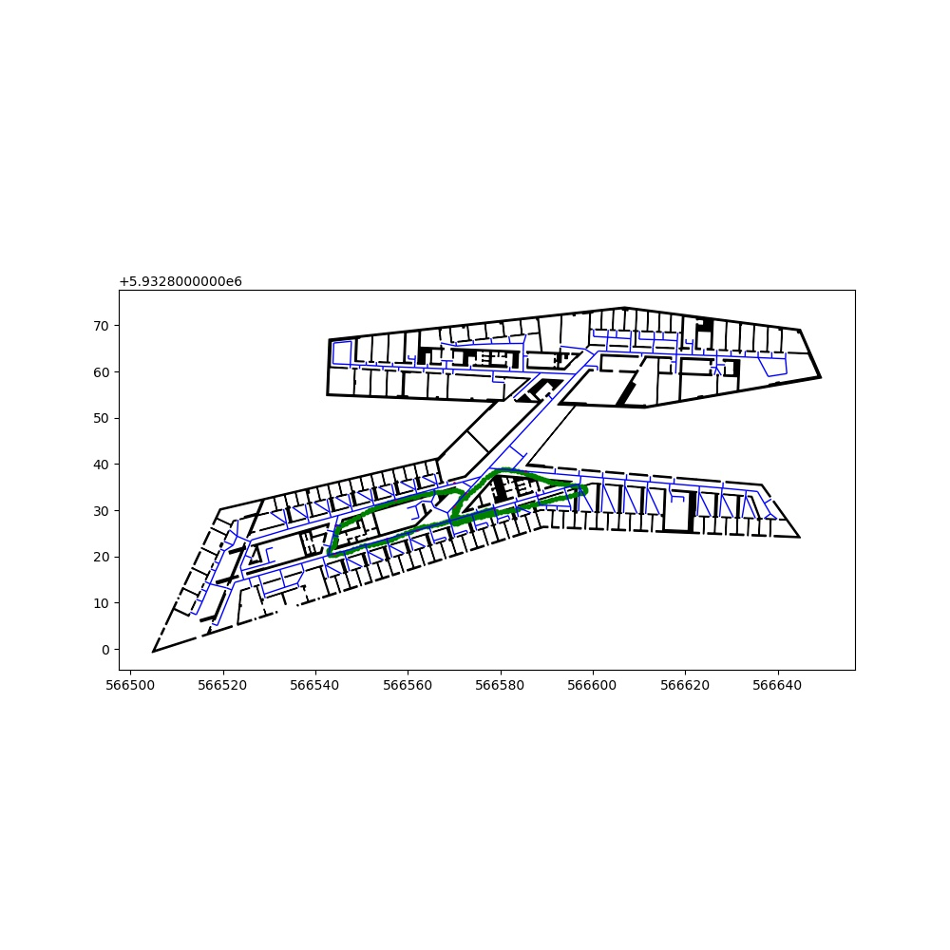

0 step correction

2m routing edge distance threshold

Run time (whole): 178s

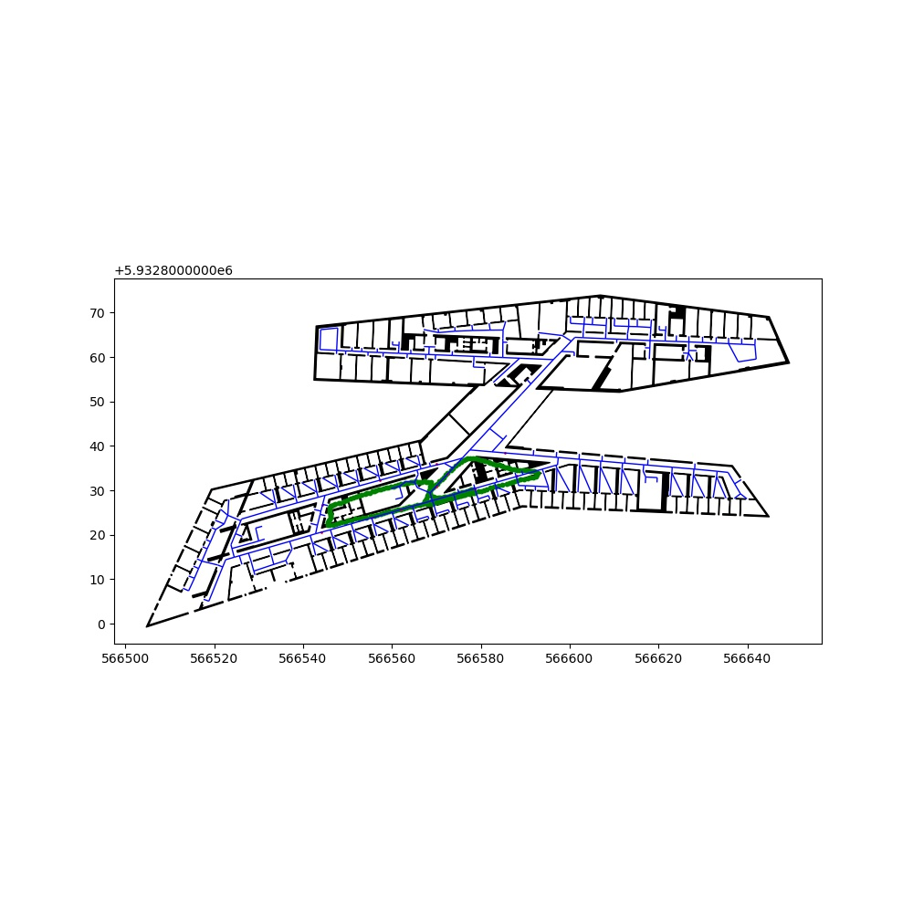

## **3 Backtracking (walls) with weighting by routing and resampling**

No reinitializing/readjusting of particles when floor changes

### **Zerotofour**

0.2 step correction

Run time (whole): 215s

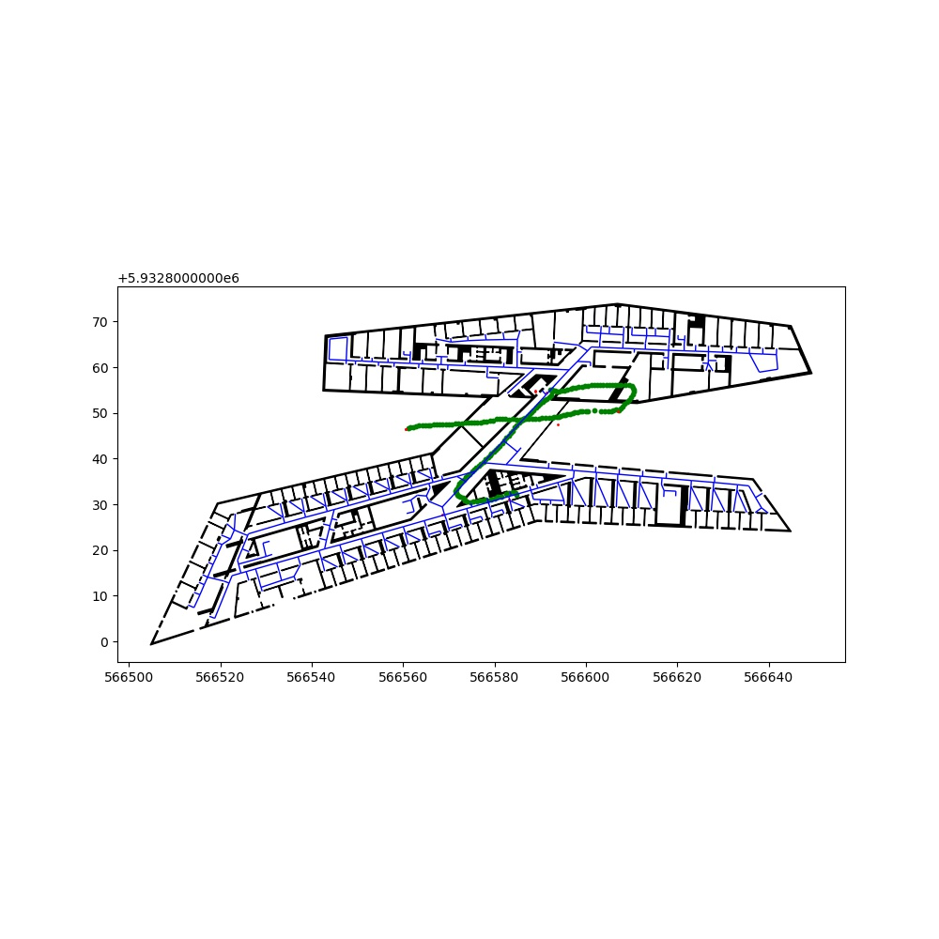

0.1 step correction

Run time (whole): 200s

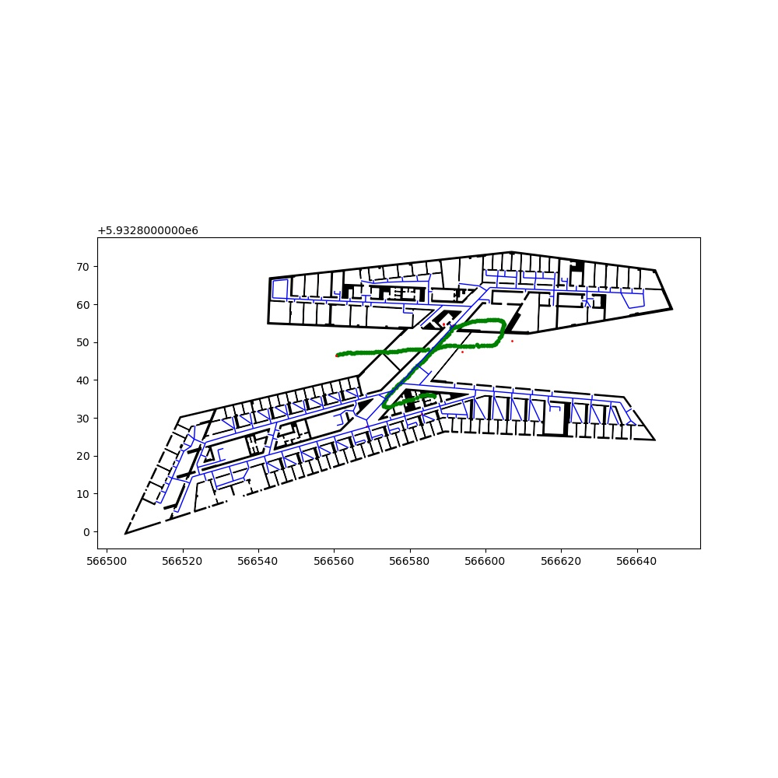

0 step correction

Run time (whole): 200s

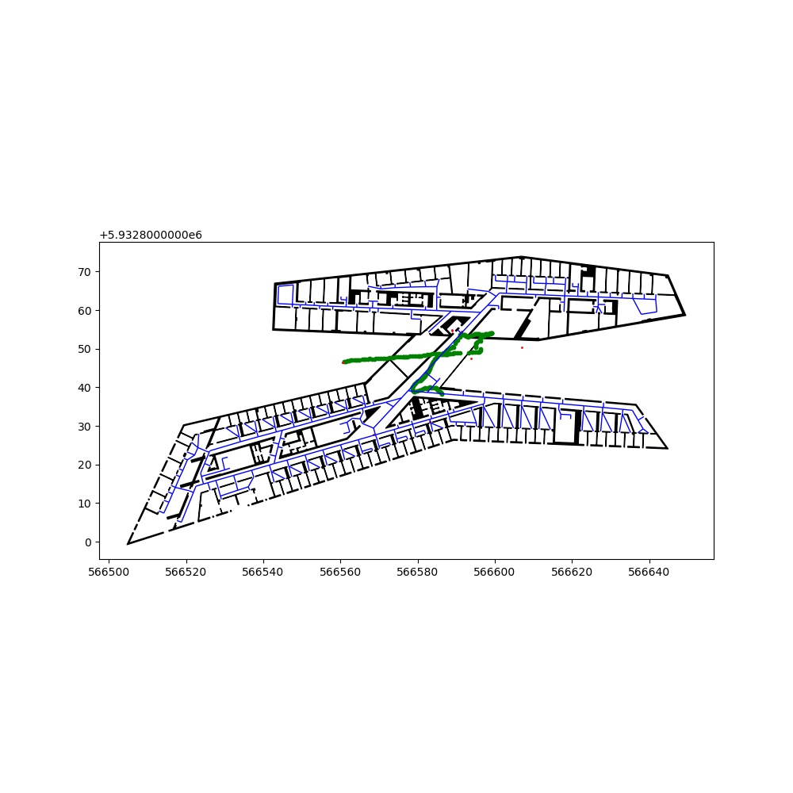

### **eight**

0.1 step correction

Run time (whole): 485s

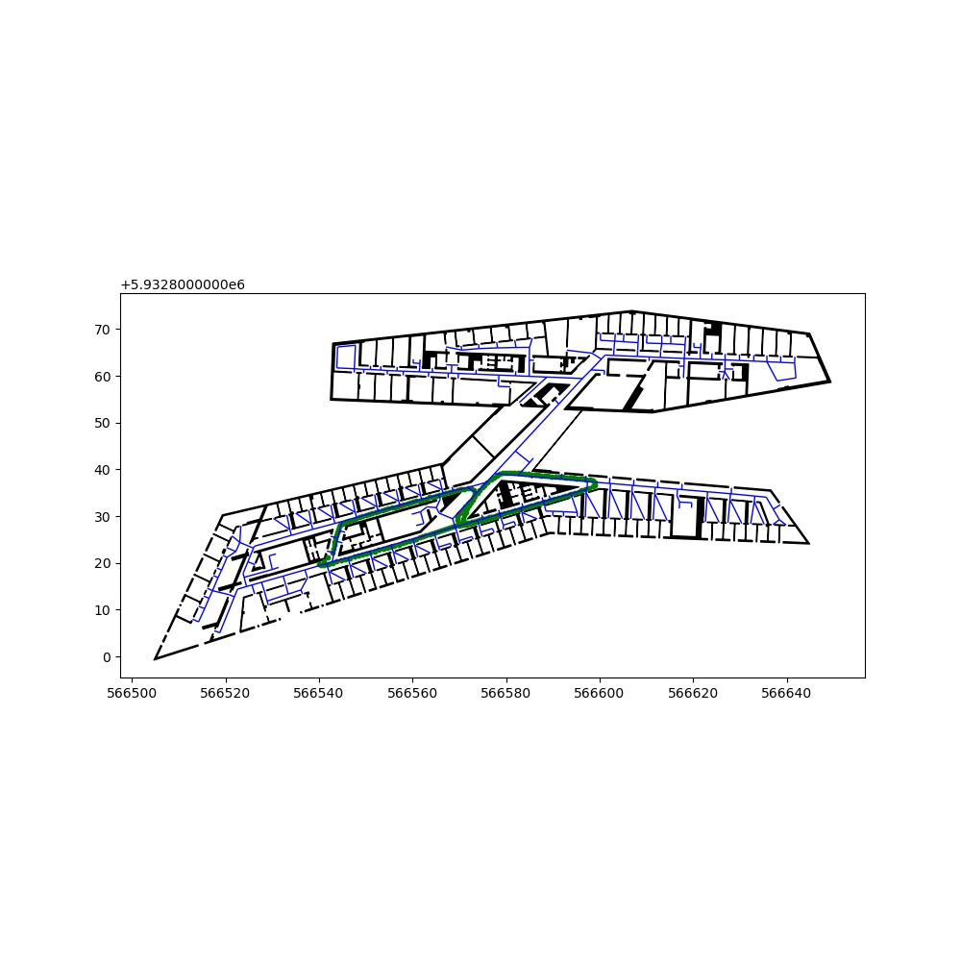

0 step correction

Run time (whole): 442s

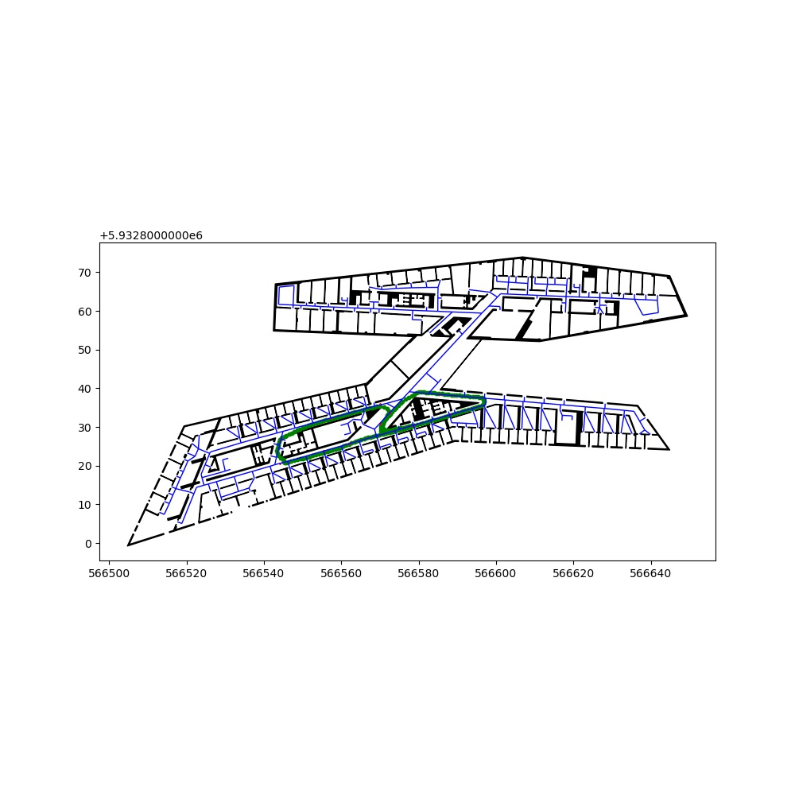

## **4 Backtracking (room concept)**

Particles are valid if they are in corridor,lift or staircase (or door)

Crossing of walls is not considered

No reinitializing/readjusting of particles when floor changes

### **Zerotofour**

0.2 step correction

Run time (whole): 89s

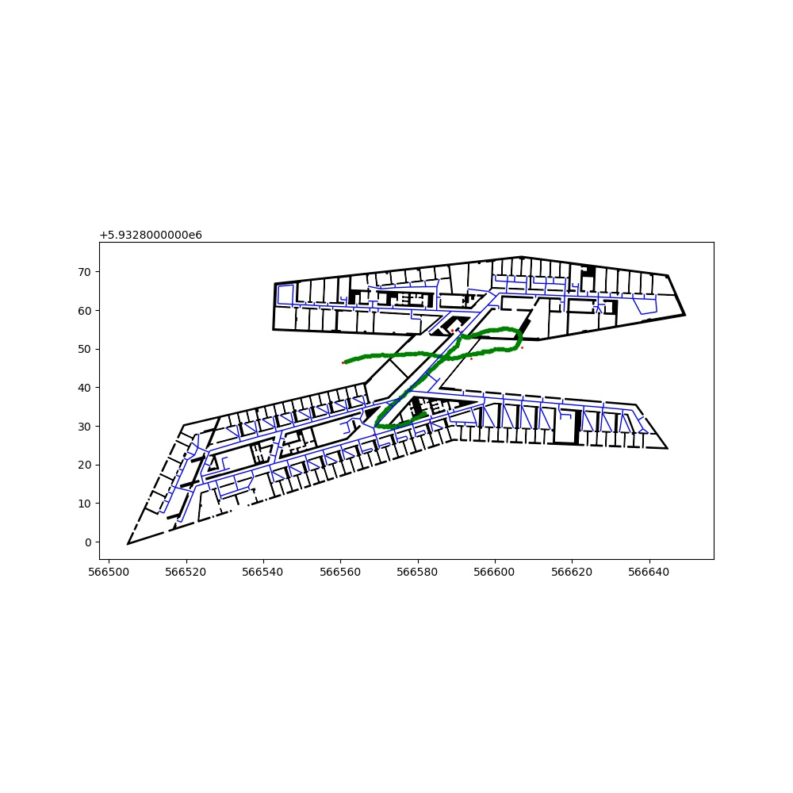

0.1 step correction

Run time (whole): 93s

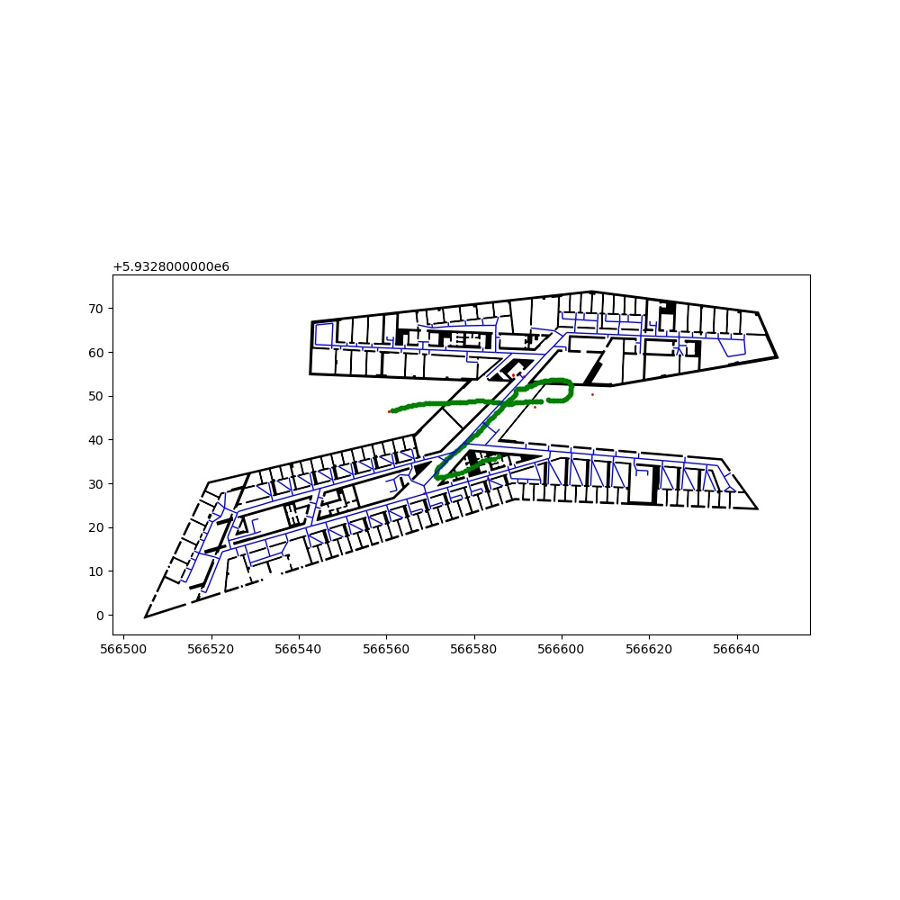

0 step correction

Run time (whole): 101s

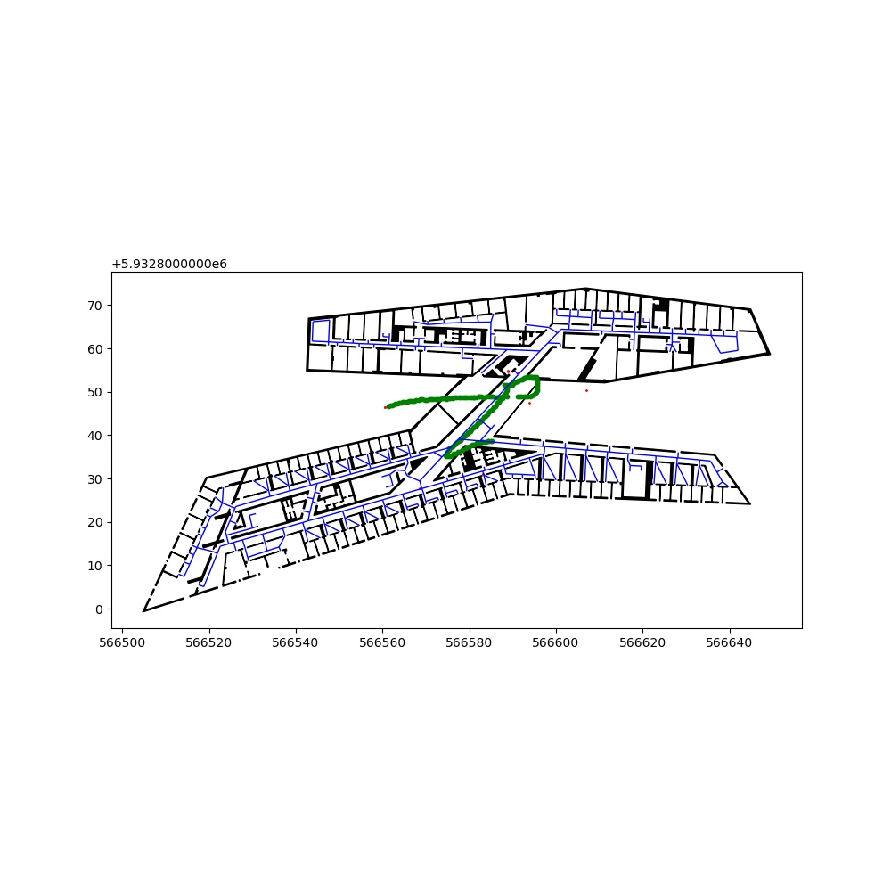

## **5 Backtracking (walls) updating the stepscale**

With every floorchange only particles in transition zones considered and the scale for the stepcorrrection is increased by the meanof all particle scales

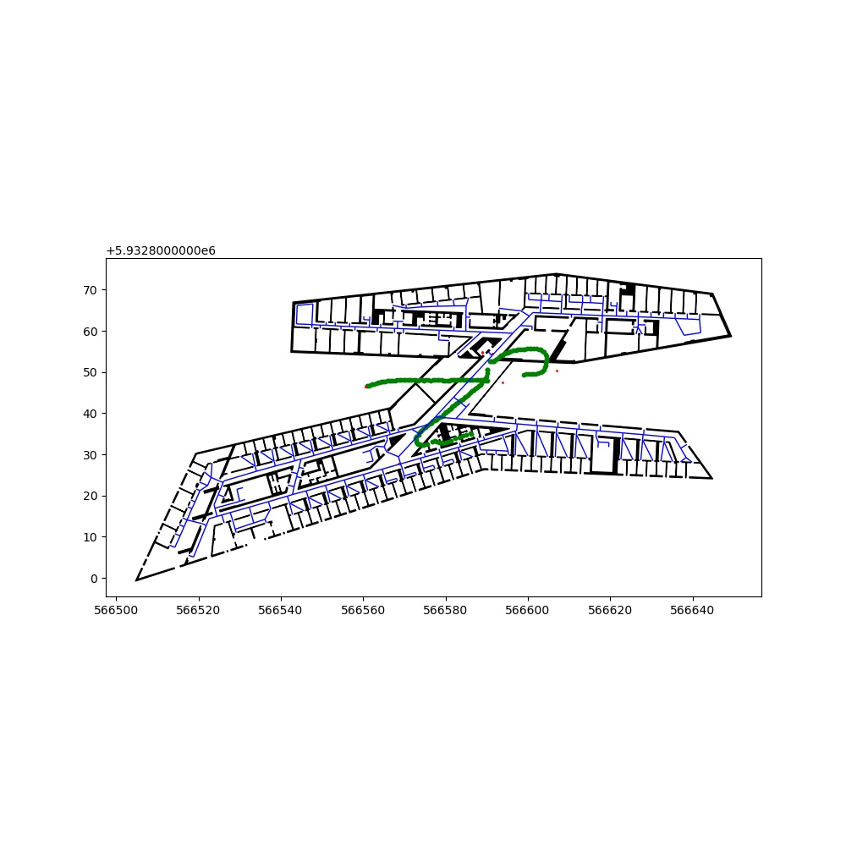

### **Zerotofour**

0 step correction

Run time (whole): 189s