# **ECOR 1010 – Introduction to Engineering**

**FULL Student’s Name**

**Assignment #1**

**Assignment Title: ...**

***TO Marking TA:***

Name: ...

Email: [...@....ca](mailto:...@....ca)

**Lab Section: L14**

**Room: 4301CB – Carleton University**

**FROM:**

Email: [dorianwang@cmail.carleton.ca](mailto:dorianwang@cmail.carleton.ca)

Student Number: 101009020

Number of Figures and Tables (Including handwritten ones): ...

Last Date and Time of Revision: DD/MM/YYYY @ HH:MM (AM/PM)

# Introduction

The goal of this lab was to demonstrate the capabilities of MATLAB as a matrix manipulation tool.

# Materials and Methods

Matlab was used, following the instructions provided.

# Results

See appendix.

# Discussion

There was one operation which could not be calculated, due to the matrices having incompatible dimensions. Pinv was required in one question due to floating point rounding errors.

# Conclusions

Matlab makes vector and matrix operations much easier. It does take time to learn, and does not support some programming patterns, but generally improves such work. Also, I should give up on passing.

# APPENDIces- Figures and Tables

|  |
| --- |
| z = [0; 0]; a = [1; 10]; b = [8; 2]; c = [8; -20];  d = [-13; 7]; e = [4; 10];  y = [z a b c d e];    h = figure;  set(h,'name','Dorian Wang''s Stuff and Things''','numbertitle','off')    position = cumsum(transpose(y));  plot(position(:,1), position(:,2))    totalDistance = norm(a) + norm(b) + norm(c) + norm(d) + norm(e);  totalDistance |

Figure

|  |
| --- |
| test = @(x) sin(x^2)*(10+4*x + x^2)/(7 + 2*x^2);    h = figure;  set(h,'name','Dorian Wang''s Stuff and Things''','numbertitle','off')    fplot(test, [-2, 2])  xlabel('x')  ylabel('sin(x^2)*(10+4*x + x^2)/(7 + 2*x^2)') |

Figure

|  |  |
| --- | --- |
| f = [3 9; 7 -2; 3 0; 6 8; 9 6; 5 2];  g = [-9 4 8 5 -1 2; 7 -1 -2 9 3 3];  q = [2 -7 2; 1 0 6; -5 3 5];  u = [1 0; 0 1]; h = [8; 5; -6];  r = -0.4; p = 0.32;    r * f*g  w = f-transpose(g)  u*g  f*u  q*h  q*g + p*transpose(f)  %This doesn't work because a 2*6 matrix cannot be multiplied by a 2*6 matrix | ans =  -14.4000 -1.2000 -2.4000 -38.4000 -9.6000 -13.2000  30.8000 -12.0000 -24.0000 -6.8000 5.2000 -3.2000  10.8000 -4.8000 -9.6000 -6.0000 1.2000 -2.4000  -0.8000 -6.4000 -12.8000 -40.8000 -7.2000 -14.4000  15.6000 -12.0000 -24.0000 -39.6000 -3.6000 -14.4000  12.4000 -7.2000 -14.4000 -17.2000 -0.4000 -6.4000  w =  12 2  3 -1  -5 2  1 -1  10 3  3 -1  ans =  -9 4 8 5 -1 2  7 -1 -2 9 3 3  ans =  3 9  7 -2  3 0  6 8  9 6  5 2  ans =  -31  -28  -55 |

Figure

|  |  |
| --- | --- |
| a = [9 3 5; 1 4 6; 2 7 1];  b = [5; 1; 3];    x = inv(a) * b | x =  0.5223  0.2962  -0.1178 |

Figure

|  |  |
| --- | --- |
| a = [1 -1 0 0 0 0; 0 1 -1 0 0 0; 0 0 1 -1 0 0; 0 0 0 1 -1 0; 0 0 0 0 1 -1; -1 0 0 0 0 1];  c = [75; -60; 105; -120; 65; -65];    x = pinv(a) * c    a * x - c | x =  45.8333  -29.1667  30.8333  -74.1667  45.8333  -19.1667 |

Figure

|  |  |
| --- | --- |
| r1 = 6; r2 = 5; r3 = 1; r4 = 8;v1 = 5.20; v2 = 3.20;    a = [r1+r2, -r1, -r2; -r1, r1+r3, -r3; -r2, -r3, r2+r3+r4 ];  c = [-v1; -v2; 0];  x = pinv(a) * c | x =  -2.4061  -2.6695  -1.0500 |

Figure

|  |  |
| --- | --- |
| A = [1 0 1; 0 0 9; 0 2 0];  b = [5 6 3];    c = b * A * transpose(b);    format bank;  E = c/pi | E =  75.76 |

Figure

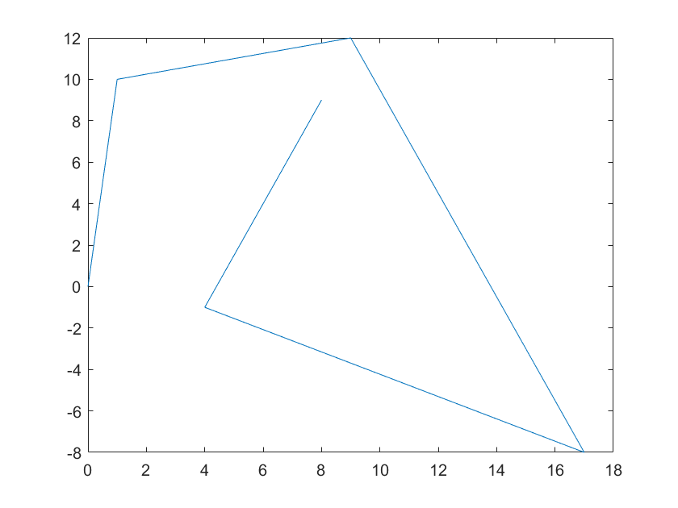Figure 8: Figure 1 result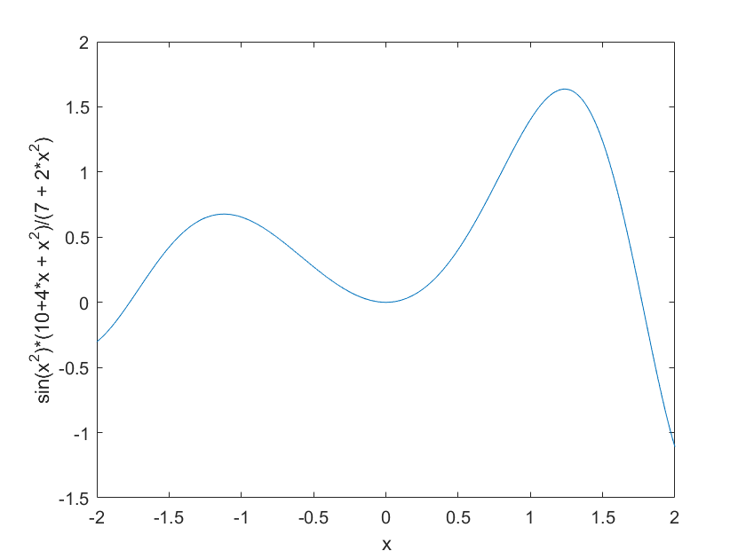Figure 9: Figure 2 result