Doris Meiers

9/26/2020

Kickstarter Report

1. Given the provided data, what are three conclusions we can draw about Kickstarter campaigns?

a. Of all the campaigns, only about 50 percent are successful and around 37 percent failed.

b. The range in which the most campaigns are started are from 1000 to 4999 which is 34 percent of the total.

c. The category that is started the most is Theater and the sub-category that is most started is Plays.

1. What are some limitations of this dataset?

You cannot get a sum of the donations in the world because there are different currencies, and the details of every donation are not provided to get the exact exchange rate from the day the donation was made. Therefore, one country cannot be compared to another.

1. What are some other possible tables and/or graphs that we could create?
   1. We can create a table of the total donations per year per country and get a clustered chart from this data.

Example:



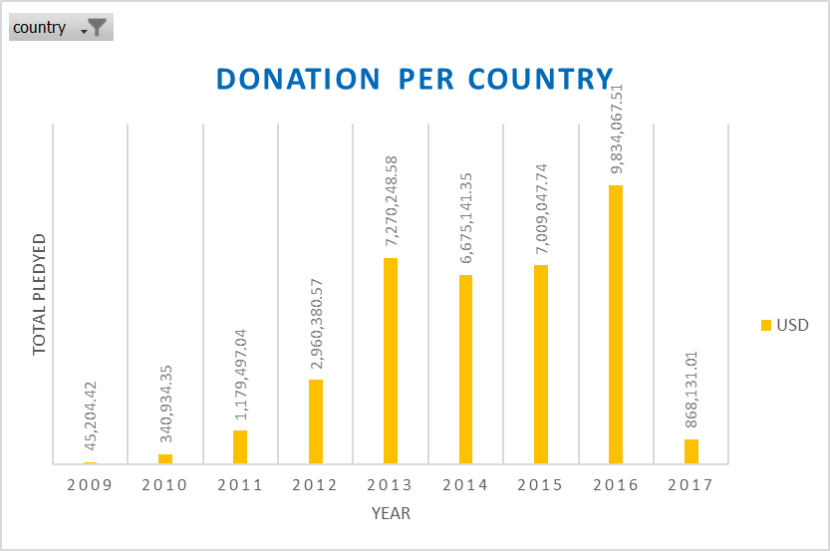

* 1. Another table and we can get from the dataset are in which country Kickstarter launched the most campaigns on down to the least.

Example:



* 1. You can also create a table of the total of the campaigns that exceeded the goal and those that fell below.

|  |  |  |
| --- | --- | --- |
| **state** | **Total** | **Percentage** |
| exceeded the goal | 2002 | 49% |
| equal or bellow | 2112 | 51% |
| **total** | **4114** | **100%** |

Example:

