E:\Projecten\Usbwebserver\V8\Source\root\images\header.pngE:\Projecten\Usbwebserver\V8\Source\root\images\background.jpg

Leon de Vries  
Border-IT  
juli 2010  
Versie 1.0

User manual

Inhoudsopgave

Introduction 3

Starting with USBWebserver 8 4

Apache 5

MySQL 5

Settings 6

PHP 7

PHPMyAdmin 7

FAQ 8

# Introduction

USBWebserver is a combination of the popular webserver software: Apache, MySQL, Php and PhpMyAdmin. With USBWebserver it is possible to develop and show your php websites, everywhere and anytime The advantage of USBWebserver is, you can use it from USB of even CD

USBWebserver is perfect for:

* Show a offline version of your website
* Anywhere and anytime develop php websites
* No need for expensive hosting
* Working at multiple locations at projects
* A good test before putting your website online
* And many more

# Starting with USBWebserver 8

To begin you need to download USBWebserver 8 from <http://www.usbwebserver.com>.  
Unpack the downloaded file with winrar of winzip.  
To begin you start usbwebserver.exe  
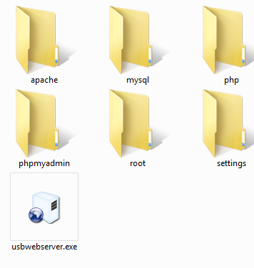

The main screen of USBWebserver 8.0 appears.  
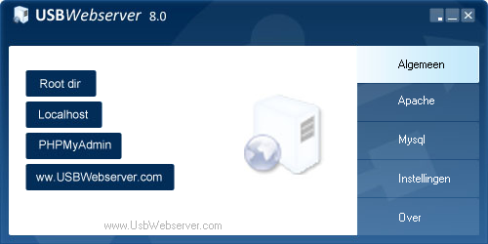

When the green sign appears by [Apache] en [MySQL], USBWebserver with his components are fully started  
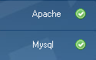

USBWebserver will be visible in the taskbar. With the symbols in the upper corner you can place USBWebserver in the taskbar (  ) or in the system tray (  ).

**Root dir:** This is the directory where you should place your website files

**Localhost:** The browser will open localhost and show your website

**PHPMyAdmin:** The database management software PHPMyAdmin will be started

**www.USBWebserver.com:** The usbwebserver website

# Apache

The webserver component is Apache 2.2.  
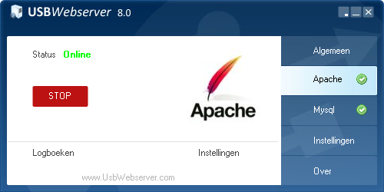

The second page will give you the possibility to check and control the status of apache  
On the bottom are two shortcuts, to the logs and to the settings (settings/httpd.conf)

# MySQL

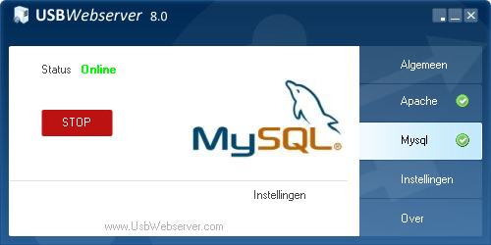

This page has the same functionality as the apache page. But it controls MySQL The shortcut is linked to the settings file for MySQL (settings/my.ini)

# Settings

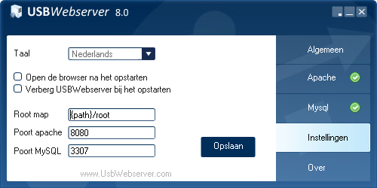

The basic settings can be found at this page  
  
**Language:** It is possible to change the language of USBWebserver

**Open de browser when start:** The default browser will open localhost when USBWebserver start

**Hide USBWebserver at start up:** USBWebserver will be placed in the system tray by default

**Root map:** You can change to root directory

**Poort apache:** The port for apache (default 8080)

**Poort MySQL:** The port for MySQL (default 3307)

**Opslaan:** The settings will be saved and USBWebserver will be restarted

# PHP

PHP is installed as a module for apache  
This module makes it possible to run dynamic php pages  
The default settings are visible at <http://localhost:8080/phpinfo.php>.

PHPMyAdmin  
PHPMyAdmin is the default database management system in USBWebserver.  
It makes it possible to create, adapt and control databases  
 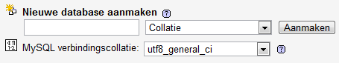  
  
For a the manual we refer to:

<http://www.phpmyadmin.net/home_page/docs.php?books>

# FAQ

**Where do i need to put the files?**  
You need to put your files in the root directory.  
You can reach the website by <http://localhost:8080/>.

**How do i chmod a file?**  
You don't need to chmod files with USBWebserver

**Where can i find the setting files?**  
All the settings files a placed in the settings directory. You need to restart USBWebserver after changing the settings.

**What are the settings for PhpMyAdmin?**  
Username is '**root**' and the password '**usbw**'