**ChatGPT in education**

1. **Introduction {with citations}**

* 1. **What is a chatbot? And short history**

A chatbot is a computer program that understands the user input and gives a sensible and human readable response through the messaging application. To understand the user input, it uses Natural Language Processing (NLP) and machine learning techniques and generates the responses. Nowadays chatbots are used for many things. Since it can be programmed for automated responses, companies use it for customer service, which helps to reduce the support costs.

The first chatbot was created in 1966 by Joseph Weizenbaum. It was designed to have conversation with psychotherapist. This bot passed the Turing test that means human beings are unable to distinguish the machine from another human. Chatbot now uses more advanced NLP and AI which make it more powerful.

* 1. **What are the significances of chatbot?**

Chatbot is advanced nowadays. With advancement come advantages and disadvantages. Some of its significances are explained below:

* **Real-time Feedback and Guidance:**

Self-paced learners can receive real-time feedback and guidance from Chat GPT as they progress through course materials and resources. This allows students to stay on task and deal with any problems they encounter.[1]

* **Cost-effective:**

Chatbot is a cheap and one-time investment instead of human resource. It reduces costly problems caused by human error. It can give responses to a huge amount of user input without any error once programmed.

* **Convenient and flexible learning:**

Self-study learners can use Chat GPT to learn at their own pace and in their own way because they can converse with chatbots whenever it's convenient for them.[1]

* **Availability:**

Once the chatbot is programmed it is available 24/7. It is useful for customer service and support as users get support outside office hours, which helps user experience.

* **Improved Use of Open Educational Resources:**

Chat GPT can provide customized suggestions and advice on how to effectively use these resources so that self-directed learners can find and use open educational resources help. This allows students to take advantage of a wide range of online learning tools and materials.[1]

* 1. **What are types of chatbot?**

Chatbot is programmed to have conversations with human users to understand the user input that provides readable and sensible responses. To understand these user input, we have many types of chatbot. Some of them are explained below:

* **Rule-based chatbots:**

Rule-based chatbot gives response on basic of predefined set of rules recognizing the user input. It uses if/then logic to have a conversation with user. It is mostly used in customer service and support in organizations. It is created by developers and is based on specific keywords or patterns in user inputs. It analyzes the user input text and tries to match with pre-defined rules if not found. It uses a decision tree and generates the response accordingly.[2]

* **AI-based chatbots:**

AI based chatbot are those chatbot that are trained to have human-like

responses using a Natural Language Processing (NLP). It can gather data from user behaviors. It is constantly learning from the conversation with the users which improves the quality of response over time. It can be used for many industries like customer service, sales and marketing.[2]

* **Hybrid chatbots:**

Hybrid chatbot is combination of both rule-based chatbot and AI based chatbot. It uses a rule-based chatbot to generate responses for the frequently asked input and AI-chatbot for the response that doesn’t have pre-defined rules which makes it more powerful from both of chatbots.[2]

**1.4 What is ChatGPT ? Discuss along with its history and differences with normal**

**chatbots.**

ChatGPT is an advanced chatbot created by Open AI using GPT technology. Designed for personalized conversations in natural language. ChatGPT is a language model created by Open AI using GPT-3. It will be spoken in a casual and natural way, like everyday conversation. ChatGPT is built upon prior research in characteristic language training and artificial intelligence. GPT-2 could produce human-like content that was difficult to distinguish from real writing. Open AI released GPT-3 in 2020, an upgraded version of GPT-2, as the largest and most powerful language model to date. ChatGPT was created as a language model designed for conversation by refining an existing model. It builds on previous work that improved GPT-2 and GPT-3 models by Open AI. These models produced impressive content that was hard to tell apart from human writing. ChatGPT is designed for conversation. This AI uses vast amounts of data to understand human language and engage in meaningful conversation with users. Regular chatbots respond to specific requests based on pre-programmed rules. ChatGPT uses advanced language processing for relevant responses. ChatGPT can respond and converse with users. It contextualizes conversations and responds accordingly. ChatGPT uses more data than regular chatbots. ChatGPT is a major advance in conversational AI and natural language processing.[3]

ChatGPT is an AI system by Open AI using GPT architecture. The system understands human speech and can converse with users after being trained on vast amounts of data. ChatGPT is more human-like than typical chatbots. ChatGPT is more human-like than other chatbots. ChatGPT is different from traditional chatbots. Chatbots follow programmed rules and respond to specific requests. Chatbots follow rules and respond to requests. ChatGPT uses NLP to respond based on previous interactions. ChatGPT employs NLP techniques to comprehend the context and provide suitable responses from past exchanges. ChatGPT relies on more data for its model training than traditional chatbots. Diff. between ChatGPT & traditional chatbots: less training data. In short, ChatGPT is a game-changer in the realm of NLP and Conversational AI. In short, ChatGPT is a significant advancement for NLP and Conversational AI.[3]

**1.5 How does ChatGPT works? Explain with diagram.**

ChatGPT has progressed NLP capabilities, counting the capacity to get it and create human-like content. This could be valuable in analyzing code because it permits the show to get it the aim behind the code and to recognize potential bugs based on the dialect utilized. [4]

**Input:**

The discussion starts with a beginning client provoke or message given to ChatGPT.

**Encoding:**

The tokenized input is passed through an encoding layer, which changes over the tokens into numerical representations that the demonstrate can get it. The tokenized input is passed through an encoding layer, which changes over the tokens into numerical representations that the demonstration can handle. The demonstration forms the encoded input tokens in conjunction with the setting of the discussion so far. The demonstration takes the encoded input tokens at the side of the setting of the progressing discussion. This permits the show to get the discussion history and produce relevantly pertinent reactions.

**Translating and Examining:**

The model creates a likelihood dissemination over the conceivable other tokens, showing the probability of each token being the following within the reaction. To create a reaction, ChatGPT employs an inspecting method, such as top-k testing or core inspecting, to choose the next token based on its probabilities. The demonstration creates a likelihood conveyance over the conceivable following tokens, showing the probability of each token being the another within the reaction.

**Reaction Era:**

The chosen token is included in the continuous discussion, and the method rehashes to create ensuing tokens until a fitting halting condition is met. The chosen token is included in the discussion, and the method is rehashed to produce consequent tokens until a suitable halting condition is met.

**Yield:**

The produced tokens are changed over back into human-readable content and displayed as the model's response. The created tokens are changed over back into human-readable content and displayed as ChatGPT's reaction to the user.

Figure: Workflow Diagram of ChatGPT[5]

**2. Literature review**

**2.1 ChatGPT and its applications**

ChatGPT is an advanced chatbot created by Open AI using GPT technology. Designed for personalized conversations in natural language. Since ChatGPT was published it is a favorite among students and teachers. It helps students to learn and find answers to the questions easily and quickly. ChatGPT is also famous among programmers as it helps to debug the error in code. The goal of ChatGPT is to equip the program to identify and fix coding mistakes in contemporary works by comprehending the correlation between code and errors. ChatGPT proposes code solutions based on error analysis. ChatGPT offers software support using NLP, data representation, and design. After prep, the demo offers code fixes using its understanding of code and errors. ChatGPT can suggest a fix for code errors with data. Programming, design, and development proposals. ChatGPT analyzes performance via data quality, system design, and bug priorities. ChatGPT detects bugs through code analysis. Catch early bugs, save time and money. ChatGPT finds coding errors by checking the code. The demo identifies coding errors through its recognition abilities. With snippets and errors, the show grasps the relationship. Collects accurate data and detects potential errors during development. Chat GPT finds and explains input code errors. Explains the issue source to programmers.[4]

ChatGPT might also play a vital role in Health-education. As it advises on improving health and preventing illness through examples. It's early screening provides crucial info on mammograms and colon screenings for treatable illnesses which reduce the risk of chronic diseases by managing stress, blood pressure, and cholesterol, and avoiding tobacco and excessive alcohol. It provides tips and info on wellness techniques. It supports health experts and educators to improve community well-being in rural and urban areas. It provides information on public health programs and services, their respective populations, and targeted health outcomes and gives information on program qualifications, costs, and available coverage for services. [6]

ChatGPT aids analysts to identify key articles by creating abstracts and providing relevant records on specific topics and keywords. ChatGPT enables easy drafting of inquiries, proposals, and other documents with a specific style and tone. ChatGPT helps analysts analyze large content information, such as social media posts and news articles, by identifying patterns and gaining insights. ChatGPT helps researchers stay updated by summarizing academic papers, reports, and other documents. ChatGPT is customizable for domain-specific questions, aiding analysts with fast and efficient answers. [7]

**2.2 ChatGPT and its Pros/Cons/Limitations**

Everything that is used by us human have advantages and disadvantages with its limitations. ChatGPT itself is never good or bad. How users use it defines its behavior. Its pros, cons and limitations are described below with some examples:

**Pros**

Students learn at their own pace and style. Lang Aptitude Improvement. ChatGPT assists 4,444 learners in enhancing their language proficiency through chatbots and virtual tutors. Chatbots provide instant feedback on language skills. ChatGPT reviews papers and assignments automatically. Saves time and gives instant feedback to students. ChatGPT aids students in research by answering queries, recommending resources, and simplifying intricate concepts. Increase critical thinking. ChatGPT prompts class discussions for critical thinking and meaningful conversations among students. Make chatbots and virtual assistants using ChatGPT for inclusive classroom participation. ChatGPT transforms education through customized learning, and automation for teachers, fostering critical thinking and accessibility, and enhancing language skills. Use ChatGPT as a learning tool, not a teacher replacement. [8]

**Cons**

Students may become excessively reliant on AI tools like ChatGPT, leading to a lack of critical thinking and independence in learning. ChatGPT can copy conversations but can't replace real-life social and emotional interactions. Excessive use of ChatGPT can harm social skills and empathy. ChatGPT's answers may be inaccurate due to biased information. Using ChatGPT without proper authorization may cause plagiarism and academic fraud. Preparing ChatGPT demands ample knowledge of student data protection and security concerns. ChatGPT can't replace human instructors who provide emotional support and adapt to individual student needs. In education, use ChatGPT as a tool to support learning, not replace teachers or critical thinking skills, considering its potential drawbacks. [8], [9]

**Limitation**

GPT models rely on training data but don't understand the context. GPT use raises concerns about moral issues. GPT technology's classroom use may lead to over-dependence and decreased critical thinking. GPT in education needs technical prerequisites like fast internet, computers, and specialized software that could challenge a few schools and students. Teachers and students require training, support, and additional resources for the effective use of GPT technology in classrooms. Managing hurdles is crucial for the ethical, optimal, and equitable use of GPT in education. Ensure diverse data, teach critical thinking, and use GPT in education. [8]

**ChatGPT and its technical implementation with diagram:**

ChatGPT operates through a complex neural network with transformer layers. These transformers prepare nonstop information. Normal dialect creates human-like output. ChatGPT is prepared with a vast amount of data to teach patterns and relationships among words and sentences. The preparation process is ongoing and improving with more information. ChatGPT can be customized for tasks like language translation and content creation. The demo uses language patterns and connections to create reactions. The response is returned to the client for further discussion or another address inquiry. This approach is based on feedback from others, learned through support. Fine-tuning demo gathers show details for preparation. Support learning refines the SFT arrangement and allows for RM optimization. PPO optimizes the proximity rule for natural-sounding ChatGPT responses. Transformer enables models to prepare and create content arrangements. The demo needs vast content for phonetic subtleties and accurate responses. An innovation that generates human-like responses to various prompts and questions.[10]

ChatGPT follow two different architectures and they are explained below:

1. **Transformer Architecture:**

It is planned to exchange successive information. We make writings by depending intensely on self-awareness instruments. A self-awareness instrument permits the demonstration to weigh the significance of diverse positions within the input arrangement when making forecasts. The Transformer design comprises numerous self-awareness layers and a feedforward neural organize. Each layer comprises a multi-headed self-recognition instrument and its two sub-layers of positionally completely associated feedforward systems.[11]

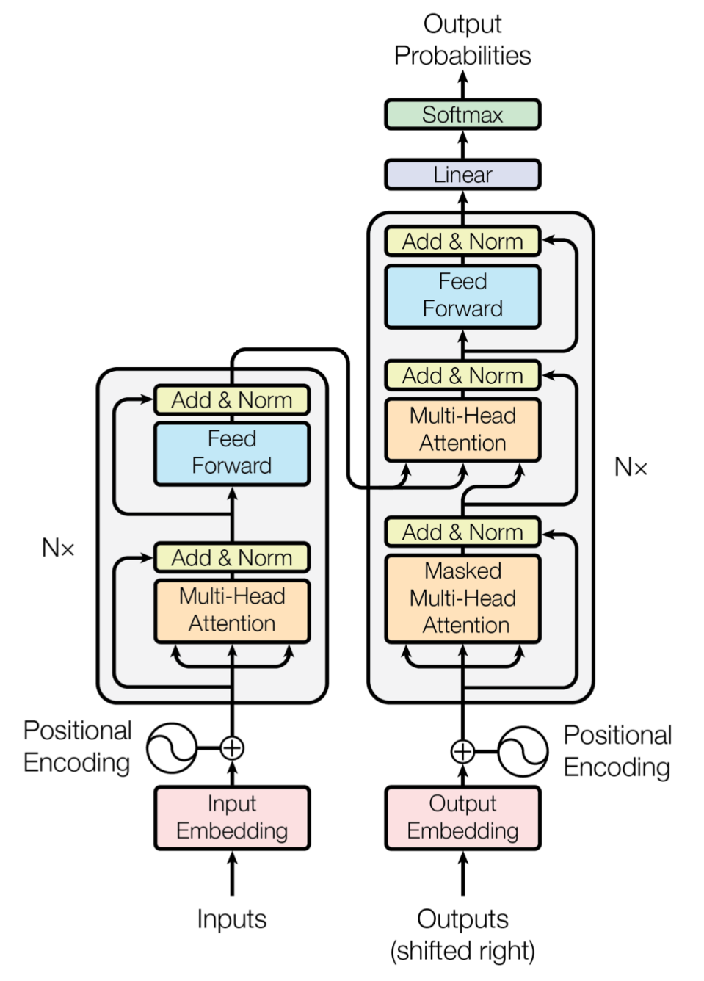

Figure: Transformer Architecture[12]

1. **Decoder Architecture:**

The decoder could be a particular component of the Transformer engineering utilized for generative assignments such as dialect era and machine interpretation. For GPT, the decoder is capable for anticipating another word within the arrangement based on the setting of the past word. The decoder takes the yield from the Transformer encoder that encodes the input grouping and forms it through numerous layers of self-recognition and feedforward systems. The decoder`s self-awareness component permits the demonstration to center on distinctive parts of the encoded input grouping when producing each word. In this strategy, the right target arrangement is given as input to the demonstration at each step. At each step amid induction, the demonstration takes it possess expectations as input and bolsters back the created yield to itself until it comes to the required arrangement length. In rundown, the GPT show employments the Transformer engineering as its spine, and the Decoder component particularly employments self-recognition and feedforward systems to handle content era.[11]

**ChatGPT and its comparison with other AI-based chatbots:**

Days after Chinese look monster Baidu's arrange to present a ChatGPT-style chatbot surfaced, Google presented its possess conversational AI device, Bard. Clients can associate with the chatbot through discourse, compared to ChatGPT. The unused chatbot is based on Google's Language Show for Exchange Application or LaMDA. Google, known for ruling the look motor advertise, has moreover declared the discharge of its AI-based chatbot, Poet. Finding the most recent and most exact answers to keep clients educated, indicating how Google's most recent AI innovation can keep shoppers up to date on the most recent happenings. LaMDA (Language Model for Dialogue Applications), a convolutional neural dialect demonstration created by Google, is based on Bard. [13]

Feb. Microsoft launched Bing with ChatGPT bot by OpenAI in 2023. Bing AI uses an improved ChatGPT for search and understanding. Bing AI ChatGPT uses Prometheus for improved current event responses compared to OpenAI ChatGPT. This innovation uses initial sentences to verify and improve web information. OpenAI lacks web query responses. Instep offers data presets. Bing ChatGPT has more control than OpenAI. Bing's OpenAI chatbot struggles. Type it yourself. AI bot writes a personalized cover letter for you. ChatGPT on Bing has secure user measures. ChatGPT is safer than Bing. Bing and OpenAI are free, but faster access is better with OpenAI's question limit for its chatbot. Join ChatGPT for better solutions. Bing's AI improves search. Bing AI is now available. MS seeks greater customer access. ChatGPT on call. [14]

ChatGPT is right now incapable of supplying location-based trending or rating looks or proposals. In differentiation, Maya AI can rapidly give wealth comes about with extra subtle elements such as appraisals, separate, driving headings, and trade objectives based on area, past choices, and other components. ChatGPT will in any case give answers by 2021, but Maya is outlined to check all major look motors for information precision and source. [15]

**ChatGPT and performance issues:**

ChatGPT has a lot of issues as an AI writing tool. "Guidelines ensure smart testing and evaluation." ChatGPT is limited by outdated news and a lack of web integration. They often fail to provide accurate and timely information for future events. OpenAI used advanced machine learning algorithms to train the program using user input, enabling the new version to extend its knowledge beyond the 2021 deadline. AI chatbots like ChatGPT require advanced thinking due to limited cognitive abilities and the need for human-like internal representations. An AI dialect has no coordination problems but faces some hurdles and requires interaction considerations.[16]

Helpful and aware answers are given without emotional bias. Subjective issues may not be fully addressed due to data preparation limits. 4443 Short and simple questions work best.   
Questions cannot be shortened as it does not provide any context or meaningful response. Instead of ChatGPT a good source of updated news is suggested for reliable news and future updates. [16]

[1] M. Firat, “How Chat GPT Can Transform Autodidactic Experiences and Open Education? Why Open and Distance Learning View project Problematic Internet use and coping tips View project”, doi: 10.31219/osf.io/9ge8m.

[2] R. Tamrakar, S. Vallabhbhai, and N. Wani, “Design and Development of CHATBOT: A Review Dynamics of cracked rotors View project Piezoelectric vibration energy harvesting View project Design and Development of CHATBOT: A Review.” [Online]. Available: https://www.researchgate.net/publication/351228837

[3] Mgr. T. ZEMČÍK, “A Brief History of Chatbots,” *DEStech Transactions on Computer Science and Engineering*, no. aicae, Oct. 2019, doi: 10.12783/dtcse/aicae2019/31439.

[4] N. M. S. Surameery and M. Y. Shakor, “Use Chat GPT to Solve Programming Bugs,” *International Journal of Information technology and Computer Engineering*, no. 31, pp. 17–22, Jan. 2023, doi: 10.55529/ijitc.31.17.22.

[5] ATRIA INNOVATION, “How does Chat GPT work?” https://www.atriainnovation.com/en/how-does-chat-gpt-work/ (accessed May 13, 2023).

[6] S. S. Biswas, “Role of Chat GPT in Public Health,” *Annals of Biomedical Engineering*. Springer, May 01, 2023. doi: 10.1007/s10439-023-03172-7.

[7] B. D. Lund and T. Wang, “Chatting about ChatGPT: how may AI and GPT impact academia and libraries?,” *Library Hi Tech News*. Emerald Publishing, 2023. doi: 10.1108/LHTN-01-2023-0009.

[8] V. Božić, “Chat GPT and education”, doi: 10.13140/RG.2.2.18837.40168.

[9] K. C. Karthikeyan and C. Karthikeyan, “Literature Review on Pros and Cons of ChatGPT Implications in Education,” *International Journal of Science and Research*, doi: 10.21275/SR23219122412.

[10] D. Kalla and N. B. Smith, “Study and Analysis of Chat GPT and its Impact on Different Fields of Study Emotet Malware-A Banking Credentials Stealer View project Computer Science: Big Data Analytics View project Study and Analysis of Chat GPT and its Impact on Different Fields of Study,” 2023. [Online]. Available: https://www.researchgate.net/publication/369539233

[11] A. Koubaa, W. Boulila, L. Ghouti, A. Alzahem, and S. Latif, “Exploring ChatGPT Capabilities and Limitations: A Critical Review of the NLP Game Changer,” 2023, doi: 10.20944/preprints202303.0438.v1.

[12] Soren D, “Understanding Transformer model architectures.” https://www.practicalai.io/understanding-transformer-model-architectures/ (accessed May 14, 2023).

[13] Bal Ram and Pratima Verma, “Artificial intelligence AI-based Chatbot study of ChatGPT, Google AI Bard and Baidu AI,” *World Journal of Advanced Engineering Technology and Sciences*, vol. 8, no. 1, pp. 258–261, Feb. 2023, doi: 10.30574/wjaets.2023.8.1.0045.

[14] Mauro Huc, “Bing AI ChatGPT vs. OpenAI ChatGPT: How do they differ?” https://pureinfotech.com/bing-ai-chatgpt-vs-openai-chatgpt-how-differ/#:~:text=The%20biggest%20difference%20between%20Bing,offer%20responses%20to%20current%20events. (accessed May 14, 2023).

[15] Tira Nur Fitria, “Artificial intelligence (AI) technology in OpenAI ChatGPT application: A review of ChatGPT in writing English essay”, doi: 10.15294/elt.v12i1.64069.

[16] L. Skavronskaya, A. Hadinejad, and D. Cotterell, “Reversing the threat of artificial intelligence to opportunity: a discussion of ChatGPT in tourism education,” *Journal of Teaching in Travel and Tourism*. Routledge, 2023. doi: 10.1080/15313220.2023.2196658.