Week-4:

Neo4j Started:

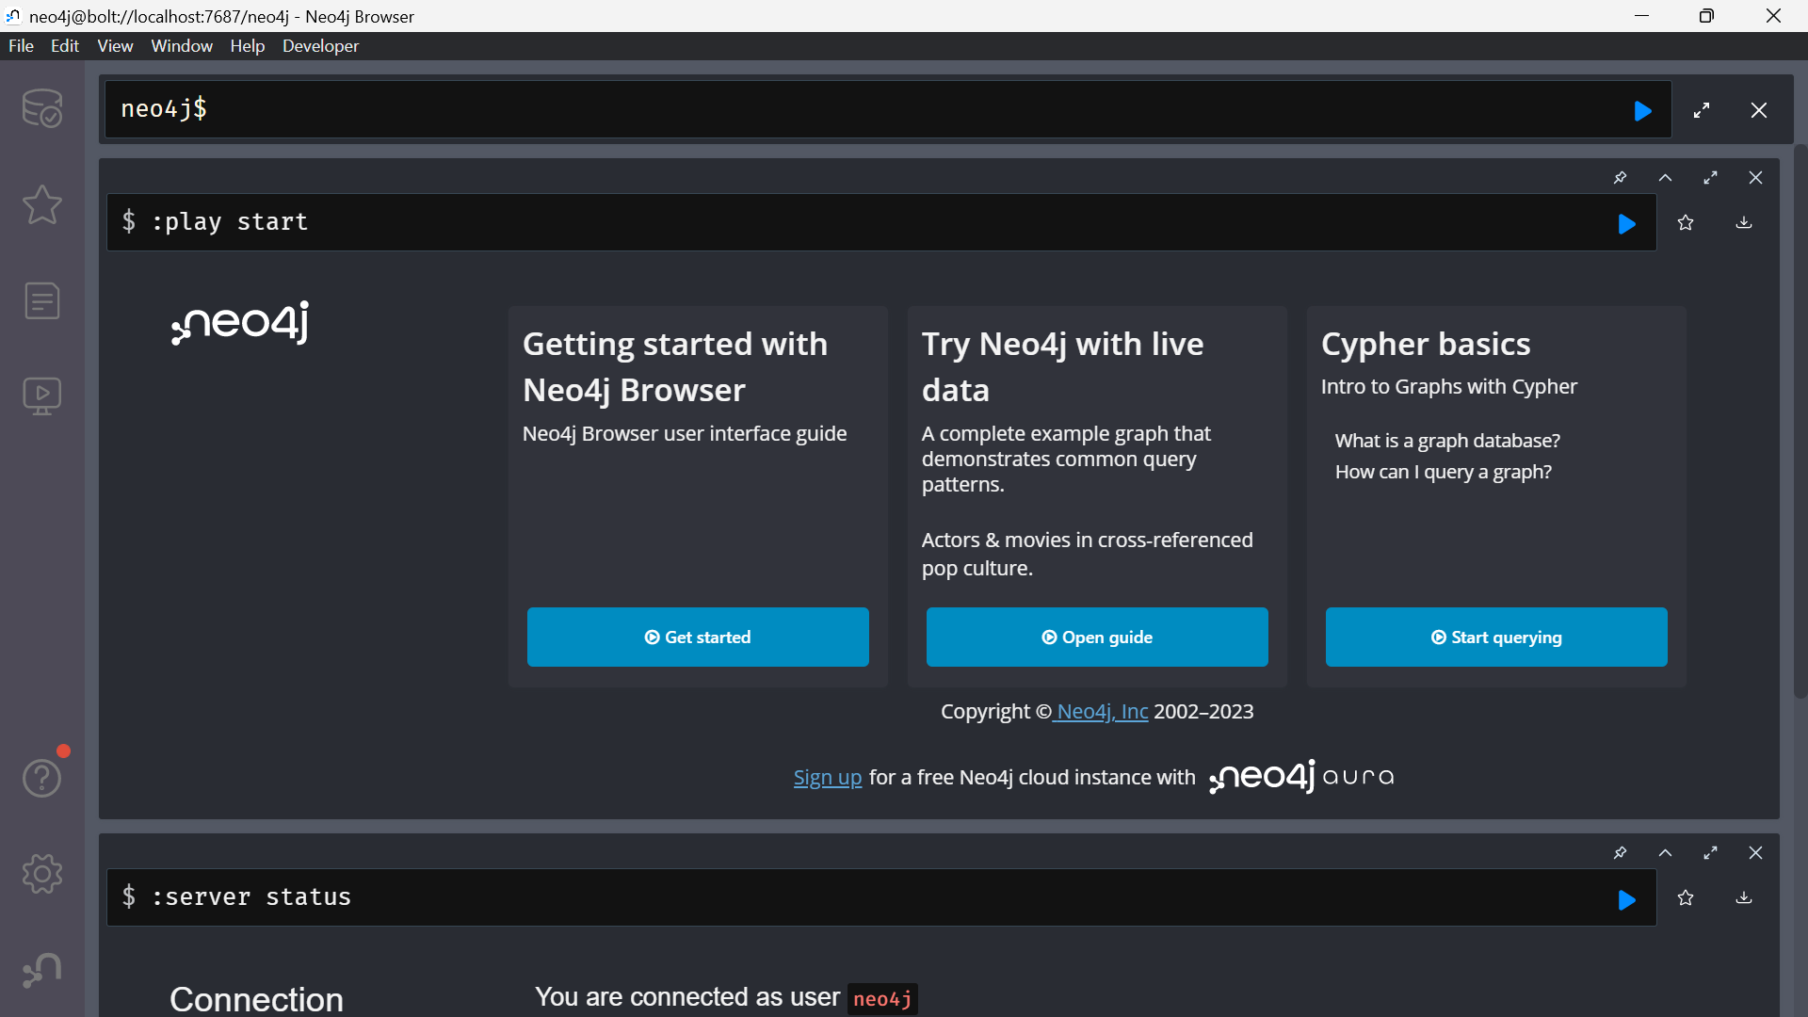

Deleting and deataching the existing database:

Match (s:sport{name:'Baskaetball'})-[ff:And]->(f:football{name:'Football'}) Delete ff

The relationship between the nodes are created and displayed in given screenshot.

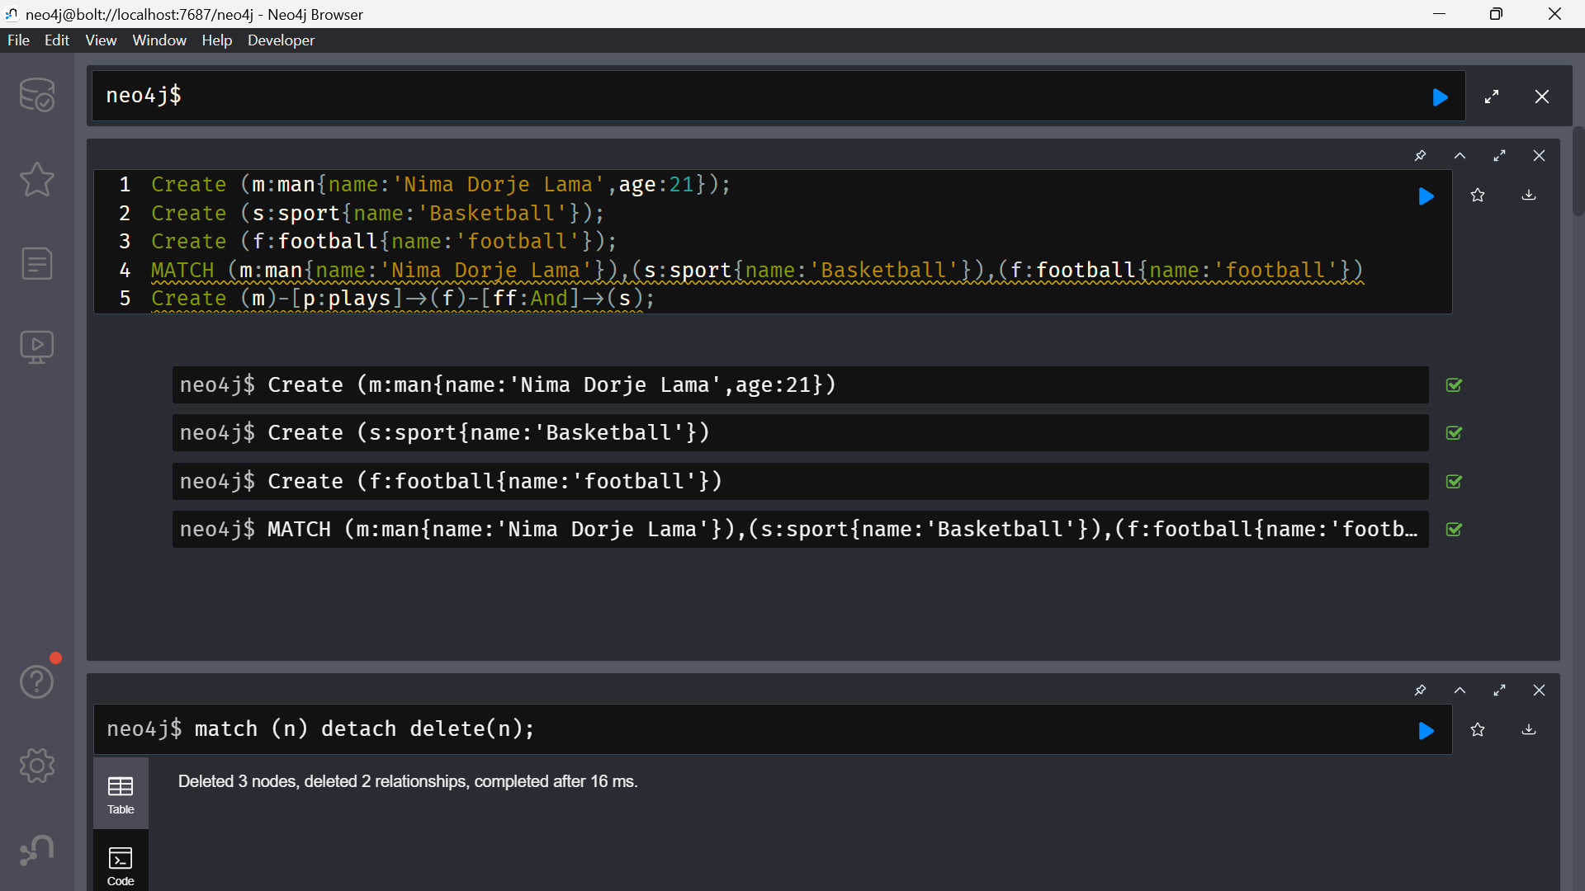

Graph:

After creating nodes to delete the node I used delete code but got an error because of relationship.

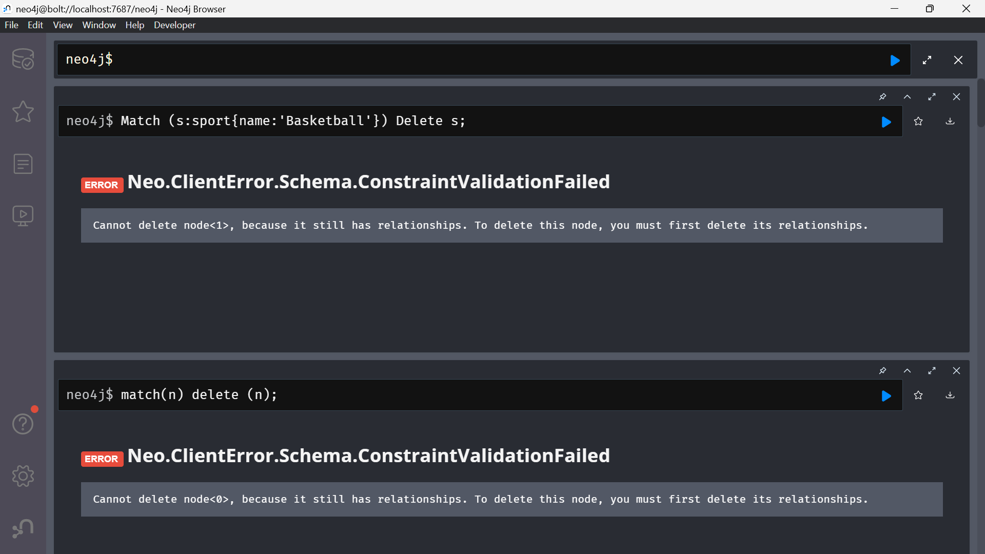

Delete Relationship:

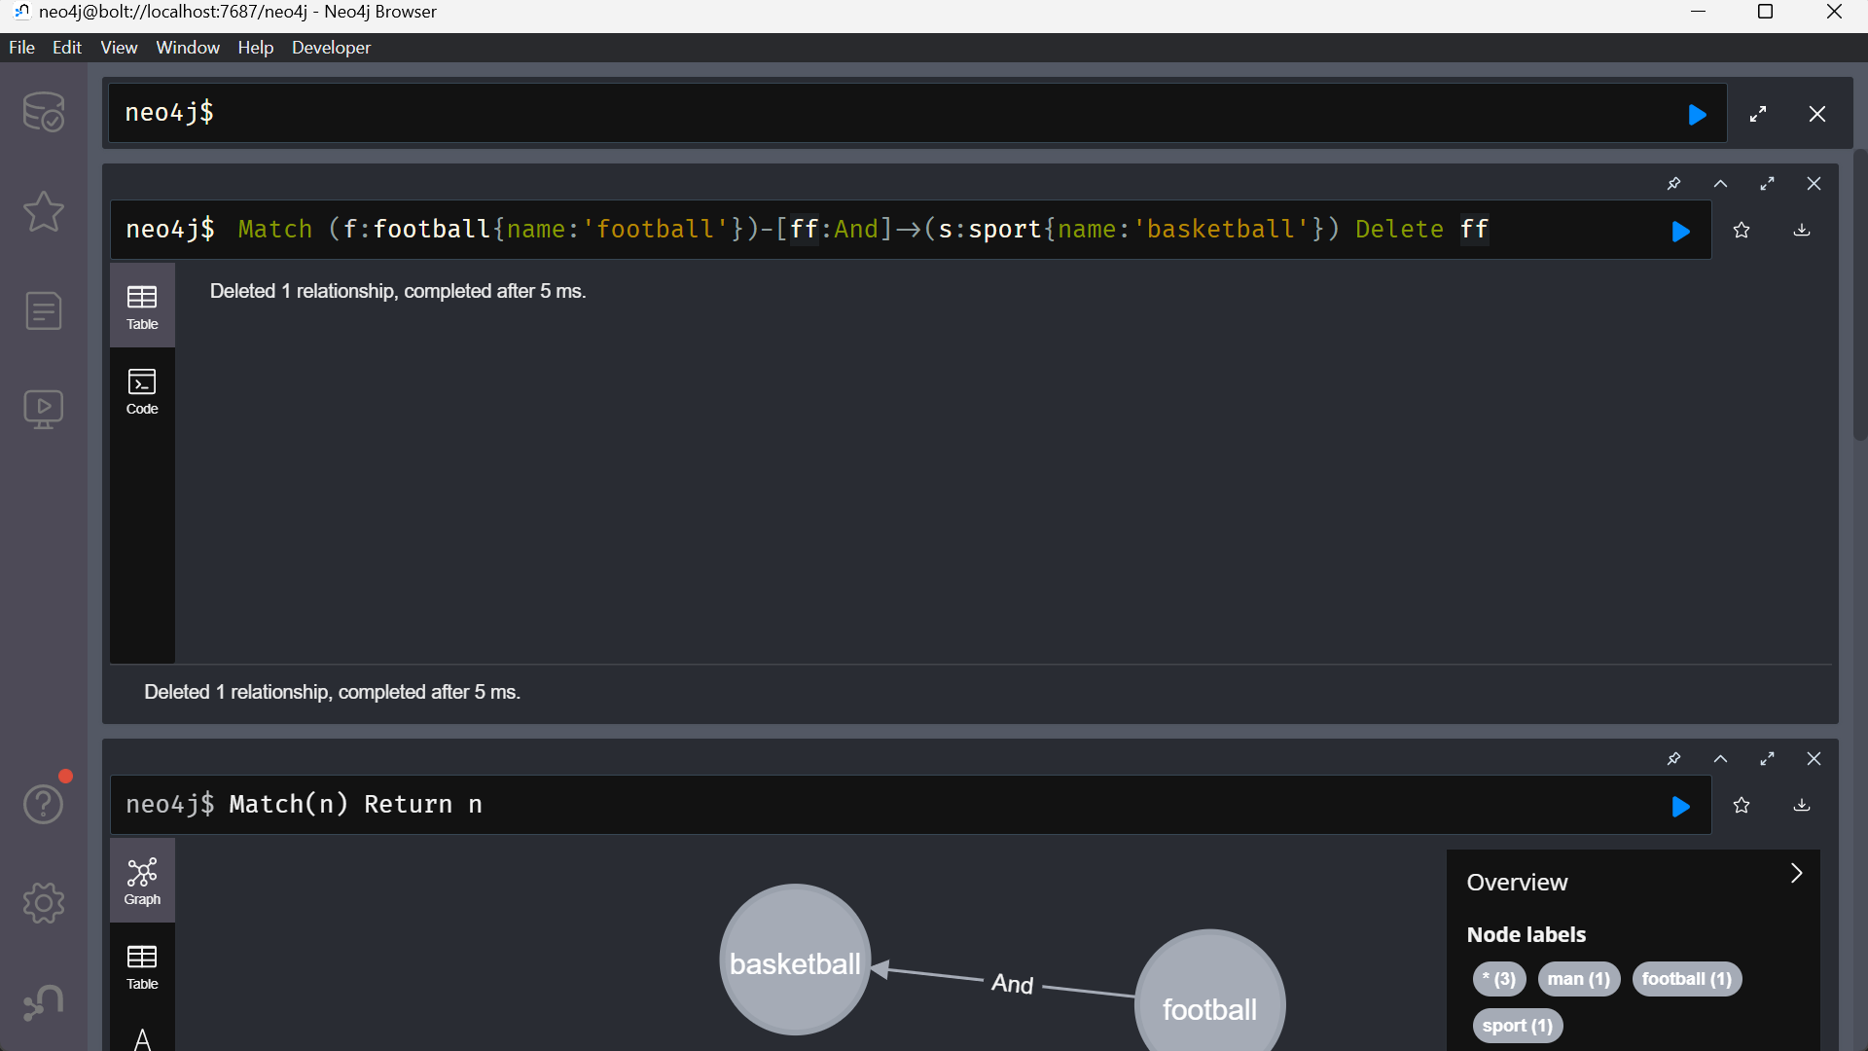

Relationship delete in graph:

