**A 3zvSystem Analysis & Design (Records Management system):**

It is comprises of two word System Analysis and System Design**.**

**System Analysis:**

Organizing facts, interpreting them, and identifying problems are the essence of system analysis. During a system analysis, a system or its components are studied to identify where they belong. In other words, it is a strategy for improving a system and ensuring that all its components work together in highly efficient manner to achieve its purpose

**System Design:**

System Design is the process if defining the architecture, modules, and components that make up a system, as well as those component’s interface and data passes through the system. Initializing design definition, establishing design characteristics, managing the design are some major task performed during the system design process.

These sections are further divided into two portions:

1. Preliminary Design stage
2. Static System Design stage

**Preliminary Design Stage:**

Preliminary design stage helps identify the customer's needs by defining the system's mission, objectives, and purpose.The status of the project is also described at this stage.This design process is the initial steps for project examine. Getting the data ready for future analysis is the purpose of preliminary data analyzing. Discussion of the findings is the outcome of preliminary analysis.

**Textual Analysis:**

Textual Analysis is a working method of extracting structured and unstructured data elements systematically from text.Through the analysis of language, symbols, and/or pictures present in texts, textual analysis strives to understand how people express their opinions, ideas, and experiences. This analysis also focuses in potential classes and their actions.

There are different category listed down below table which can be modified by student on student portal, teacher on teacher portal and all this is handled by Administrator and administrator has excess to all functions.

|  |  |
| --- | --- |
| Category | Category Identification |
| Students | Login, Logout,add_student, edit_student,search_student, Change_password, view_student, hide_student, remove_student |
| Admin | Login, logout, add_admin, edit_admin,view_admin, , change_password, hide_admin, remove_admin, |
| Course_leader | Login, Logout, add_course_leader, edit_course_leader, search_course_leader, change_password, view_course_leader, hide_course_leader, remove_course_leader |
| Lecturers | Login, logout, add_lecturer, edit_lecturer, search_lecturer, view_lecturer, hide_lecturer, remove_lecturer, change_password |
| Personal_tutors | Login, logout, add_tutor, edit_tutor, search_tutor, aloocate_tutor, change_password, view_tutor, hide_tutor, remove_tutor |
| Courses | Add_course, edit_course, search_course, view_course, hide_course, remove_course |
| Modules | Add_module, edit_ module, search_ module, view_ module, hide_module, remove_ module |
| Attendance | Add_attendance, edit_ attendance, search_ attendance, view_ attendance,hide_attendance, remove_ attendance, send_low_attendance_warning, low_attendance_action |
| Assignments | Add_assignment, edit_ assignment, search_ assignment, view_ assignment,hide_assignment, remove_ assignment, allocate_assignment, submit_assignment, mark_assignment, download_assignment |
| Results | Publish_result, edit_ result, search_ result, view_ result,hide_result, remove_ result,provide_feedback,download_result,print_result |
| Timetable_Managment | Add_timetable, edit_ timetable, view_ timetable, hide_ timetable , remove_ timetable, download_timetable |
| Diary_Managment | Add_diary, edit_diary, view_diary, |

Significant Event Analysis:

|  |  |  |
| --- | --- | --- |
| **EVENT** | **PERFORMER** | **Fields Involved** |
| Login | Students, Admin, Courser_leader, Lecturer | ID, Password |
| Logout | Students, Admin,Courser_leader, Lecturer | - |
| Change_password | Admin, Student,Courser_leader, Lecturer | ID |
| **STUDENT** |  |  |
| Add_student | Admin | Student_id, First_name, Last_name, D.O.B, Contact_no, Email, Address, Guardian_name, Course_name, Year, Semester, Emergency_contact, Blood_group |
| Edit_student | Admin | Student_id, First_name, Last_name, D.O.B, Contact_no, Email, Address, Guardian_name,Emergency_contact, Course_name, Year, Semester, Blood_group |
| Search_student | Admin, Courser_leader | Student_id |
| View_student | Admin, Courser_leader | - |
| Hide_student | Admin | Student_id |
| Remove_student | Admin | Student_id |
| **Admin** |  |  |
| Add_admin | Admin | Admin_id, First_name, Last_name, D.O.B, Contact_no, Email, Address,Emergency_contact, Blood_group, Course_name |
| Edit_admin | Admin | Admin_id, First_name, Last_name, D.O.B, Contact_no, Email, Address, Emergency_contact, Blood_group, Course_name |
| View_admin | Admin | ------------------------ |
| Hide_admin | Admin | Admin_id |
| Remove_admin | Admin | Admin_id |
| **Course_leader** |  |  |
| Add_course_leader | Admin | Course_leader_id, First_name, Last_name, D.O.B, Contact_no, Email, Address, Blood_group, Emergency_contact |
| Edit_course_leader | Admin | Course_leader_id, First_name, Last_name, D.O.B, Contact_no, Email, Address, Blood_group, Emergency_contact |
| Search_course_leaedr | Admin | Course_leader_id |
| View_course-leader | Admin | ---------- |
| Hide_course_leader | Admin | Course_leader_id |
| Remove_course_leader | Admin | Course_leader_id |
| **Lecturer** |  |  |
| Add_lecturer | Admin | Lecturer_id, First_name, Last_name, D.O.B, Contact_no, Email, Address, Blood_group, Emergency_contact |
| Edit_lecturer | Admin | Lecturer_id, First_name, Last_name, D.O.B, Contact_no, Email, Address, Blood_group,Emergency_contact |
| Search_lecturer | Admin, Courser_leader | Lecturer_id |
| View_lecturer | Admin, Courser_leader, | ------------------ |
| Hide_lecturer | Admin | Lecturer_id |
| Remove_lecturer | Admin | Lecturer_id |
| **Personal_Tutor** | ` |  |
| Add_tutor | Admin | Lecturer_id, module_id |
| Allocate_tutor | Admin | Student_id |
| Edit_tutor | Admin | Lecturer_id, Student_id, module_id |
| Search_tutor | Admin, Courser_leader | Lecturer_id |
| View_tutor | Admin, Courser_leader | ---------- |
| Hide_tutor | Admin | Lecturer_id |
| Remove_tutor | Admin | Lecturer_id |
| **Course** |  |  |
| Add_course | Admin, Courser_leader | Course_name, Course_leader, Course_length,No_of_semesters, Module_id |
| Edit_course | Admin, Courser_leader | Course_id, Course_name, Course_leader_id, Course_length,No_of _semesters, Module_id |
| Search_course | Admin, Student, Courser_leader, Lecturer | Course_name |
| View_course | Admin, Student, Courser_leader, Lecturer | ---------------- |
| Hide_course | Admin, Courser_leader | Course_name |
| Remove_course | Admin, Courser_leader | Course_name |
| **Module** |  |  |
| Add_module | Admin, lecturer, Courser_leader | Module_id, Module_name, no_of_students, no_of_lecturers, Module_length, Lecturer_id, Credit |
| Edit_module | Admin, Courser_leader | Module_id, Module_name, Module_length, Lecturer_id, Credit |
| Search_module | Admin, Student, Courser_leader, Lecturer | Module_id |
| View_module | Admin, Student, Courser_leader, Lecturer | ------------------ |
| Hide_module | Admin | Module_id |
| Remove_module | Admin | Module_id |
| **Attendance** |  |  |
| Add_attendance | Lecturer | Year, Semester, Module_id, Date, Lecturer_id, Student_id, |
| Edit_attendance | Lecturer | Year, Semester, Module_id, Date, Lecturer_id, Student_id, |
| Search_attendance | Admin, Lecturer, Courser_leader | Year, Semester, Module_id, Date |
| View_attendance | Admin, Student, Lecturer, Courser_leader | ------------------- |
| Send_low_attendance_warning | Admin | Student_id |
| Low_attendance_action | Admin | Student_id |
| **Assignment** |  |  |
| Add_assignment | Lecturer, Courser_leader | Assignment_id, Assigned_date, Deadline |
| Edit_assignment | Lecturer, Courser_leader | Assignment_id, Assigned_date, Deadline |
| Search_assignment | Student, Lecturer, Courser_leader | Assignment_id |
| View_assignment | Student, Lecturer, Courser_leader | -------------------- |
| Hide_assignment | Lecturer, Courser_leader | Assignment_id |
| Remove_assignment | Lecturer, Courser_leader | Assignment_id |
| Allocate_assignment | Lecturer, Courser_leader | Assignment_id, Module_id |
| Submit_assignment | Student | Student_id, Assignment_id, Attach_files |
| Mark_assignment | Lecturer | Assignment_id, Module_id, Student_id, Lecturer_id |
| Download_assignment | Student, Lecturer, Courser_leader | ------------- |
| **Result** |  |  |
| Publish_result | Admin | Assignment_id, Module_id, Student_id, Marks, Grade, Year, Semester, Total_marks, Final_grade, |
| Edit_result | Admin | Assignment_id, Module_id, Student_id, Year, Semester, Marks, Grade, Total_marks, Final_grade |
| Search_result | Admin, Lecturer, Student | Student_id, Year, Semester |
| View_result | Admin, Lecturer, Student, Courser_leader | - |
| Hide_result | Admin | Student_id, Year, Semester |
| Remove_result | Admin | Student_id, Year, Semester |
| Provide_feedback | Lecturer | Student_id, Year, Semester |
| Download_result | Student, Lecturer, Admin | - |
| Print_result | Admin, Lecturer, Student | - |
| **Timetable** |  |  |
| Add_timetable | Admin | Day, Time, Course name, Module_name, Teacher_name, Room_no, Year, Semester |
| Edit_timetable | Admin | Day, Time, Course name, Module_name, Teacher_name, Room_no, Year, Semester |
| View__timetable | Students, Lecturer, Admin, Courser_leader | --------- |
| Download_timetable | Admin, Lecturer, Courser_leader, Student | ------------ |
| Hide_timetable | Admin | Course name, Year, Semester |
| Remove_timetable | Admin | Course name, Year, Semester |
| **Diary** |  |  |
| Add_diary | Admin |  |
| Edit_diary | Admin |  |
| View_dairy | Students, Lecturer, Admin, Courser_leader |  |
|  |  |  |
|  |  |  |

**Commands Queries and Constraints:**

**Student**

|  |  |  |  |
| --- | --- | --- | --- |
| Class | *Student* | | Part: |
| Type of object :  A Student object | | Author : Yangtze  Created: 05/08/2022 | |
| Queries | | Id, password, Full name, Email, Status, contact number, Blood group, guardian name, | |
| Commands | | Login, logout, Add, Amend, change password | |
| Constraints | | * Password should contain not less 8 characters with uppercase, lowercase, any symbol and numeric value * Students can download their assignments * Students can only view their results. * Students will not have excess to modify their results, attendance | |

**Administrator**

|  |  |  |  |
| --- | --- | --- | --- |
| Class | *Administrator* | | Part: |
| Type of object:  An administrator object | | Author : Yangtze  Created: 05/08/2022 | |
| Queries | | Id, password, fullname, Email, Status | |
| Commands | | Login, logout, Add, Amend, Archive, Remove, change password | |
| Constraints | | * Password should contain not less 8 characters with uppercase, lowercase, any symbol and numeric value * Have excess to everything | |

**Tutor**

|  |  |  |  |
| --- | --- | --- | --- |
| Class | *Tutor* | | Part: |
| Type of object:  A tutor object | | Author : Yangtze  Created: 05/08/2022 | |
| Queries | | Id, Password,Full name, Email, | |
| Commands | | Login, logout, Add, Amend, Archive, Change Password, delete | |
| Constraints | | * Password should contain not less 8 characters with uppercase, lowercase, any symbol and numeric value * Tutor can modify course content * Have excess to view student information | |

**Course**

|  |  |  |  |
| --- | --- | --- | --- |
| Class | *Course* | | Part: |
| Type of object:  A course object | | Author : Yangtze  Created: 05/08/2022 | |
| Queries | | Id, name,module_id | |
| Commands | | Add, Amend, Archive,duration, delete | |
| Constraints | | * Course must have course id and course name * Course cannot be delete or modify by students | |

**Module**

|  |  |  |  |
| --- | --- | --- | --- |
| Class | *Module* | | Part: |
| Type of object:  A module object | | Author : Yangtze  Created: 05/08/2022 | |
| Queries | | Id, name, Tutor_name | |
| Commands | | Add, amend, archive, duration, remove | |
| Constraints | | * Module with course content can’t be delete | |

**Personal Tutor**

|  |  |  |
| --- | --- | --- |
| Class | *Personal Tutor* | Part |
| Type of object:  A personal tutor object | Author: Yangtze  Created : 05/08/2022 | |
| Queries | Tutor_id, Full name, Email | |
| Commands | Add, amend, assign, Display | |
| Constraints | * Personal tutor are not allowed to select student * More than one personal tutor are not allowed for one student | |

**Result(Overal performance)**

|  |  |  |  |
| --- | --- | --- | --- |
| Class | *Result* | | Part: |
| Type of object: | | Author : Yangtze  Created: 05/08/2022 | |
| Queries | | Id, course_name | |
| Commands | | Add, amend, Display, Print | |
| Constraints | | * Result can’t be modify by students * Only tutors and administrator has excess to modify and delete results | |

**Attendance**

|  |  |  |  |
| --- | --- | --- | --- |
| Class | *Attendance* | | Part: |
| Type of object:  An attendance object | | Author : Yangtze  Created: 05/08/2022 | |
| Queries | | Srudent_name, student_id | |
| Commands | | Add, amend, Action, monitor, Display | |
| Constraints | | * Have excess to administrator and tutor * Student can only view their attendance | |

**Assignments**

|  |  |  |  |
| --- | --- | --- | --- |
| Class | *Assignment* | | Part: |
| Type of object:  An assignment object | | Author : Yangtze  Created: 05/08/2022 | |
| Queries | | Id, module name, tutor name | |
| Commands | | Add, amend, delete, archive, display | |
| Constraints | | * Before end of deadline assignment can’t be delete | |

**Time_Managment**

|  |  |  |  |
| --- | --- | --- | --- |
| Class | *Time Management* | | Part: |
| Type of object:  A Time table object | | Author : Yangtze  Created: 05/08/2022 | |
| Queries | |  | |
| Commands | |  | |
| Constraints | |  | |

**Diary_Managment**

|  |  |  |  |
| --- | --- | --- | --- |
| Class | *Diary Management* | | Part: |
| Type of object:  A diary object | | Author : Yangtze  Created: 05/08/2022 | |
| Queries | |  | |
| Commands | |  | |
| Constraints | |  | |

**Note: Only administrator has excess to this page.**

**Static System Designs:**

1. **First Draft BON System Architecture Diagram:**

As a conceptual model, system architecture describes the structure, behavior, and more views of a given system. This architecture consists of Class, Root class, Cluster.

* **Class:** A class is a group of objects, all with similar roles in the system and consist of structural and behavioral features where structural function represents the state of an object of the class and behavioral features defines the way the objects may interacts. Classes are represented on elliptical circle.

Student, Course Leader, Course, Module, Assignment, Attendance, Personal Tutor, Timetable, Diary, Admin, Lecturer, Result are some main classes and they are represented below:

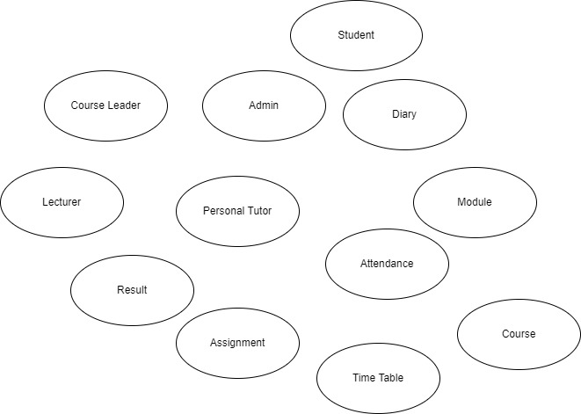

* **Root Class:**

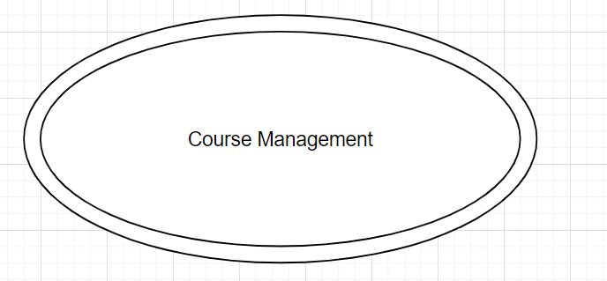

**BON System Architecture Diagram:**

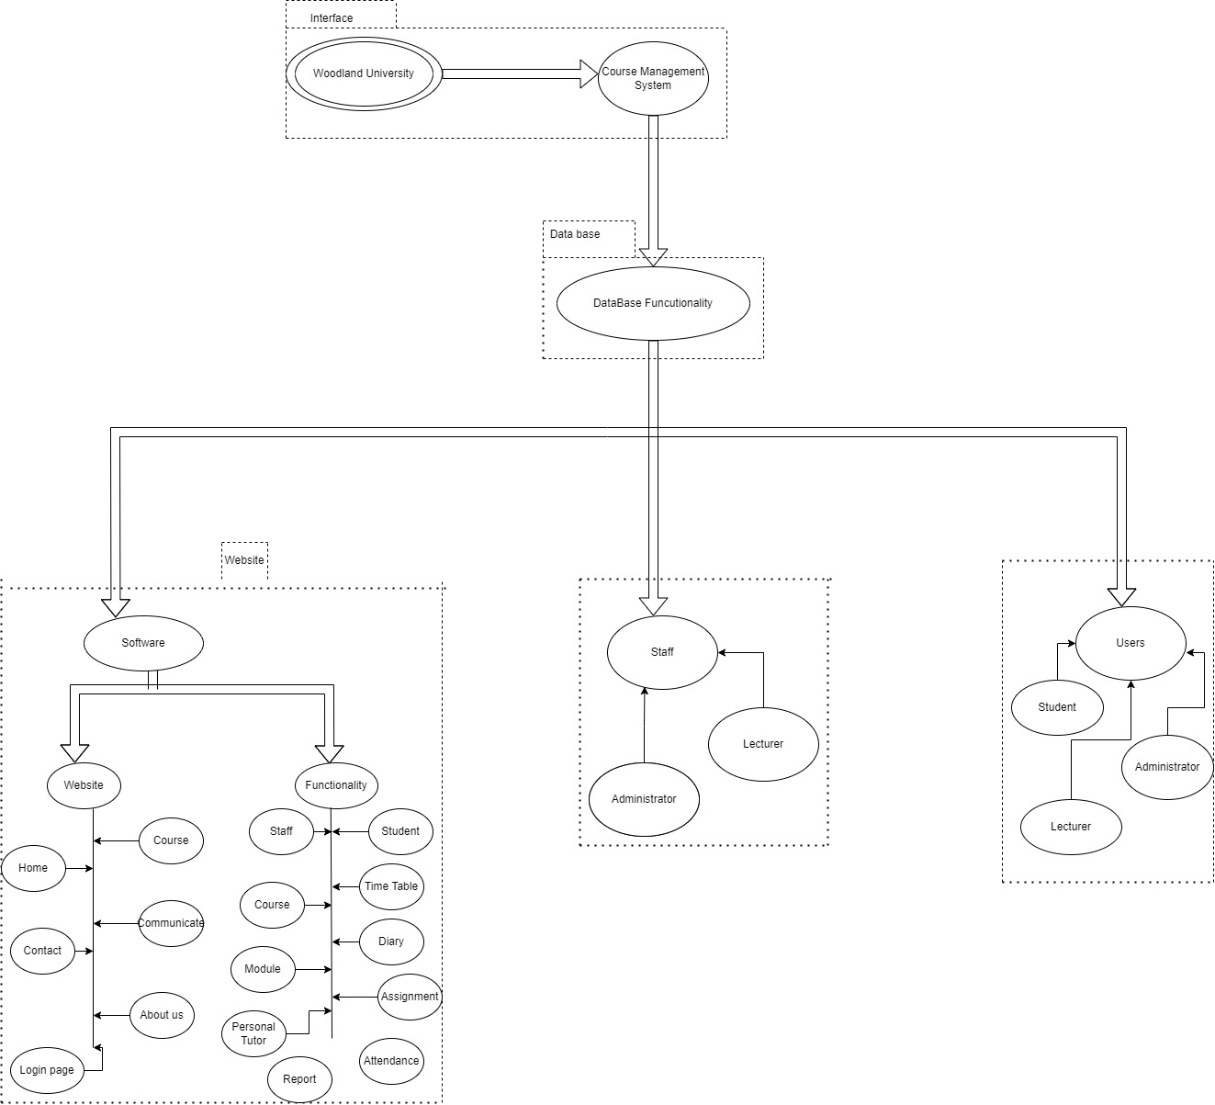

**BON System Chart:**

|  |  |  |  |  |  |  |  |  |  |  |  |  |  |  |  |  |  |  |  |  |  |  |  |  |  |  |  |  |  |  |  |
| --- | --- | --- | --- | --- | --- | --- | --- | --- | --- | --- | --- | --- | --- | --- | --- | --- | --- | --- | --- | --- | --- | --- | --- | --- | --- | --- | --- | --- | --- | --- | --- |
| |  |  |  | | --- | --- | --- | | **System** | **Course Management system** | **Part: 1/1** |  |  |  | | --- | --- | | Purpose:  To keep the records of academic activities. | Indexing:  Author:  Keyword: |  |  |  | | --- | --- | | **Cluster** | **Description** | | Student | To keep records of individual student information enrolled in the college and which course they are currently studying. | | Admin | To keep records of admins who holds special privilege to alter data of students, admins, courses, lecturers, modules, result, personal tutor, diary and time table. | | Course leader | To keep the records of course leaders. | | Lecturer | To keep the records of lecturers. | | Course | To keep the information of course content, course leader, time length of that course and number of semesters, the course is divided into. | | Module | To keep the information about module, lecturer who is teaching that module,number of students and lecturers in that module and the credit score the module carries. | | Assignment | To upload, assign and mark assignments of a module to students in order to check their progress and understanding of the topic. It also allows to download the assignment. | | Attendance | To keep record of students and lecturer in that module in that semester of that year and the record each student and staff present each day. Admins can also send low attendance warning and take actions against them. | | Personal Tutor | To keep record of personal tutor assigned to student and which module he looks after. | | Diary management |  | | Time Table management | To provide the information for students and teachers about which class will be held in which day and time. It also allows to download time table. | | Result | To keep record of marks and grade obtained by students in each semester/year and to provide feedback to student by lecturer. It also allows to print and download result. | |

This system chart keeps the detail records of every class

**BON Cluster Chart:**

**BON Class Chart:**

**Student**

|  |  |  |  |
| --- | --- | --- | --- |
| Class | *Student* | | Part: |
| Type of object :  A Student object | | Author : Yangtze  Created: 05/08/2022 | |
| Queries | | Id, password, Full name, Email, Status, contact number, Blood group, guardian name, | |
| Commands | | Login, logout, Add, Amend, change password | |
| Constraints | | * Password should contain not less 8 characters with uppercase, lowercase, any symbol and numeric value * Students can download their assignments * Students can only view their results. * Students will not have excess to modify their results, attendance | |

**Administrator**

|  |  |  |  |
| --- | --- | --- | --- |
| Class | *Administrator* | | Part: |
| Type of object:  An administrator object | | Author : Yangtze  Created: 05/08/2022 | |
| Queries | | Id, password, fullname, Email, Status | |
| Commands | | Login, logout, Add, Amend, Archive, Remove, change password | |
| Constraints | | * Password should contain not less 8 characters with uppercase, lowercase, any symbol and numeric value * Have excess to everything | |

**Tutor**

|  |  |  |  |
| --- | --- | --- | --- |
| Class | *Tutor* | | Part: |
| Type of object:  A tutor object | | Author : Yangtze  Created: 05/08/2022 | |
| Queries | | Id, Password,Full name, Email, | |
| Commands | | Login, logout, Add, Amend, Archive, Change Password, delete | |
| Constraints | | * Password should contain not less 8 characters with uppercase, lowercase, any symbol and numeric value * Tutor can modify course content * Have excess to view student information | |

**Course**

|  |  |  |  |
| --- | --- | --- | --- |
| Class | *Course* | | Part: |
| Type of object:  A course object | | Author : Yangtze  Created: 05/08/2022 | |
| Queries | | Id, name, | |
| Commands | | Add, Amend, Archive,duration, delete | |
| Constraints | | * Course must have course id and course name * Course cannot be delete or modify by students | |

**Module**

|  |  |  |  |
| --- | --- | --- | --- |
| Class | *Module* | | Part: |
| Type of object:  A module object | | Author : Yangtze  Created: 05/08/2022 | |
| Queries | | Id, name, Tutor_name | |
| Commands | | Add, amend, archive, duration, remove | |
| Constraints | | * Module with course content can’t be delete | |

**Personal Tutor**

|  |  |  |
| --- | --- | --- |
| Class | *Personal Tutor* | Part |
| Type of object:  A personal tutor object | Author: Yangtze  Created : 05/08/2022 | |
| Queries | Tutor_id, Full name, Email | |
| Commands | Add, amend, assign, Display | |
| Constraints | * Personal tutor are not allowed to select student * More than one personal tutor are not allowed for one student | |

**Result(Overal performance)**

|  |  |  |  |
| --- | --- | --- | --- |
| Class | *Result* | | Part: |
| Type of object: | | Author : Yangtze  Created: 05/08/2022 | |
| Queries | | Id, course_name | |
| Commands | | Add, amend, Display, Print | |
| Constraints | | * Result can’t be modify by students * Only tutors and administrator has excess to modify and delete results | |

**Attendance**

|  |  |  |  |
| --- | --- | --- | --- |
| Class | *Attendance* | | Part: |
| Type of object:  An attendance object | | Author : Yangtze  Created: 05/08/2022 | |
| Queries | | Srudent_name, student_id | |
| Commands | | Add, amend, Action, monitor, Display | |
| Constraints | | * Have excess to administrator and tutor * Student can only view their attendance | |

**Assignments**

|  |  |  |  |
| --- | --- | --- | --- |
| Class | *Assignment* | | Part: |
| Type of object:  An assignment object | | Author : Yangtze  Created: 05/08/2022 | |
| Queries | | Id, module name, tutor name | |
| Commands | | Add, amend, delete, archive, display | |
| Constraints | | * Before end of deadline assignment can’t be delete | |

**Time_Managment**

|  |  |  |  |
| --- | --- | --- | --- |
| Class | *Time Management* | | Part: |
| Type of object:  A Time table object | | Author : Yangtze  Created: 05/08/2022 | |
| Queries | |  | |
| Commands | |  | |
| Constraints | |  | |

**Diary_Managment**

|  |  |  |  |
| --- | --- | --- | --- |
| Class | *Diary Management* | | Part: |
| Type of object:  A diary object | | Author : Yangtze  Created: 05/08/2022 | |
| Queries | |  | |
| Commands | |  | |
| Constraints | |  | |

**Dynamic Static Design:**

It is an iterative and incremental approach based on the rapid application development methodologies. Dynamic static design is an agile technique used to develop software using an iterative and incremental process. Feasibility and business study, functional method/ prototype iteration are four-phase framework involved in this method. It focuses on the mechanism how the component and the system evolve across the time.

**Event Charts:**

**Object Creation chart**

**System Scenario Chart**

**Dynamic Diagram**

**System Database Design:**

**E-R model:**

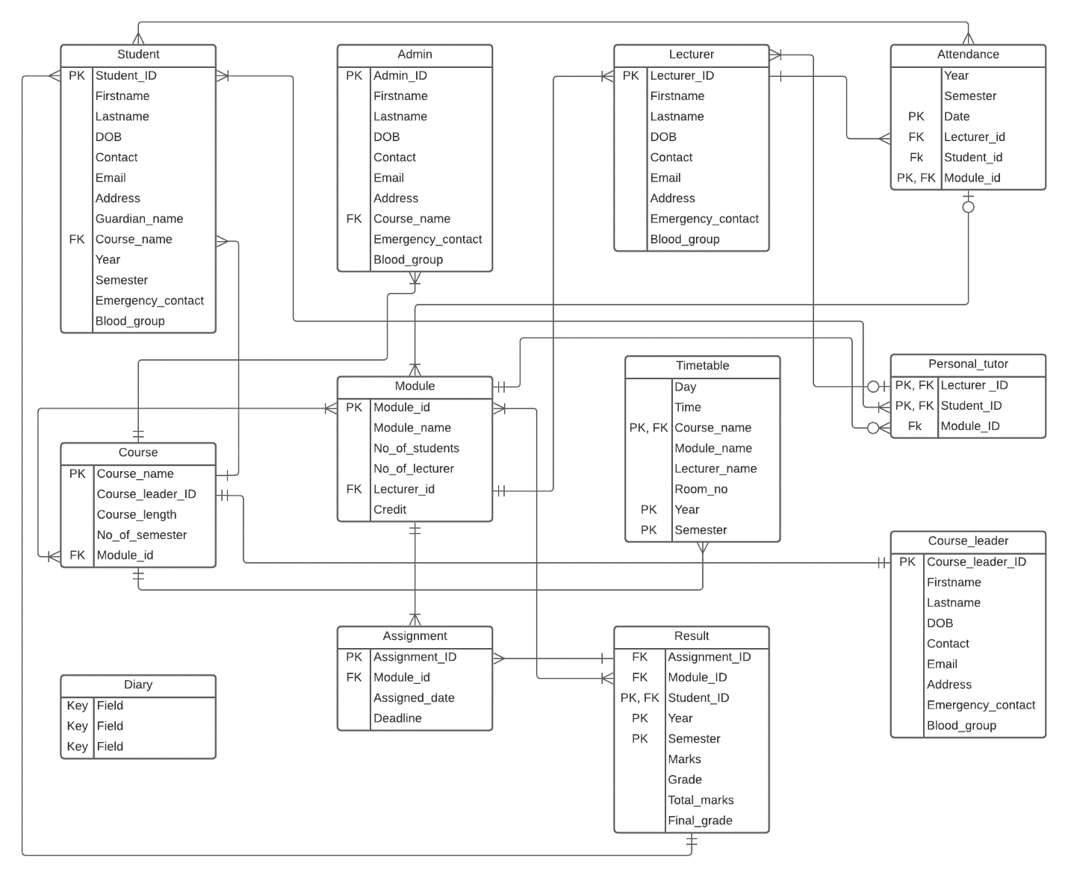

Figure 1: Entity Relationship Diagram

**Attribute Listings:**

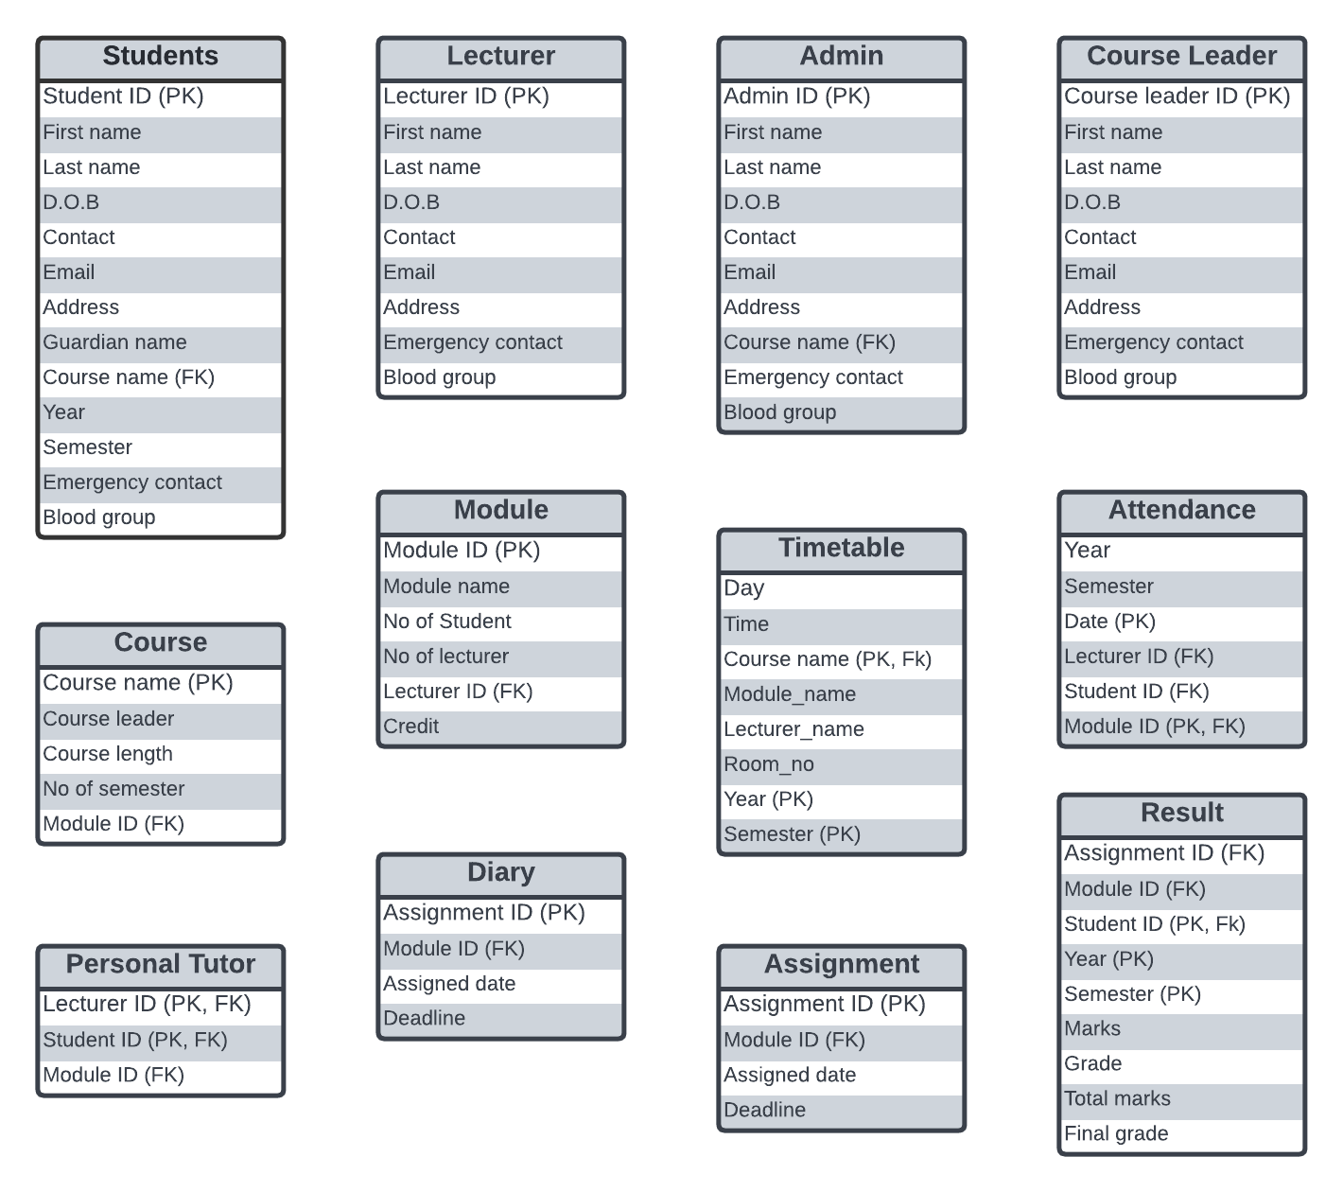

Figure Attribute List