# Visualising Data Assignment Proposal

## Semester 2, 2022-23

## D20125299

## Luke Hallinan

### datasets used

[Data on CO2 and Greenhouse Gas Emissions by Our World in Data](https://nyc3.digitaloceanspaces.com/owid-public/data/co2/owid-co2-data.csv)

<https://nyc3.digitaloceanspaces.com/owid-public/data/co2/owid-co2-data.csv>

[Data on Energy by Our World in Data](https://nyc3.digitaloceanspaces.com/owid-public/data/energy/owid-energy-data.csv)

<https://nyc3.digitaloceanspaces.com/owid-public/data/energy/owid-energy-data.csv>

[Global Power Plant Database](https://wri-dataportal-prod.s3.amazonaws.com/manual/global_power_plant_database_v_1_3.zip)

<https://wri-dataportal-prod.s3.amazonaws.com/manual/global_power_plant_database_v_1_3.zip>

## Introduction

Climate change has emerged as one of the most pressing issues of the 21st century, with far-reaching consequences for ecosystems, human health, and global economies [1]. The main driver of climate change is the increasing concentration of greenhouse gases (GHGs) in the atmosphere, primarily carbon dioxide (CO2), resulting from human activities such as burning fossil fuels for energy production [2]. Consequently, understanding the correlation between CO2 emissions and the energy consumption patterns of countries around the world is crucial for developing effective strategies to mitigate climate change and transition to sustainable energy systems.

This project aims to analyse global environmental data to establish the relationship between CO2 emissions, fossil fuel energy consumption, and renewable energy utilization across different countries. By identifying key patterns and trends in energy use, the research seeks to inform policy recommendations for reducing GHG emissions and promoting the adoption of renewable energy sources. The scope of the project will focus on data from around 1970 to 2020, while acknowledging the limitations imposed by data availability and reliability for some countries and regions.

## Global Climate Change

Climate change refers to long-term alterations in the Earth's average weather patterns, primarily driven by the rise in anthropogenic greenhouse gas (GHG) emissions [1]. These emissions, particularly carbon dioxide (CO2), methane (CH4), and nitrous oxide (N2O), trap heat in the Earth's atmosphere, leading to an increase in global temperatures, commonly known as global warming [1]. This warming has far-reaching implications for the planet's ecosystems, human societies, and economies.

A brief history and key milestones of climate change science date back to the 19th century when scientists, such as Svante Arrhenius, began to investigate the impact of CO2 on the Earth's temperature [3]. However, it was not until the late 20th century that the international community recognized the severity of the problem and started to respond. The United Nations Framework Convention on Climate Change (UNFCCC) was established in 1992, followed by the Kyoto Protocol in 1997, and the Paris Agreement in 2015, all of which aimed to reduce GHG emissions and limit global temperature rise [4].

Greenhouse gas emissions can be attributed to various sources, including energy production, industrial processes, agriculture, deforestation, and waste management [1]. The energy sector, however, is the most significant contributor, accounting for approximately 73% of global CO2 emissions in 2019 [4]. Fossil fuels, such as coal, oil, and natural gas, are the primary energy sources responsible for these emissions. As the world's population and economies continue to grow, the demand for energy rises, further exacerbating the problem of climate change.

The role of CO2 in global warming is significant due to its ability to absorb and emit infrared radiation, thereby trapping heat in the Earth's atmosphere [1]. Although CO2 is not the most potent greenhouse gas, it is the most abundant and has the longest atmospheric lifetime. The rapid increase in CO2 concentrations since the industrial revolution, primarily from burning fossil fuels, has caused a significant rise in global temperatures, resulting in consequences such as sea-level rise, increased frequency and intensity of extreme weather events, and disruptions to ecosystems and agriculture [4].

To address the challenges posed by climate change, there is an urgent need to reduce GHG emissions, particularly from the energy sector. Understanding the correlation between CO2 emissions and energy consumption patterns across different countries will provide valuable insights this.

## Fossil Fuel Energy Consumption and Renewable Energy

Fossil fuels, including coal, oil, and natural gas, have been the dominant sources of energy for human societies since the industrial revolution. They provide energy for transportation, electricity generation, heating, and industrial processes, among other applications [1]. However, the combustion of these fuels results in significant CO2 emissions, contributing to global climate change [2].

The global distribution of fossil fuels varies, with some countries and regions possessing abundant reserves while others remain dependent on imports. This uneven distribution has led to geopolitical tensions and concerns about energy security. Furthermore, fossil fuel consumption trends have evolved over time, with developed nations historically being the largest consumers, but emerging economies such as China and India experiencing rapid growth in demand [4].

Renewable energy refers to energy generated from natural resources that are continuously replenished, such as sunlight, wind, water, and geothermal heat. These sources offer several advantages over fossil fuels, including reduced greenhouse gas emissions, improved air quality, increased energy security, and potential economic benefits through job creation and technological innovation [1].

Solar, wind, and hydroelectric power are the most common types of renewable energy, although other forms such as biomass, geothermal, and ocean energy also contribute to the global energy mix. While the adoption of renewables has accelerated in recent years, their share of the total energy supply remains relatively low. In 2019, renewable energy accounted for 11.4% of global primary energy consumption, with the majority coming from hydropower and traditional biomass [4].

Despite the many benefits of renewable energy, there are also limitations, including the intermittent nature of some sources (e.g., solar and wind), higher upfront costs for certain technologies, and concerns about land use and environmental impacts of large-scale projects. Technological advancements and grid modernization are critical for addressing these challenges and enabling a more significant share of renewables in the global energy mix [3].

## Vision For The Investigation

The aim of this investigation is to analyse the correlation between CO2 emissions, fossil fuel energy generation, and renewable energy generation across the world's countries. By studying these variables, the investigation seeks to identify the relationship between CO2 output and energy consumption patterns, ultimately increasing the awareness and understanding of the general public regarding climate change and the need for renewable energy adoption.

Through a thorough analysis of the data, the investigation will aim to uncover trends and patterns in CO2 emissions and energy consumption across different regions and countries, providing a better understanding of the global climate change crisis. The investigation will also aim to highlight successful case studies of countries that have made significant strides in incorporating renewable energy into their national grids and implementing policies to reduce their reliance on fossil fuels, inspiring and motivating individuals to support a sustainable, low-carbon energy future.

The vision for the end investigation is to contribute to the broader effort to combat climate change and ensure a more sustainable future for generations to come. By raising awareness and providing valuable insights and recommendations, the investigation aims to empower individuals to take action and support the transition to renewable energy. Ultimately, the investigation will find a posative coralation between teh increase in renuable energy and a decrese in co2 emmisiions as well as the scale of this based on countries.

## Planned files to use

### OWID CO2 Data:

This dataset, provided by Our World in Data, contains historical CO2 emissions data for countries and regions around the world, spanning many years but we will be looking mostly at the 1900s to 2021. The file includes information on CO2 emissions from various sectors, such as energy, cement production, and land use, as well as per capita emissions and consumption-based emissions data. This dataset is a valuable resource for analysing the relationship between CO2 emissions and energy consumption patterns across countries.

Source: <https://github.com/owid/co2-data/blob/master/owid-co2-data.csv>

### OWID Energy Data:

This dataset, also provided by Our World in Data, offers a comprehensive overview of global energy consumption spanning many years but we will be looking mostly at the 1900s to 2021. It includes data on total primary energy consumption, consumption by energy source (fossil fuels, nuclear, and renewables), and energy intensity. This file will be instrumental in understanding the historical trends in energy consumption and the correlation between different energy sources and CO2 emissions.

Source: <https://github.com/owid/energy-data/blob/master/owid-energy-data.csv>

### Global Power Plant Database:

The Global Power Plant Database, developed by the World Resources Institute (WRI), contains information on over 35,000 power plants from 167 countries, including their location, capacity, primary fuel type, and technology. The database covers various power generation technologies, including fossil fuel, nuclear, and renewable energy sources. This dataset can help analyse the distribution of power plants and their impact on CO2 emissions and energy consumption patterns.

Source: <https://wri-dataportal-prod.s3.amazonaws.com/manual/global_power_plant_database_v_1_3.zip>

## Relevant variables

### owid-co2-data.csv:

1. country (string): Country name
2. year (integer): Year
3. iso_code (string): ISO 3166-1 alpha-3 country code
4. population (integer): Population size
5. gdp (float): Gross Domestic Product (GDP)
6. co2 (float): Total CO2 emissions (in million tonnes)
7. co2_per_capita (float): CO2 emissions per capita (in tonnes)
8. co2_per_gdp (float): CO2 emissions per unit of GDP (in kg per international dollar)
9. co2_per_unit_energy (float): CO2 emissions per unit of energy (in kg per kg of oil equivalent)
10. coal_co2 (float): CO2 emissions from coal (in million tonnes)
11. gas_co2 (float): CO2 emissions from natural gas (in million tonnes)
12. oil_co2 (float): CO2 emissions from oil (in million tonnes)

### owid-energy-data.csv:

1. year (integer): Year
2. iso_code (string): ISO 3166-1 alpha-3 country code
3. electricity_generation (float): Total electricity generation (in terawatt-hours)
4. energy_per_capita (float): Total primary energy consumption per capita (in kg of oil equivalent)
5. energy_per_gdp (float): Total primary energy consumption per unit of GDP (in kg of oil equivalent per international dollar)
6. fossil_electricity (float): Electricity generation from fossil fuels (in terawatt-hours)
7. fossil_energy_per_capita (float): Fossil fuel energy consumption per capita (in kg of oil equivalent)
8. renewables_electricity (float): Electricity generation from renewable sources (in terawatt-hours)
9. renewables_energy_per_capita (float): Renewable energy consumption per capita (in kg of oil equivalent)

### global_power_plant_database.csv:

1. country_long (string): Country name
2. name (string): Power plant name
3. capacity_mw (float): Power plant capacity (in megawatts)
4. latitude (float): Power plant latitude
5. longitude (float): Power plant longitude
6. primary_fuel (string): Primary fuel type used in the power plant (e.g., coal, gas, oil, solar, wind, hydro)
7. estimated_generation_gwh_2013 (float): Estimated electricity generation in 2013 (in gigawatt-hours)
8. estimated_generation_gwh_2015 (float): Estimated electricity generation in 2015 (in gigawatt-hours)
9. estimated_generation_gwh_2017 (float): Estimated electricity generation in 2017 (in gigawatt-hours)

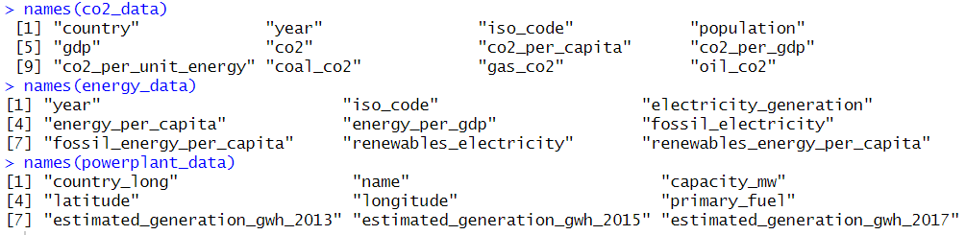

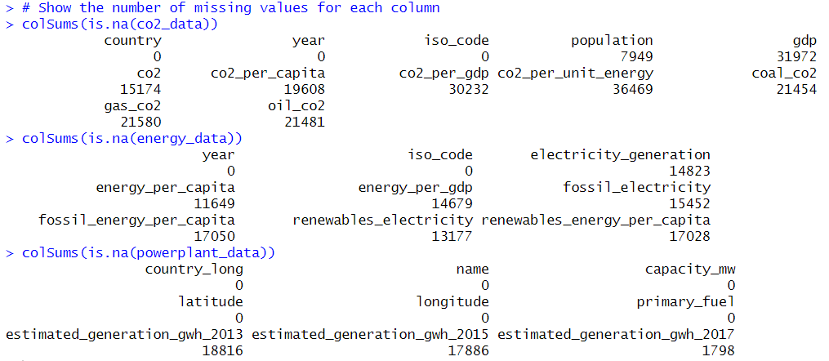

## Preliminary Data Examination

### Data import and format

All three datasets are in csv format so they can be easily imported.

### Data structure

All three sets have a large number of columns. Most of these will not be needed for this analysis so only the relevant ones will be selected.

### Missing or incomplete data

There are a large number of missing values for less developed countries as well as older data entries mostly before about 1970. This will need to be taken into account in the analysis but thankfully the more recent data, after about 2000, is much more complete.

### Merging or linking datasets

Both OWID data sets have iso codes so they can be merged and used without too much difficulty. The powerplant dataset has longitude and latitude which will be harder to handle. The will need to be converted to the coordinate system used which will more than likely be a CRS system.