LAB 5: Data Integration
Student: Dorline TIAKO OKASSIE | ING4 Data & Artificial Intelligence – Group 01 | ECE Paris
Tool: Talend Open Studio for Data Integration 8.0.1 | Input files: movies.csv, Directors.txt

Exercise 1:
This exercise describes a simple data integration job that reads movie-related data from a locally stored CSV file and displays the data in the Run view console (Extract ETL step).
Project Creation:
1. Launch Talend.
2. Create a new project named PW1.
3. Select the PW1 project.
Answer – Project Creation
Talend Open Studio was launched and, in the project selection window, the option Create a project was used to create a new local project named PW1. The project was then selected and opened. The title bar of the studio confirms that the active project is PW1 (Connexion: Local), and the Repository shows the standard folders (Jobs, Contexts, Code, SQL Templates, Metadata, Documentation, Recycle bin).
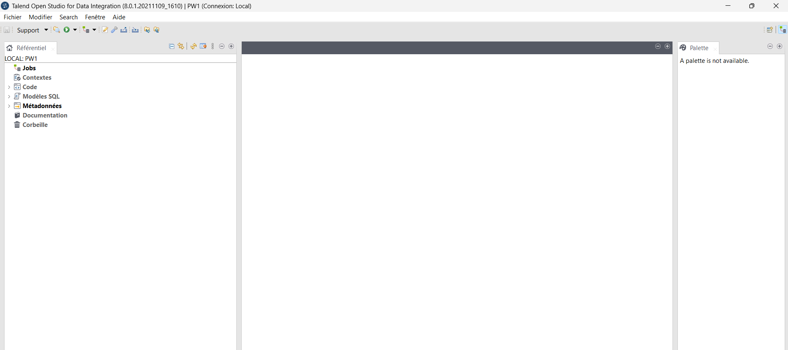
Figure 1: Project PW1 opened in Talend Open Studio (title bar: “PW1 (Connexion: Local)”)

Metadata Creation:
1. Create the metadata for the movies.csv file (Delimited File).
2. Create a delimited file named movies.
3. Browse the file.
4. Set the field separator to ";".
5. Enable the Define Header Line option.
6. Click Next and Finish.
Answer – Metadata Creation
A Delimited File metadata named movies was created in the Repository (Metadata › File delimited › Create file delimited). The wizard has four steps:
• Step 1 – Properties: name movies, purpose “Read movies data from movies.csv”.
• Step 2 – File: the file movies.csv was selected with the Browse button. Talend detected the UNIX format (the file uses LF line endings), which was kept.
• Step 3 – Parsing: field separator set to Semicolon (";"), row separator “Standard EOL”, and the option Set heading row as column names enabled (header = 1 line ignored). The preview shows the five real column names.
• Step 4 – Schema: five columns were detected. directorID was kept as String so that it can later be joined with the director_id column of the directors file, and all columns are nullable (many movies have an empty directorID).
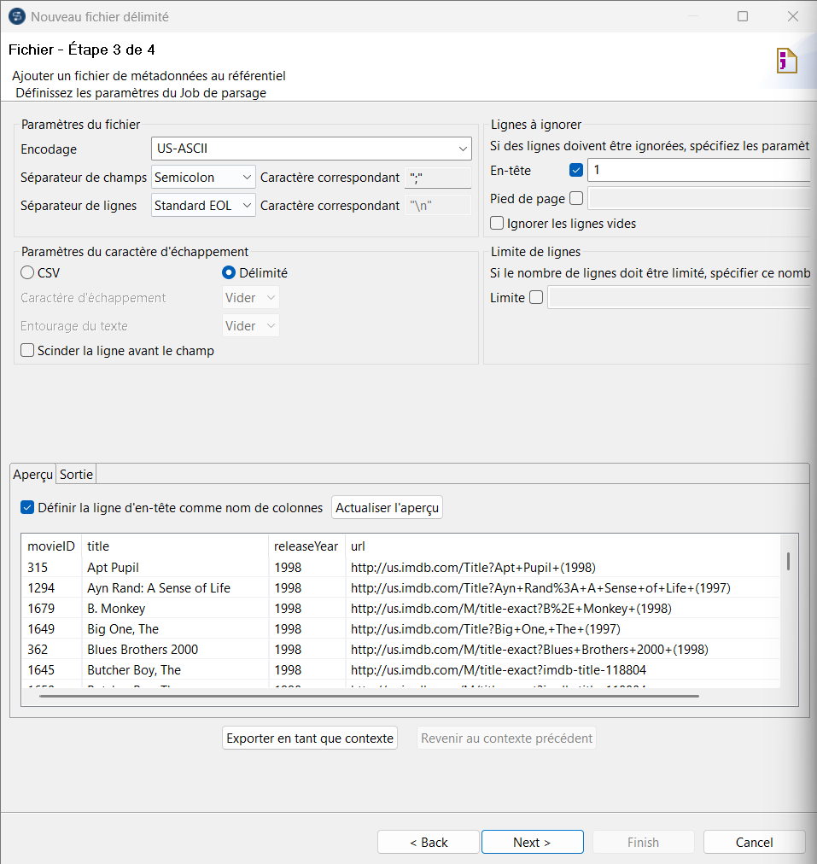
Figure 2: Metadata “movies” – step 3: semicolon separator and header line enabled
Column | Type | Description
movieID | Integer | Unique identifier of the movie
title | String | Title of the movie
releaseYear | Integer | Year of release
url | String | IMDb link
directorID | String | Foreign key to the director (empty for 1,200 movies)

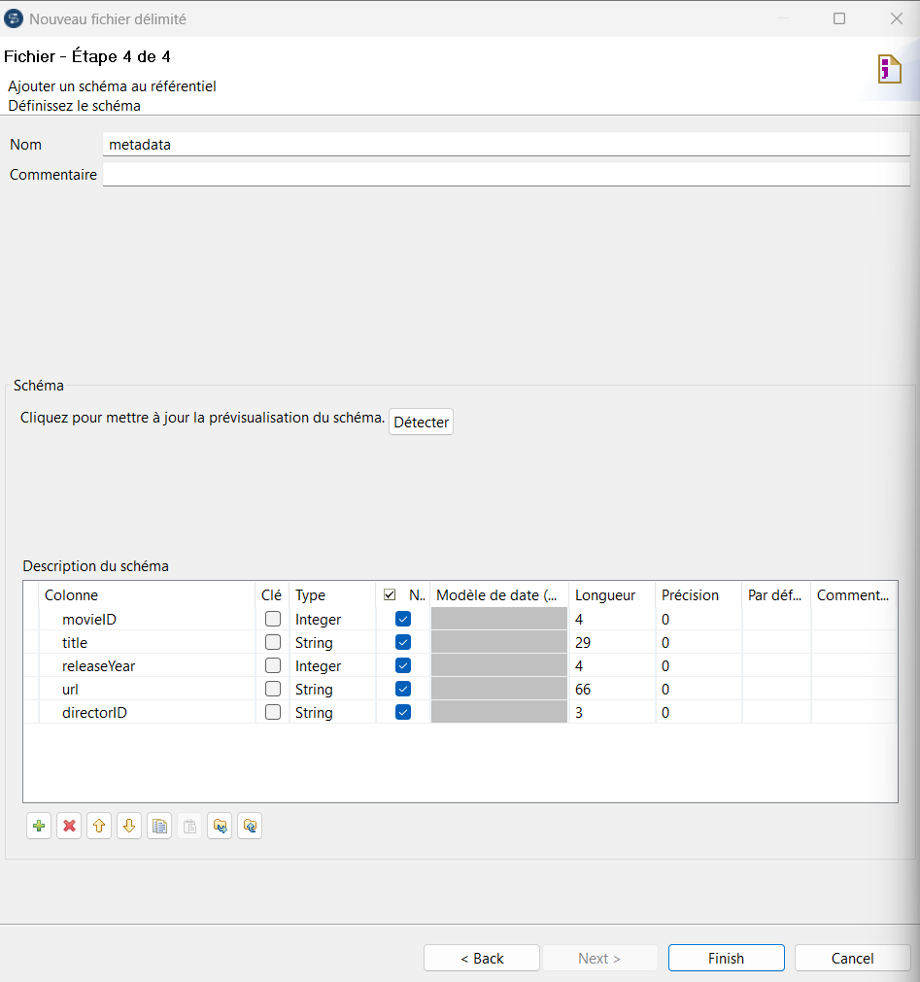
Figure 3: Metadata “movies” – step 4: schema of the file

Job Creation
1. Create a Job Exercise 1:
2. Drag the movies file and choose TFileInputDelimited.
3. Drag a TLogROW component.
4. Connect movies to TLogROW with a Main link.
5. Execute the job
6. Document the job.
Answer – Job Creation, Execution and Documentation
A job named Exercise1 was created. The movies metadata was dragged onto the design workspace as a tFileInputDelimited component, a tLogRow component was added from the Palette, and both were connected with a Row › Main link (row1). The tLogRow was set to Table mode to obtain a readable output in the console.
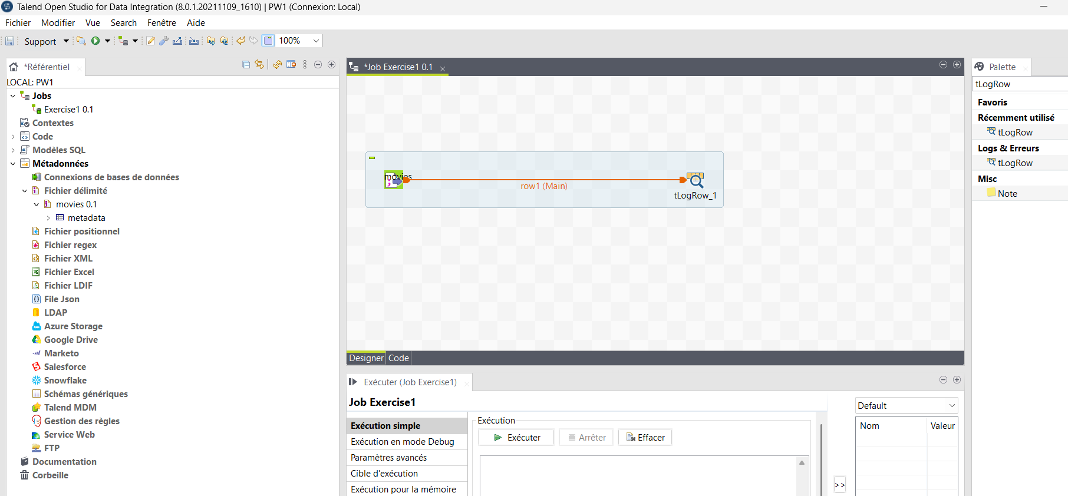
Figure 4: Job Exercise1 – movies (tFileInputDelimited) connected to tLogRow with a Main link
The job was executed from the Run view. The statistics on the link show 1455 rows read in about 0.1 s, and the console displays every movie of the file. The job ends with exit code 0 (no error).
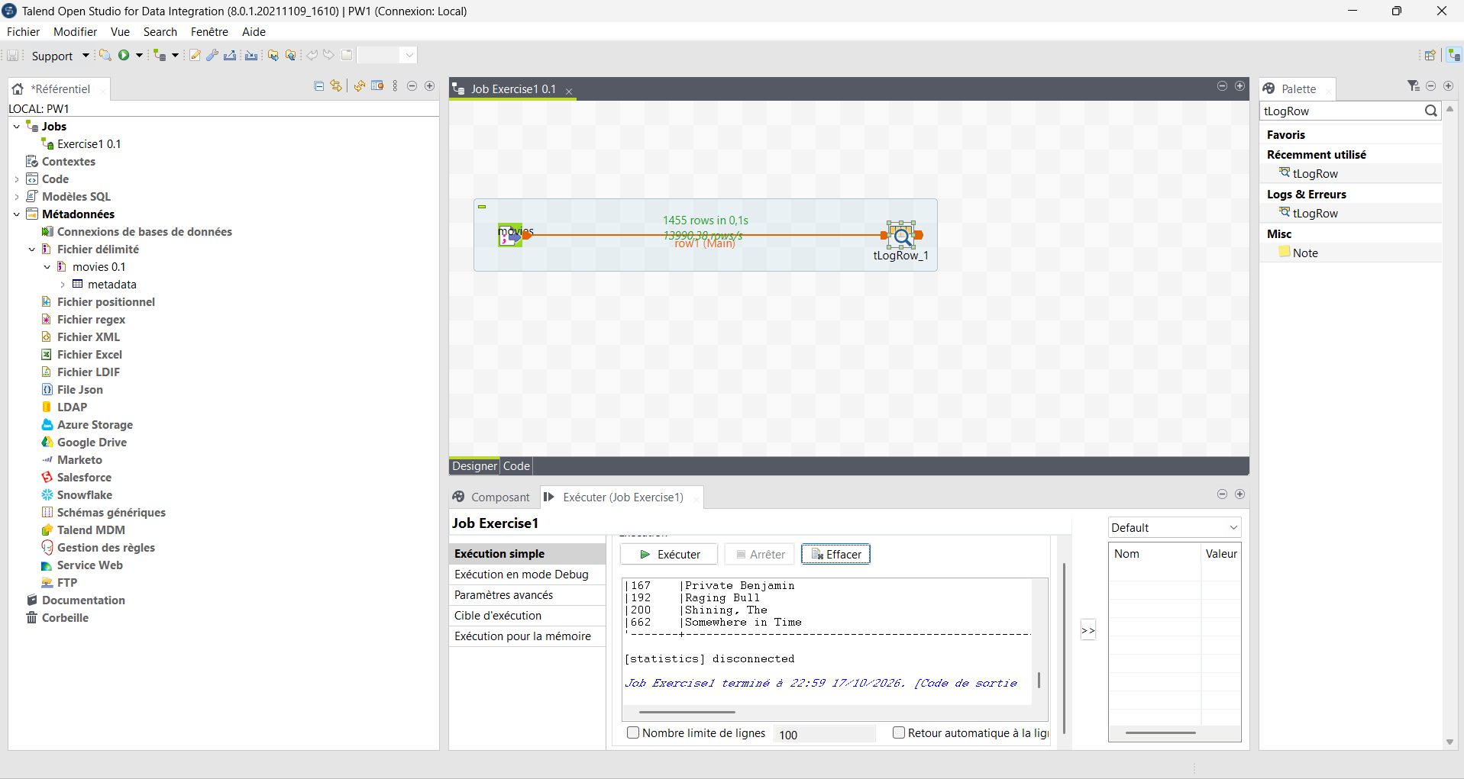
Figure 5: Execution of Exercise1: 1455 rows displayed in the Run console (exit code 0)
Job documentation
Component | Role | Main settings
movies (tFileInputDelimited) | Extract – reads the source file | Repository metadata movies, separator ";", header = 1, schema of 5 columns
row1 (Main) | Data flow | Carries the 5 columns of each movie
tLogRow_1 | Displays the data | Mode Table, output in the Run console

Result: this job illustrates the Extract step of the ETL process: the 1,455 movies of the CSV source are accessed through a reusable metadata definition and displayed without any transformation.

Exercise 2:
This exercise describes how to filter the data stream (Movies) and obtain only valid movies with valid information about directors (Transform ETL step).
1. Create a Job Exercise 2
2. Drag the movies file and choose TFileInputDelimited.
3. Create a delimited file named directors.
4. Browse the file.
5. Set the field separator to ",".
6. Change column names to director_id and director_name.
7. Change the type of director_id to String.
8. Drag the directors file and choose TFileInputDelimited.
9. Drag a TMap component.
10. Connect movies to TMap with a Main link.
11. Connect directors to TMap with a Main link.
12. Drag a TLogROW component.
13. Connect TMap to TLogROW with an output Main link named output.
14. Double-click on the TMap.
15. Join the director_id column from movies with the director_id column from directors.
16. Set the JoinModel option to "Inner Join".
17. Transfer the title columns from movies and director_name columns from directors to the output stream output.
18. Click Apply and OK.
19. Execute the job
20. Document the job
Answer – Exercise 2
1. Metadata of the directors file (steps 3 to 7)
A second Delimited File metadata named directors was created for Directors.txt. Unlike movies.csv, this file uses WINDOWS line endings (CRLF), has no header line, and its separator is a comma. The encoding was set to UTF-8.
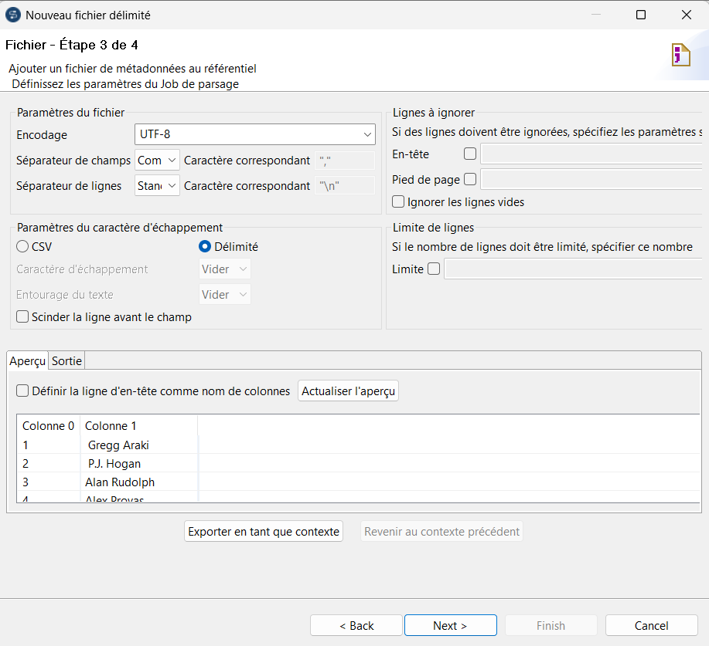
Figure 6: Metadata “directors” – step 3: comma separator, no header, two columns detected
In the schema step, the default columns “Column0” and “Column1” were renamed director_id and director_name, and the type of director_id was set to String (same type as directorID in movies, which is required for the join).
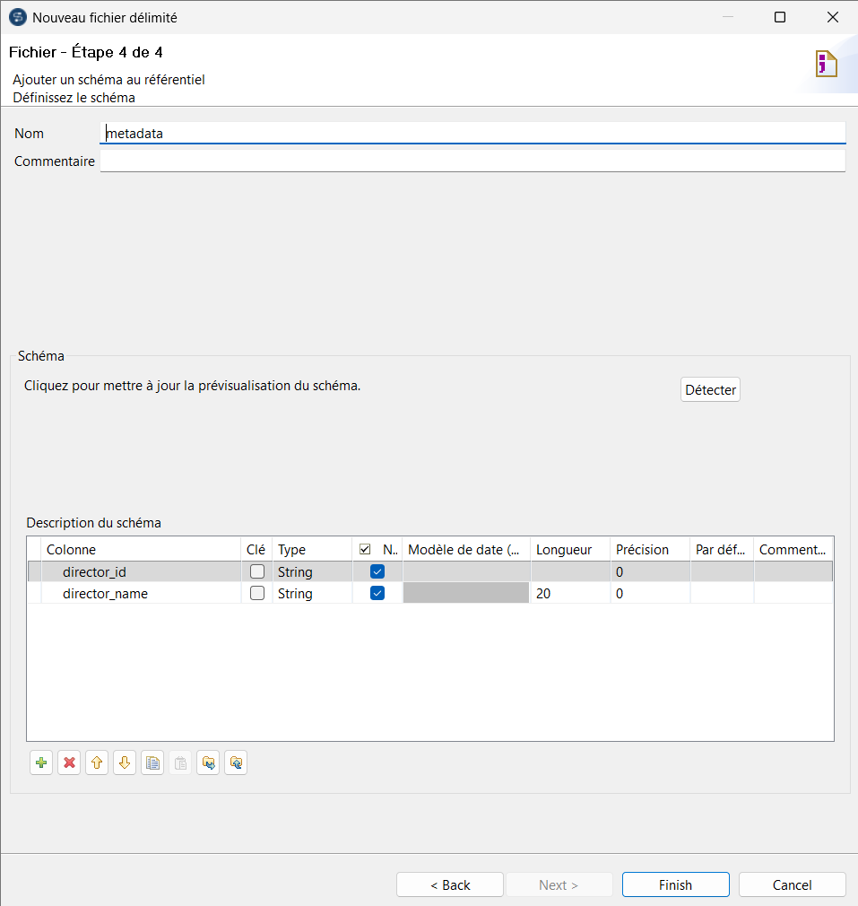
Figure 7: Metadata “directors” – step 4: columns renamed and director_id set to String
2. Design of the job (steps 8 to 13)
In the job Exercise2, the movies and directors metadata were added as two tFileInputDelimited components and connected to a single tMap. The first connection (movies) becomes the main flow – row1 (Main), and the second one (directors) automatically becomes the lookup flow – row2 (Lookup), drawn as a dotted line. The tMap is connected to a tLogRow through a new output named output.
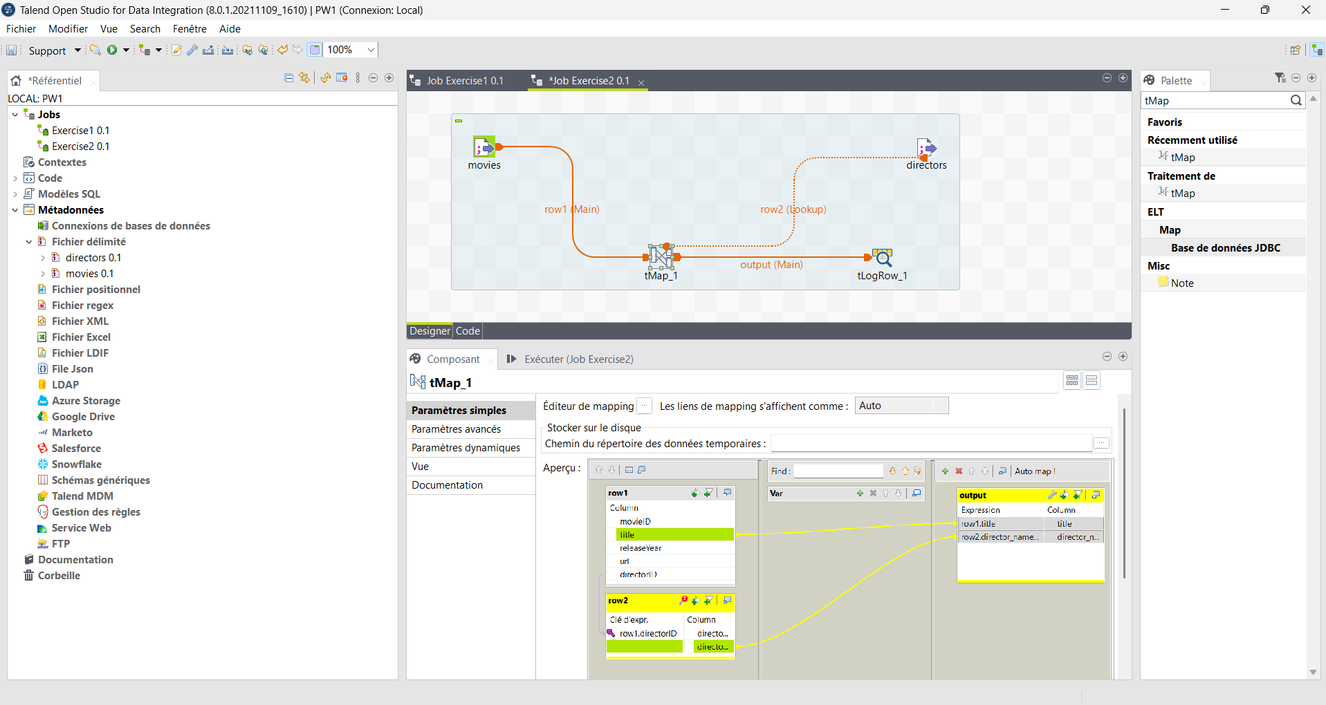
Figure 8: Job Exercise2 – movies (Main) and directors (Lookup) joined in the tMap, output sent to tLogRow
3. Configuration of the tMap (steps 14 to 18)
• Join (step 15): directorID from row1 was dragged onto the Expr. key of director_id in row2 → join key row1.directorID = row2.director_id.
• Join model (step 16): in the row2 settings, Join Model was changed from Left Outer Join to Inner Join, so only movies that find a matching director are kept.
• Output (step 17): row1.title and row2.director_name were transferred to the output table. The expression row2.director_name.trim() was used to remove the leading/trailing spaces and tabs found in the source file (data cleaning of noisy values).
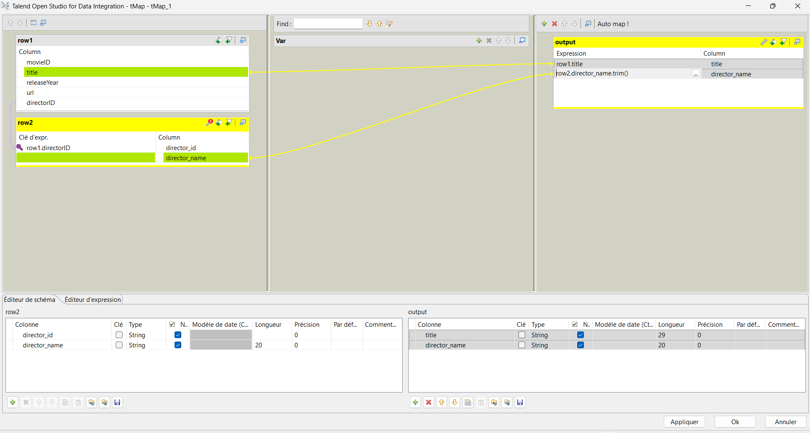
Figure 9: tMap editor – inner join on directorID = director_id and output columns title / director_name
4. Execution (step 19)
At the first execution, Talend asked to install a missing third-party library (jboss-marshalling-river, Apache-2.0 licence) used internally by the tMap lookup (tAdvancedHash). After accepting the licence and downloading it, the job ran successfully:
Flow | Rows | Meaning
row1 (movies) | 1455 | All movies read from movies.csv
row2 (directors) | 204 | All directors loaded into the lookup
output | 255 | Movies with a valid director (inner join)

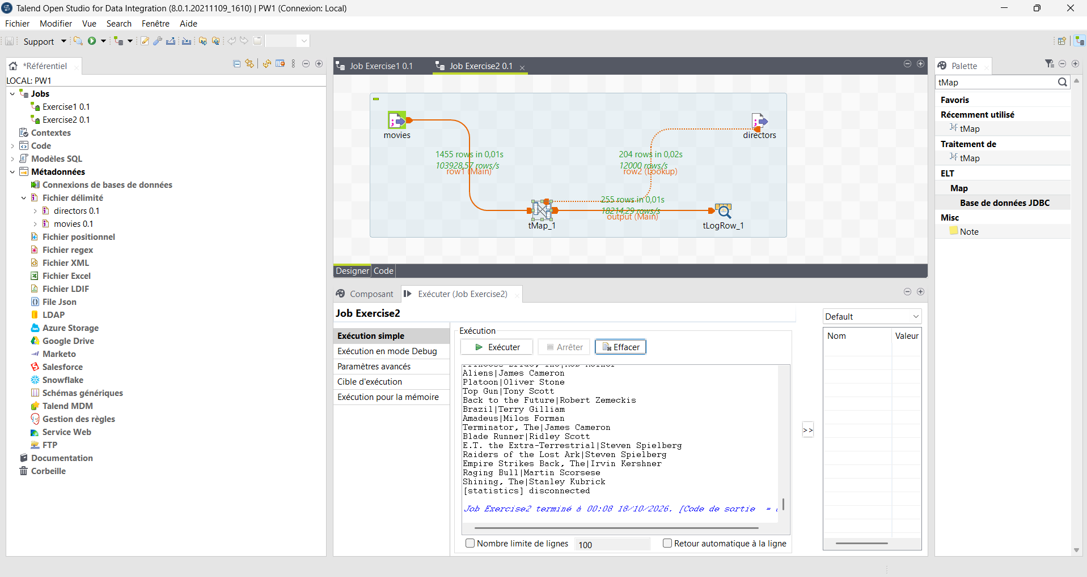
Figure 10: Execution of Exercise2: 1455 movies, 204 directors, 255 valid movies displayed (exit code 0)
5. Job documentation (step 20)
Component | Role | Main settings
movies (tFileInputDelimited) | Main input | Metadata movies, separator ";"
directors (tFileInputDelimited) | Lookup input | Metadata directors, separator ",", UTF-8, no header
tMap_1 | Transformation – join | Key directorID = director_id, Inner Join, unique match, load once
tLogRow_1 | Displays the result | Columns title, director_name

Interpretation: only 255 of the 1,455 movies (17.5 %) have a director. The other 1,200 movies have an empty directorID (missing data) and are removed by the Inner Join. This job illustrates the Transform step of ETL: integration of two heterogeneous sources and filtering of incomplete records.

Ehxercise 3: This exercise describes how to filter the data stream (Movies) and obtain valid and invalid movies (use output files Load ETL step).
1. Create a Job Exercise 3:
2. Drag the movies file and choose TFileInputDelimited.
3. Drag the directors file and choose TFileInputDelimited.
4. Drag a TMap component.
5. Connect movies to TMap with a Main link.
6. Connect directors to TMap with a Main link.
7. Drag a TFileOutputDelimited component.
8. Drag a TFileOutputXML component.
9. Connect TMap to TFileOutputDelimited with a Main link named output_CSV.
10. Connect TMap to TFileOutputXML with a Main link named output_XML.
11. Double-click on the TMap.
12. Join the director_id column of movies with the director_id column of directors.
13. Set the JoinModel option to "Inner Join".
14. Transfer the title columns of movies and director name columns of directors to the output stream output_CSV.
15. Set the InnerJoinReject option to "false".
16. Transfer the title columns of movies to the output stream output_XML.
17. Set the InnerJoinReject option to "true".
18. Click Apply and OK.
19. Double-click on the TFileOutputDelimited and change the file name.
20. Double-click on the TFileOutputXML and change the file name. Execute the job Document the job
Answer – Exercise 3
1. Design of the job (steps 1 to 10)
The job Exercise3 reuses the two input metadata (movies and directors) and one tMap. Two output components were added: a tFileOutputDelimited and a tFileOutputXML. The tMap is connected to them with two new Main outputs named output_CSV (order 1) and output_XML (order 2).
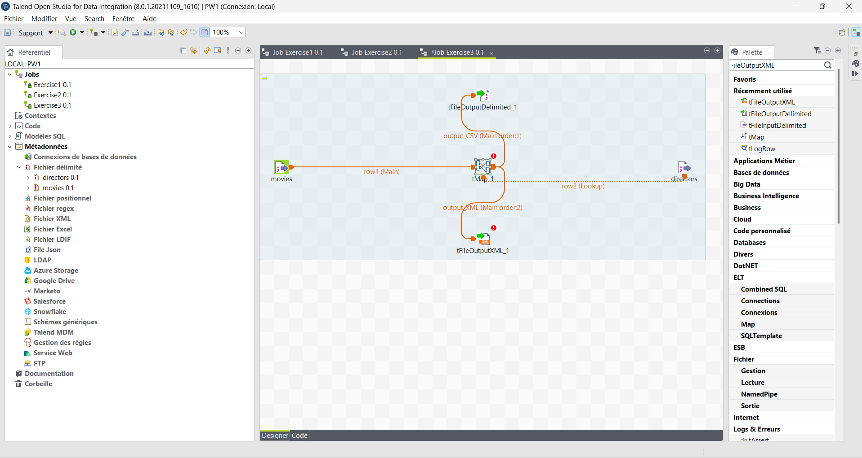
Figure 11: Job Exercise3 – one tMap with two outputs: output_CSV and output_XML
2. Configuration of the tMap (steps 11 to 18)
• Join: row1.directorID = row2.director_id with Join Model = Inner Join (steps 12–13).
• output_CSV: columns row1.title and row2.director_name.trim(); option Catch lookup inner join reject = false → receives the movies that match a director (steps 14–15).
• output_XML: column row1.title; option Catch lookup inner join reject = true → receives the movies rejected by the inner join, i.e. without a valid director (steps 16–17).
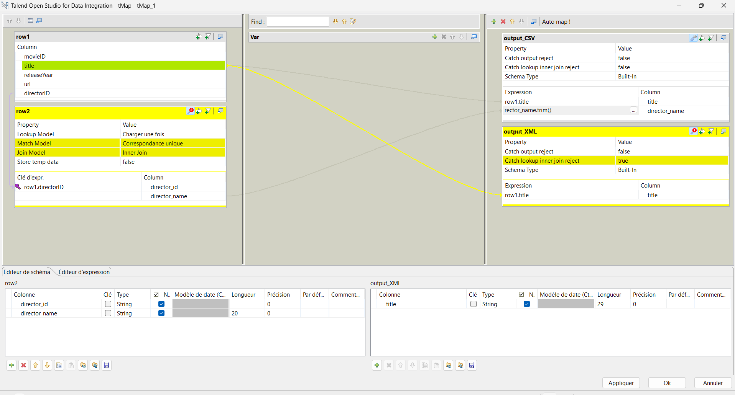
Figure 12: tMap editor – output_CSV (reject = false) for valid movies and output_XML (reject = true) for rejected movies
3. Output files (steps 19 and 20)
The file names were typed directly in the component settings (the Browse button only opens existing files):
• tFileOutputDelimited: …/TalendLab5/valid_movies.csv, field separator ";", option Include header enabled.
• tFileOutputXML: …/TalendLab5/invalid_movies.xml, row tag "row".
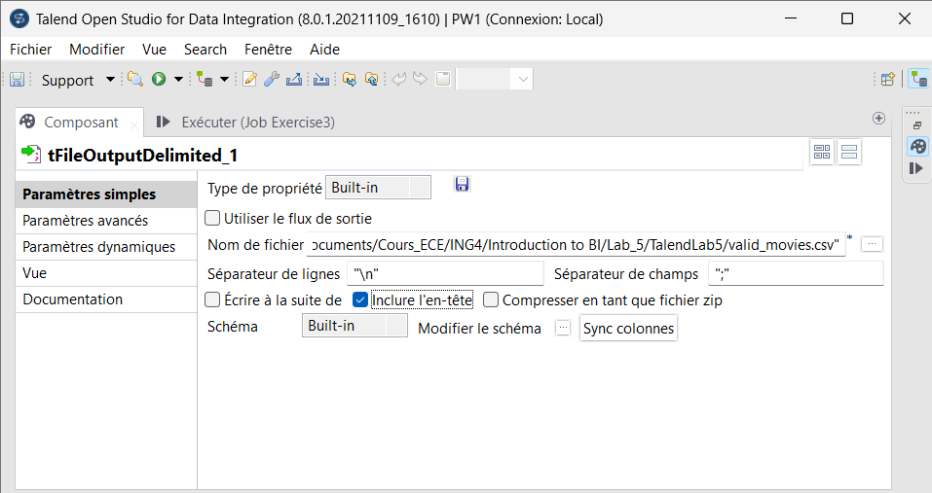
Figure 13: tFileOutputDelimited settings – valid_movies.csv with header
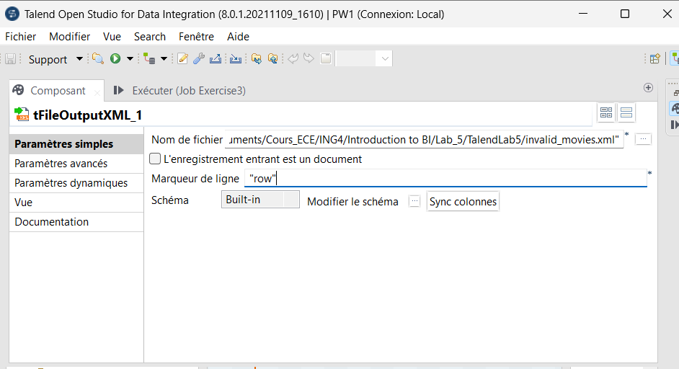
Figure 14: tFileOutputXML settings – invalid_movies.xml
4. Execution
A first run stopped with the error “The particular file … valid_movies.csv already exist” (exit code 1), because the file had been created by an earlier attempt and the advanced option Throw an error if the file already exist was enabled. After unchecking this option, the file is simply overwritten and the job ends with exit code 0.
Flow | Rows | Destination
row1 (movies) | 1455 | Main input
row2 (directors) | 204 | Lookup input
output_CSV | 255 | valid_movies.csv – valid movies with their director
output_XML | 1200 | invalid_movies.xml – rejected movies (no director)

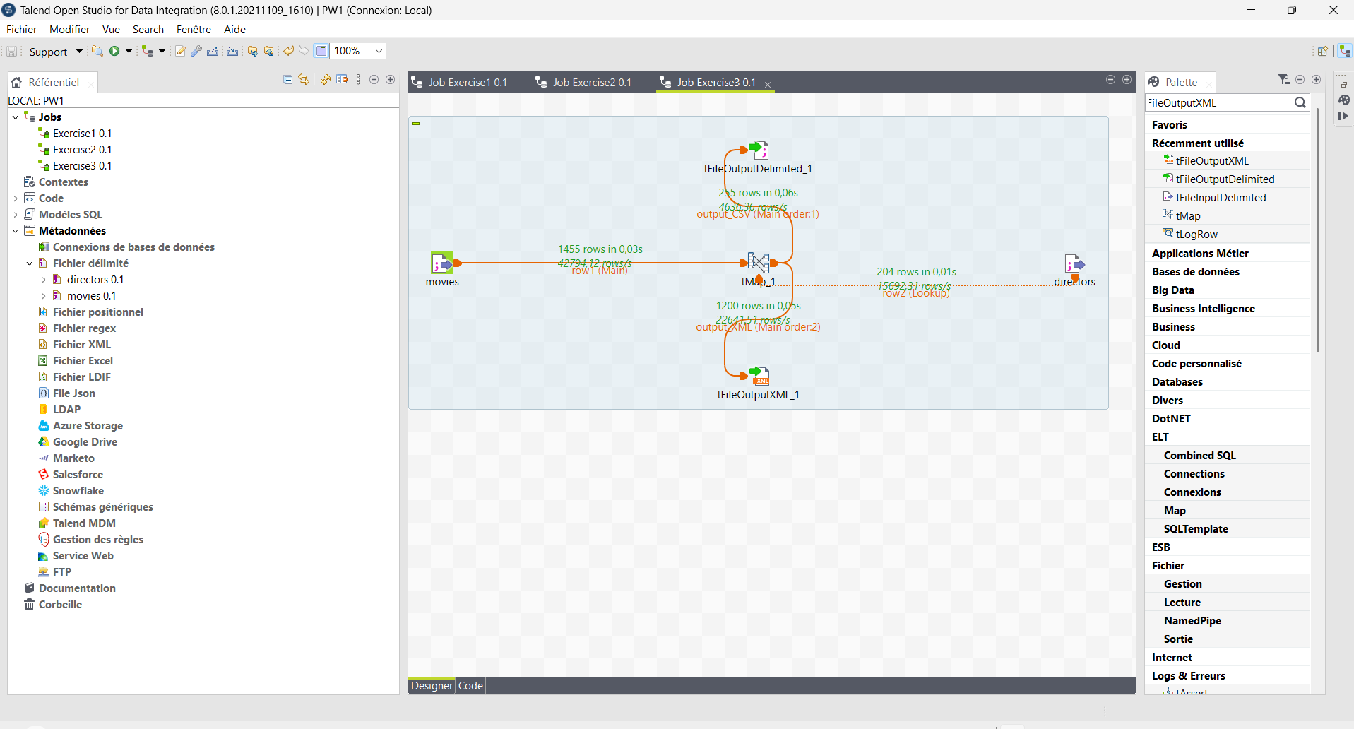
Figure 15: Execution of Exercise3: 255 valid movies to the CSV file and 1200 rejected movies to the XML file
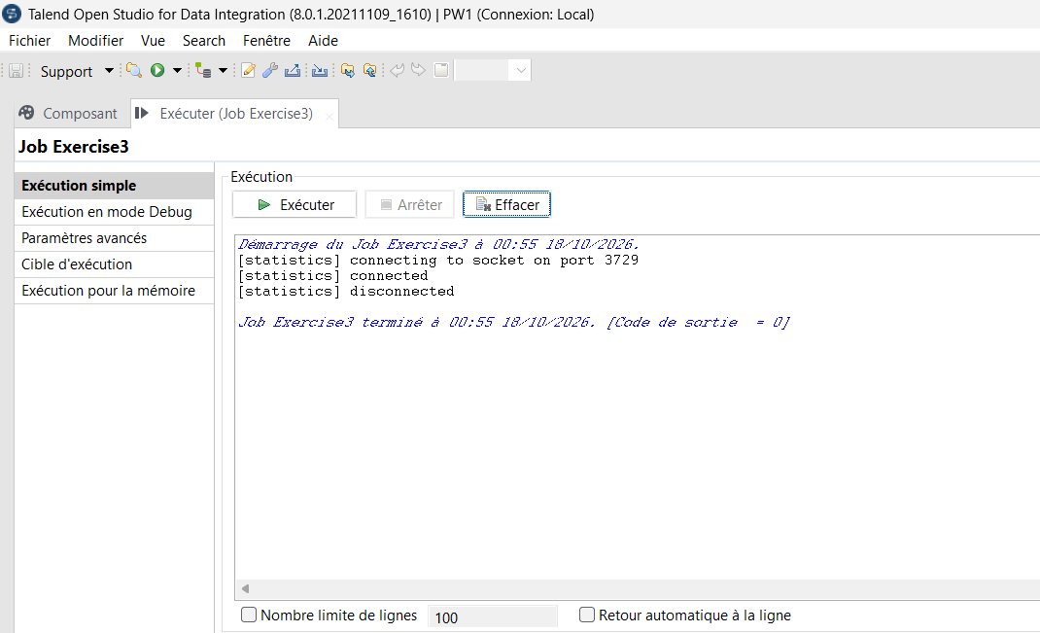
Figure 16: Run console of Exercise3 – job completed with exit code 0
The check 255 + 1,200 = 1,455 confirms that every movie of the source ends up in exactly one of the two files: no record is lost or duplicated by the job.
5. Content of the generated files
valid_movies.csv (header + 255 lines, extract):
title;director_name
Apt Pupil;Bryan Singer
Titanic;James Cameron
Pulp Fiction;Quentin Tarantino
Shining, The;Stanley Kubrick
invalid_movies.xml (1,200 <row> elements, extract):
<?xml version="1.0" encoding="ISO-8859-15"?>
<root>
<row><title>Duoluo tianshi</title></row>
<row><title>Great Expectations</title></row>
<row><title>Cats Don&apos;t Dance</title></row>
...
</root>
6. Job documentation
Component | Role | Main settings
movies / directors (tFileInputDelimited) | Main and lookup inputs | Repository metadata movies and directors
tMap_1 | Transformation and routing | Inner Join on directorID; output_CSV (reject = false); output_XML (reject = true)
tFileOutputDelimited_1 | Load – valid movies | valid_movies.csv, separator ";", header included
tFileOutputXML_1 | Load – rejected movies | invalid_movies.xml, row tag "row"

Result: this job illustrates the Load step of ETL. Instead of silently losing the incomplete records, the inner-join rejects are captured and stored in a separate file, so that they can be audited and corrected later (data governance).

Data Quality Observations and Conclusion
While building the three jobs, several data quality problems described in Chapter 4 were observed in the source files:
Problem (Chapter 4) | Observation in the lab data | Treatment
Missing data | 1,200 of the 1,455 movies have an empty directorID | Rejected by the Inner Join and stored in invalid_movies.xml
Noisy data | Extra spaces and tabs around director names (e.g. " Gregg Araki", " Alex Sichel") | Cleaned with .trim() in the tMap
Duplicated data | Repeated titles (e.g. Butcher Boy, Chairman of the Board, Hugo Pool) and Barbet Schroeder listed twice (IDs 13 and 14) | Identified; could be removed with a tUniqRow component
Conversion / encoding | Accented characters already lost in the sources (Cuar�n, Hallstr�m, C?r?monie, Mis?rables) | Not recoverable in Talend; must be fixed at the source
Format conflicts | Different separators (";" vs ","), header vs no header, UNIX vs WINDOWS line endings | Handled by two separate metadata definitions

This lab covered the three steps of an ETL process with Talend Open Studio: Extract (reading a delimited file through a reusable metadata), Transform (joining two heterogeneous sources in a tMap with an Inner Join and cleaning the values) and Load (writing the valid movies to a CSV file and the rejected movies to an XML file). The final results (255 valid movies and 1,200 rejected movies, for a total of 1,455) are consistent with the source data, which confirms that the jobs are correct and that no record was lost.

