Lab title: Learning Vi

Name: Dorine Khainza

Date of completion: 16-Nov-23

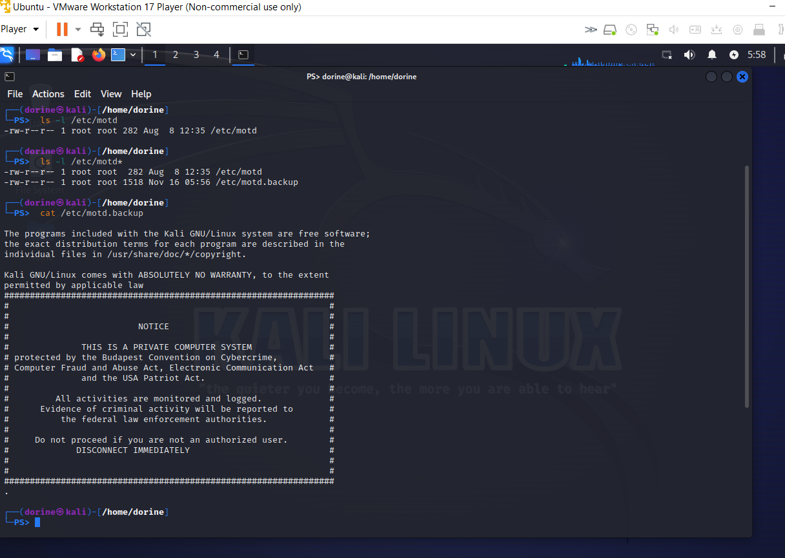

1) Who is the owner of /etc/motd?

Root

2) Under what circumstances is the content of /etc/motd displayed?

Contents of **/etc/motd** are displayed when users log into the system. Message is displayed after user logs in, but before shell prompt appears.

3) How did you confirm the change took effect?

By sing the cat /etc/motd.backup command to view if there were changes

4) What did you learn from this exercise?

I cannot edit a file unless I am in root with admin permission.