Lab title: **Linda Needs Help**

Name: Dorine Khainza

Date of completion: 17-Nov-23

Forensic Investigation Requirement

1. The name of the city and country where the photograph was taken.
2. The GPS coordinates (rounded up to 4 decimals) where Linda was standing to take the photograph.

For this case study I wanted to find the meta data of the photograph, after several attempts with online software or checking properties of the images I released the meta data didn’t have the GPS coordinates. I used to google images instead.

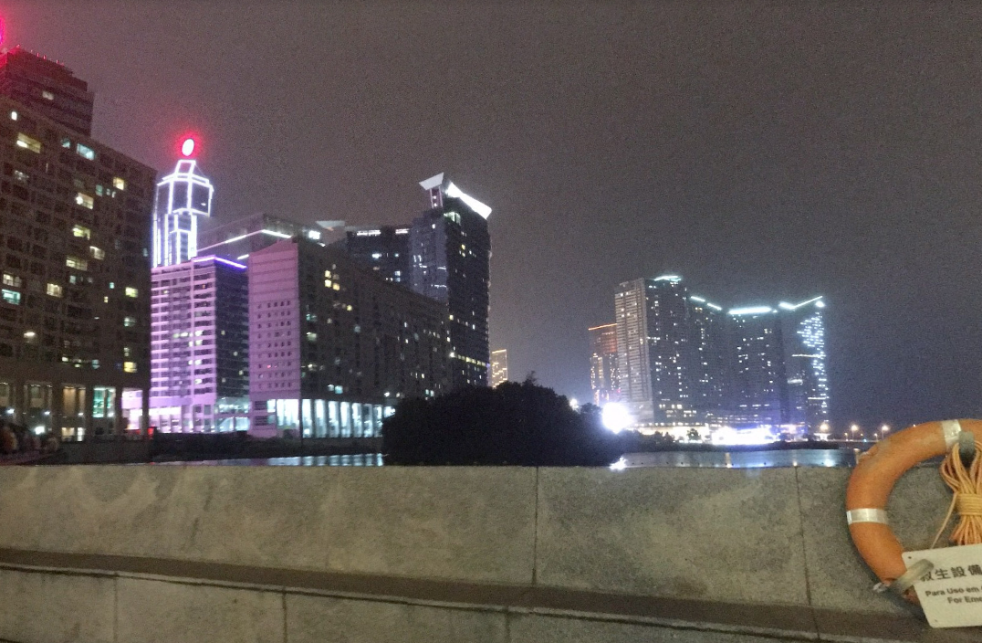

The picture was taken in MACAU; Looking at the bottom right at the life ring, there are 2 languages traditional Chinese and Portuguese and there are only 2 areas in the world were both languages are spoken East Timor and Macau, however East Timor is not as developed as the image, so Macau is most guaranteed answer.

I went on to use google street view I saw the Lisboa Hotel, the only thing left is to discover or find location where Linda was when she actually took the picture;

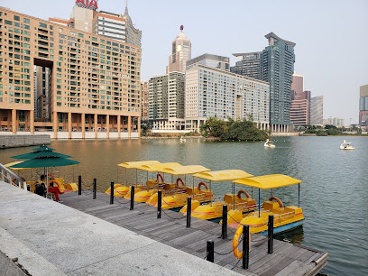

The GPS coordinates from google maps show that picture was taken from **Nam Van Lake Nautical Center, GPS 22.1869, 113.5383**