Geog 575 – Fall 2018 Project Proposal

Project Team: Jim Cunningham, Randy Garcia, and Dorn Moore

# Imagined RFP

The International Crane Foundation has asked our team to respond to an RFP to produce and interactive geo-visualization tool inspired by an article published by their staff in 2015. The article (“[Changes in the number and distribution of Greater Sandhill Cranes in the Eastern Population](https://www.researchgate.net/publication/284663849_Changes_in_the_number_and_distribution_of_Greater_Sandhill_Cranes_in_the_Eastern_Population)”) reviews lends itself to an interactive tool for use on the organization’s blog to help their members better understand the research and highlight the work of the staff. The International Crane Foundation marketing and communications staff has provided basic information about their average membership to help refine the users who will be interacting with the blog. The site should be responsive and, generally, match the organization’s graphic standards as it will be embedded into an existing website.

# Persona/Scenario

The primary audience for the visualization and blog post are members and supporters of the International Crane Foundation and the general public that might find the article while searching the internet for information about cranes. This is a very general audience. The International Crane Foundation communications and marketing staff describe their average website and social media user in the attached documents. Our approach is to see the audience as a general audience, with slightly higher than average education levels (Bachelor’s degree or higher), primarily based in the USA, with an interest in birding and, more specifically, cranes. Given that, we will assume that the audience is comfortable with using the internet, has an interest in the topic, possesses some background knowledge and interest in biology and ecology with a specific interest in cranes.

The user’s goal in using this tool is to learn about this particular research topic and to visualize the changes in Sandhill crane numbers and distribution during the winter over the past 50 years. Initially, the user will be presented with a pre-canned, animated visualization of the changes, as outlined in the original article. The user will then have the ability to take control of the visualization and inspect details about a specific area and query information about specific count locations to see how they have changed over time.

A specific example of actions on the user driven portion of the interactive map might be:

* User controls the time bar to navigate in time and see changes in the relative size of the Christmas Bird Count results at each count site.
* User has the ability to select an item on the map where they will be presented with the Item name and crane population information
* Line graph will update with relevant data for each time value the user selects on the map time navigation bar. User can pan and zoom on the map with controls on the maximum and minimum zooms. Map extent will be set to the eastern United States with a minimum zoom that shows the study area extent.
* Users will also be able to choose a region for preset pan and zoom while having recourse to a “Home” button to take them back to the initial extent.
* The interactive portion of the tool will only be usable on tablet and desktop versions of the tool. Phone users will see some of the story and some of the pre-canned visualization with a link to explore the site on a tablet or desktop.
* User will be able to change base map from light grey canvas to world imagery as a way to provide real world context to the data.

# Requirements Document

|  |  |  |
| --- | --- | --- |
| **Function/Layer** | **Team Description** | **User Description** |
| Basemap: Light gray canvas | Use the MapBox or ESRI Light gray tile service. | Light gray world base map, allows the data to standout. |
| Basemap: World Imagery | This is under consideration. It may be useful for this to be visible at a certain zoom level and not at all levels. | Satellite images that allow the user to give greater context to the data on the map. |
| Pan | Pan the map and view more detail in data. Limits on panning to keep the user within the study area. | Performed through a user clicking a moving with a mouse or panning with their finger |
| Zoom | Displays a smaller or larger extent while changing layer and base map resolution.  Limited in the maximum and minimum extent. | Performed with the user clicking on the zoom navigation icon, scrolling with a mouse wheel or pinching and zooming on mobile |
| Time selection | Change the data displayed on the map relative to a selected time frame | Using the time slider, a user will be able to view the progression of the data over a period. |
| Area refinement | Change the extent of the map based on predefined values | The user will select a geographic area based on predefined extents where the map will only display data within that area. |
| Graph relation | Map selection will highlight data in the graph. | User will select a point on the map that will then highlight the item on the graph.  Graph will show an indicator to highlight when in time the data is being shown on the map. |
| Filter | Filter map data sets based on crane counts (Breeding Bird Survey vs Christmas Bird Counts) | Drop down menu allows user to filter on desired data set |

# Lo-fi Wireframes

## Phone Wireframe

## C:\Users\dorn.SAVINGCRANES\AppData\Local\Temp\flaC52D.tmp\Snapshot.png

## Tablet Wireframe

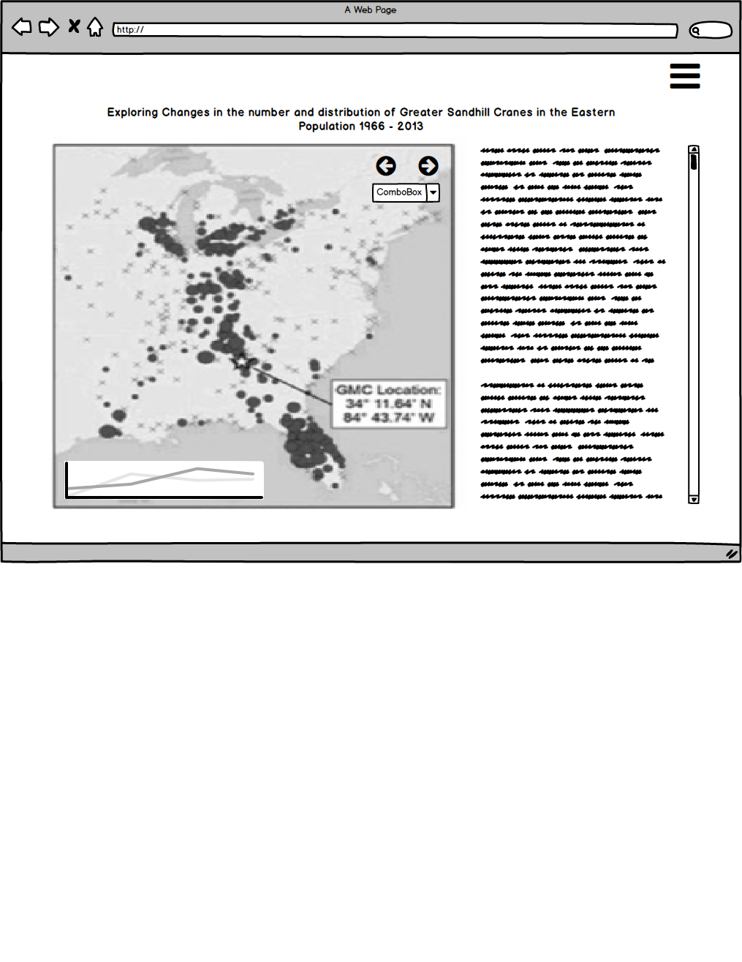

# Desktop Wireframe

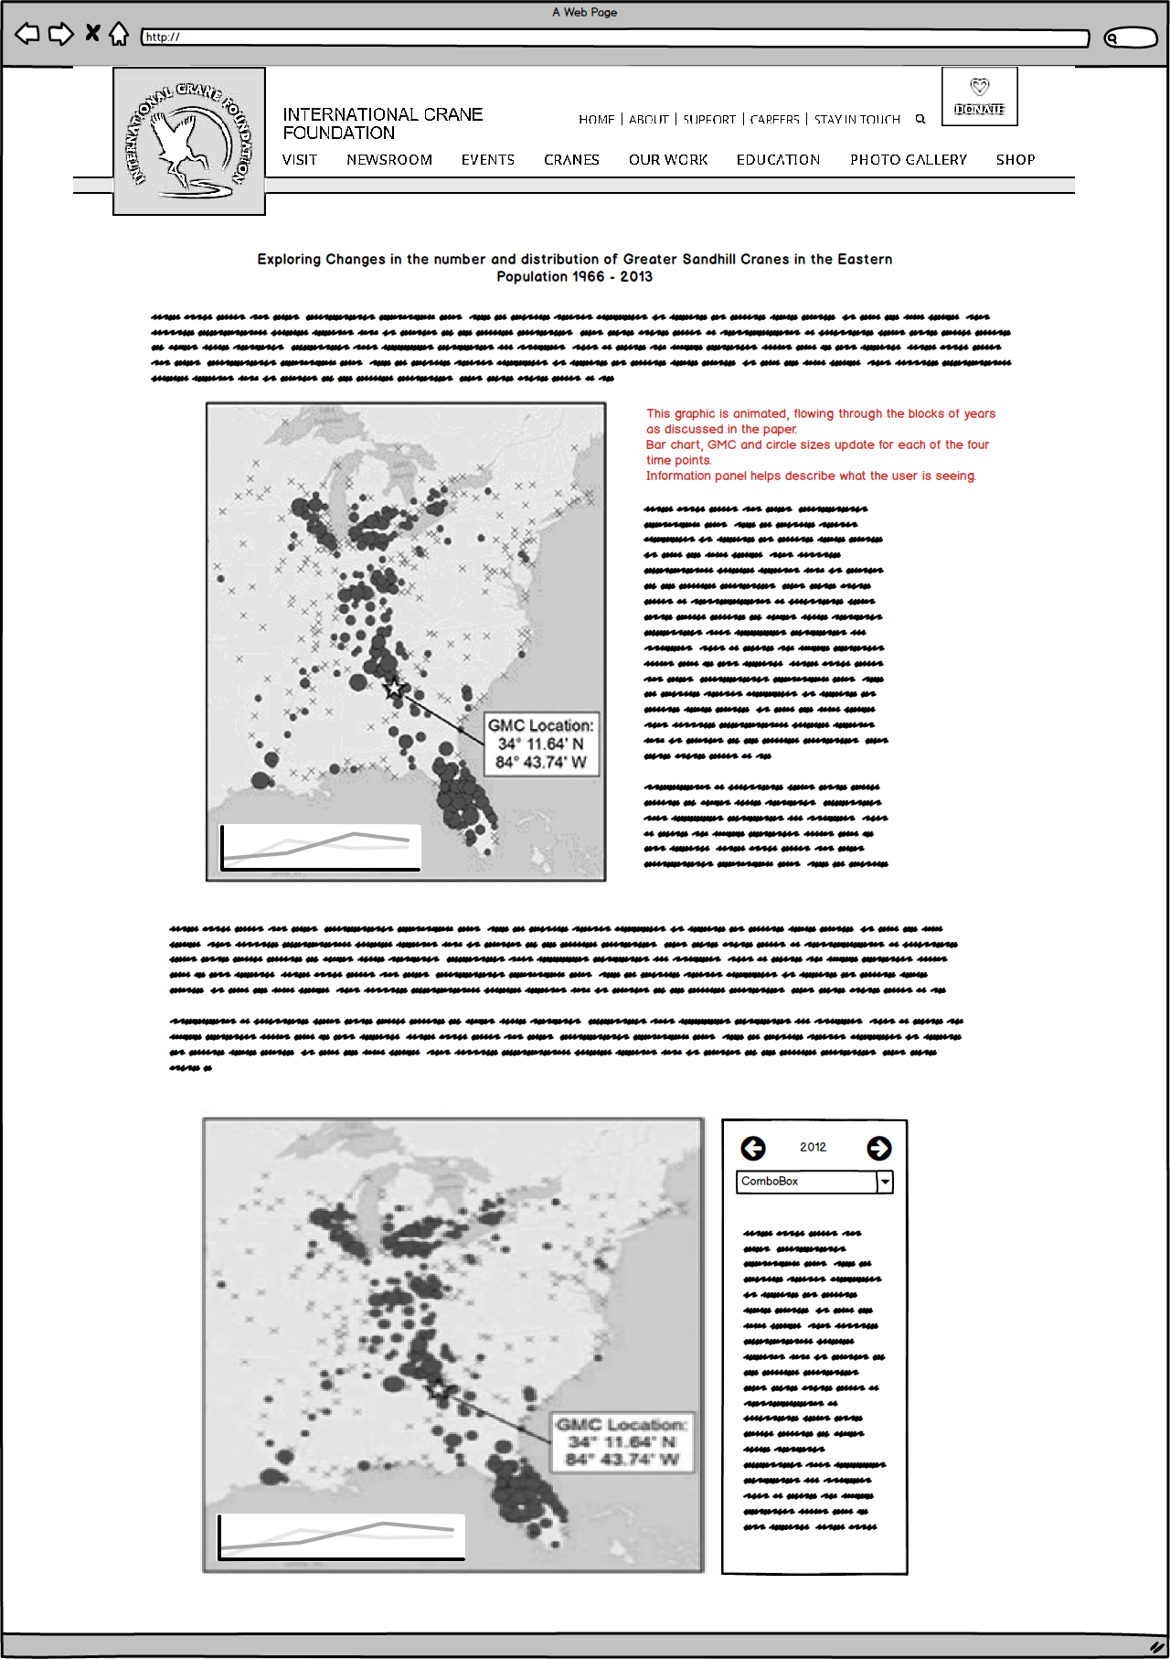

# International Crane Foundation Website Demographics

Language – 88.22 % English – US | 5.26% English – GB | .99% English – Canada

Country –79.95% United States | 4.61% India | 2.78% United Kingdom

Gender - 57.6% Female | 42.4 % Male

Acquisition – 94,202 users in period | 54.9% organic search | 30.5% direct | 6.1% social | 5.7% referral | 2.8% paid search (Google AdWords)

