DOCUMENTATIE

TEMA 3

NUME STUDENT: Dornea Andrei Daniel
GRUPA: 30228

CUPRINS

1. Obiectivul temei 3
2. Analiza problemei, modelare, scenarii, cazuri de utilizare 3
3. Proiectare 5
4. Implementare 8
5. Rezultate 44
6. Concluzii 52
7. Bibliografie 52

Obiectivul temei
Obiectiv principal:
•Proiectarea și implementarea unei aplicații de gestionare a comenzilor clienților pentru un deposit, introducand si luand informatii dintr-o baza de date a acesteia.
Sub-obiective
•Analizarea problemei și identificarea cerințelor
•Proiectarea aplicației de gestionare a comenzilor
•Implementarea aplicației de gestionare a comenzilor
•Testarea aplicației de gestionare a comenzilor

Analiza problemei, modelare, scenarii, cazuri de utilizare
Cerinte functionale
Aplicatia ar trebui sa permita utilizatorului sa:
- Introduca un nou client
- Introduca un nou produs
- Introduca o noua comanda
- Sa stearga un client
- Sa stearga un produs
- Sa stearga o comanda
- Sa modifice un client
- Sa modifice un produs
- Sa vizualizeze toti clientii
- Sa vizualizeze toate produsele
- Sa vizualizeze toate comenzile

Cerinte non functionale
Aplicatia ar trebui sa fie intuitive si usor de utilizat de catre utilizator

Use-case-uri
Main Frame:
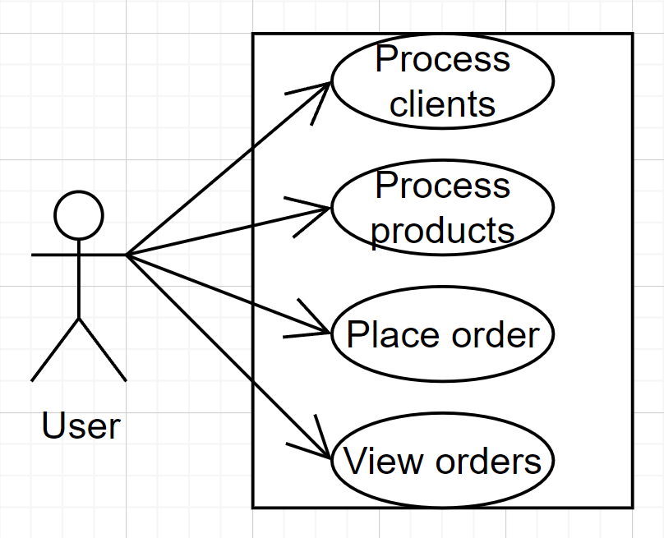

Use case: Schimbarea interfetei
Actor principal: User
Scenariu principal de succes:
- User-ul selecteaza unul din cele 4 butoane specific fiecarei interfete
- Butonul “Process clients” transfera utilizatorul in interfata Client Page
- Butonul “Process products” transfera utilizatorul in interfata Product Page
- Butonul “Place order” transfera utilizatorul in interfata Order Page
- Butonul “View orders” transfera utilizatorul in interfata View Orders

Client / Product Page

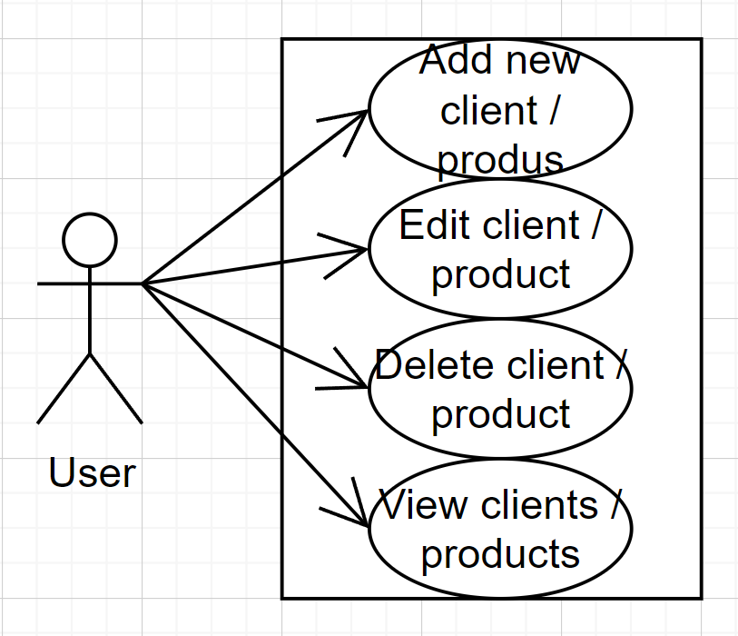

Use case: alegerea operatiei
Actor principal: User
Scenariul principal de succes:
- Utilizatorul insereaza elemente in casutele reprezentative campurilor entitatea bazei de date din tabelele respective
- Se alege operatia “Add new”, “Edit”, “Delete”
- Datele introduse sunt verificate si apasam pe “View” pentru a vedea inregistrarile
- Dupa definitivarea actiunii, inchidem fereastra pentru a reveni la Main Frame.
Scenariu alternativ:
- In momentul in care datele introduse sunt incorecte, va aparea un mesaj de exceptie si vor trebui reintroduse.

Order Page:

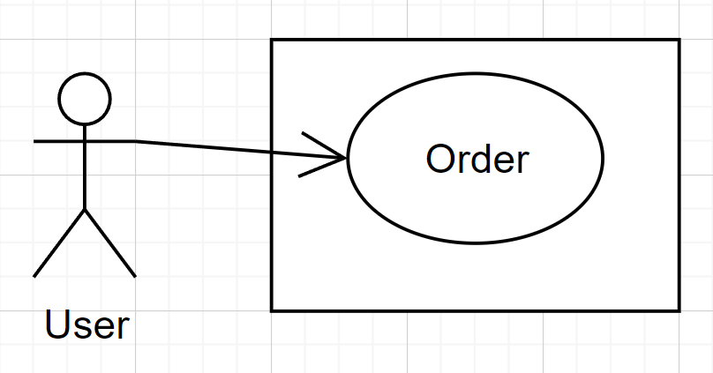

Use case: plasarea comenzii
Actor principal: User
Scenariu principal:
- User-ul trebuie sa aleaga clientul, produsul si cantitatea
- Acesta trebuie sa apese butonul “Order” pentru a plasa comanda.
Scenariu alternativ:
- In cazul in care utilizatorul introduce o cantitate mai mare ca si stocul, va aparea un mesaj de eroare, iar cantitatea trebuie modificata pentru a plasa comanda.

Proiectare
Arhitectura conceptuala:
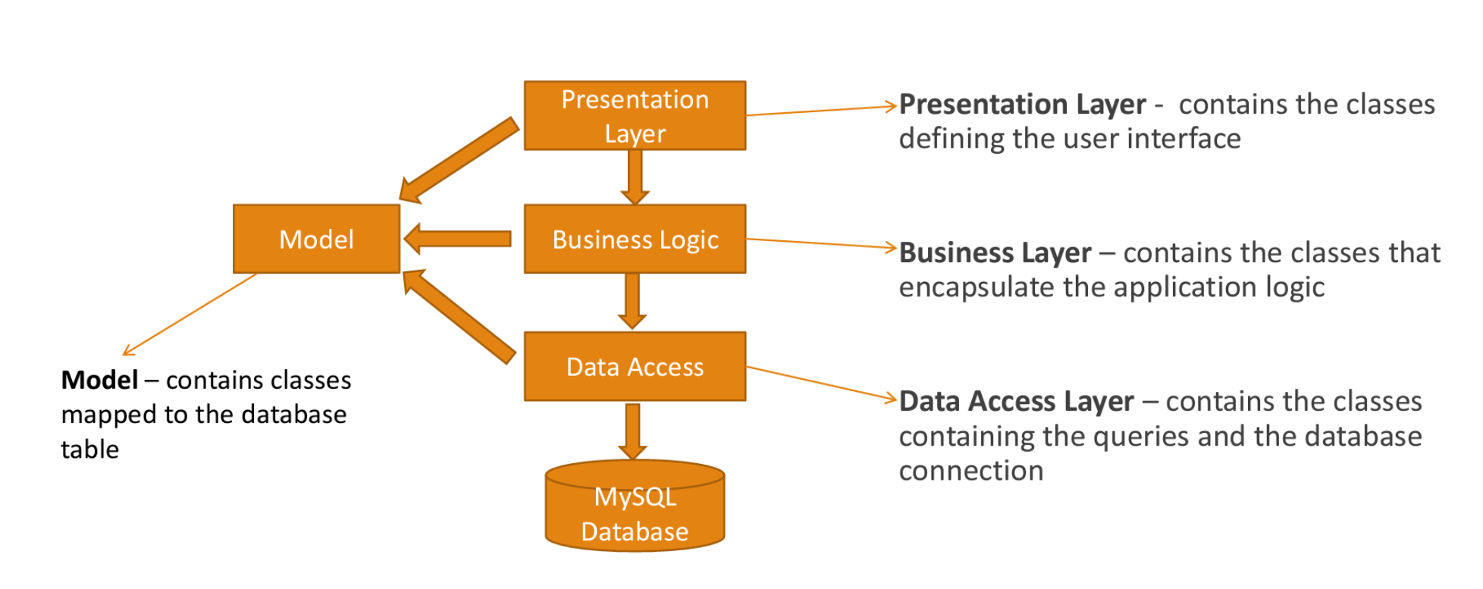

Divizarea in pachete:

- Model:
  - Bill
  - Client
  - Order
  - Product
- Presentation:
  - ClientManipulation
  - OrderManipulation
  - ProductManipulation
  - EditClient
  - EditProduct
  - View
  - ViewOrder
  - NamesBox
- BusinessLogic
  - BillBLL
  - ClientBLL
  - OrderBLL
  - ProductBLL
- DataAccess
  - AbstractDAO
  - BillDAO
  - ClientDAO
  - OrderDAO
  - ProductDAO
  - Validators
    - ClientFieldsValidator
    - EmailValidator
    - ProductPriceValidator
    - QuantityOrderingValidator
    - Validator
- Connect
  - ConnectionFactory

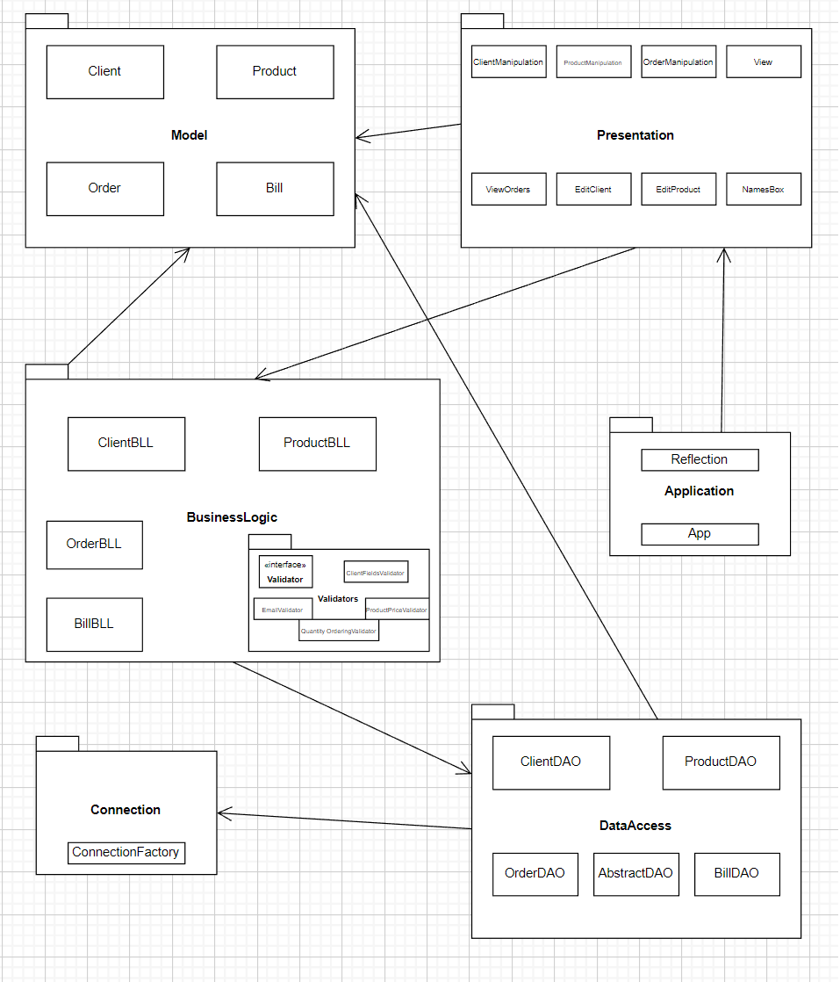

Divizarea in clase:

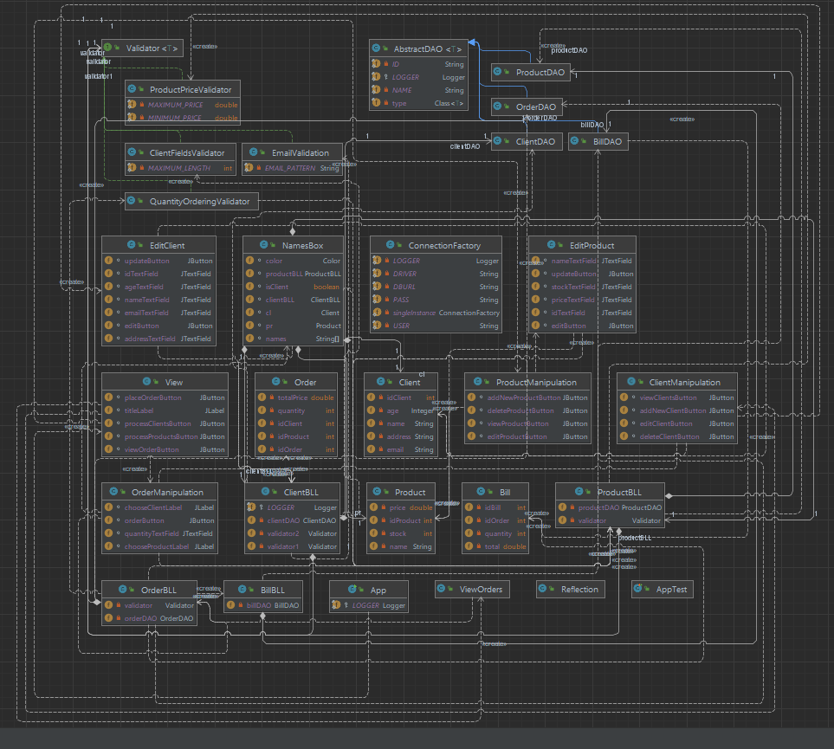

Implementare
App
- Metoda main in care instantiem un obiect de tip View:
- public class App {
protected static final Logger LOGGER = Logger.getLogger(App.class.getName());
public static void main(String[] args) throws Exception {
View view=new View();
}
}

Bill

- Clasa destinata facturilor
- Atribute: idBill, idOrder, quantity, total
- Metode:
- public Bill(int idOrder, int quantity, double total) {
this.idOrder = idOrder;
this.quantity = quantity;
this.total = total;
}
public Bill(){}
public int getIdOrder() {
return idOrder;
}
public int getQuantity() {
return quantity;
}
public double getTotal() {
return total;
}
@Override
public String toString() {
return "Bill{" +
"idBill=" + idBill +
", idOrder=" + idOrder +
", quantity=" + quantity +
", total=" + total +
'}';
}

Client

- Clasa destinata clientilor
- Atribute: idClient, name, address, email, age
- Metode:

public Client(String name, String address, String email, Integer age) {
super();
this.name = name;
this.address = address;
this.email = email;
this.age = age;
}
public Client(int idClient, String name, String address, String email, Integer age) {
super();
this.idClient = idClient;
this.name = name;
this.address = address;
this.email = email;
this.age = age;
}
public Client() {
}
public int getIdClient() {
return idClient;
}
public String getName() {
return name;
}
public void setName(String name) {
this.name = name;
}
public String getAddress() {
return address;
}
public String getEmail() {
return email;
}
public Integer getAge() {
return age;
}
@Override
public String toString() {
return "Client[" +
"idClient=" + idClient +
", name='" + name + '\'' +
", address='" + address + '\'' +
", email='" + email + '\'' +
", age=" + age +
']';
}

Order

- Clasa destinata comenzilor
- Atribute: idOrder, idClient, idProduct, quantity, totalPrice
- Metode:
- public Order(int idClient, int idProduct, int quantity, double totalPrice) {
super();
this.idClient = idClient;
this.idProduct = idProduct;
this.quantity = quantity;
this.totalPrice = totalPrice;
}
public Order(){}
public int getIdProduct() {
return idProduct;
}
public int getQuantity() {
return quantity;
}
@Override
public String toString() {
return "Order[" + "idOrder=" + idOrder +
", idClient=" + idClient +
", idProduct=" + idProduct +
", quantity=" + quantity +
", totalPrice=" + totalPrice +
']';
}

Product

- Clasa destinata produselor
- Atribute: idProduct, name, stock, price
- Metode:

public Product(int idProduct, String name, int stock, double price) {
super();
this.idProduct = idProduct;
this.name = name;
this.stock = stock;
this.price = price;
}
public Product(String name, int stock, double price) {
super();
this.name = name;
this.stock = stock;
this.price = price;
}
public Product() {
}
public int getIdProduct() {
return idProduct;
}
public void setIdProduct(int idProduct) {
this.idProduct = idProduct;
}
public String getName() {
return name;
}
public void setName(String name) {
this.name = name;
}
public double getPrice() {
return price;
}
public int getStock() {
return stock;
}
public void setStock(int stock) {
this.stock = stock;
}
@Override
public String toString() {
return "Product[" +
"idProduct=" + idProduct +
", name='" + name + '\'' +
", stock=" + stock +
", price=" + price +
']';
}

AbstractDAO

- Clasa destinate mostenirii de tip DataAcces, clasa in care sunt create metode pentru preluarea si manipularea datelor din baza de date
- Atribute: LOGGER, NAME, ID, type
- Metode:

public AbstractDAO() {
this.type = (Class<T>) ((ParameterizedType) getClass().getGenericSuperclass()).getActualTypeArguments()[0];
}
public List<T> createObjects(ResultSet resultSet) {
List<T> list = new ArrayList<T>();
Constructor[] ctors = type.getDeclaredConstructors();
Constructor ctor = null;
for (int i = 0; i < ctors.length; i++) {
ctor = ctors[i];
if (ctor.getGenericParameterTypes().length == 0)
break;
}
try {
while (resultSet != null && resultSet.next()) {
ctor.setAccessible(true);
T instance = (T) ctor.newInstance();
for (Field field : type.getDeclaredFields()) {
String fieldName = field.getName();
Object value = resultSet.getObject(fieldName);
PropertyDescriptor propertyDescriptor = new PropertyDescriptor(fieldName, type);
Method method = propertyDescriptor.getWriteMethod();
method.invoke(instance, value);
}
list.add(instance);
}
} catch (InstantiationException e) {
e.printStackTrace();
} catch (IllegalAccessException e) {
e.printStackTrace();
} catch (SecurityException e) {
e.printStackTrace();
} catch (IllegalArgumentException e) {
e.printStackTrace();
} catch (InvocationTargetException e) {
e.printStackTrace();
} catch (SQLException e) {
e.printStackTrace();
} catch (IntrospectionException e) {
e.printStackTrace();
}
return list;
}
private String createSelectQuery() {
StringBuilder stringBuilder = new StringBuilder();
stringBuilder.append("SELECT ");
stringBuilder.append(" * ");
stringBuilder.append(" FROM schooldb.");
stringBuilder.append(type.getSimpleName().toLowerCase());
return stringBuilder.toString();
}
public String createSelectWhereQueryWithEqual(String field) {
StringBuilder stringBuilder = new StringBuilder();
stringBuilder.append("SELECT ");
stringBuilder.append(" * ");
stringBuilder.append(" FROM ");
stringBuilder.append(type.getSimpleName());
stringBuilder.append(" WHERE " + field + " = ? ");
return stringBuilder.toString();
}
public String createSelectWhereQueryWithLike(String field) {
StringBuilder stringBuilder = new StringBuilder();
stringBuilder.append("SELECT ");
stringBuilder.append(" * ");
stringBuilder.append(" FROM ");
stringBuilder.append(type.getSimpleName());
stringBuilder.append(" WHERE " + field + " LIKE ? ");
return stringBuilder.toString();
}
private String createDeleteQuery(String field) {
StringBuilder stringBuilder = new StringBuilder();
stringBuilder.append("DELETE FROM ");
stringBuilder.append(type.getSimpleName());
stringBuilder.append(" WHERE ");
stringBuilder.append(field);
stringBuilder.append(" = ?;");
return stringBuilder.toString();
}
private String createInsertQuery(ArrayList<String> field) {
StringBuilder stringBuilder = new StringBuilder();
stringBuilder.append("INSERT INTO schooldb." + type.getSimpleName() + " (");
for (int i = 0; i < field.size(); i++) {
if (i == 0) {
continue;
}
if (i == field.size() - 1) {
stringBuilder.append(field.get(i) + ") ");
break;
}
stringBuilder.append(field.get(i) + ",");
}
stringBuilder.append(" VALUES (");
for (int i = 0; i < field.size(); i++) {
if (i == 0) {
continue;
}
if (i == field.size() - 1) {
stringBuilder.append("?);");
break;
}
stringBuilder.append("?,");
}
return stringBuilder.toString();
}
private String createUpdateQuery(ArrayList<String> fields) {
StringBuilder stringBuilder = new StringBuilder();
stringBuilder.append("UPDATE " + type.getSimpleName());
stringBuilder.append(" SET ");
for (int i = 0; i < fields.size(); i++) {
if (i == fields.size() - 1) {
stringBuilder.append(fields.get(i) + " = ? ");
break;
}
stringBuilder.append(fields.get(i) + " = ?, ");
}
stringBuilder.append("WHERE id" + type.getSimpleName() + " = ?;");
return stringBuilder.toString();
}
public List<T> findAll() {
Connection connection = null;
PreparedStatement statement = null;
ResultSet resultSet = null;
String query = createSelectQuery();
try {
connection = ConnectionFactory.getConnection();
statement = connection.prepareStatement(query);
resultSet = statement.executeQuery();
return createObjects(resultSet);
} catch (SQLException throwables) {
LOGGER.log(Level.WARNING, type.getName() + "DAO:findAll " + throwables.getMessage());
} finally {
ConnectionFactory.close(resultSet);
ConnectionFactory.close(statement);
ConnectionFactory.close(connection);
}
return null;
}
public T findById(int id) {
Connection connection = null;
PreparedStatement statement = null;
ResultSet resultSet = null;
String query = createSelectWhereQueryWithEqual(ID+type.getSimpleName());
try {
connection = ConnectionFactory.getConnection();
statement = connection.prepareStatement(query);
statement.setInt(1, id);
resultSet = statement.executeQuery();
return getEntityResult(resultSet);
} catch (SQLException e) {
LOGGER.log(Level.WARNING, type.getName() + "DAO:findById " + e.getMessage());
} finally {
ConnectionFactory.close(resultSet);
ConnectionFactory.close(statement);
ConnectionFactory.close(connection);
}
return null;
}
public T findByName(String name) {
Connection connection = null;
PreparedStatement statement = null;
ResultSet resultSet = null;
String query = createSelectWhereQueryWithLike(NAME);
try {
connection = ConnectionFactory.getConnection();
statement = connection.prepareStatement(query);
statement.setString(1, "%" + name + "%" );
resultSet = statement.executeQuery();
return getEntityResult(resultSet);
} catch (SQLException e) {
LOGGER.log(Level.WARNING, "ClientDAO:findByName " + e.getMessage());
} finally {
ConnectionFactory.close(resultSet);
ConnectionFactory.close(statement);
ConnectionFactory.close(connection);
}
return null;
}
private T getEntityResult(ResultSet resultSet) {
if(resultSet!=null) {
List<T> result = createObjects(resultSet);
if(!result.isEmpty()) {
return result.get(0);
}
LOGGER.log(Level.INFO, "No result was found for type " + type.getSimpleName());
}
return null;
}
private void getValuesFromDB(T t, ArrayList<Object> values, ArrayList<String> fields) {
for (Field field : t.getClass().getDeclaredFields()) {
field.setAccessible(true);
fields.add(field.getName());
Object value;
try {
value = field.get(t);
values.add(value);
} catch (IllegalAccessException e) {
e.printStackTrace();
}
}
}
public void insert(T t) {
Connection connection = null;
PreparedStatement statement = null;
ArrayList<Object> values = new ArrayList<>();
ArrayList<String> fields = new ArrayList<String>();
getValuesFromDB(t, values, fields);
String query = createInsertQuery(fields);
System.out.println(query);
try {
connection = ConnectionFactory.getConnection();
statement = connection.prepareStatement(query);
for (int i = 1; i < fields.size(); i++) {
if (values.get(i) instanceof Integer) {
statement.setInt(i, (Integer) values.get(i));
}
if (values.get(i) instanceof String) {
statement.setString(i, values.get(i).toString());
}
if (values.get(i) instanceof Double) {
statement.setDouble(i, (Double) values.get(i));
}
}
statement.execute();
} catch (SQLException throwables) {
throwables.printStackTrace();
} finally {
ConnectionFactory.close(connection);
ConnectionFactory.close(statement);
}
}
public void update(T t, int id) {
Connection connection = null;
PreparedStatement statement = null;
ArrayList<Object> values = new ArrayList<>();
ArrayList<String> fields = new ArrayList<String>();
getValuesFromDB(t, values, fields);
String query = createUpdateQuery(fields);
try {
int i;
connection = ConnectionFactory.getConnection();
statement = connection.prepareStatement(query);
for (i = 0; i < fields.size(); i++) {
if (values.get(i) instanceof Integer) {
statement.setInt(i + 1, ((Integer) values.get(i)).intValue());
}
if (values.get(i) instanceof String) {
statement.setString(i + 1, values.get(i).toString());
}
if (values.get(i) instanceof Double) {
statement.setDouble(i + 1, ((Double) values.get(i)).doubleValue());
}
}
statement.setInt(i + 1, id);
statement.executeUpdate();
} catch (SQLException throwables) {
throwables.printStackTrace();
} finally {
ConnectionFactory.close(connection);
ConnectionFactory.close(statement);
}
}
public void delete(int id) {
Connection connection = null;
PreparedStatement statement = null;
String query = createDeleteQuery("id"+type.getSimpleName());
T t = findById(id);
try {
int i;
connection = ConnectionFactory.getConnection();
statement = connection.prepareStatement(query);
statement.setInt(1, id);
statement.execute();
} catch (SQLException throwables) {
throwables.printStackTrace();
} finally {
ConnectionFactory.close(connection);
ConnectionFactory.close(statement);
}
}

ClientDAO

- Clasa destinate mostenirii de tip DataAcces, clasa in care sunt create metode pentru preluarea si manipularea datelor clientilor din baza de date
- Atribute: -
- Metode: -
- public class ClientDAO extends AbstractDAO<Client> { //the class is a subclass of AbstractDAO
//in this class we define the original class methods
}

ProductDAO

- Clasa destinate mostenirii de tip DataAcces, clasa in care sunt create metode pentru preluarea si manipularea datelor produselor din baza de date
- Atribute: -
- Metode: -

public class ProductDAO extends AbstractDAO<Product> {//the class is a subclass of AbstractDAO
//in this class we define the original class methods
}

BillDAO

- Clasa destinate mostenirii de tip DataAcces, clasa in care sunt create metode pentru preluarea si manipularea datelor facturilor din baza de date
- Atribute: -
- Metode:

private String createInsertBillInDB(ArrayList<String> fields) {
StringBuilder stringBuilder = new StringBuilder();
stringBuilder.append("INSERT INTO schooldb.log (");
for (String string : fields) {
if (fields.get(0).equals(string)) {
continue;
}
if (fields.get(fields.size() - 1).equals(string)) {
stringBuilder.append(string + ") ");
break;
}
stringBuilder.append(string + ", ");
}
stringBuilder.append(" VALUES (");
for (String string : fields) {
if (fields.get(0).equals(string)) {
continue;
}
if (fields.get(fields.size() - 1).equals(string)) {
stringBuilder.append("?);");
break;
}
stringBuilder.append("?,");
}
return stringBuilder.toString();
}
public void addBill(int idOrder, int quantity, double total) {
Connection connection = null;
PreparedStatement statement = null;
Bill bill = new Bill();
Class<?> c = bill.getClass();
ArrayList<String> fields = new ArrayList<>();
for (Field fd : c.getDeclaredFields()) {
fields.add(fd.getName());
}
String query = createInsertBillInDB(fields);
try {
connection = ConnectionFactory.getConnection();
statement = connection.prepareStatement(query);
statement.setInt(1, idOrder);
statement.setInt(2, quantity);
statement.setDouble(3, total);
statement.executeUpdate();
} catch (SQLException e) {
e.printStackTrace();
} finally {
ConnectionFactory.close(connection);
ConnectionFactory.close(statement);
}
}

OrderDAO

- Clasa destinate mostenirii de tip DataAcces, clasa in care sunt create metode pentru preluarea si manipularea datelor comenzilor din baza de date
- Atribute: -
- Metode:
- private String createInsertOrderInDB(ArrayList<String> fields) {
StringBuilder stringBuilder = new StringBuilder();
stringBuilder.append("INSERT INTO schooldb.order (");
for (String string : fields) {
if (fields.get(0).equals(string)) {
continue;
}
if (fields.get(fields.size() - 1).equals(string)) {
stringBuilder.append(string + ") ");
break;
}
stringBuilder.append(string + ", ");
}
stringBuilder.append(" VALUES (");
for (String string : fields) {
if (fields.get(0).equals(string)) {
continue;
}
if (fields.get(fields.size() - 1).equals(string)) {
stringBuilder.append("?);");
break;
}
stringBuilder.append("?,");
}
return stringBuilder.toString();
}
public int addOrder(int idClient, int idProdus, int quantity, Product product) {
Connection connection = null;
PreparedStatement statement = null;
Order o = new Order();
Class<?> c = o.getClass();
ArrayList<String> fields = new ArrayList<>();
for (Field fd : c.getDeclaredFields()) {
fields.add(fd.getName());
}
String query = createInsertOrderInDB(fields);
try {
connection = ConnectionFactory.getConnection();
String[] generatedColumns = { "idOrder" };
statement = connection.prepareStatement(query, generatedColumns);
double price = product.getPrice() * quantity;
int stockLeft = product.getStock() - quantity;
product.setStock(stockLeft);
statement.setInt(1, idClient);
statement.setInt(2, idProdus);
statement.setInt(3, quantity);
statement.setDouble(4, price);
statement.executeUpdate();
ResultSet rs = statement.getGeneratedKeys();
if (rs.next()) {
int id = rs.getInt(1);
LOGGER.log(Level.INFO, "Inserted order with ID - " + id); // display inserted record
return id;
}
} catch (SQLException e) {
e.printStackTrace();
} finally {
ConnectionFactory.close(connection);
ConnectionFactory.close(statement);
}
return 0;

ConnectionFactory

- Clasa pentru crearea conexiunii intre programul Java si data de baza pentru a avea access la tabelele acesteia.
- Atribute: LOGGER, DRIVER, DBURL, USER, PASS, singleInstance
- Metode:
- private ConnectionFactory() {
try {
Class.forName(DRIVER);
} catch (ClassNotFoundException e) {
e.printStackTrace();
}
}
private Connection createConnection() {
Connection connection = null;
try {
connection = DriverManager.getConnection(DBURL, USER, PASS);
} catch (SQLException e) {
LOGGER.log(Level.WARNING, "An error occured while trying to connect to the database");
e.printStackTrace();
}
return connection;
}
public static Connection getConnection() {
return singleInstance.createConnection();
}
public static void close(Connection connection) {
if (connection != null) {
try {
connection.close();
} catch (SQLException e) {
LOGGER.log(Level.WARNING, "An error occured while trying to close the connection");
}
}
}
public static void close(Statement statement) {
if (statement != null) {
try {
statement.close();
} catch (SQLException e) {
LOGGER.log(Level.WARNING, "An error occured while trying to close the statement");
}
}
}
public static void close(ResultSet resultSet) {
if (resultSet != null) {
try {
resultSet.close();
} catch (SQLException e) {
LOGGER.log(Level.WARNING, "An error occured while trying to close the ResultSet");
}
}
}

BillBLL

- Clasa pentru manipularea datelor cu ajutorul metodelor din clasa BillDAO
- Atribute: billDAO
- Metode:

- public BillBLL(){
billDAO=new BillDAO();
}
public void insertOrderBill(Bill bill) {
billDAO.addBill(bill.getIdOrder(), bill.getQuantity(), bill.getTotal());
}
public List<Bill> findAllBill() {
List<Bill> billList = billDAO.findAll();
if (billList == null) {
throw new NoSuchElementException("There are no orders in the bill table!");
}
return billList;
}

ClientBLL

- Clasa pentru manipularea datelor cu ajutorul metodelor din clasa ClientDAO
- Atribute: clientDAO, validator1, validator2
- Metode:
- public ClientBLL() {
validator1 = new EmailValidation();
validator2 = new ClientFieldsValidator();
clientDAO = new ClientDAO();
}
public Client findClientById(int idClient) {
Client client = clientDAO.findById(idClient);
if (client == null) {
throw new NoSuchElementException("The client with id =" + idClient + "does not exist in data base!");
}
return client;
}
public Client findClientByName(String name) {
Client client = clientDAO.findByName(name);
if (client == null) {
throw new NoSuchElementException("The client with name =" + name + "does not exist in data base!");
}
return client;
}
public void insertClient(Client client) {
validator1.validate(client);
validator2.validate(client);
clientDAO.insert(client);
}
public List<Client> findAllClients() {
List<Client> clientList = clientDAO.findAll();
if (clientList == null) {
throw new NoSuchElementException("There are no clients in the data base!");
}
return clientList;
}
public void updateClientById(Client client, int idClient) {
validator1.validate(client);
validator2.validate(client);
clientDAO.update(client, idClient);
}
public void deleteClient(String name) {
Client client = clientDAO.findByName(name);
if(client != null) {
LOGGER.log(Level.INFO, "Delete Client with id " + client.getIdClient());
clientDAO.delete(client.getIdClient());
}
}

ProductBLL

- Clasa pentru manipularea datelor cu ajutorul metodelor din clasa ProductDAO
- Atribute: productDAO, validator
- Metode:
- public ProductBLL() {
validator=new ProductPriceValidator();
productDAO=new ProductDAO();
}
public Product findProductById(int idProduct) {
Product product = productDAO.findById(idProduct);
validator.validate(product);
if (product == null) {
throw new NoSuchElementException("The product with id = " + idProduct + " does not exist in data base!");
}
return product;
}
public Product findProductByName(String name) {
Product product = productDAO.findByName(name);
if (product == null) {
throw new NoSuchElementException("The product with name = " + name + " does not exist in data base!");
}
return product;
}
public void insertProduct(Product product) {
validator.validate(product);
productDAO.insert(product);
}
public List<Product> findAllProducts() {
List<Product> productList = productDAO.findAll();
if (productList == null) {
throw new NoSuchElementException("There are no products in data base!");
}
return productList;
}
public void updateProduct(Product product, int idProduct) {
validator.validate(product);
productDAO.update(product, idProduct);
}
public void updateProductById(Product pd, int id) {
productDAO.update(pd, id);
}
public void deleteProduct(String name) {
Product product=productDAO.findByName(name);
productDAO.delete(product.getIdProduct());
}

OrderBLL

- Clasa pentru manipularea datelor cu ajutorul metodelor din clasa OrderDAO
- Atribute: orderDAO, validator
- Metode:
- public OrderBLL(){
orderDAO = new OrderDAO();
validator = new QuantityOrderingValidator();
}
public void placeNewOrder(int idClient, int idProdus, int quantity){
Order order= new Order(idClient, idProdus, quantity, 0);
validator.validate(order);
ProductBLL productBLL=new ProductBLL();
Product product=productBLL.findProductById(idProdus);
int orderID = orderDAO.addOrder(idClient, idProdus, quantity, product);
productBLL.updateProduct(product, idProdus);
Bill bill=new Bill(orderID, order.getQuantity(), product.getPrice() * quantity);
BillBLL billBLL=new BillBLL();
billBLL.insertOrderBill(bill);
if(product.getStock()==0){
productBLL.deleteProduct(product.getName());
}
}
public List<Order> findAllOrders(){
List<Order> orderList=orderDAO.findAll();
if(orderList==null){
throw new NoSuchElementException("There are no existing orders in data base!");
}
return orderList;
}

Validator

- Interfata pentru clasele de validare ale campurilor de introducere a datelor
- Atribute: -
- Metode:
public interface Validator<T>{
public void validate(T t);
}

ClientFieldsValidator

- Clasa pentru clasele de validare ale campurilor de introducere a datelor unui client
- Atribute: MAXIMUM_LENGTH
- Metode:
@Override
public void validate(Client client) {
if (client.getAddress().length() > MAXIMUM_LENGTH || client.getName().length() < 1) {
throw new IllegalArgumentException("The client name is not valid!");
}
if (client.getAddress().length() > MAXIMUM_LENGTH || client.getAddress().length() < 1) {
throw new IllegalArgumentException("The client address is not valid!");
}
}

EmailValidator

- Clasa pentru clasele de validare ale campurilor de introducere a emailului
- Atribute: EMAIL_PATTERN
- Metode:
@Override
public void validate(Client t) {
Pattern pattern = Pattern.compile(EMAIL_PATTERN);
if (!pattern.matcher(t.getEmail()).matches()) {
throw new IllegalArgumentException("Entered email is not a valid!");
}
}

ClientFieldsValidator

- Clasa pentru clasele de validare ale campurilor de introducere a emailului
- Atribute: EMAIL_PATTERN
- Metode:
@Override
public void validate(Client t) {
Pattern pattern = Pattern.compile(EMAIL_PATTERN);
if (!pattern.matcher(t.getEmail()).matches()) {
throw new IllegalArgumentException("Entered email is not a valid!");
}
}

ProductPriceValidator

- Clasa pentru clasele de validare ale campurilor de introducere a pretului
- Atribute: MINIMUM_PRICE, MAXIMUM_PRICE
- Metode:

@Override
public void validate(Product product) {
if(product.getPrice()<MINIMUM_PRICE){
throw new IllegalArgumentException("The product price is to small!");
}
if(product.getPrice()>MAXIMUM_PRICE){
throw new IllegalArgumentException("The product price is to big!");
}
}

QuantityOrderingValidator

- Clasa pentru clasele de validare ale campurilor de introducere a cantitatii
- Atribute: -
- Metode:
@Override
public void validate(Order order) {
ProductBLL productBLL = new ProductBLL();
Product product = productBLL.findProductById(order.getIdProduct());
if (order.getQuantity() < 1 || order.getQuantity() > product.getStock()) {
throw new IllegalArgumentException("The Product Stock is under quantity you have ordered!");
}
}

Reflection

- Clasa pentru extragerea proprietatiilor bazei de date conectate la program
- Atribute: -
- Metode:
public static ArrayList<Object> getValues(Object o){
int i=0;
ArrayList<Object> objects = new ArrayList<>();
for (Field field : o.getClass().getDeclaredFields()) {
field.setAccessible(true);
try {
objects.add(field.get(o));
} catch (IllegalArgumentException e) {
e.printStackTrace();
} catch (IllegalAccessException e) {
e.printStackTrace();
}
}
return objects;
}
public static List<String> getFields(Object o){
ArrayList<String> fields = new ArrayList<>();
Class<?> c = o.getClass();
for(Field field:c.getDeclaredFields()){
fields.add(field.getName());
}
return fields;
}

View

- Clasa pentru crearea Main Frame ce contine butoanele catre ferestrele aditionale
- Atribute: titleLabel, processClientsButton, processProductsButton, placeOrderButton, viewOrderButton
- Metode:

public View() {
Color color1=new Color(254, 232, 176);
Color color2=new Color(156, 167, 119);
setDefaultCloseOperation(JFrame.EXIT_ON_CLOSE);
getContentPane().setLayout(null);
this.setTitle("Main Frame");
titleLabel=new JLabel("Hello! Please choose the action you would like to proceed.");
titleLabel.setBounds(75, 15, 450, 50);
titleLabel.setFont(new Font("Calibri",Font.BOLD,14));
this.getContentPane().add(titleLabel);
processClientsButton = new JButton("Process clients");
processClientsButton.setFont(new Font("Calibri",Font.BOLD,12));
processClientsButton.setBounds(75, 100, 120,30);
processClientsButton.setBackground(color2);
processClientsButton.addActionListener(new ActionListener() {
@Override
public void actionPerformed(ActionEvent e) {
if(e.getSource() == processClientsButton){
new ClientManipulation();
}
}
});
this.getContentPane().add(processClientsButton);
processProductsButton = new JButton("Process products");
processProductsButton.setFont(new Font("Calibri",Font.BOLD,12));
processProductsButton.setBounds(305, 100, 120,30);
processProductsButton.setBackground(color2);
processProductsButton.addActionListener(new ActionListener() {
@Override
public void actionPerformed(ActionEvent e) {
if(e.getSource() == processProductsButton){
new ProductManipulation();
}
}
});
this.getContentPane().add(processProductsButton);
placeOrderButton = new JButton("Place order");
placeOrderButton.setFont(new Font("Calibri",Font.BOLD,12));
placeOrderButton.setBounds(75, 175, 120,30);
placeOrderButton.setBackground(color2);
placeOrderButton.addActionListener(new ActionListener() {
@Override
public void actionPerformed(ActionEvent e) {
if(e.getSource() == placeOrderButton){
new OrderManipulation();
}
}
});
this.getContentPane().add(placeOrderButton);
viewOrderButton = new JButton("View orders");
viewOrderButton.setFont(new Font("Calibri",Font.BOLD,12));
viewOrderButton.setBounds(305, 175, 120,30);
viewOrderButton.setBackground(color2);
viewOrderButton.addActionListener(new ActionListener() {
@Override
public void actionPerformed(ActionEvent e) {
if(e.getSource() == viewOrderButton){
new ViewOrders();
}
}
});
this.getContentPane().add(viewOrderButton);
setSize(500,300);
getContentPane().setBackground(color1);
setVisible(true);
}

ViewOrders

- Clasa pentru crearea Order Page ce contine o tabela cu toate comenzile bazei de date
- Atribute: -
- Metode:
ViewOrders(){
OrderBLL orderBLL = new OrderBLL();
Color color1=new Color(254, 232, 176);
Color color2=new Color(156, 167, 119);
JFrame frame = new JFrame("View orders");
List<Order> orders = orderBLL.findAllOrders();
List<String> fieldsList = Reflection.getFields(orders.get(0));
String[] fields = new String[fieldsList.size()];
int i = 0;
for(String field:fieldsList){
fields[i++] = field;
}
Object[][] data = new Object[orders.size()][fieldsList.size()];
i=0;
for(Order order:orders){
ArrayList<Object> obj = Reflection.getValues(order);
int j=0;
for(Object o : obj){
data[i][j++] = o;
}
i++;
}
JTable table = new JTable(data, fields);
table.setPreferredSize(new Dimension(600,400));
table.setBackground(color2);
JScrollPane scrollPane = new JScrollPane(table);
table.setFillsViewportHeight(true);
scrollPane.setBackground(color2);
frame.add(scrollPane);
frame.setLayout(new FlowLayout());
frame.setSize(700, 500);
frame.getContentPane().setBackground(color1);
frame.setDefaultCloseOperation(JFrame.DISPOSE_ON_CLOSE);
frame.setResizable(false);
frame.setVisible(true);
}

ClientManipulation

- Clasa pentru crearea Client Page ce contine 4 butoane specifice fiecarei actiuni pentru maipularea tabelei Client din baza de date
- Atribute: addNewClientButton, editClientButton, deleteClientButton, viewClientsButton
- Metode:

public ClientManipulation(){
Color color1=new Color(254, 232, 176);
Color color2=new Color(156, 167, 119);
setTitle("Client Page");
getContentPane().setLayout(null);
ClientBLL clientBLL=new ClientBLL();
List<Client> clientList=null;
addNewClientButton=new JButton();
addNewClientButton.setText("Add new client");
addNewClientButton.setBackground(color2);
addNewClientButton.setBounds(25, 50, 200, 50);
addNewClientButton.setFont(new Font("Calibri",Font.BOLD,16));
addNewClientButton.addActionListener(new ActionListener() {
@Override
public void actionPerformed(ActionEvent e) {
if(e.getSource() == addNewClientButton) {
JFrame frame = new JFrame("Add new client");
// frame.setDefaultCloseOperation(JFrame.EXIT_ON_CLOSE);
frame.getContentPane().setLayout(null);
JTextField nameTextField = new JTextField("Name");
nameTextField.setFont(new Font("Consolas", Font.PLAIN, 16));
nameTextField.setBounds(25, 25, 200, 20);
nameTextField.setBackground(color2);
frame.getContentPane().add(nameTextField);
JTextField addressTextField = new JTextField("Address");
addressTextField.setFont(new Font("Consolas", Font.PLAIN, 16));
addressTextField.setBounds(25, 60, 200, 20);
addressTextField.setBackground(color2);
frame.getContentPane().add(addressTextField);
JTextField emailTextField = new JTextField("Email");
emailTextField.setFont(new Font("Consolas", Font.PLAIN, 16));
emailTextField.setBounds(25, 95, 200, 20);
emailTextField.setBackground(color2);
frame.getContentPane().add(emailTextField);
JTextField ageTextField = new JTextField("Age");
ageTextField.setFont(new Font("Consolas", Font.PLAIN, 16));
ageTextField.setBounds(25, 130, 200, 20);
ageTextField.setBackground(color2);
frame.getContentPane().add(ageTextField);
JButton addButton = new JButton("Add client");
addButton.setFont(new Font("Consolas", Font.PLAIN, 15));
addButton.setBackground(color2);
addButton.setBounds(300, 165, 150, 50);
addButton.addActionListener(new ActionListener() {
@Override
public void actionPerformed(ActionEvent e) {
Client cl = new Client(nameTextField.getText(), addressTextField.getText(), emailTextField.getText(), Integer.parseInt(ageTextField.getText()));
clientBLL.insertClient(cl);
}
});
frame.getContentPane().add(addButton);
frame.setSize(500,280);
frame.getContentPane().setBackground(color1);
frame.setVisible(true);
}
}
});
getContentPane().add(addNewClientButton);
editClientButton=new JButton();
editClientButton.setText("Edit client");
editClientButton.setBackground(color2);
editClientButton.setBounds(250, 50, 200, 50);
editClientButton.setFont(new Font("Calibri",Font.BOLD,16));
editClientButton.addActionListener(new ActionListener() {
@Override
public void actionPerformed(ActionEvent e) {
if(e.getSource() == editClientButton) {
new EditClient();
}
}
});
getContentPane().add(editClientButton);
deleteClientButton=new JButton();
deleteClientButton.setText("Delete client");
deleteClientButton.setBackground(color2);
deleteClientButton.setBounds(25, 150, 200, 50);
deleteClientButton.setFont(new Font("Calibri",Font.BOLD,16));
deleteClientButton.addActionListener(new ActionListener() {
@Override
public void actionPerformed(ActionEvent e) {
if(e.getSource() == deleteClientButton){
JFrame frame = new JFrame("Delete client");
frame.getContentPane().setLayout(null);
JTextField nameTextField = new JTextField("Name");
nameTextField.setFont(new Font("Consolas", Font.PLAIN, 16));
nameTextField.setBounds(25, 15, 400, 30);
nameTextField.setBackground(color2);
frame.getContentPane().add(nameTextField);
JButton deleteButton = new JButton("Delete client");
deleteButton.setFont(new Font("Consolas", Font.PLAIN, 15));
deleteButton.setBackground(color2);
deleteButton.setBounds(300, 60, 150, 40);
deleteButton.addActionListener(new ActionListener() {
@Override
public void actionPerformed(ActionEvent e) {
clientBLL.deleteClient(nameTextField.getText());
}
});
frame.getContentPane().add(deleteButton);
frame.setSize(500,140);
frame.getContentPane().setBackground(color1);
frame.setVisible(true);
}
}
});
getContentPane().add(deleteClientButton);
viewClientsButton=new JButton();
viewClientsButton.setText("View clients");
viewClientsButton.setBackground(color2);
viewClientsButton.setBounds(250, 150, 200, 50);
viewClientsButton.setFont(new Font("Calibri",Font.BOLD,16));
viewClientsButton.addActionListener(new ActionListener() {
@Override
public void actionPerformed(ActionEvent e) {
JFrame frame = new JFrame("View clients");
frame.getContentPane().setLayout(null);
List<Client> clients = clientBLL.findAllClients();
List<String> fieldsList = Reflection.getFields(clients.get(0));
String[] fields = new String[fieldsList.size()];
int i = 0;
for(String field:fieldsList){
fields[i++] = field;
}
Object[][] data = new Object[clients.size()][fieldsList.size()];
i=0;
for(Client client:clients){
ArrayList<Object> obj = Reflection.getValues(client);
int j=0;
for(Object o : obj){
data[i][j++] = o;
}
i++;
}
JTable table = new JTable(data, fields);
table.setPreferredSize(new Dimension(600,400));
table.setBackground(color2);
frame.getContentPane().add(table);
JScrollPane scrollPane = new JScrollPane(table);
table.setFillsViewportHeight(true);
scrollPane.setBackground(color2);
frame.getContentPane().add(scrollPane);
frame.setLayout(new FlowLayout());
frame.setSize(700, 500);
frame.getContentPane().setBackground(color1);
frame.setDefaultCloseOperation(JFrame.DISPOSE_ON_CLOSE);
frame.setResizable(false);
frame.setVisible(true);
}
});
getContentPane().add(viewClientsButton);
setSize(500,300);
getContentPane().setBackground(color1);
setVisible(true);
}

ProductManipulation

- Clasa pentru crearea Product Page ce contine 4 butoane specifice fiecarei actiuni pentru maipularea tabelei Product din baza de date
- Atribute: addNewProductButton, editProductButton, deleteProductButton, viewProductsButton
- Metode:

public ProductManipulation(){
ProductBLL productBLL = new ProductBLL();
GridLayout layout = new GridLayout(4,1,30,30);
Color color1=new Color(254, 232, 176);
Color color2=new Color(156, 167, 119);
List<Product> list = null;
addNewProductButton = new JButton("Add new product");
addNewProductButton.setBackground(color2);
addNewProductButton.setForeground(Color.WHITE);
addNewProductButton.setSize(200,50);
addNewProductButton.setFont(new Font("Calibri",Font.BOLD,20));
addNewProductButton.setBorder(BorderFactory.createLineBorder(Color.black));
addNewProductButton.addActionListener(new ActionListener() {
@Override
public void actionPerformed(ActionEvent e) {
if(e.getSource() == addNewProductButton) {
JFrame frame = new JFrame("Add product");
JTextField nameTextField= new JTextField("Name");
nameTextField.setFont(new Font("Consolas", Font.PLAIN, 20));
nameTextField.setPreferredSize(new Dimension(400, 30));
nameTextField.setBackground(color2);
JTextField stockTextField = new JTextField("Stock");
stockTextField.setFont(new Font("Consolas", Font.PLAIN, 20));
stockTextField.setPreferredSize(new Dimension(400, 30));
stockTextField.setBackground(color2);
JTextField priceTextField = new JTextField("Price");
priceTextField.setFont(new Font("Consolas", Font.PLAIN, 20));
priceTextField.setPreferredSize(new Dimension(400, 30));
priceTextField.setBackground(color2);
JButton addButton = new JButton("Add");
addButton.setFont(new Font("Consolas", Font.PLAIN, 15));
addButton.setBackground(color2);
addButton.setForeground(Color.WHITE);
addButton.setPreferredSize(new Dimension(100, 40));
addButton.setBorder(BorderFactory.createLineBorder(Color.black));
addButton.addActionListener(new ActionListener() {
@Override
public void actionPerformed(ActionEvent e) {
Product pd = new Product(nameTextField.getText(), Integer.parseInt(stockTextField.getText()), Double.parseDouble(priceTextField.getText()));
productBLL.insertProduct(pd);
}
});
frame.setLayout(new FlowLayout());
frame.add(nameTextField);
frame.add(stockTextField);
frame.add(priceTextField);
frame.add(addButton);
frame.setSize(500, 250);
frame.getContentPane().setBackground(color1);
frame.setDefaultCloseOperation(JFrame.DISPOSE_ON_CLOSE);
frame.setResizable(false);
frame.setVisible(true);
}
}
});
editProductButton = new JButton("Edit product");
editProductButton.setBackground(color2);
editProductButton.setForeground(Color.WHITE);
editProductButton.setSize(200,50);
editProductButton.setFont(new Font("Calibri",Font.BOLD,20));
editProductButton.setBorder(BorderFactory.createLineBorder(Color.black));
editProductButton.addActionListener(new ActionListener() {
@Override
public void actionPerformed(ActionEvent e) {
if(e.getSource() == editProductButton) {
new EditProduct();
}
}
});
deleteProductButton = new JButton("Delete product");
deleteProductButton.setBackground(color2);
deleteProductButton.setForeground(Color.WHITE);
deleteProductButton.setSize(200,50);
deleteProductButton.setFont(new Font("Calibri",Font.BOLD,20));
deleteProductButton.setBorder(BorderFactory.createLineBorder(Color.black));
deleteProductButton.addActionListener(new ActionListener() {
@Override
public void actionPerformed(ActionEvent e) {
if(e.getSource() == deleteProductButton){
JFrame frame = new JFrame("Delete product");
JTextField nameTextField = new JTextField("Name");
nameTextField.setFont(new Font("Consolas", Font.PLAIN, 20));
nameTextField.setPreferredSize(new Dimension(400, 30));
nameTextField.setBackground(color2);
JButton deleteButton = new JButton("Delete");
deleteButton.setFont(new Font("Consolas", Font.PLAIN, 15));
deleteButton.setBackground(color2);
deleteButton.setForeground(Color.WHITE);
deleteButton.setPreferredSize(new Dimension(100, 40));
deleteButton.setBorder(BorderFactory.createLineBorder(Color.black));
deleteButton.addActionListener(new ActionListener() {
@Override
public void actionPerformed(ActionEvent e) {
productBLL.deleteProduct(nameTextField.getText());
}
});
frame.setLayout(new FlowLayout());
frame.add(nameTextField);
frame.add(deleteButton);
frame.setSize(500, 140);
frame.getContentPane().setBackground(color1);
frame.setDefaultCloseOperation(JFrame.DISPOSE_ON_CLOSE);
frame.setResizable(false);
frame.setVisible(true);
}
}
});
viewProductButton= new JButton("View products");
viewProductButton.setBackground(color2);
viewProductButton.setForeground(Color.WHITE);
viewProductButton.setSize(200,50);
viewProductButton.setFont(new Font("Calibri",Font.BOLD,20));
viewProductButton.setBorder(BorderFactory.createLineBorder(Color.black));
viewProductButton.addActionListener(new ActionListener() {
@Override
public void actionPerformed(ActionEvent e) {
JFrame frame = new JFrame("View products");
List<Product> products = productBLL.findAllProducts();
List<String> fieldsList = Reflection.getFields(products.get(0));
String[] fields = new String[fieldsList.size()];
int i = 0;
for(String field:fieldsList){
fields[i++] = field;
}
Object[][] data = new Object[products.size()][fieldsList.size()];
i=0;
for(Product pd:products){
ArrayList<Object> obj = Reflection.getValues(pd);
int j=0;
for(Object o : obj){
data[i][j++] = o;
}
i++;
}
JTable table = new JTable(data, fields);
table.setPreferredSize(new Dimension(600,400));
table.setBackground(color2);
JScrollPane scrollPane = new JScrollPane(table);
table.setFillsViewportHeight(true);
scrollPane.setBackground(color2);
frame.add(scrollPane);
frame.setLayout(new FlowLayout());
frame.setSize(700, 500);
frame.getContentPane().setBackground(color1);
frame.setDefaultCloseOperation(JFrame.DISPOSE_ON_CLOSE);
frame.setResizable(false);
frame.setVisible(true);
}
});
this.setLayout(layout);
this.add(addNewProductButton);
this.add(editProductButton);
this.add(deleteProductButton);
this.add(viewProductButton);
this.setSize(400,400);
this.setTitle("Product Page");
this.getContentPane().setBackground(color1);
this.setDefaultCloseOperation(JFrame.DISPOSE_ON_CLOSE);
this.setResizable(false);
this.setVisible(true);
}

OrderManipulation

- Clasa pentru crearea Order Page ce contine 2 field-uri pentru alegerea clientului si produsului si un field pentru introducerea cantitatii. Clasa gestioneaza plasarea acestora si generarea unui fisier text cu bonul
- Atribute: chooseClientLabel, chooseProductLabel, quantityTextField, orderButton
- Metode:
OrderManipulation() {
Color color1=new Color(254, 232, 176);
Color color2=new Color(156, 167, 119);
OrderBLL orderBLL = new OrderBLL();
chooseClientLabel = new JLabel("Choose Client");
chooseClientLabel.setFont(new Font("Calibri",Font.BOLD,18));
chooseClientLabel.setForeground(Color.WHITE);
chooseClientLabel.setSize(200,20);
chooseClientLabel.setBackground(color2);
ClientBLL clientBLL = new ClientBLL();
List<Client> clients = clientBLL.findAllClients();
String[] names = new String[clients.size()];
int i = 0;
for(Client cl:clients){
names[i++] = cl.getName();
}
NamesBox nb1 = new NamesBox(names,true);
chooseProductLabel = new JLabel("Choose Product");
chooseProductLabel.setFont(new Font("Calibri",Font.BOLD,18));
chooseProductLabel.setForeground(Color.WHITE);
chooseProductLabel.setSize(200,20);
chooseProductLabel.setBackground(color2);
ProductBLL productBLL = new ProductBLL();
List<Product> products = productBLL.findAllProducts();
String[] names1 = new String[products.size()];
i = 0;
for(Product pd:products){
names1[i++] = pd.getName();
}
NamesBox nb2 = new NamesBox(names1,false);
quantityTextField = new JTextField("Quantity");
quantityTextField.setFont(new Font("Consolas", Font.PLAIN, 20));
quantityTextField.setPreferredSize(new Dimension(300, 30));
quantityTextField.setBackground(color2);
orderButton = new JButton("Order");
orderButton.setFont(new Font("Consolas", Font.PLAIN, 15));
orderButton.setBackground(color2);
orderButton.setForeground(Color.WHITE);
orderButton.setPreferredSize(new Dimension(100, 40));
orderButton.setBorder(BorderFactory.createLineBorder(Color.black));
orderButton.addActionListener(new ActionListener() {
@Override
public void actionPerformed(ActionEvent e) {
if(e.getSource() == orderButton) {
Product p = nb2.pr;
int quantity = Integer.parseInt(quantityTextField.getText());
if (p.getStock() < quantity) {
final JOptionPane optionPane = new JOptionPane(
"The quantity is bigger than the stock!\n" +
"Would you like to try again?",
JOptionPane.QUESTION_MESSAGE,
JOptionPane.YES_NO_OPTION);
optionPane.setBackground(color1);
final JDialog dialog = new JDialog((Dialog) getOwner(), "Click a button", true);
dialog.setBackground(color1);
dialog.setContentPane(optionPane);
dialog.setDefaultCloseOperation(
JDialog.DO_NOTHING_ON_CLOSE);
dialog.addWindowListener(new WindowAdapter() {
public void windowClosing(WindowEvent we) {
optionPane.setVisible(false);
dialog.setVisible(false);
}
});
optionPane.addPropertyChangeListener(
new PropertyChangeListener() {
public void propertyChange(PropertyChangeEvent e) {
String prop = e.getPropertyName();
if (dialog.isVisible() && (e.getSource() == optionPane) && (prop.equals(JOptionPane.VALUE_PROPERTY))) {
//If you were going to check something
//before closing the window, you'd do
//it here.
dialog.setVisible(false);
}
}
});
dialog.pack();
dialog.setVisible(true);
int value = ((Integer) optionPane.getValue()).intValue();
if (value == JOptionPane.YES_OPTION) {
optionPane.setVisible(false);
dialog.setVisible(false);
} else if (value == JOptionPane.NO_OPTION) {
optionPane.setVisible(false);
dialog.setVisible(false);
OrderManipulation.super.dispose();
}
} else {
FileWriter file;
BufferedWriter writer;
try {
file = new FileWriter("nota.txt");
writer = new BufferedWriter(file);
double rez = quantity * p.getPrice();
writer.write("--------------------- BILL ---------------------\n\n\n");
writer.write("The client " + nb1.cl.getName() + " placed today the order:\n");
writer.write(p.getName() + "--------------------------------" + quantity+"\n");
writer.write(p.getPrice() + "-----------------------------------" + rez+"\n");
writer.write("----------------------------Total: " + rez+"\n\n\n");
writer.write("-----------------------Thank you-----------------------");
writer.close();
} catch (IOException ei) {
ei.printStackTrace();
}
orderBLL.placeNewOrder(nb1.cl.getIdClient(), nb2.pr.getIdProduct(), quantity);
}
}
}
}
);
this.add(chooseClientLabel);
this.add(nb1);
this.add(chooseProductLabel);
this.add(nb2);
this.add(quantityTextField);
this.add(orderButton);
this.setLayout(new FlowLayout());
this.setSize(400, 400);
this.setTitle("Order Page");
this.getContentPane().setBackground(color1);
this.setDefaultCloseOperation(JFrame.DISPOSE_ON_CLOSE);
this.setResizable(false);
this.setVisible(true);
}

EditClient

- Clasa pentru executarea operatiei de editare asupra unui rand din tabela Clienti
- Atribute: editButton, updateButton, idTextField, nameTextField, addressTextField, emailTextField. ageTextField
- Metode:

EditClient() {
Color color1=new Color(254, 232, 176);
Color color2=new Color(156, 167, 119);
JFrame frame = new JFrame("Edit client");
idTextField = new JTextField("id");
idTextField.setFont(new Font("Consolas", Font.PLAIN, 20));
idTextField.setPreferredSize(new Dimension(400, 30));
idTextField.setBackground(color2);
editButton = new JButton("Edit");
editButton.setFont(new Font("Consolas", Font.PLAIN, 15));
editButton.setBackground(color2);
editButton.setForeground(Color.WHITE);
editButton.setPreferredSize(new Dimension(100, 40));
editButton.setBorder(BorderFactory.createLineBorder(color2));
editButton.addActionListener(this);
nameTextField = new JTextField("Name");
nameTextField.setFont(new Font("Consolas", Font.PLAIN, 20));
nameTextField.setPreferredSize(new Dimension(400, 30));
nameTextField.setBackground(color2);
addressTextField = new JTextField("Address");
addressTextField.setFont(new Font("Consolas", Font.PLAIN, 20));
addressTextField.setPreferredSize(new Dimension(400, 30));
addressTextField.setBackground(color2);
emailTextField = new JTextField("Email");
emailTextField.setFont(new Font("Consolas", Font.PLAIN, 20));
emailTextField.setPreferredSize(new Dimension(400, 30));
emailTextField.setBackground(color2);
ageTextField = new JTextField("Age");
ageTextField.setFont(new Font("Consolas", Font.PLAIN, 20));
ageTextField.setPreferredSize(new Dimension(400, 30));
ageTextField.setBackground(color2);
idTextField.setBackground(color2);
updateButton = new JButton("Update");
updateButton.setFont(new Font("Consolas", Font.PLAIN, 15));
updateButton.setBackground(color2);
updateButton.setForeground(Color.WHITE);
updateButton.setPreferredSize(new Dimension(100, 40));
updateButton.setBorder(BorderFactory.createLineBorder(color2));
updateButton.addActionListener(new ActionListener() {
@Override
public void actionPerformed(ActionEvent e) {
ClientBLL clientBLL = new ClientBLL();
Client cl = new Client(Integer.parseInt(idTextField.getText()), nameTextField.getText(), addressTextField.getText(), emailTextField.getText(), Integer.parseInt(ageTextField.getText()));
clientBLL.updateClientById(cl, cl.getIdClient());
}
});
frame.setLayout(new FlowLayout());
frame.add(idTextField);
frame.add(editButton);
frame.add(nameTextField);
frame.add(addressTextField);
frame.add(emailTextField);
frame.add(ageTextField);
frame.add(updateButton);
frame.setSize(500, 320);
frame.getContentPane().setBackground(color1);
frame.setDefaultCloseOperation(JFrame.DISPOSE_ON_CLOSE);
frame.setResizable(false);
frame.setVisible(true);
}
@Override
public void actionPerformed(ActionEvent e) {
if(e.getSource() == editButton){
int id = Integer.parseInt(idTextField.getText());
ClientBLL clientBLL = new ClientBLL();
Client client = clientBLL.findClientById(id);
nameTextField.setText(client.getName());
addressTextField.setText(client.getAddress());
emailTextField.setText(client.getEmail());
ageTextField.setText(Long.toString(client.getAge()));
}
}

EditProduct

- Clasa pentru executarea operatiei de editare asupra unui rand din tabela Product
- Atribute: editButton, updateButton, idTextField, nameTextField, addressTextField, emailTextField. ageTextField
- Metode:

EditProduct() {
JFrame frame = new JFrame("Edit product");
Color color1=new Color(254, 232, 176);
Color color2=new Color(156, 167, 119);
idTextField = new JTextField("id");
idTextField.setFont(new Font("Consolas", Font.PLAIN, 20));
idTextField.setPreferredSize(new Dimension(400, 30));
idTextField.setBackground(color2);
editButton = new JButton("Edit");
editButton.setFont(new Font("Consolas", Font.PLAIN, 15));
editButton.setBackground(color2);
editButton.setForeground(Color.WHITE);
editButton.setPreferredSize(new Dimension(100, 40));
editButton.setBorder(BorderFactory.createLineBorder(Color.black));
editButton.addActionListener(this);
nameTextField = new JTextField("Name");
nameTextField.setFont(new Font("Consolas", Font.PLAIN, 20));
nameTextField.setPreferredSize(new Dimension(400, 30));
nameTextField.setBackground(color2);
stockTextField = new JTextField("Stock");
stockTextField.setFont(new Font("Consolas", Font.PLAIN, 20));
stockTextField.setPreferredSize(new Dimension(400, 30));
stockTextField.setBackground(color2);
priceTextField = new JTextField("Price");
priceTextField.setFont(new Font("Consolas", Font.PLAIN, 20));
priceTextField.setPreferredSize(new Dimension(400, 30));
priceTextField.setBackground(color2);
updateButton = new JButton("Update");
updateButton.setFont(new Font("Consolas", Font.PLAIN, 15));
updateButton.setBackground(color2);
updateButton.setForeground(Color.WHITE);
updateButton.setPreferredSize(new Dimension(100, 40));
updateButton.setBorder(BorderFactory.createLineBorder(Color.black));
updateButton.addActionListener(new ActionListener() {
@Override
public void actionPerformed(ActionEvent e) {
ProductBLL productBLL = new ProductBLL();
Product pd = new Product(Integer.parseInt(idTextField.getText()), nameTextField.getText(), Integer.parseInt(stockTextField.getText()), Double.parseDouble(priceTextField.getText()));
productBLL.updateProductById(pd,Integer.parseInt(idTextField.getText()));
}
});
frame.setLayout(new FlowLayout());
frame.add(idTextField);
frame.add(editButton);
frame.add(nameTextField);
frame.add(stockTextField);
frame.add(priceTextField);
frame.add(updateButton);
frame.setSize(500, 320);
frame.getContentPane().setBackground(color1);
frame.setDefaultCloseOperation(JFrame.DISPOSE_ON_CLOSE);
frame.setResizable(false);
frame.setVisible(true);
}
@Override
public void actionPerformed(ActionEvent e) {
if(e.getSource() == editButton){
int id = Integer.parseInt(idTextField.getText());
ProductBLL productBLL = new ProductBLL();
Product pd = productBLL.findProductById(id);
nameTextField.setText(pd.getName());
stockTextField.setText(Integer.toString(pd.getStock()));
priceTextField.setText(Double.toString(pd.getPrice()));
}
}

NamesBox

- Clasa pentru field-urile cu nume din interfata OrderPage pentru algerea clientului si produsului pentru comanda
- Atribute: client, product, clientBLL, productBLL, names, isClient, color
- Metode:

NamesBox(String[] names, boolean isClient) {
super(names);
this.names = names;
this.setBackground(color);
this.setForeground(Color.WHITE);
this.setPreferredSize(new Dimension(150, 30));
this.setFont(new Font("Consolas", Font.PLAIN, 20));
this.addItemListener(this);
clientBLL = new ClientBLL();
productBLL = new ProductBLL();
this.isClient = isClient;
if (isClient == true) {
client = clientBLL.findClientByName(names[0]);
} else {
product = productBLL.findProductByName(names[0]);
}
}
@Override
public void itemStateChanged(ItemEvent e) {
if (e.getSource() == this) {
if (isClient == true) {
client = clientBLL.findClientByName((String) this.getSelectedItem());
} else {
product = productBLL.findProductByName((String) this.getSelectedItem());
}
}
}

Rezultate
Main Frame

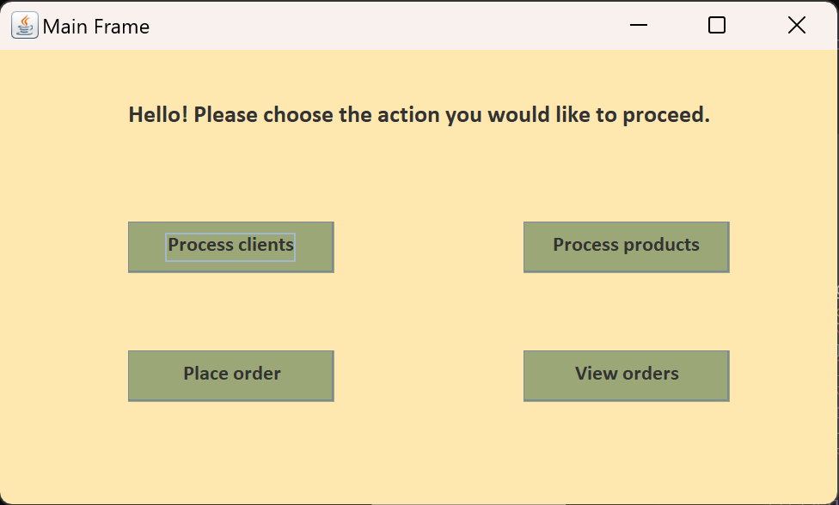

Client Page

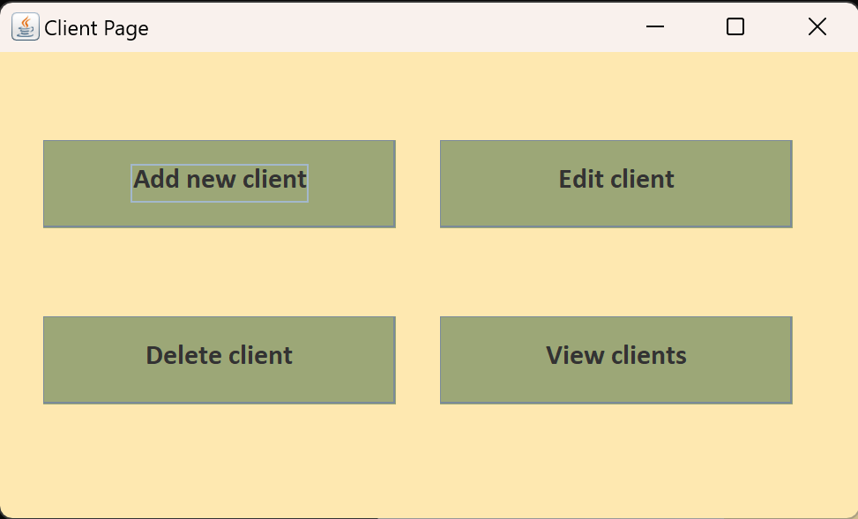

Add new client

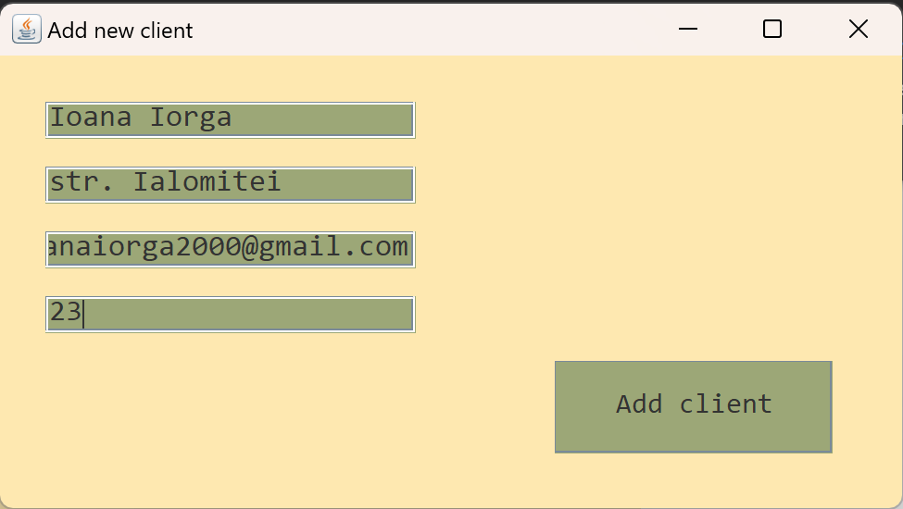

View clients

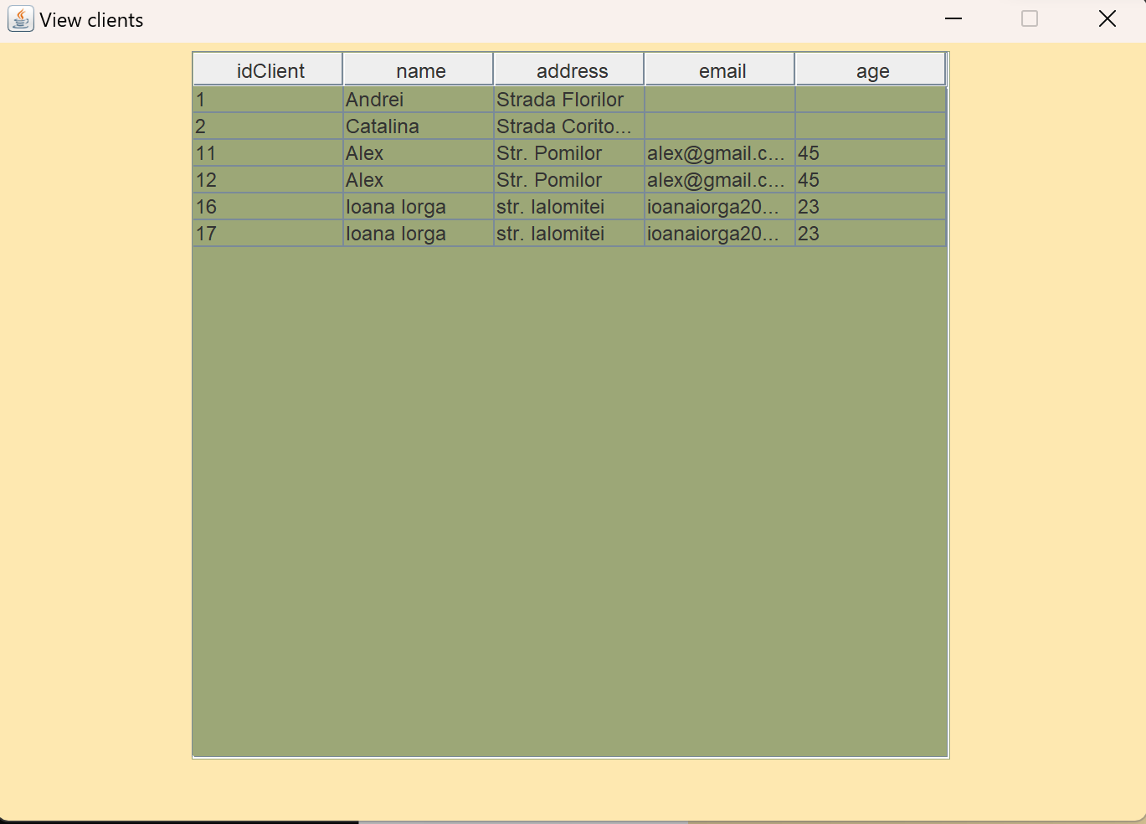

Delete client

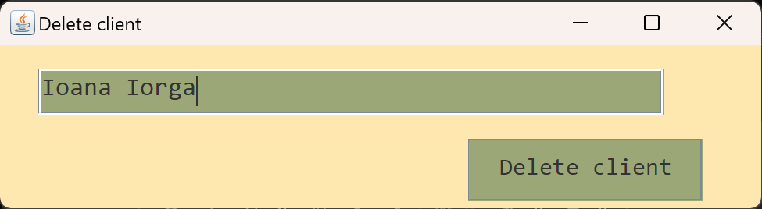
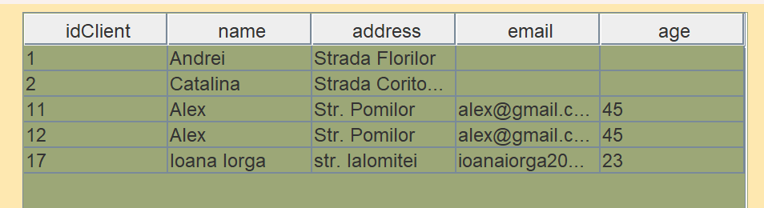

Edit client

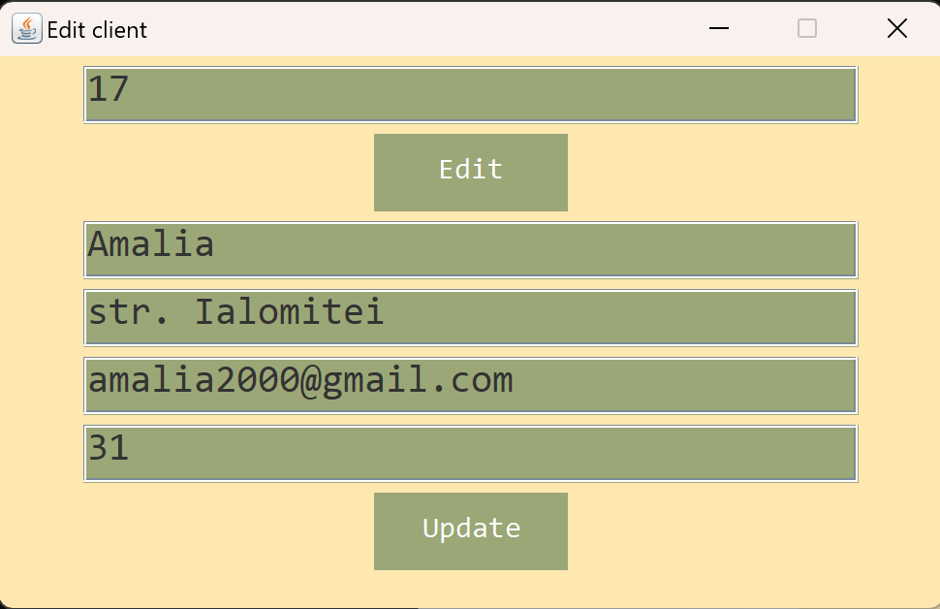
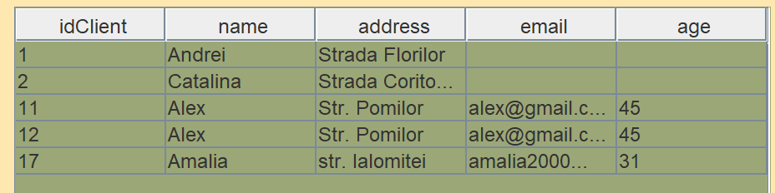

Product Page

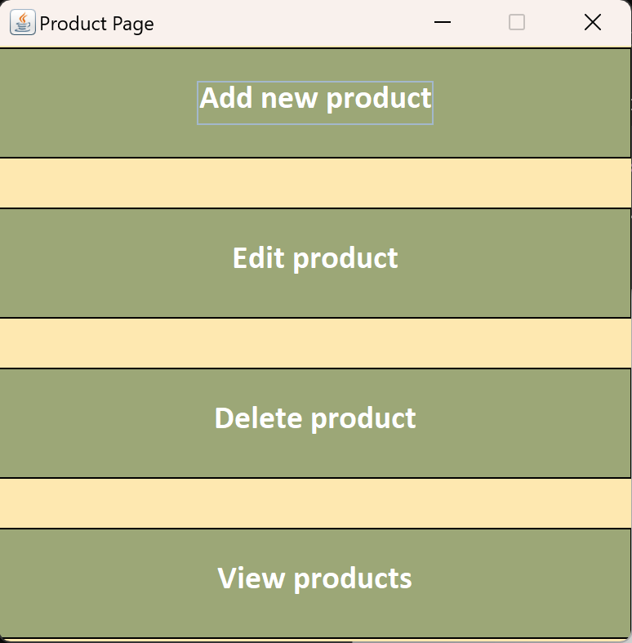

Add new product

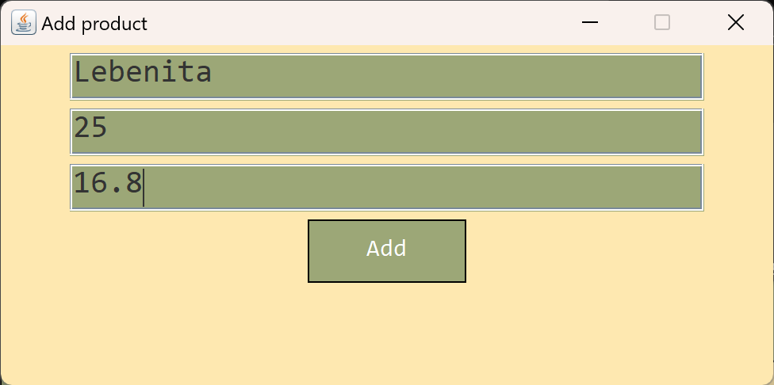

View products

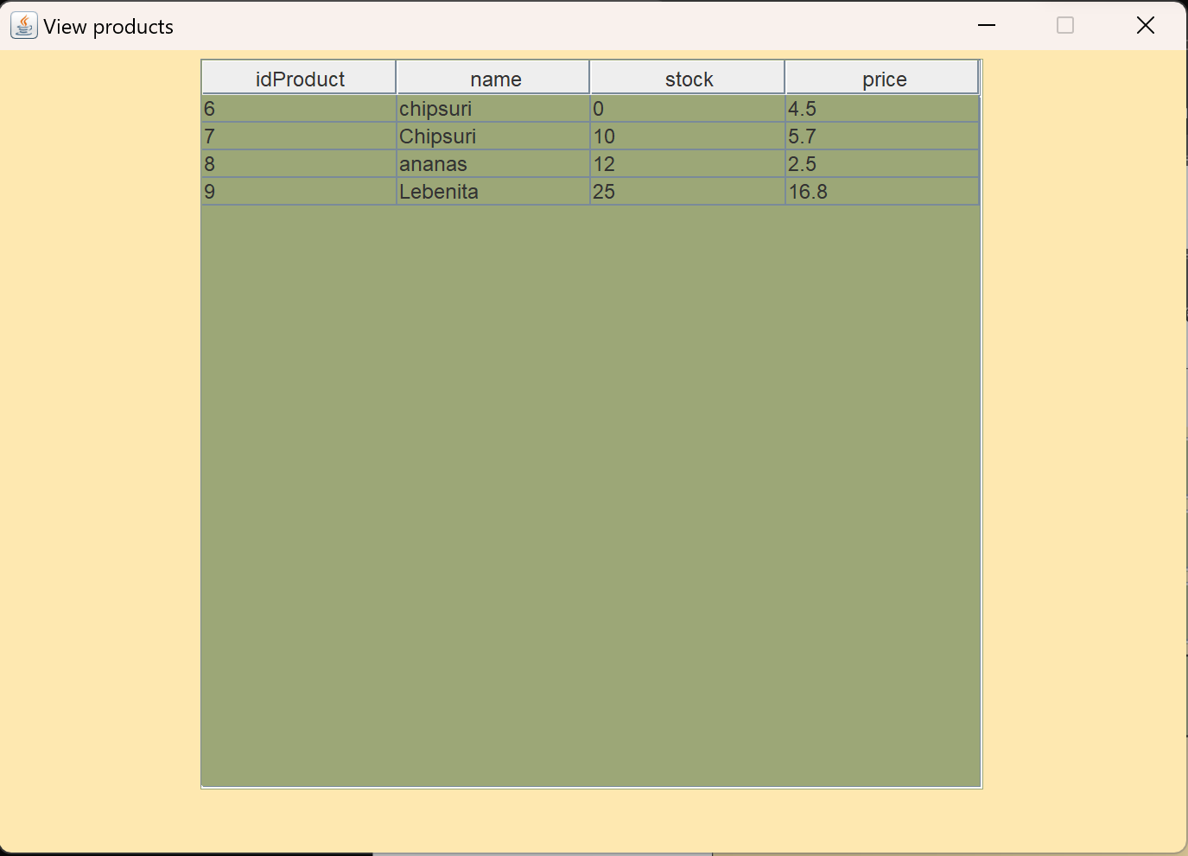

Edit product

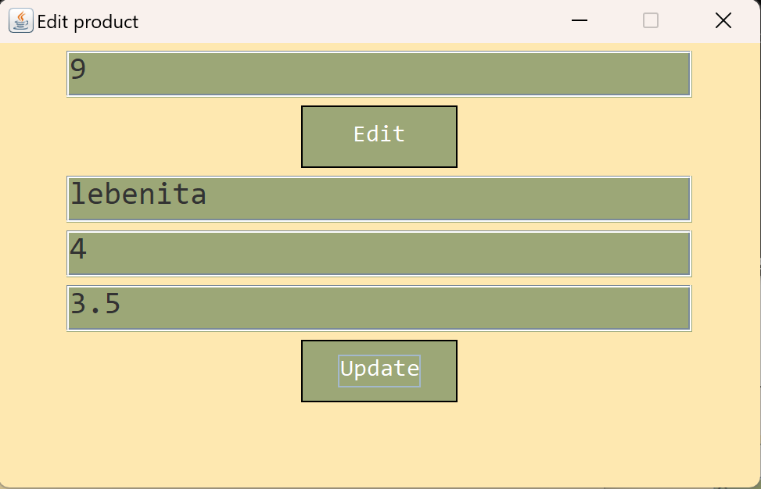
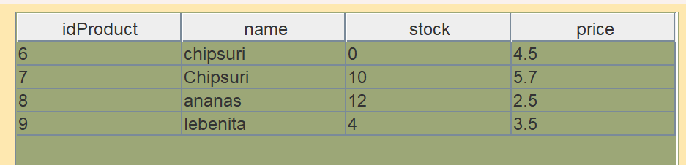

Delete product

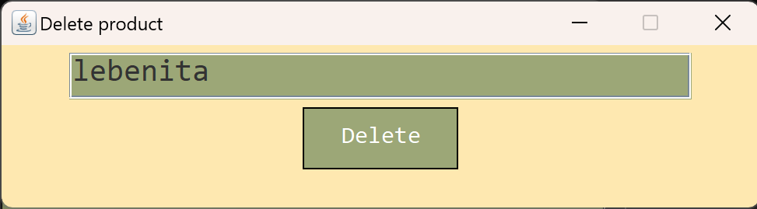
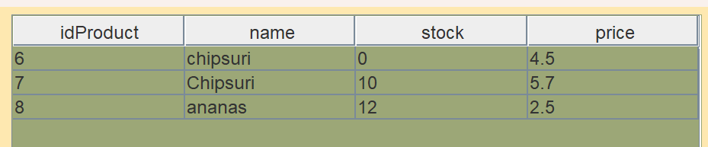

Order page

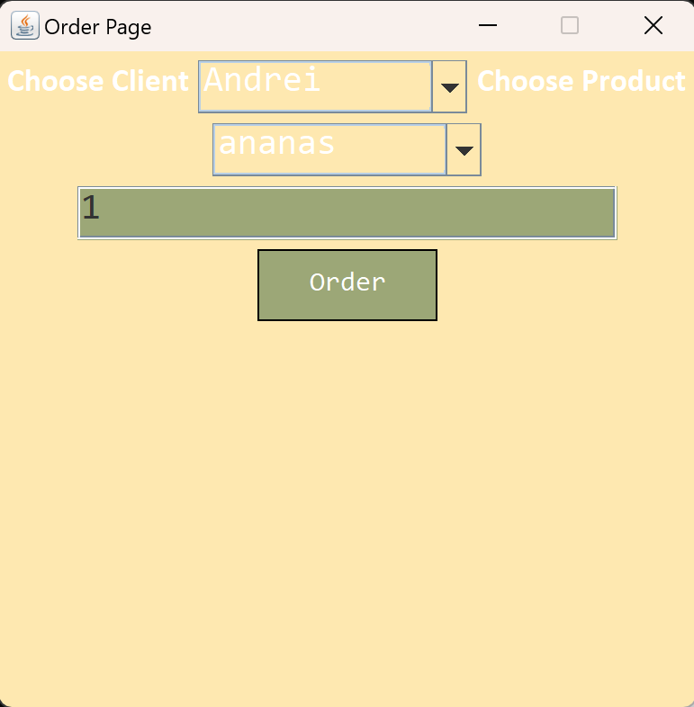
View orders

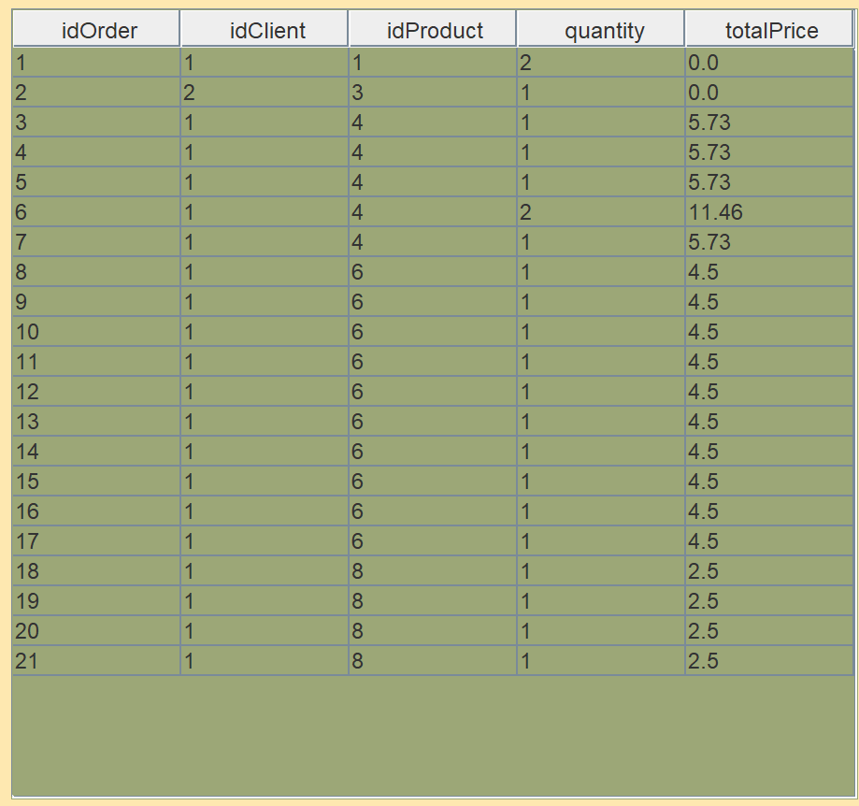

Errors

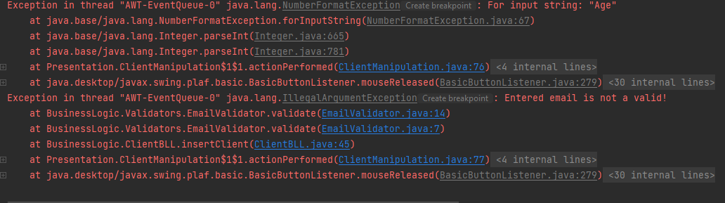
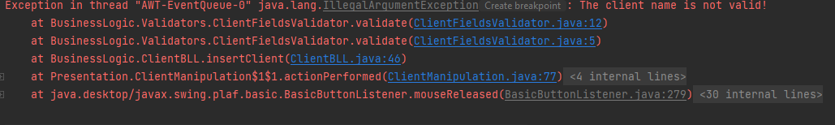
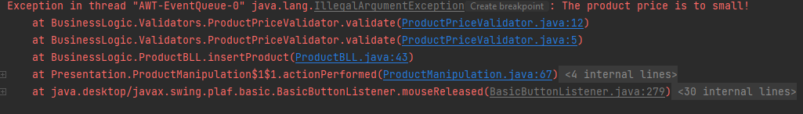
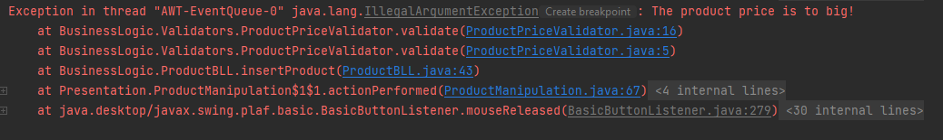
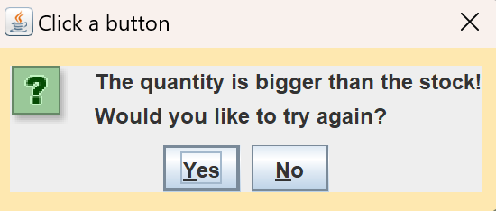

Log table

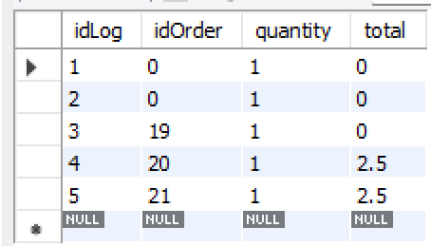

Concluzii
Am invatat sa conectez o baza de date la un program java, sa lucrez cu o distribuire a claselor pe pachete, sa scriu un cod cat de lizibil si clean, am invatat sa lucrez cu clasele Reflection, Connect, ResultSet si PreparedStatement.

O ulterioara dezvoltare ar fi aducerea aplicatiei la un nivel mai inalt si o scara mai larga, pentru a putea fi implementata in companii.

Bibliografie
Exemplu:
- Bruce Eckel, Thinking in Java (4th Edition), Publisher: Prentice Hall PTRUpper Saddle River, NJUnited States, ISBN:978-0-13-187248-6 Published:01 December 2005.
- What are Java classes? - www.tutorialspoint.com
- https://dsrl.eu/courses/pt/materials/PT2023_A3_S1.pdf
- https://dsrl.eu/courses/pt/materials/PT2023_A3_S2.pdf
- https://gitlab.com/utcn_dsrl/pt-layered-architecture

