DOCUMENTATIE

TEMA 2

NUME STUDENT: Dornea Andrei - Daniel
GRUPA: 30228

CUPRINS

1. Obiectivul temei 3
2. Analiza problemei, modelare, scenarii, cazuri de utilizare 3
3. Proiectare 4
4. Implementare 5
5. Rezultate 12
6. Concluzii 19
7. Bibliografie 19

Obiectivul temei
- Obiectivul principal:
Proiectarea și implementarea unei aplicatii ce are ca scop analiza sistemelor bazate pe cozi de asteptare prin: (1) simuland o serie de N clienti care sosesc pentru servicii, care intra in Q cozi, asteapta, sunt serviti si in final parasesc cozile si (2) calculand timpul mediu de asteptare, timpul mediu de serviciu si ora de varf.

- Sub-obiective:
- Analiza problemei si identificarea cererilor, necesitatiilor
- Proiectarea aplicatiei de simulare
- Implementarea aplicatiei de simulare
- Testarea aplicatiei de simulare

Analiza problemei, modelare, scenarii, cazuri de utilizare
- Cerinte functionale:
- Aplicația de simulare ar trebui să permită utilizatorilor să configureze simularea
- Aplicația de simulare ar trebui să permită utilizatorilor să înceapă simularea
- Aplicația de simulare ar trebui să afișeze evoluția cozilor în timp real
- Aplicatia de simulare ar trebui sa afiseze rezultatele finale
- Cerinte non-functionale:
- Aplicația de simulare ar trebui să fie intuitivă și ușor de utilizat de către utilizator
- Aplicatia de simulare ar trebui sa fie user-friendly pentru utilizator
- Caz de utilizare: simulare de configurare
- Actor principal: utilizator
- Scenariul principal de succes:
1.Utilizatorul introduce valorile pentru: numărul de clienți, numărul de cozi, intervalul de simulare, timpul minim și maxim de sosire și timpul minim și maxim de serviciu
2.Utilizatorul face clic pe butonul de validare a datelor de intrare
3. Aplicația validează datele și afișează un mesaj care informează utilizatorul să înceapă simularea
- Secvență alternativă: Valori nevalide pentru parametrii de configurare
  - Utilizatorul introduce valori nevalide pentru parametrii de configurare ai aplicației
  - Aplicația afișează un mesaj de eroare și solicită utilizatorului să introducă valori valide
  - Scenariul revine la pasul 1

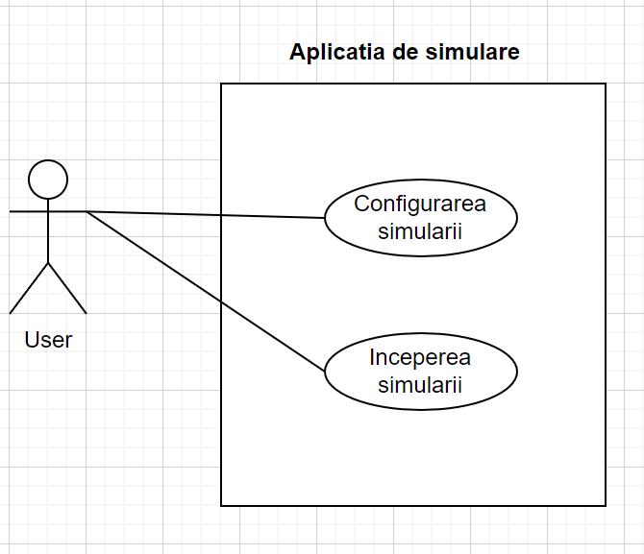

Proiectare

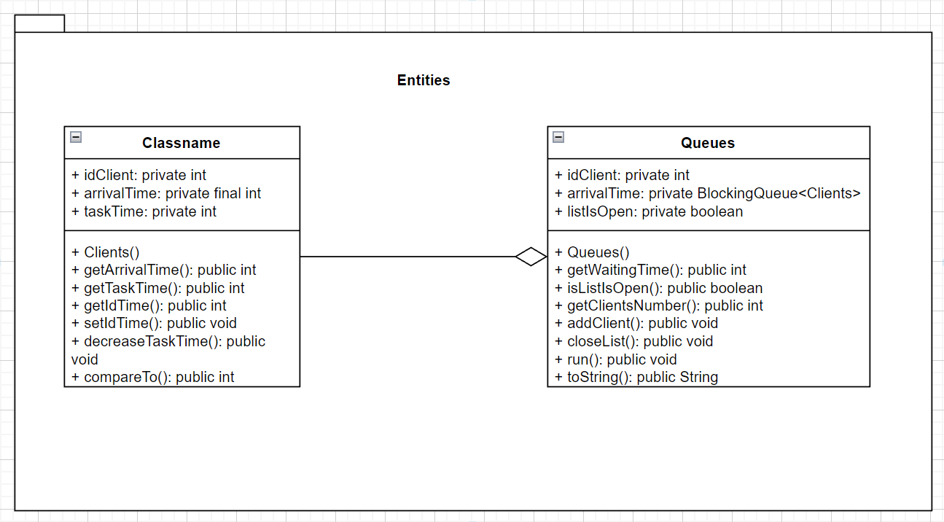

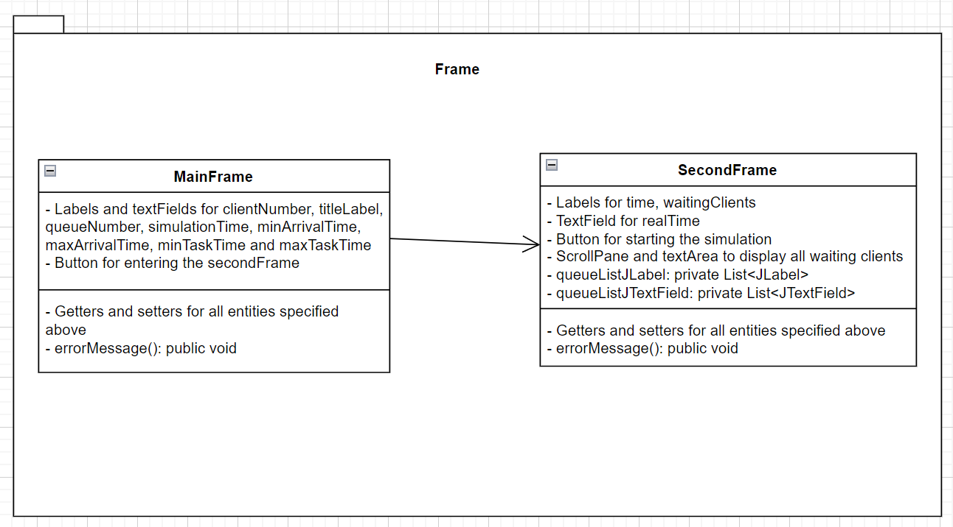
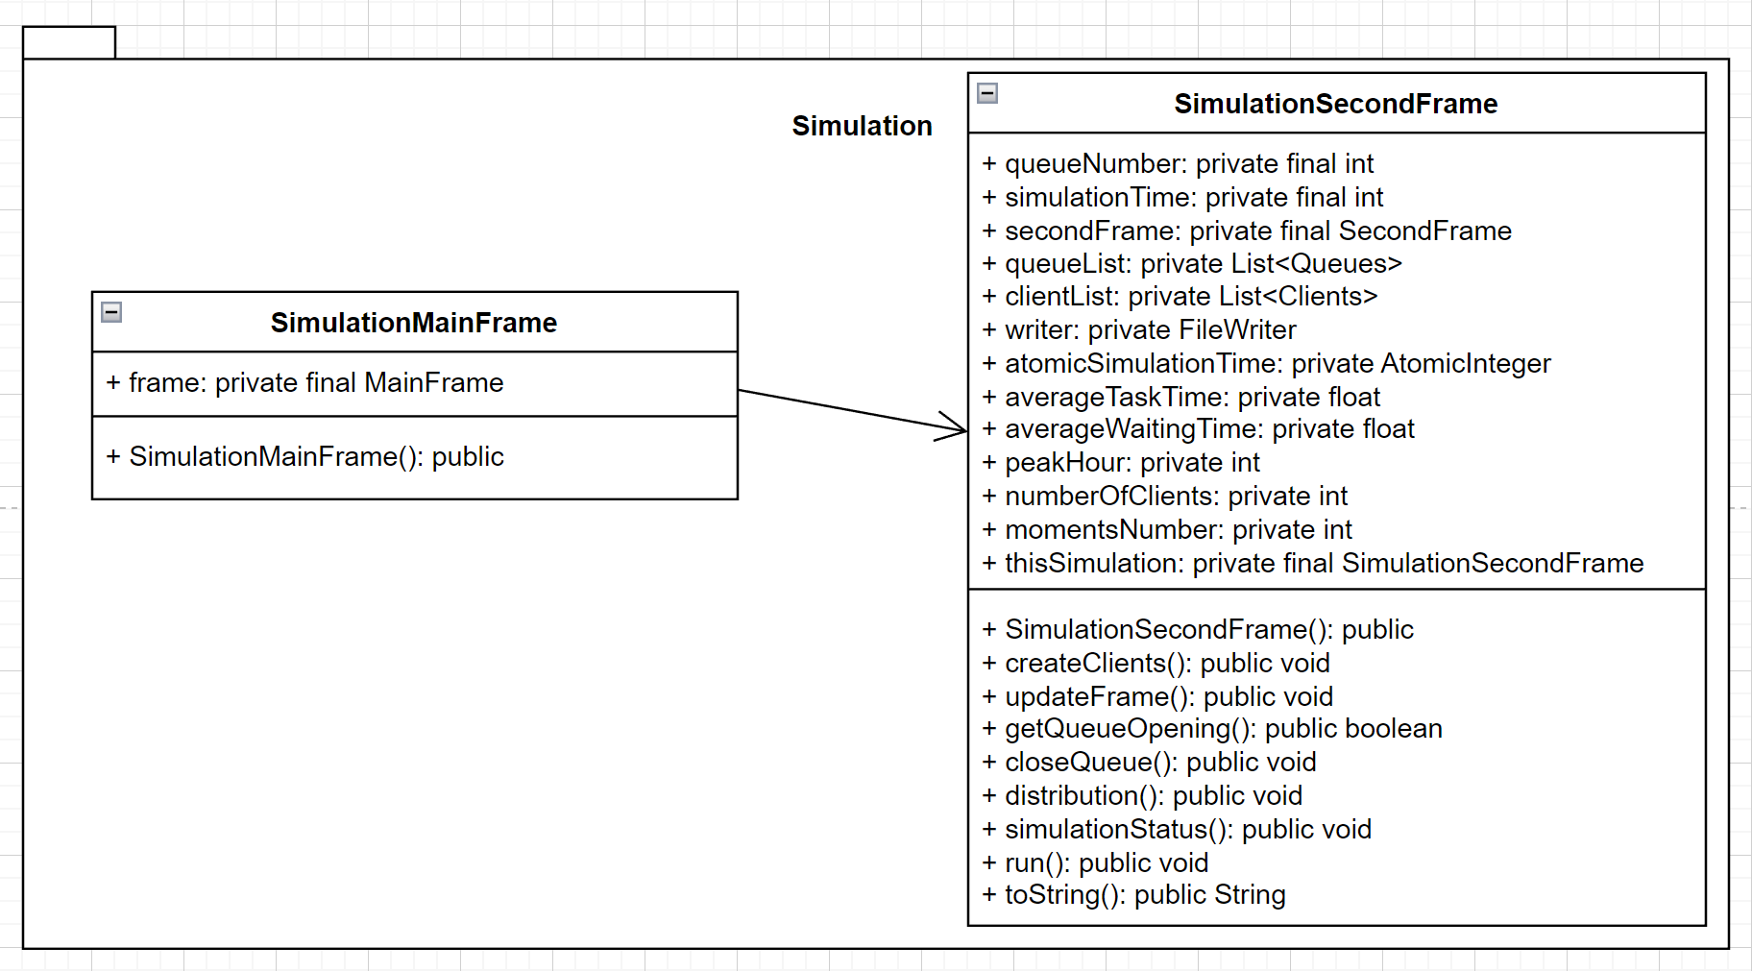

Implementare
Codul este compentat si explicat pe parcurs.
- Clients
- public Clients(int arrivalTime, int taskTime) {
this.arrivalTime = arrivalTime;
this.taskTime = taskTime;
}
public void setIdClient(int idClient) {
this.idClient = idClient;
}
public void decreaseTaskTime(){ //decrease the task time of every client when get to the front of the queue
this.taskTime--;
}
@Override
public int compareTo(Clients o) { //get the client with the minimum arrival time
if(this.arrivalTime<o.arrivalTime)
return -1;
else if(this.arrivalTime>o.arrivalTime)
return 1;
return 0;
}

- Queues
- public Queues() {
this.waitingTime = 0;
this.clientsList = new ArrayBlockingQueue<>(1000);
this.listIsOpen = true;
}
public int getClientsNumber(){
return clientsList.size();
}
public void addClient(Clients c){ //add client to queue
clientsList.add(c);
waitingTime+=c.getTaskTime();
}
public void closeList(){ //close queue if we don't have clients in it
if(getClientsNumber()==0){
listIsOpen=false;
}
}
@Override
public void run() {
while(listIsOpen){ //if queue is opened
if(getClientsNumber()>0){ //if we have clients in the queue
Clients c=clientsList.peek(); //take the first client of the queue
assert c != null;
c.decreaseTaskTime(); //decrease the task time
if(c.getTaskTime()==0){ //if the client finishes the task we remove him
clientsList.remove();
}
waitingTime--;
try{
Thread.sleep(1000);
} catch (InterruptedException e) {
e.setStackTrace(null);
}
}
}
}
@Override
public String toString() {
if(getClientsNumber()==0){
return "The queue is closed!";
}
String string="";
for(Clients c:clientsList){
string+=String.format("[%d, %d, %d]", c.getIdClient(), c.getArrivalTime(), c.getTaskTime());
}
return string;
}

- MainFrame
- public MainFrame() {
Color color1=new Color(205, 199,118);
Color color2=new Color(165, 170,82);
this.setTitle("Main Frame");
this.setBounds(600, 400, 600, 400);
this.setDefaultCloseOperation(JFrame.EXIT_ON_CLOSE);
this.getContentPane().setBackground(color1);
this.getContentPane().setLayout(null);
titleJLabel = new JLabel();
titleJLabel.setText("Please fill the gaps!");
titleJLabel.setFont(new Font("Tahoma", Font.BOLD, 18));
titleJLabel.setBounds(220, 20, 200, 25);
this.getContentPane().add(titleJLabel);
etc…………
this.setVisible(true);
}

- SecondFrame
- public SecondFrame(int queueNumber) {
Color color1 = new Color(205, 199, 118);
Color color2 = new Color(165, 170, 82);
//Create the frame
this.setTitle("Second Frame");
this.setBounds(600, 600, 600, 600);
this.setDefaultCloseOperation(JFrame.EXIT_ON_CLOSE);
this.getContentPane().setBackground(color1);
this.getContentPane().setLayout(null);
//setup time simulation
timeJLabel = new JLabel();
timeJLabel.setText("TIME: ");
timeJLabel.setFont(new Font("Tahoma", Font.BOLD, 18));
timeJLabel.setBounds(250, 20, 200, 25);
this.getContentPane().add(timeJLabel);
realTimeJTextField = new JTextField();
realTimeJTextField.setFont(new Font("Tahoma", Font.TYPE1_FONT, 14));
realTimeJTextField.setBounds(320, 20, 35, 25);
realTimeJTextField.setBackground(color2);
this.getContentPane().add(realTimeJTextField);
//setup the waiting cient list
waitingClientsJlabel = new JLabel();
waitingClientsJlabel.setText("Waiting clients list ");
waitingClientsJlabel.setBounds(20, 50, 200, 25);
waitingClientsJlabel.setFont(new Font("Tahoma", Font.TYPE1_FONT, 14));
this.getContentPane().add(waitingClientsJlabel);

etc……………

- //set visible the entered number queues
for (int i=0; i<queueNumber; i++){
this.getContentPane().add(queueListJLabel.get(i));
this.getContentPane().add(queueListJTextField.get(i));
}
this.setVisible(true);
}

- SimulationMainFrame
- public SimulationMainFrame() {
frame = new MainFrame();
frame.addSimulateButtonListener(new ActionListener() {
@Override
public void actionPerformed(ActionEvent e) {
int clientNumber;
int queueNumber;
int simulationTime;
int minArrivalTime;
int maxArrivalTime;
int minTaskTime;
int maxTaskTime;
//get informations from main frame
try {
clientNumber = frame.getClientNumberJTextField();
queueNumber = frame.getQueueNumberJTextField();
simulationTime = frame.getSimulationTimeJTextField();
minArrivalTime = frame.getMinArrvialTimeJTextField();
maxArrivalTime = frame.getMaxArrvialTimeJTextField();
minTaskTime = frame.getMinTaskTimeJTextField();
maxTaskTime = frame.getMaxTaskTimeJTextField();
} catch (Exception exp) {
//show error if the user did not complete all gaps
frame.errorMessage("Please fill each gap!");
return;
}
if (queueNumber > 10) { //check if the user enterd under 10 queues
frame.errorMessage("You can not have more than 10 queues!");
} else if (minArrivalTime > maxArrivalTime) {//check if the user enterd arrival time correctly
frame.errorMessage("Minimum arrival time can not be bigger than maximum arrival time!");
} else if (minTaskTime > maxTaskTime) { //check if user entered task time correctly
frame.errorMessage("Minimum task time can not be bigger than maximum task time!");
} //if all is ok then we create the second frame to simulate
else
//create a simulation using informations from main frame
new SimulationSecondFrame(clientNumber, queueNumber, simulationTime, minArrivalTime, maxArrivalTime, minTaskTime, maxTaskTime);
}
});
}

- SImulationSecondFrame
- public SimulationSecondFrame(int clientNumber, int queueNumber, int simulationTime, int minArrivalTime, int maxArrivalTime, int minTaskTime, int maxTaskTime) {
secondFrame = new SecondFrame(queueNumber);
//create thread for the second frame
secondFrame.addStartButtonListener(new ActionListener() {
@Override
public void actionPerformed(ActionEvent e) {
Thread thread = new Thread(thisSimulation);
thread.start();
}
});
// memorate the information
this.queueNumber = queueNumber;
this.simulationTime = simulationTime;
this.atomicSimulationTime = new AtomicInteger(0);
this.queueList = new ArrayList<>();
this.clientList = new ArrayList<>();
//create all clients with random values
createClients(clientNumber, minArrivalTime, maxArrivalTime, minTaskTime, maxTaskTime);
//create all queues
for (int i = 0; i < queueNumber; i++) {
Queues queue = new Queues();
queueList.add(queue);
}
//write in the write.txt file the result
try {
writer = new FileWriter("write.txt");
} catch (IOException e) {
e.printStackTrace();
}
//update the frame in real time
updateFrame();
}
private void createClients(int clientNumber, int minArrivalTime, int maxArrivalTime, int minTaskTime, int maxTaskTime) {
Random random = new Random();
for (int i = 1; i <= clientNumber; i++) { //generate number of clients randomly
int arrivalTime = random.nextInt(minArrivalTime, maxArrivalTime);
int taskTime = random.nextInt(minTaskTime, maxTaskTime);
clientList.add(new Clients(arrivalTime, taskTime));
}
Collections.sort(clientList); //sort the list ascending by arrival time
averageTaskTime = 0;
int id = 1;
for (Clients c : clientList) { //set the id of the clients and calculate the average task time
c.setIdClient(id);
id++;
averageTaskTime += c.getTaskTime();
}
averageTaskTime /= clientList.size();
}
private void updateFrame() {
//update the real time
secondFrame.setRealTime(String.format("%d", atomicSimulationTime.get()));
//update the client list
String waitingClientList = "";
for (Clients client : clientList) {
waitingClientList += String.format("[%d, %d, %d]\n", client.getIdClient(), client.getArrivalTime(), client.getTaskTime());
}
secondFrame.setWaitingClientsJTextArea(waitingClientList);
//update each queue list with all the clients that are entering them
for (int i = 0; i < queueNumber; i++) {
String string = queueList.get(i).toString();
secondFrame.setQueueListJTextField(i, string);
}
}
//check if queues are opened or closed
private boolean getQueueOpening() {
for (Queues q : queueList) {
if (q.isListIsOpen())
return true;
}
return false;
}
//close queue method
private void closeQueue() {
for (Queues q : queueList) {
q.closeList();
}
}
private void distribution() {
//distribute the clients by the arrival time
for (int i = 0; i < clientList.size(); i++) { //iterate all client list
int minWaitingTime = queueList.get(0).getWaitingTime();
int queue = 0;
for (int j = 0; j < queueList.size(); j++) { //iterate the queues list in which are clients waiting
if (queueList.get(j).getWaitingTime() < minWaitingTime) {
minWaitingTime = queueList.get(j).getWaitingTime(); //find the minimum waiting time from all queues
queue = j;
}
}
if (clientList.get(i).getArrivalTime() <= atomicSimulationTime.get()) { //if the client is ready to enter a queue
Clients client = clientList.remove(i); //remove the client from the list
queueList.get(queue).addClient(client); //add the client to the minimum queue found
i--;
}
}
}
private void simulationStatus() {
int numberOfClients = 0;
float waitingTime = 0;
//calculate number of clients and waiting time average
for (Queues q : queueList) {
numberOfClients += q.getClientsNumber();
waitingTime += q.getWaitingTime();
}
//increase the moment number
if (waitingTime != 0) {
momentsNumber++;
}
//calculate the average waiting time
averageWaitingTime += waitingTime / queueNumber;
//calculate the peak hour by finding the time when the queues list had the maximum possible number
if (numberOfClients > maxNumberClients) {
maxNumberClients = numberOfClients;
peakHour = atomicSimulationTime.get();
}
}
@Override
public void run() {
for (Queues q : queueList) { //create thread for each queue
Thread thread = new Thread(q);
thread.start();
}
while (atomicSimulationTime.get() <= simulationTime || getQueueOpening()) { //while we still have time and the queue is opened
updateFrame();
if (atomicSimulationTime.get() >= simulationTime) {//if the simulation time is over the queue is closed
closeQueue();
}
try {
writer.write(toString());
Thread.sleep(1000); //thread sleeps for 1 second
} catch (IOException | InterruptedException e) {
e.printStackTrace();
}
atomicSimulationTime.incrementAndGet(); //increase the real time
distribution(); //add the next client to the queue
simulationStatus(); //get status of the simulation
}
averageWaitingTime/=momentsNumber; //calculate the average time
try{
//write the end status in the write.txt file
writer.write(String.format("\nThe average waiting time of the simulation: %.3f\nThe average task time of the simulation: %.3f\nThe peak hour of the simulation: %d\n", averageWaitingTime, averageTaskTime, peakHour));
writer.close();
} catch (IOException e){
e.printStackTrace();
}
//display the end status in the GUI
secondFrame.errorMessage(String.format("\nThe average waiting time of the simulation: %.3f\nThe average task time of the simulation: %.3f\nThe peak hour of the simulation: %d\n", averageWaitingTime, averageTaskTime, peakHour));
}
@Override
public String toString() { //to string method to display status in write.txt
String string=String.format("\nReal Time: %d", atomicSimulationTime.get()); //add real time
string+=String.format("\nWaiting clients: "); //add the still waiting clients
for(Clients c:clientList){
string+=String.format("[%d %d %d] ", c.getIdClient(), c.getArrivalTime(), c.getTaskTime());
}
for(int i=0; i<queueNumber; i++){ //add the queues with its clients
string+=String.format("\nQueue %d: %s", i+1, queueList.get(i).toString());
}
string+=String.format("\r\n");
return string;
}

Rezultate
La apasarea butonului de run:
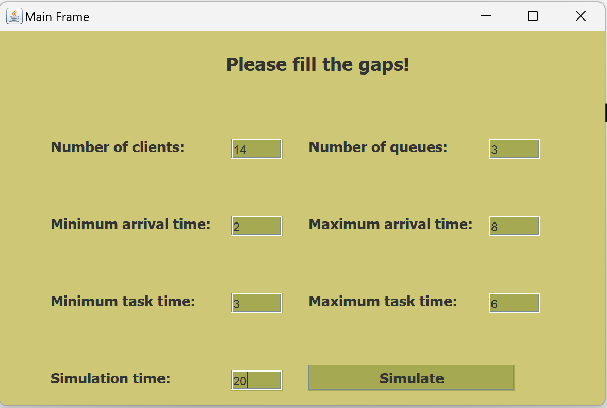
La apasarea butonului “Simulate”:
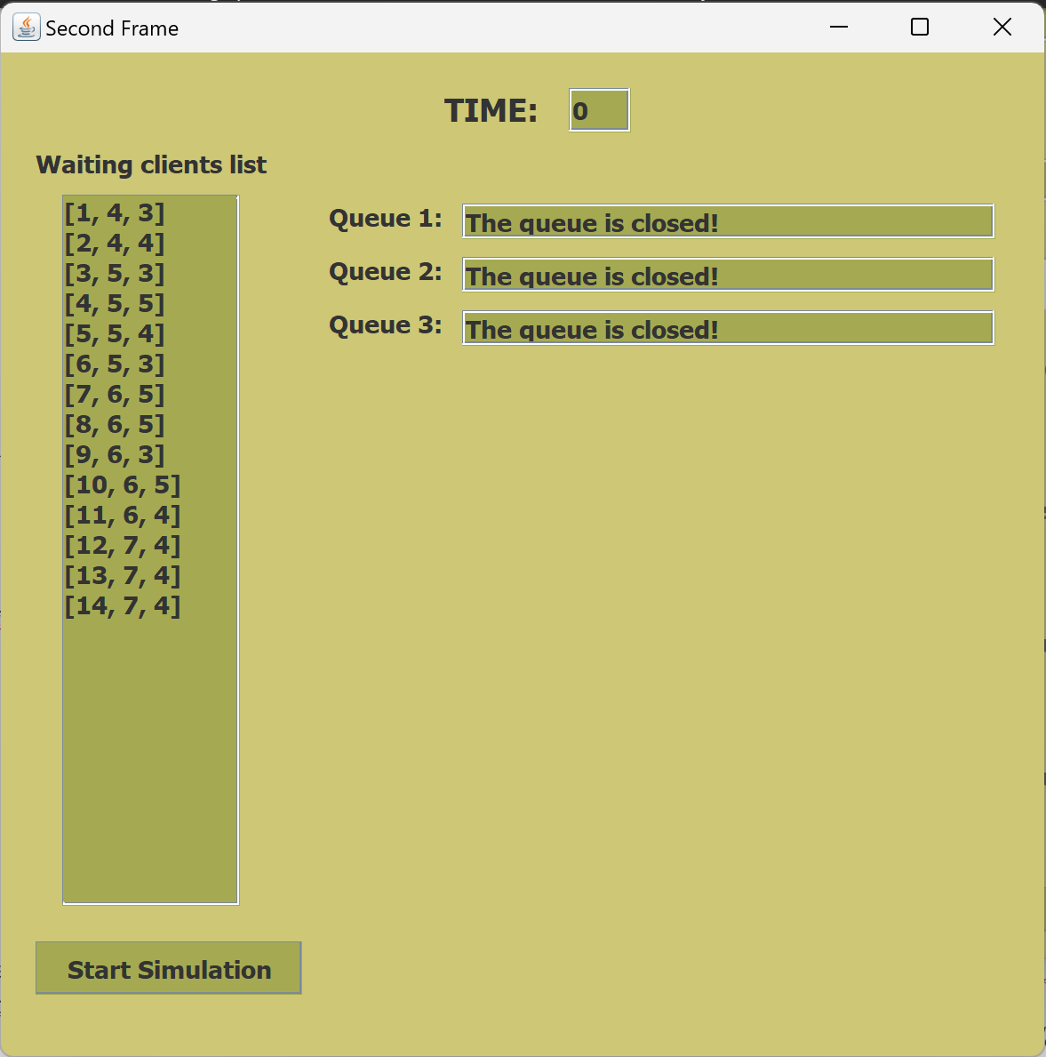
La apasarea butonului “Start Simulation”:
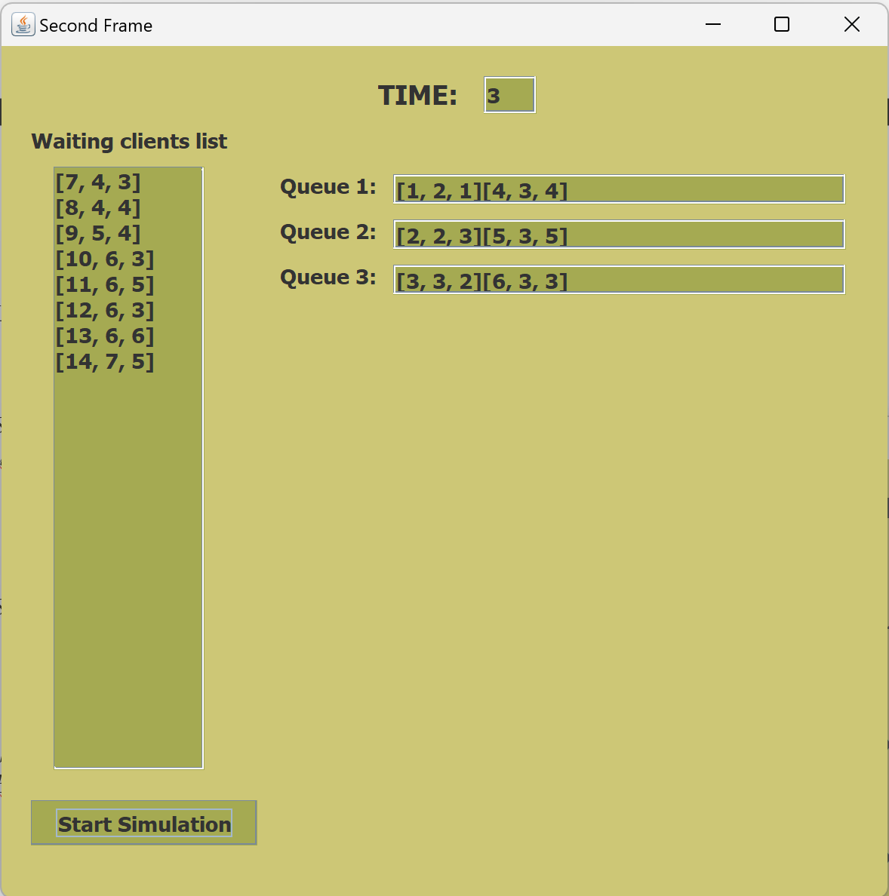
Mesaj de terminare a simularii:
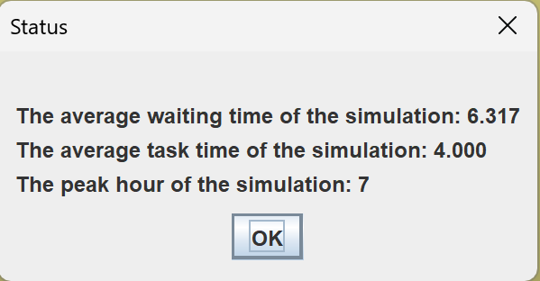
La apasarea butonului “OK”:
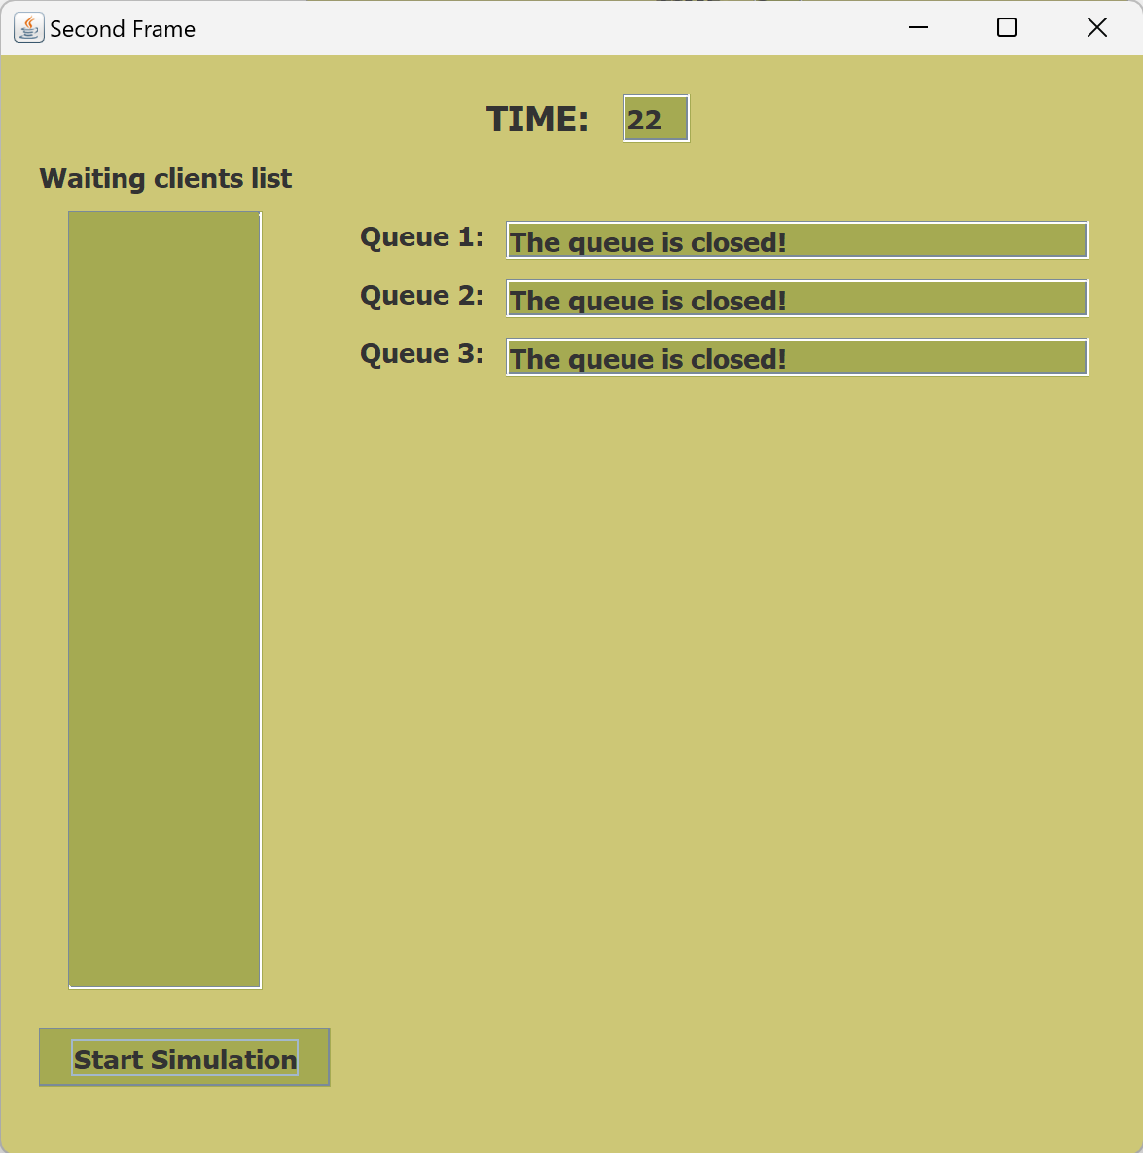

Erori:
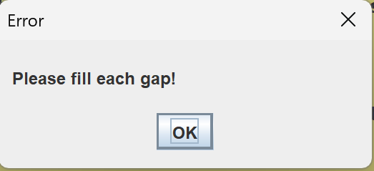
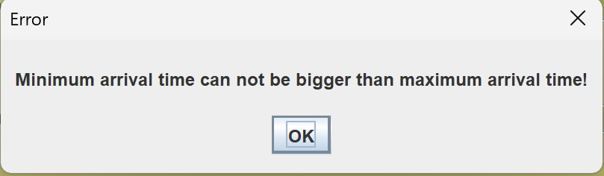
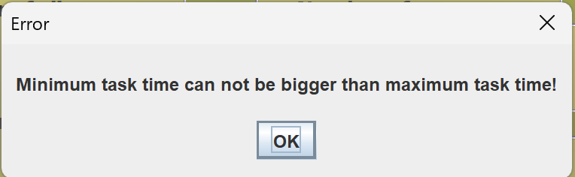
Continutul fisierului “write.txt”:

Real Time: 0
Waiting clients: [1 1 5] [2 1 4] [3 1 5] [4 1 5] [5 2 4] [6 2 5] [7 4 5] [8 5 4] [9 5 5] [10 7 6] [11 7 4]
Queue 1: The queue is closed!
Queue 2: The queue is closed!
Queue 3: The queue is closed!
Queue 4: The queue is closed!

Real Time: 1
Waiting clients: [5 2 4] [6 2 5] [7 4 5] [8 5 4] [9 5 5] [10 7 6] [11 7 4]
Queue 1: [1, 1, 4]
Queue 2: [2, 1, 3]
Queue 3: [3, 1, 4]
Queue 4: [4, 1, 4]

Real Time: 2
Waiting clients: [7 4 5] [8 5 4] [9 5 5] [10 7 6] [11 7 4]
Queue 1: [1, 1, 3][6, 2, 5]
Queue 2: [2, 1, 2][5, 2, 4]
Queue 3: [3, 1, 3]
Queue 4: [4, 1, 3]

Real Time: 3
Waiting clients: [7 4 5] [8 5 4] [9 5 5] [10 7 6] [11 7 4]
Queue 1: [1, 1, 2][6, 2, 5]
Queue 2: [2, 1, 1][5, 2, 4]
Queue 3: [3, 1, 2]
Queue 4: [4, 1, 2]

Real Time: 4
Waiting clients: [8 5 4] [9 5 5] [10 7 6] [11 7 4]
Queue 1: [1, 1, 1][6, 2, 5]
Queue 2: [5, 2, 4]
Queue 3: [3, 1, 1][7, 4, 5]
Queue 4: [4, 1, 1]

Real Time: 5
Waiting clients: [10 7 6] [11 7 4]
Queue 1: [6, 2, 5]
Queue 2: [5, 2, 3][9, 5, 5]
Queue 3: [7, 4, 5]
Queue 4: [8, 5, 4]

Real Time: 6
Waiting clients: [10 7 6] [11 7 4]
Queue 1: [6, 2, 4]
Queue 2: [5, 2, 2][9, 5, 5]
Queue 3: [7, 4, 4]
Queue 4: [8, 5, 3]

Real Time: 7
Waiting clients:
Queue 1: [6, 2, 3][11, 7, 4]
Queue 2: [5, 2, 1][9, 5, 5]
Queue 3: [7, 4, 3]
Queue 4: [8, 5, 2][10, 7, 6]

Real Time: 8
Waiting clients:
Queue 1: [6, 2, 2][11, 7, 4]
Queue 2: [9, 5, 5]
Queue 3: [7, 4, 2]
Queue 4: [8, 5, 1][10, 7, 6]

Real Time: 9
Waiting clients:
Queue 1: [6, 2, 1][11, 7, 4]
Queue 2: [9, 5, 4]
Queue 3: [7, 4, 1]
Queue 4: [10, 7, 6]

Real Time: 10
Waiting clients:
Queue 1: [11, 7, 4]
Queue 2: [9, 5, 3]
Queue 3: The queue is closed!
Queue 4: [10, 7, 5]

Real Time: 11
Waiting clients:
Queue 1: [11, 7, 3]
Queue 2: [9, 5, 2]
Queue 3: The queue is closed!
Queue 4: [10, 7, 4]

Real Time: 12
Waiting clients:
Queue 1: [11, 7, 2]
Queue 2: [9, 5, 1]
Queue 3: The queue is closed!
Queue 4: [10, 7, 3]

Real Time: 13
Waiting clients:
Queue 1: [11, 7, 1]
Queue 2: The queue is closed!
Queue 3: The queue is closed!
Queue 4: [10, 7, 2]

Real Time: 14
Waiting clients:
Queue 1: The queue is closed!
Queue 2: The queue is closed!
Queue 3: The queue is closed!
Queue 4: [10, 7, 1]

Real Time: 15
Waiting clients:
Queue 1: The queue is closed!
Queue 2: The queue is closed!
Queue 3: The queue is closed!
Queue 4: The queue is closed!

Real Time: 16
Waiting clients:
Queue 1: The queue is closed!
Queue 2: The queue is closed!
Queue 3: The queue is closed!
Queue 4: The queue is closed!

The average waiting time of the simulation: 3.679
The average task time of the simulation: 4.727
The peak hour of the simulation: 7

Concluzii
Ce am invatat din aceasta tema:
- Perferctionare in ce priveste lucrul cu GUI
- Folosirea tipului AtomicInteger si a timpului
- Folosirea threadurilor
- O mai buna organizare a claselor si pachetelor
Posibile dezvoltari:
Implementarea acestui program la o scara mult mai larga si folosirea lui de catre supermarket-uri, mall-uri, etc.

Bibliografie
Se vor adauga referintele care au fost consultate de student pe parcursul implementarii temei .
Exemplu:
- Bruce Eckel, Thinking in Java (4th Edition), Publisher: Prentice Hall PTRUpper Saddle River, NJUnited States, ISBN:978-0-13-187248-6 Published:01 December 2005.
- What are Java classes? - www.tutorialspoint.com
- https://www.w3schools.blog/atomicinteger-in-java
- https://www.w3schools.com/java/java_threads.asp
- https://www.geeksforgeeks.org/java-threads/
- https://www.geeksforgeeks.org/synchronization-in-java/

