Mandatory I

01a-03a
Assignments 01a through 03a were all collected into a single project
Data parsing server project

04a
Server sent event example

04b

Exposee documentation
The below documentation is copied from my logseq graph

Connect
For my database I chose postgres so be sure to install postgresql so that you can run the cli tool used in this documentation For this exercise I will be providing you with two db users. see username below, for easy use both of their passwords are ‘si-o4b’
- lasse
- troels
- As I use Pinggy, the free tier only allow for random subdomains, I will be providing the host and port name to you upon request instead of in this documentation
To connect to the db instance via my TCP tunnel, use the following command, replace the placeholder with the information provided upon your request
psql -h <host> -p <port> -U <lasse|troels> -d si-04b

Granular control

Views
- masked_employee_salary:
  - Restricts employees access to each others salary in the employee table, allows sales persons to see their own salary and managers to see all but other managers salary

Roles
- Customer
  - Access level
    - SELECT (name, price) on products table
    - SELECt on customer, but only their own row
    - SELECT on purchases, but only their own
    - SELECT on discounts, but only their own
- Sales_person
  - Access level
    - SELECT on products
    - SELECT on customers
    - SELECT, INSERT on purchases, but only with their own id
    - SELECT, INSERT on discounts, but only with their own id
    - SELECT (id, name) on employees
    - SELECT on masked_employee_salary
- Manager
  - Access level
    - SELECT, INSERT, UPDATE, DELETE on products
    - SELECT, INSERT, UPDATE, DELETE on customers
    - SELECT, INSERT, UPDATE, DELETE on purchases
    - SELECT, INSERT, UPDATE, DELETE on discounts
    - SELECT, INSERT, UPDATE, DELETE on employees but their own or other managers
    - SELECT on masked_employee_salary
    - The two users provided in the previous section have different levels of control in the database
    - The user ‘lasse’ has the sales_person role
    - The user ‘troels’ has the manager role

Integrator images

Read only table
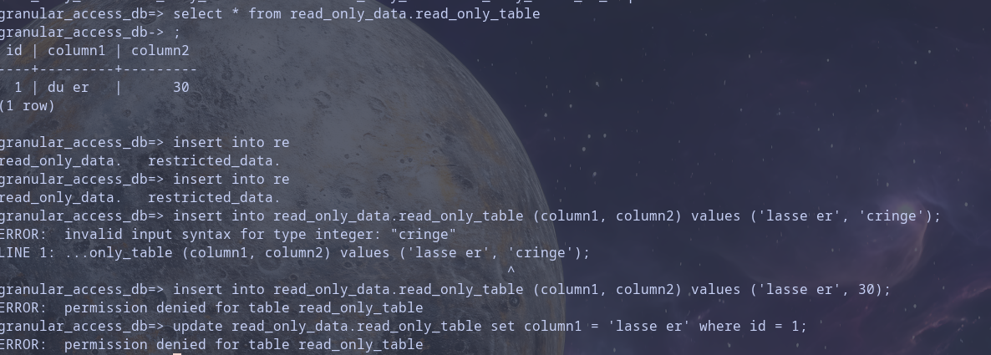

Write only table

Restricted table
I could only see my own user in the table
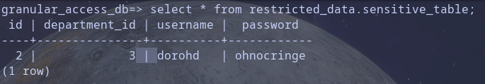

06a
Websocket example

Mandatory II

08a - WebRTC example
Repo

08b - Document DLS
For this assignment, we have chosen to document our fullstack project instead of DLS. At this point in time our DLS project mainly consists of yaml configuration files for kubernetes. Therefore we thought it would be more interesting to show documented business logic from our fullstack project.
Repo

10a - Database Documentation
Repo

10b - Database Migration
Repo

11a - Auth Integration
Repo

11b - Paymnet integration
Repo

12a - Webhooks
Repo

13a - GraphQL
Repo

