ToothGrow Data Analysis

Dorota

21 June 2015

Load the ToothGrowth data and perform some basic exploratory data analyses Provide a basic summary of the data. Use confidence intervals and/or hypothesis tests to compare tooth growth by supp and dose. (Only use the techniques from class,

## Summary of the data

The aim of the analysis is to show how tooth length of guinea pigs depends on dosage of Vitamin C (on 0.5, 1, and 2 mg level) with each of two delivery methods: orange juice OJ or ascorbic acid VC

data<-ToothGrowth  
dt<-data  
dt$dose<-as.factor(dt$dose)  
  
#exploratory plot  
library(ggplot2)  
ggplot(dt, aes(x=dose, y = len, fill=dose)) +  
 geom_boxplot() + labs(title = "Length of Tooth by Dosage of the Vitamine C") + facet_grid( . ~ supp)

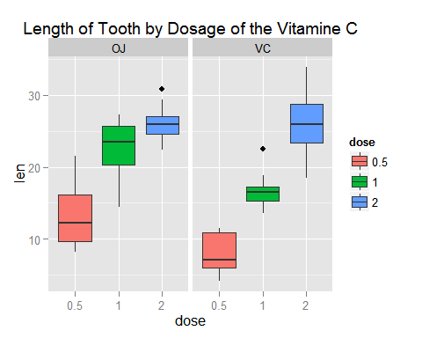

## Hypothesis Tests

Below we run t tests separately for dose and type of supplement, to chekc if differency between those groups are sigificant

dt12<- subset(data, dose %in% c(0.5, 1))   
dt13<- subset(data, dose %in% c(0.5, 2))  
dt23<- subset(data, dose %in% c(1, 2))  
  
dt12$dose<-as.factor(dt12$dose)  
dt13$dose<-as.factor(dt13$dose)  
dt23$dose<-as.factor(dt23$dose)  
  
print ('Diferences beeteen Orange Juice and Vitamine C')

## [1] "Diferences beeteen Orange Juice and Vitamine C"

t.test(len ~ supp, paired = FALSE,   
 var.equal = FALSE, data = dt)

##   
## Welch Two Sample t-test  
##   
## data: len by supp  
## t = 1.9153, df = 55.309, p-value = 0.06063  
## alternative hypothesis: true difference in means is not equal to 0  
## 95 percent confidence interval:  
## -0.1710156 7.5710156  
## sample estimates:  
## mean in group OJ mean in group VC   
## 20.66333 16.96333

print ('Diferences beeteen 0.5 mg and 1 mg dosage')

## [1] "Diferences beeteen 0.5 mg and 1 mg dosage"

t.test(len ~ dose, paired = FALSE,   
 var.equal = FALSE, data = dt12)

##   
## Welch Two Sample t-test  
##   
## data: len by dose  
## t = -6.4766, df = 37.986, p-value = 1.268e-07  
## alternative hypothesis: true difference in means is not equal to 0  
## 95 percent confidence interval:  
## -11.983781 -6.276219  
## sample estimates:  
## mean in group 0.5 mean in group 1   
## 10.605 19.735

print ('Diferences beeteen 0.5 mg and 2 mg dosage')

## [1] "Diferences beeteen 0.5 mg and 2 mg dosage"

t.test(len ~ dose, paired = FALSE,   
 var.equal = FALSE, data = dt13)

##   
## Welch Two Sample t-test  
##   
## data: len by dose  
## t = -11.799, df = 36.883, p-value = 4.398e-14  
## alternative hypothesis: true difference in means is not equal to 0  
## 95 percent confidence interval:  
## -18.15617 -12.83383  
## sample estimates:  
## mean in group 0.5 mean in group 2   
## 10.605 26.100

print ('Diferences beeteen 1 mg and 2 mg dosage')

## [1] "Diferences beeteen 1 mg and 2 mg dosage"

t.test(len ~ dose, paired = FALSE,   
 var.equal = FALSE, data = dt23)

##   
## Welch Two Sample t-test  
##   
## data: len by dose  
## t = -4.9005, df = 37.101, p-value = 1.906e-05  
## alternative hypothesis: true difference in means is not equal to 0  
## 95 percent confidence interval:  
## -8.996481 -3.733519  
## sample estimates:  
## mean in group 1 mean in group 2   
## 19.735 26.100

## Conclusions

As p Value is 0.06, higher than standard cut-off 0.05, we canot reject null hyphothesis and there is no signifiact inidiacation that there is difference in tooth growth based on the type of suplement (juice vs vitamine). However the size of the dosage matters. Bothe 0.5 mg causes signigicantly longer tooth than 1mg and, there is also significant difference between 1mg and 2mg.