Create a new repo named “Receiver Rename”
App Type: Winform
Import any assemblies, dependencies you need to complete this.
What it will do:
Get the contents of “H:\scans” and do the following
For each PDF File in this folder rename it by reading the 1st page of the PDF file and pulling the following Information:
PO Number (Highlighted in Yellow, in the below picture, would be PO-064483)
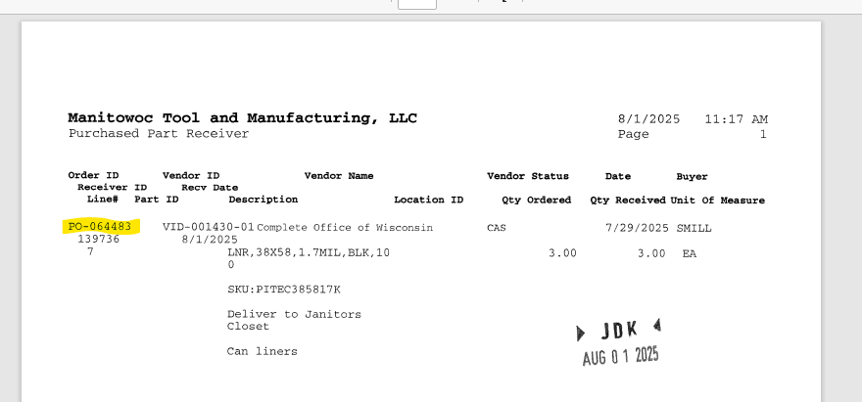
Receiver (Highlighted in Yellow, in the below picture, would be 139736)
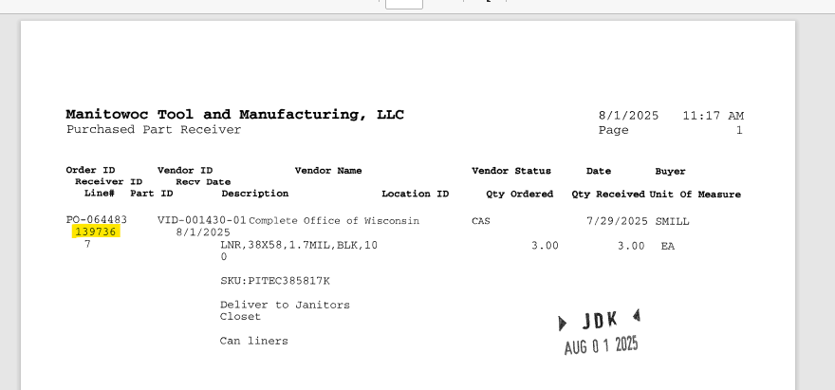
Date (Highlighted in Yellow, in the below picture) (Pad the month and day with a 0 if below 10 to make it 2 digets, the below example would be 08/01/2025)
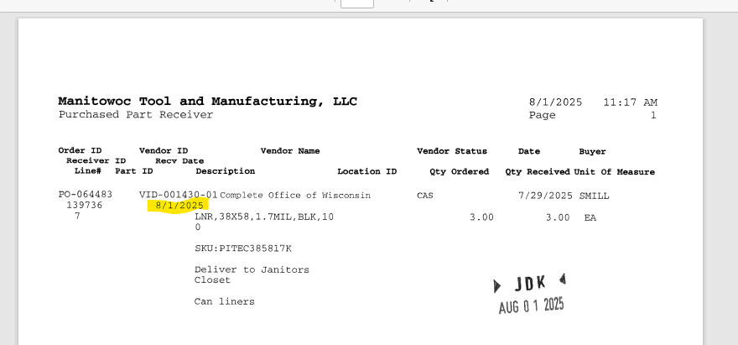
Format the name in this format “{DATE}{SPACE}{PO Number}{SPACE}{Receiver}
Show the progress of each renamed file and any skipped files.
Open the “H:\scans” folder when complete
Other things in the app to do:
Add the option on the Form where I can change the Format and Scans Folder Location

