In today's fast-paced and dynamic business environment, effective project management is critical for organizational success. However, many organizations face challenges in planning, executing, and monitoring projects due to the lack of a centralized and efficient management tool. The proposed Project Management System aims to address these challenges by providing a comprehensive solution that integrates task scheduling, resource allocation, progress tracking, and communication. This system will streamline project workflows, enhance team collaboration, and improve overall productivity, ultimately leading to the timely and successful completion of projects.

Realized by : Dorra Nsir

Project Background:

Project Name :

Project Management system

Specifications

**User Authentication System**

* Users must be able to register an account.
* Users must be able to log in with a valid username and password.
* Users must be able to log out of their account.

**Project Management (CRUD Operations)**

* Create Project: Users must be able to add a new project with relevant details such as project name, description, start date, end date, category, and tags.
* Read Project: Users must be able to view the details of a specific project.
* Update Project: Users must be able to edit the details of an existing project.
* Delete Project: Users must be able to delete a project from the system.
* Users must be able to view a list of all projects.
* Users must be able to search for projects by keywords.
* Users must be able to filter projects by category.
* Users must be able to filter projects by tags.

Purpose:

The purpose of the Project Management System is to streamline project planning, execution, and monitoring, enhancing collaboration and ensuring timely and successful project completion.

Target Users:

Project Managers/ Team Members/ Executives and Stakeholders/ Clients

Functional Requirements:

Non-Functional Requirements:

**Performance**

* The system must respond to user actions (e.g., login, CRUD operations) within 2 seconds.
* The project listing and search functionality must return results within 3 seconds.
* Scalability
* The system must be able to handle concurrent access by multiple users without significant degradation in performance.

**Security**

* User passwords must be stored securely using encryption.
* The system must have protection against common security threats such as SQL injection and cross-site scripting (XSS).

**Usability**

* The user interface must be intuitive and easy to navigate.
* Users must be able to perform all CRUD
* operations with minimal effort and clicks.

**Availability**

* The system must be available 99.9% of the time, with downtime primarily reserved for scheduled maintenance.

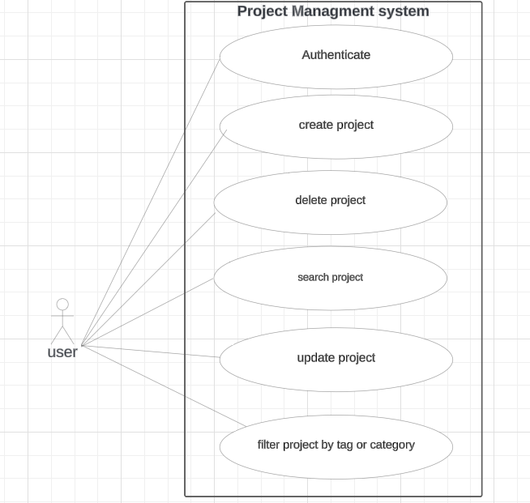

Use case diagram:

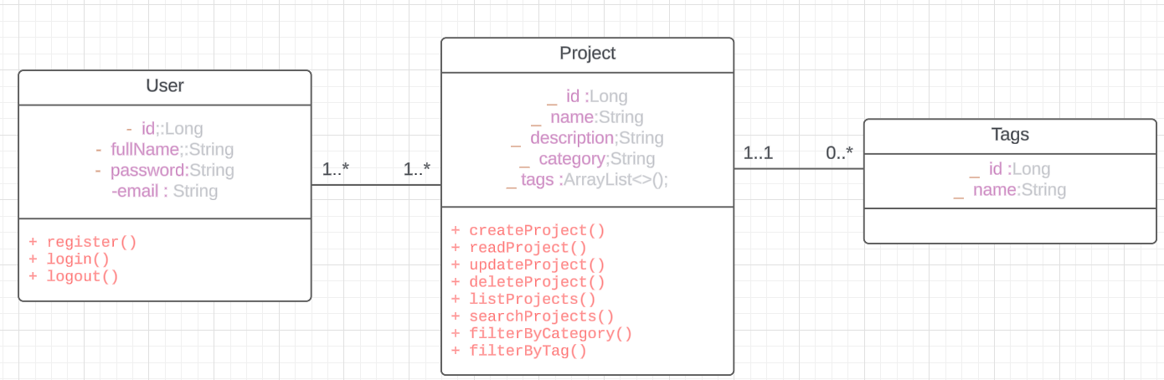

Project interfaces

class diagram:

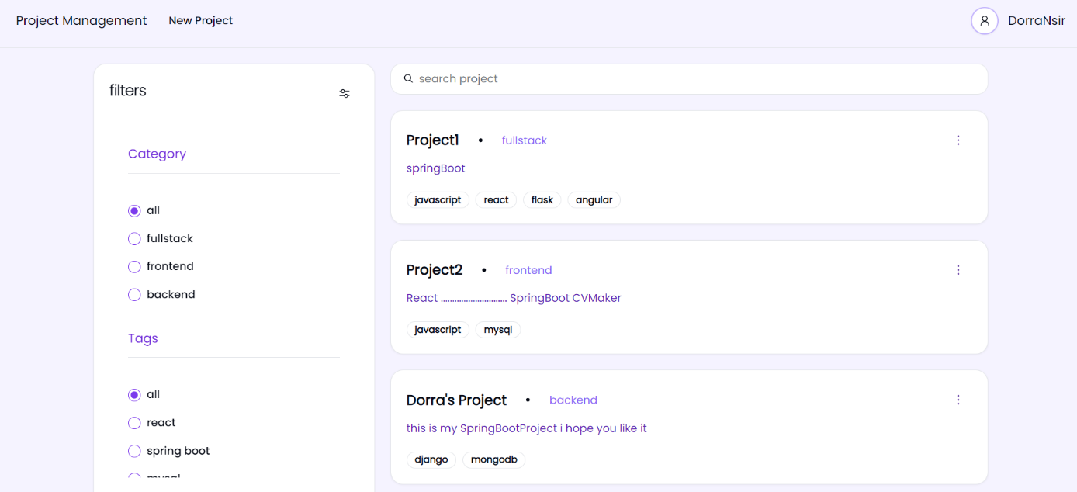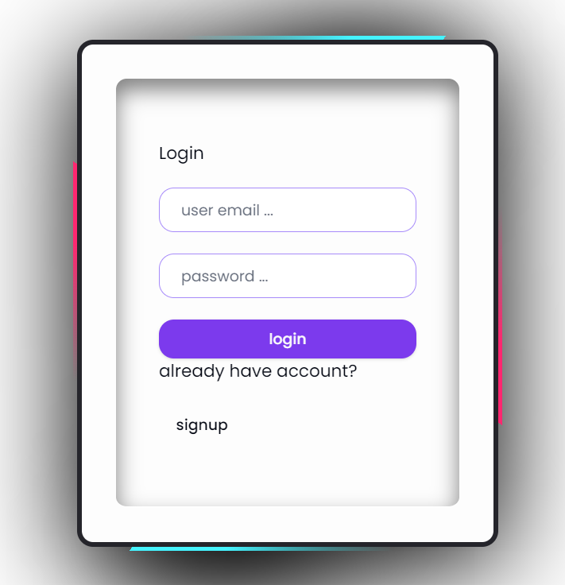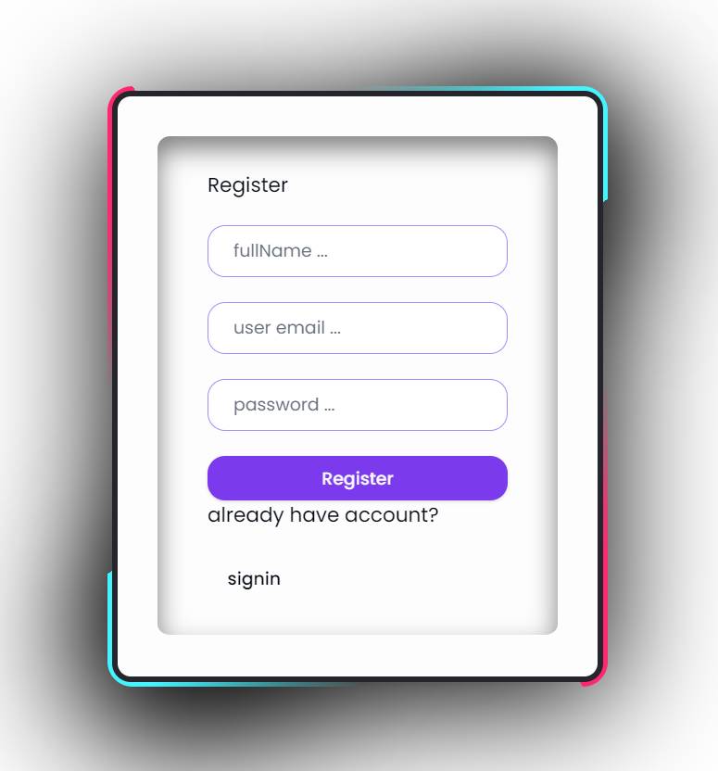

After logging in, the user will be redirected to their home page, where they can view and manage their projects.

The user can register through the registration interface, or if they already have an account, they should press the sign-in button to log in.

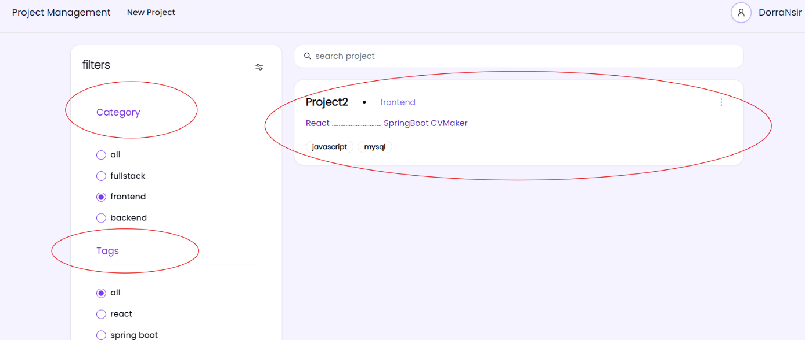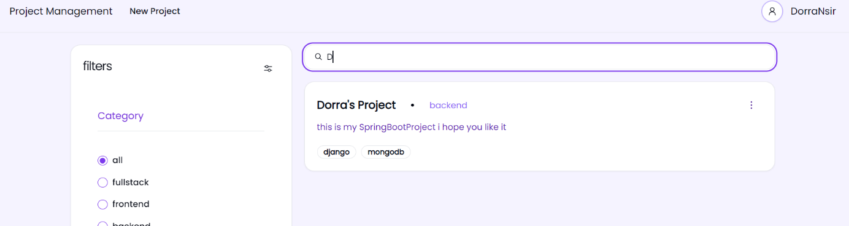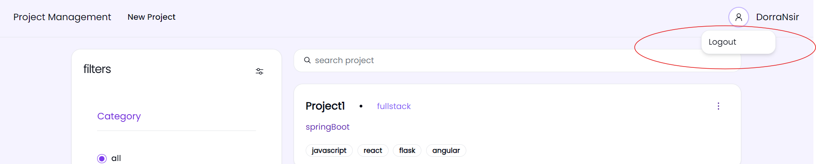

Additionally, users have the capability to search for projects by keyword. For instance, if a user is seeking projects containing the letter "D", they can simply input the letter into the search bar (like the example below)

Upon initiating logout, the system will purge the JWT from local storage, thereby effectively terminating the user's session. Consequently, the user will be seamlessly redirected to the login page, ensuring a secure and streamlined authentication experience.

Similarly, users can filter projects by category or tags. For instance, in this example, the user is filtering projects with the "frontend" category.

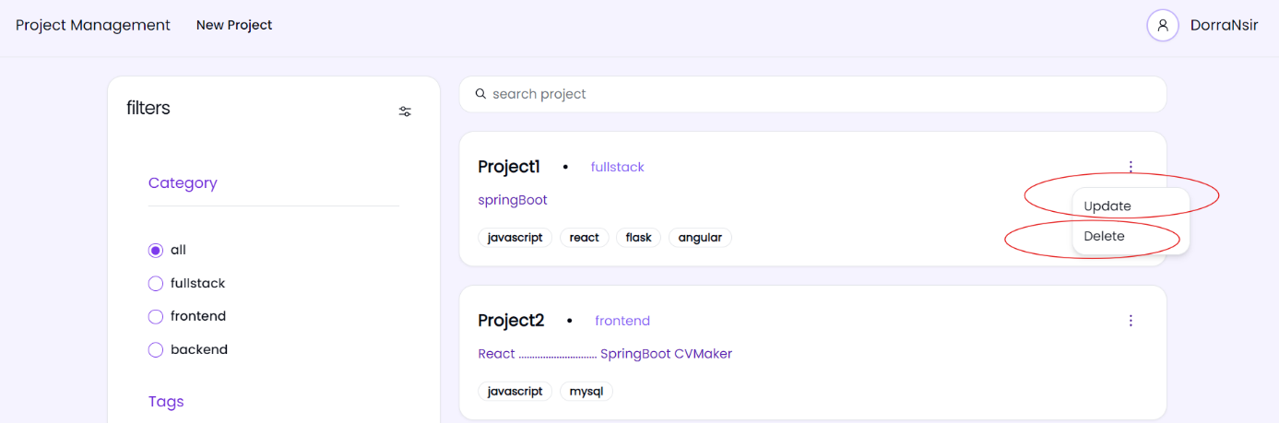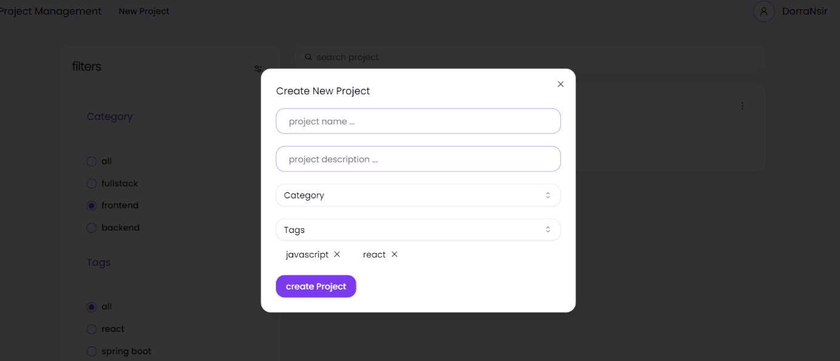

Here, users can locate delete and update buttons, granting them the ability to either delete any project they desire or update its details as needed.

By clicking on this button, users can initiate the project creation process via a form that will appear on the screen.

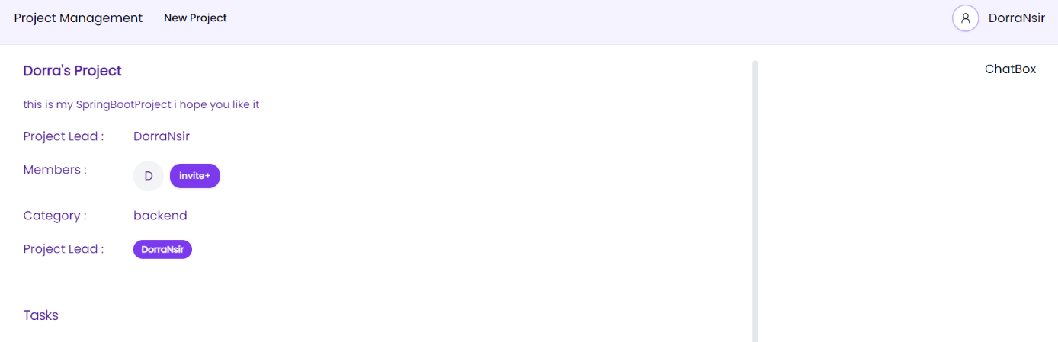

**Github Link:** https://github.com/DorraNsir/Project_Managment_System.git

**Technologies :**

* React + vite
* SpringBoot
* SpringSecurity
* Redux
* shadcn

And finally by clicking on the project name user can see the data of the project