MATLAB – HW5 Upload Date: 29 Nov. 2020

Dorreen Rostami – 97243034   
Zahra Hashemi – 97243072

5-1)

|  |  |  |
| --- | --- | --- |
|  | Syntax | Description |
| trapz | trapz(Y) | trapz evaluates the approximate integral of Y via a special method called *trapezoidal method*. If Y is a vector, this function calculates the approximate integral of Y, if Y is a matrix, it integrates over each column and returns a row vector of integration values. |
| trapz(X,Y) | This function integrates Y with respect to the coordinates of X. If X is a vector of coordinates, then length(X) must be equal to the size of the first dimension of Y whose size does not equal 1. |

In the second example, because x^3 is a symmetric function, with respect to the y axis, and the range is also symmetric, the value would be 0.

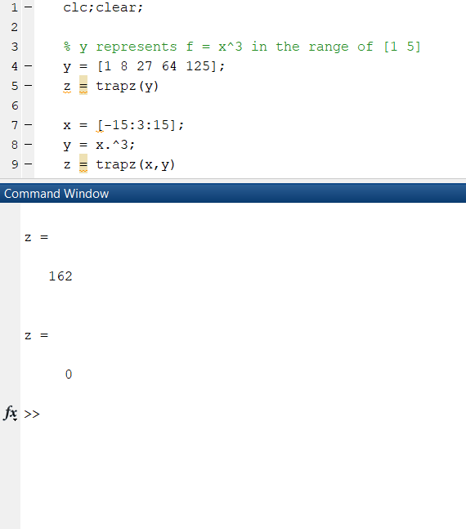

5-2)

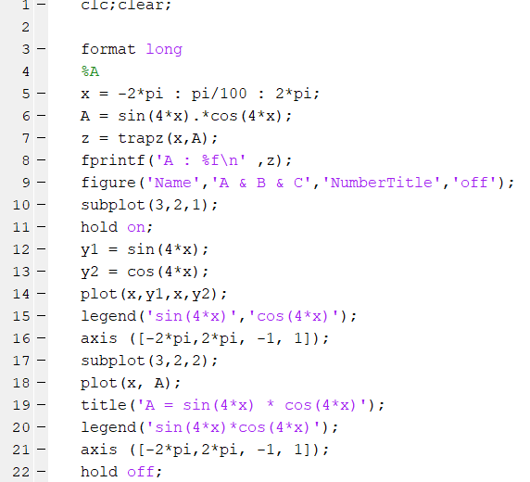

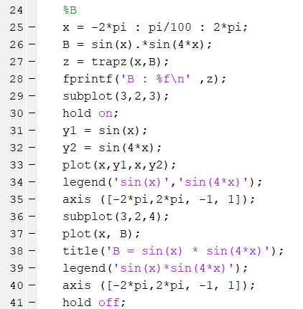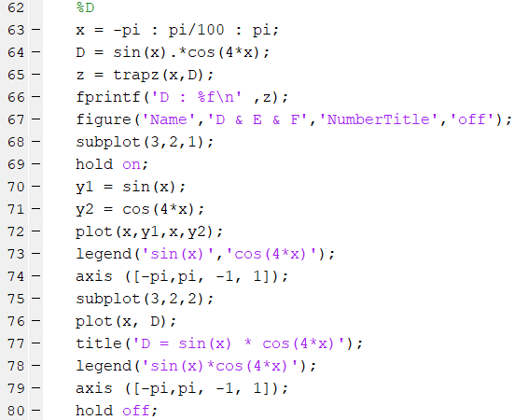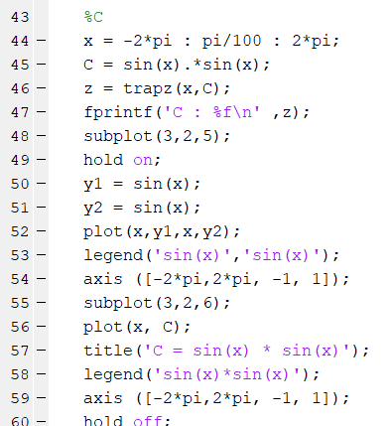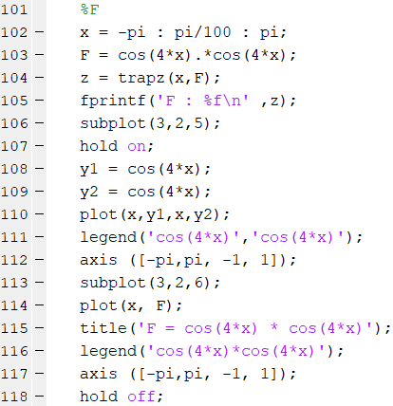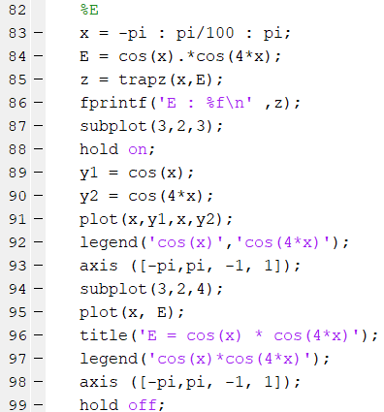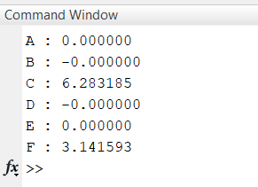

----- > A = 0 & D = 0

$$\int_{-p}^{p}{\sin\left(\frac{mπx}{p}\right)\cos\left(\frac{nπx}{p}\right)dx=0, for all m and n }$$

$$\int_{-p}^{p}{\sin\left(\frac{mπx}{p}\right)\sin\left(\frac{nπx}{p}\right)dx=}$$

----- > B = 0

0 , if m $≠$ n

---- > C = 2 $π$

P , if m =n

---- > E = 0

0 , if m $≠$ n

$$\int_{-p}^{p}{\cos\left(\frac{mπx}{p}\right)\cos\left(\frac{nπx}{p}\right)dx=}$$

---- > F = $π$

P , if m =n

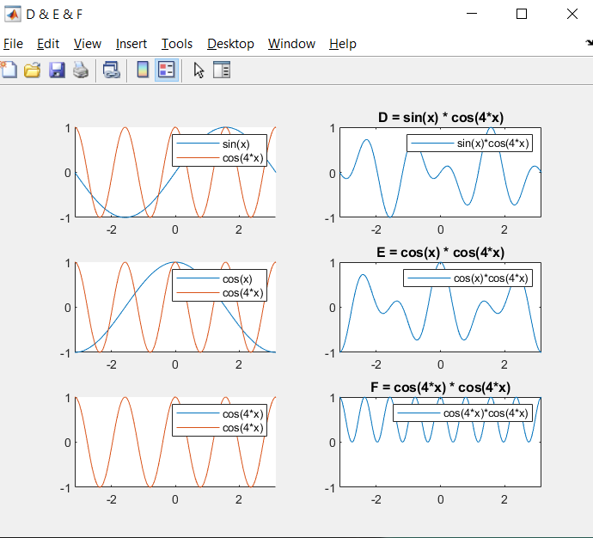

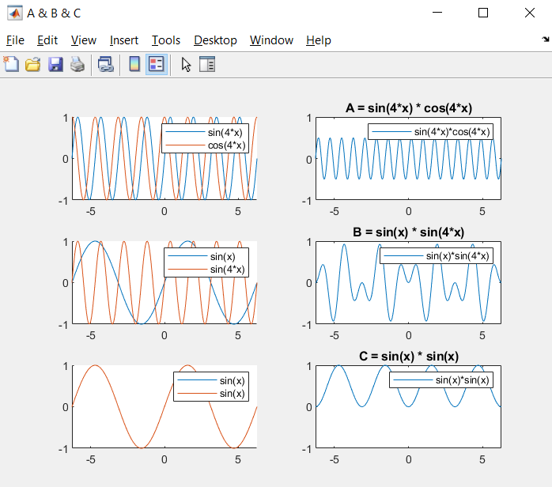

5-3)

|  |  |  |
| --- | --- | --- |
|  | Syntax | Description |
| integral | integral(fun,xmin,xmax) | This will return the integration of function fun from xmin to xmax using global adaptive quadrature and default error tolerances. |
| integral(fun,xmin,xmax,Name,Value) | This function works like the previous one, except it has 2 more arguments in order to specify additional options. |

|  |  |  |
| --- | --- | --- |
|  | Syntax | Description |
| quad | quad(fun,a,b) | quad function is very similar to the integral function. It is used to find the area under the graph of function fun in the range of a and b. |
| quad(fun,a,b,tol) | In this syntax, tol represents an absolute error tolerance and it will use this instead of default error 1.0e-6. |
| [ q, fcnt ] = quad(…) | This function returns the number of function evaluations. |

Integral with integral function

Integral with quad function

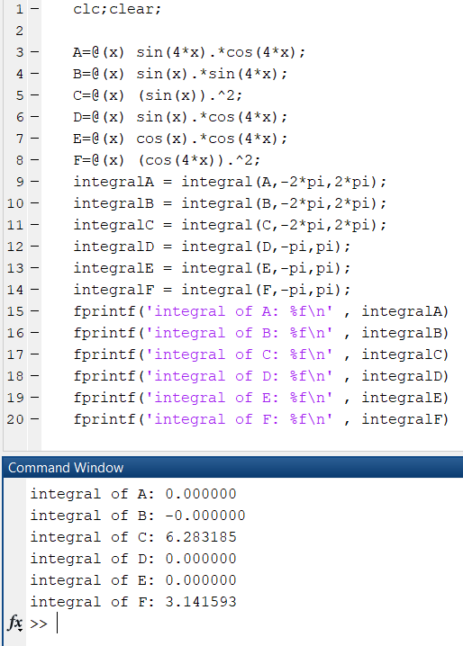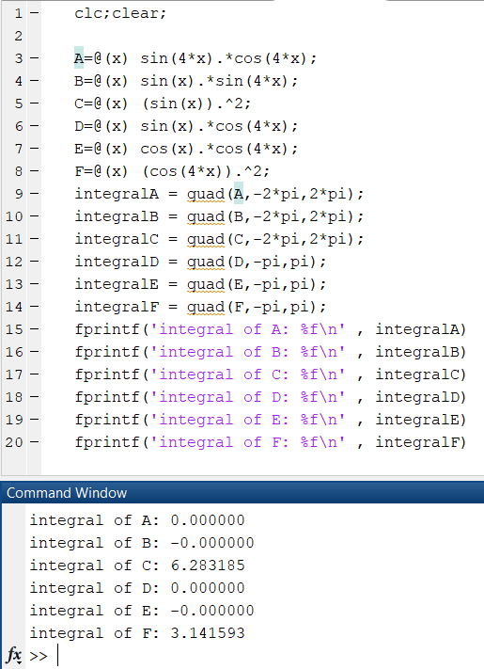

We use fprintf to easily view the results (like how they are equal to zero). By using fprintf to compare the outputs we’ll see no difference but if we were to use display, we’ll see that the result will vary only a small amount. For example, Integral of A will be 5.2042e-16 by using integral and 6.9389e-17 by using quad, but basically that amount is so little that we’ll still stay it’s zero.

5-4-1)



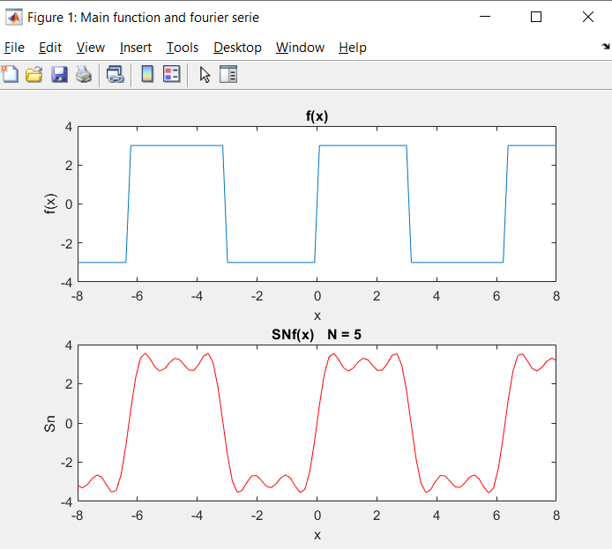

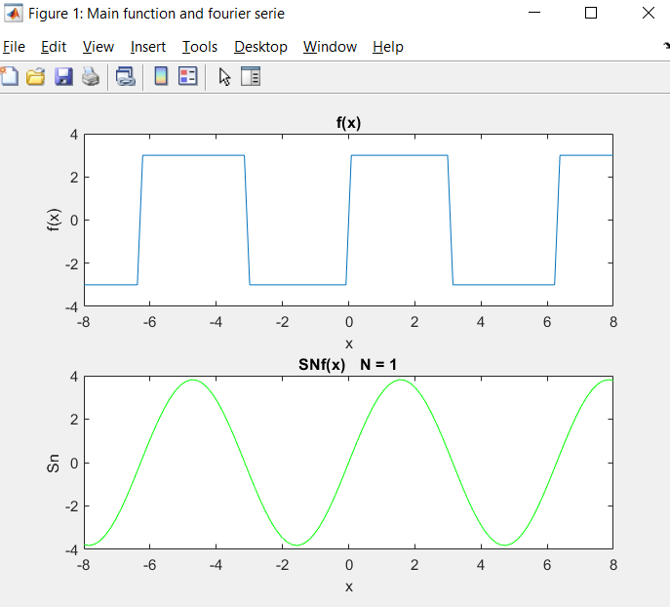

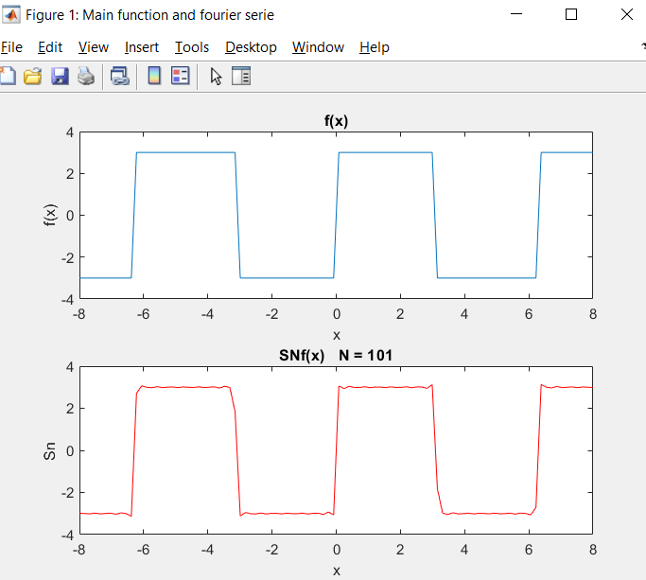

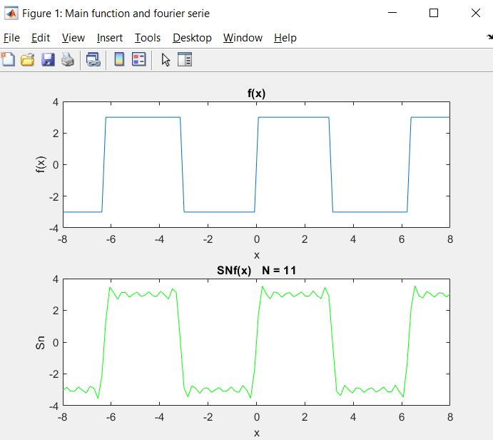

5-4-2)



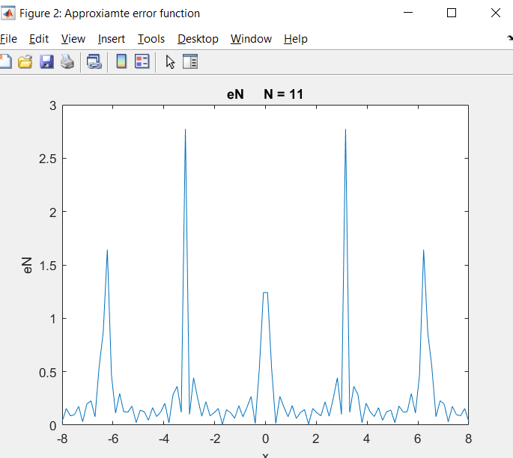

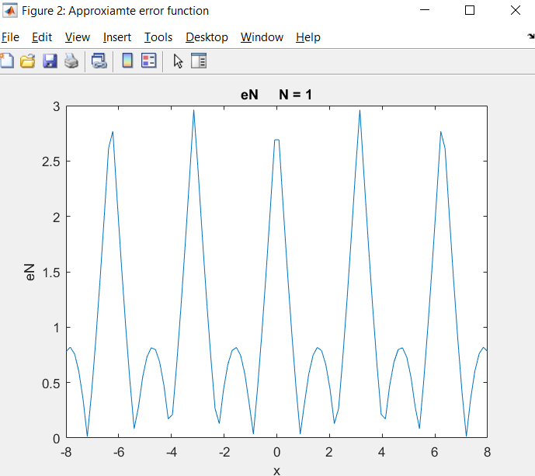

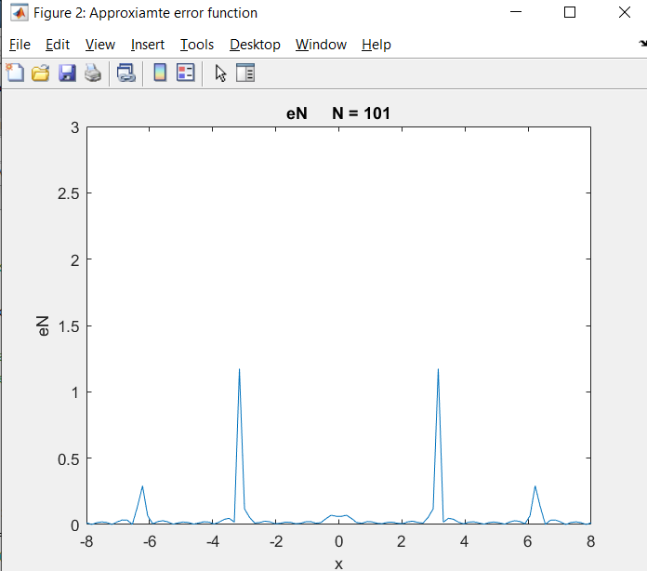

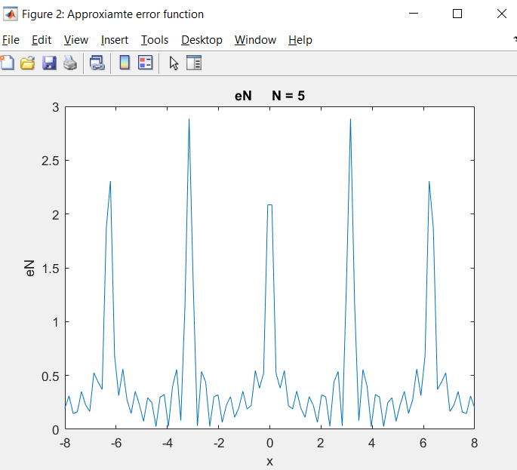

5-4-3)



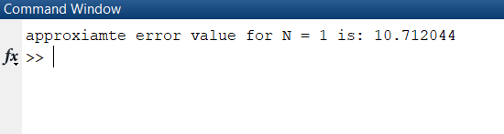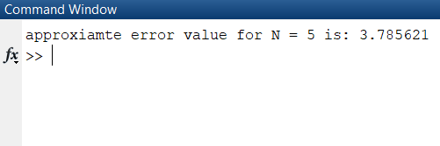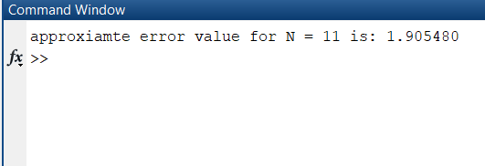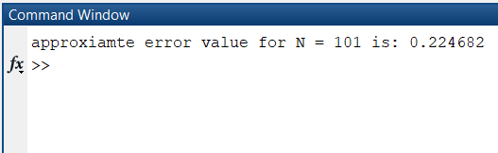

5-4-4)

