**微算機實驗報告格式**

**姓姓名：陳達軒**

**學號：0610837**

**上課時間：**

**2018 Fall 2EF**



Lab # 1

**ㄧ、實驗目的：**

但請以自己對本次實驗的認知來加以說明。

複習搖搖棒的顯示原理、傾斜開關的觸發原理、大型文字table的讀取方式，學習外部中斷的控制方式以及和delay的掌控

**二、硬體架構：**

請儘量自己畫圖不管是手繪或者是以電腦繪圖(Word or PoworPoint)。

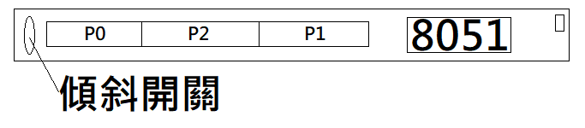

**三、程式流程圖：**

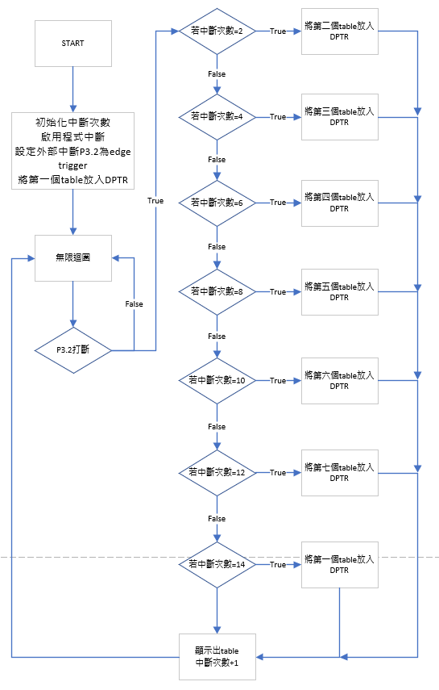

**四、問題與討論：**

Note:

1.回答助教在實驗講義中所提的問題。

2.自己發現的疑問以及如何解決的方法。

1. 若是使用搖搖棒發出中斷訊號，只要CPU在執行完現在的指令之後，就會跳到中斷程式，比起polling更有效率和便捷，對於delay的掌控可以簡單點，但是使用中斷程式，CPU需要重新設計硬體架構，較為複雜。

2. 這次的進階題，在做的時候因為表格過大，需要用到256以上的數字去做紀錄表格位置，來達到表格互換的功能，所以兩個數來記錄就是重點，以及如何讓執行完的表格位置回歸原點，在做的時候當R超過固定的大小，就會爆掉，導致綠色LED全部亮起，搖搖棒不工作。

**五、心得：**

Note:

1.對於實驗內容的心得感想

2.對本課程的建議。

這次實驗很可惜沒有做出進階題，在實驗的部分感覺到比以往困難的挑戰，不光是單單處理delay，處理表格與表格間的轉換也成為了一個能不能寫出來的關鍵。在使用中斷的情況下，delay行為相對polling簡單上許多，此時其他的程式技巧也顯得相當重要。實驗時，在處理不一樣的板子也必須有相當的熟練度，了解不同板子工作的方式，才能有更好的發揮。

**六、程式碼與註解：**

ORG 00H

JMP INITIAL

ORG 03H

JMP INTERRUPT

INITIAL:

SETB IT0 ;外部中斷P3.2設為edge trigger

MOV IE,#10000001B ;interrupt enable EA=1,EX0=1

MOV R4,#0 ;計算中斷次數用

MOV DPTR,#TABLE0 ;第一個字的table

WAIT:

JMP WAIT ;一個無限循環的空loop

INTERRUPT: ;中斷程式

CJNE R4,#2,J1 ;如果中斷次數＝2次

MOV DPTR,#TABLE1 ;放入第1個字的table

INC R4 ;紀錄中斷次數+1

JMP LOOP ;跳去顯示字

J1:

CJNE R4,#4,J2 ;如果中斷次數＝4次

MOV DPTR,#TABLE2 ;放入第2個字的table

INC R4 ;紀錄中斷次數+1

JMP LOOP ;跳去顯示字

J2:

CJNE R4,#6,J3 ;邏輯同上

MOV DPTR,#TABLE3

INC R4

JMP LOOP

J3:

CJNE R4,#8,J4 ;邏輯同上

MOV DPTR,#TABLE4

INC R4

JMP LOOP

J4:

CJNE R4,#10,J5 ;邏輯同上

MOV DPTR,#TABLE5

INC R4

JMP LOOP

J5:

CJNE R4,#12,BACK ;邏輯同上

MOV DPTR,#TABLE6

INC R4

JMP LOOP

BACK:

CJNE R4,#14,FIRST ;如果中斷次數=14次

MOV DPTR,#TABLE0 ;放入第0個字的table

MOV R4,#0 ;中斷次數歸0

JMP LOOP ;跳去顯示字

FIRST:

INC R4

LOOP: ;顯示字

MOV R0,#71 ;一個字有72*8bit組成

MOV R1,#24 ;顯示24次

NEXT_COLUMN: ;一次顯示3*8bit的燈

CALL READ_BYTE

MOV P0,A

CALL READ_BYTE

MOV P2,A

CALL READ_BYTE

MOV P1,A

CALL DELAY ;短暫的delay視覺暫留

DJNZ R1,NEXT_COLUMN

RETI ;一個字顯示完畢跳回WAIT

;等待下次interrupt

READ_BYTE: ;讀取table用

MOV A,R0

MOVC A,@A+DPTR

CPL A

DEC R0

RET

DELAY:

MOV R6,#70

DELAY1:

MOV R7,#70

DELAY2:

DJNZ R7,DELAY2

DJNZ R6,DELAY1

RET

TABLE0:

DB 0000000B,00000000B,00000000B

DB 0000001B,11111111B,11100000B

DB 0000111B,11111111B,11111000B

DB 0001111B,11111111B,11111100B

DB 0001111B,00000000B,00111100B

DB 0001100B,00000000B,00001100B

DB 0001100B,00000000B,00001100B

DB 0001111B,10000000B,01111100B

DB 0001111B,11111111B,11111100B

DB 0000111B,11111111B,11111000B

DB 0000000B,11111111B,11000000B

DB 0000000B,00000000B,00000000B

DB 0000000B,00000000B,00000000B

DB 0000000B,00000000B,00000000B

DB 0000000B,00000000B,00000000B

DB 0000000B,00000000B,00000000B

DB 0000000B,00000000B,00000000B

DB 0000000B,00000000B,00000000B

DB 0000000B,00000000B,00000000B

DB 0000000B,00000000B,00000000B

DB 0000000B,00000000B,00000000B

DB 0000000B,00000000B,00000000B

DB 0000000B,00000000B,00000000B

DB 0000000B,00000000B,00000000B

TABLE1:

DB 0000001B,11111100B,01100000B

DB 0000111B,11111110B,01111000B

DB 0001111B,11111111B,00001100B

DB 0001111B,00000111B,00001100B

DB 0001100B,00000011B,00001110B

DB 0001100B,00000011B,00001110B

DB 0001100B,00000011B,00001110B

DB 0001110B,00000111B,00111100B

DB 0001111B,11111111B,11111100B

DB 0000111B,11111111B,11100000B

DB 0000001B,11111111B,11000000B

DB 0000000B,00000000B,00000000B

DB 0000000B,00000000B,00000000B

DB 0000000B,00000000B,00000000B

DB 0000000B,00000000B,00000000B

DB 0000000B,00000000B,00000000B

DB 0000000B,00000000B,00000000B

DB 0000000B,00000000B,00000000B

DB 0000000B,00000000B,00000000B

DB 0000000B,00000000B,00000000B

DB 0000000B,00000000B,00000000B

DB 0000000B,00000000B,00000000B

DB 0000000B,00000000B,00000000B

DB 0000000B,00000000B,00000000B

TABLE2:

DB 0001000B,00000000B,00000000B

DB 0001000B,00000000B,00000000B

DB 0001111B,11111111B,11111100B

DB 0001111B,11111111B,11111100B

DB 0001111B,11111111B,11111000B

DB 0001000B,00000000B,00001000B

DB 0001000B,00000000B,00001000B

DB 0000000B,00000000B,00000000B

DB 0000000B,00000000B,00000000B

DB 0000000B,00000000B,00000000B

DB 0000000B,00000000B,00000000B

DB 0000000B,00000000B,00000000B

DB 0000000B,00000000B,00000000B

DB 0000000B,00000000B,00000000B

DB 0000000B,00000000B,00000000B

DB 0000000B,00000000B,00000000B

DB 0000000B,00000000B,00000000B

DB 0000000B,00000000B,00000000B

DB 0000000B,00000000B,00000000B

DB 0000000B,00000000B,00000000B

DB 0000000B,00000000B,00000000B

DB 0000000B,00000000B,00000000B

DB 0000000B,00000000B,00000000B

DB 0000000B,00000000B,00000000B

TABLE3:

DB 0000000B,00000000B,00000000B

DB 0000001B,11111111B,11100000B

DB 0000111B,11111111B,11111000B

DB 0001111B,11111111B,11111100B

DB 0001111B,00000000B,00111100B

DB 0001000B,00000000B,00000100B

DB 0001100B,00000000B,00001100B

DB 0001111B,10000000B,01111100B

DB 0001111B,11111111B,11111100B

DB 0000111B,11111111B,11111000B

DB 0000000B,11111111B,11000000B

DB 0000000B,00000000B,00000000B

DB 0000000B,00000000B,00000000B

DB 0000000B,00000000B,00000000B

DB 0000000B,00000000B,00000000B

DB 0000000B,00000000B,00000000B

DB 0000000B,00000000B,00000000B

DB 0000000B,00000000B,00000000B

DB 0000000B,00000000B,00000000B

DB 0000000B,00000000B,00000000B

DB 0000000B,00000000B,00000000B

DB 0000000B,00000000B,00000000B

DB 0000000B,00000000B,00000000B

DB 0000000B,00000000B,00000000B

TABLE4:

DB 0000000B,00000000B,00000000B

DB 0000011B,11100011B,01110000B

DB 0000111B,11110111B,11111000B

DB 0001111B,11111111B,11111100B

DB 0001000B,10001100B,01001100B

DB 0001000B,00001100B,00000100B

DB 0001000B,00001100B,00000100B

DB 0001100B,00001111B,10011100B

DB 0001111B,11111111B,11111100B

DB 0000111B,11111011B,11111000B

DB 0000011B,11110011B,11110000B

DB 0000000B,00000000B,00000000B

DB 0000000B,00000000B,00000000B

DB 0000000B,00000000B,00000000B

DB 0000000B,00000000B,00000000B

DB 0000000B,00000000B,00000000B

DB 0000000B,00000000B,00000000B

DB 0000000B,00000000B,00000000B

DB 0000000B,00000000B,00000000B

DB 0000000B,00000000B,00000000B

DB 0000000B,00000000B,00000000B

DB 0000000B,00000000B,00000000B

DB 0000000B,00000000B,00000000B

DB 0000000B,00000000B,00000000B

TABLE5:

DB 0000011B,11110000B,11110000B

DB 0000111B,11111011B,11111000B

DB 0001111B,11111011B,11111100B

DB 0001100B,00001111B,10011100B

DB 0001000B,00000100B,00000100B

DB 0001000B,00000100B,00000100B

DB 0001000B,10000100B,01001100B

DB 0001111B,11000000B,11111100B

DB 0000111B,11000000B,11111000B

DB 0000011B,11000000B,01110000B

DB 0000000B,00000000B,00000000B

DB 0000000B,00000000B,00000000B

DB 0000000B,00000000B,00000000B

DB 0000000B,00000000B,00000000B

DB 0000000B,00000000B,00000000B

DB 0000000B,00000000B,00000000B

DB 0000000B,00000000B,00000000B

DB 0000000B,00000000B,00000000B

DB 0000000B,00000000B,00000000B

DB 0000000B,00000000B,00000000B

DB 0000000B,00000000B,00000000B

DB 0000000B,00000000B,00000000B

DB 0000000B,00000000B,00000000B

DB 0000000B,00000000B,00000000B

TABLE6:

DB 0000000B,00000000B,00001100B

DB 0000000B,00000000B,00111100B

DB 0000000B,00000000B,01111100B

DB 0000000B,00000011B,11101100B

DB 0001111B,11111111B,11001100B

DB 0001111B,11111110B,00001100B

DB 0001111B,11111000B,00001100B

DB 0000111B,00000000B,00001100B

DB 0000000B,00000000B,00011100B

DB 0000000B,00000000B,01111100B

DB 0000000B,00000000B,01111100B

DB 0000000B,00000000B,00000000B

DB 0000000B,00000000B,00000000B

DB 0000000B,00000000B,00000000B

DB 0000000B,00000000B,00000000B

DB 0000000B,00000000B,00000000B

DB 0000000B,00000000B,00000000B

DB 0000000B,00000000B,00000000B

DB 0000000B,00000000B,00000000B

DB 0000000B,00000000B,00000000B

DB 0000000B,00000000B,00000000B

DB 0000000B,00000000B,00000000B

DB 0000000B,00000000B,00000000B

DB 0000000B,00000000B,00000000B

END