Doruk Taneli **LAB4:** 23.02.2018

**Design and Implementation of LED Ping Pong**

**Introduction:**

The aim of this lab is to design a sequential circuit for LED pattern animations with control inputs and status output functions

**Methodology:**

I used the given clock and made the period half second, so it does not take too long from one edge of LEDs to other.

I made a next state decider process. According to the current state, LEDs and next state is decided.

In the rising edge of the CLK_DIV, current state is set to the next state.

In the falling edge of CLK_DIV, which is the exact middle of the duration of a state, If the current state is the leftmost one and left catch is selected, the counter is incremented. The same is also implemented for rightmost LED.

And seven segment outputs are set based on the counter.

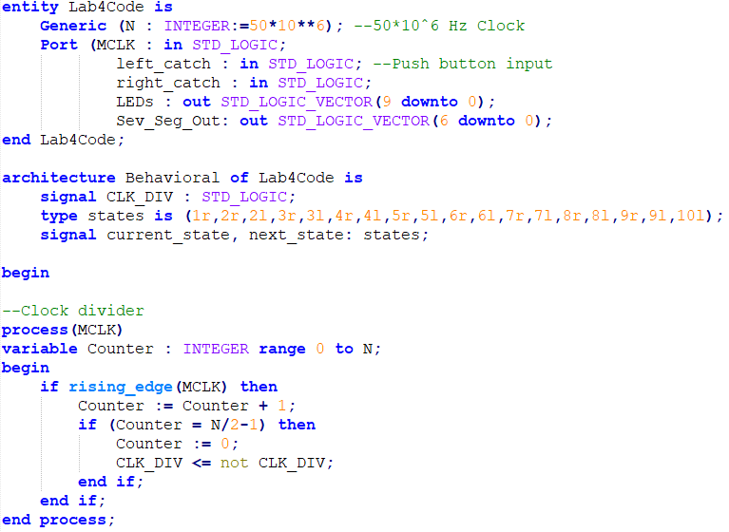

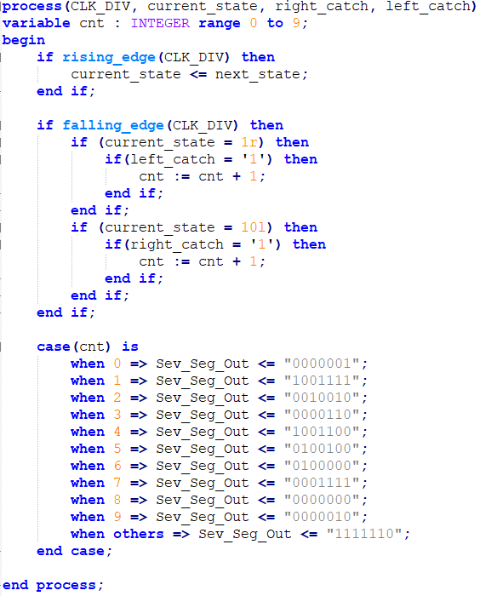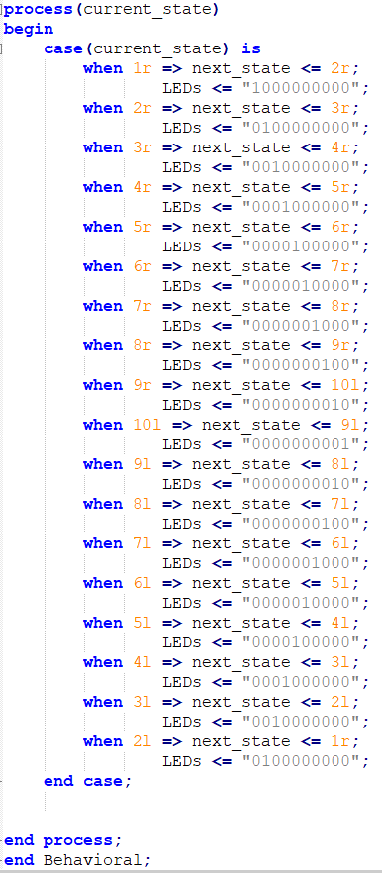

**Experimental Results:**

I mapped left catch and right catch to buttons. It performed correctly on the FPGA board. The light is periodically going left and right, and if you press the respective button, the number on seven segment increases.

**Discussion and Conclusion:**

In this lab, I learned about of clock circuits and I learned how to use sequential circuits making use of states. I made a basic game on the FPGA that is open to improve.