**Architecture document**

***Service provider dashboard***

*ROOSH*

|  |
| --- |
| **Date: 01-11-2023** |
| **Version: 1.0** |
| **Author: Pixel Pioneers** |

Table of Contents

C1 and C2: 3

Database Diagram: 4

# C1 and C2:

# C3:

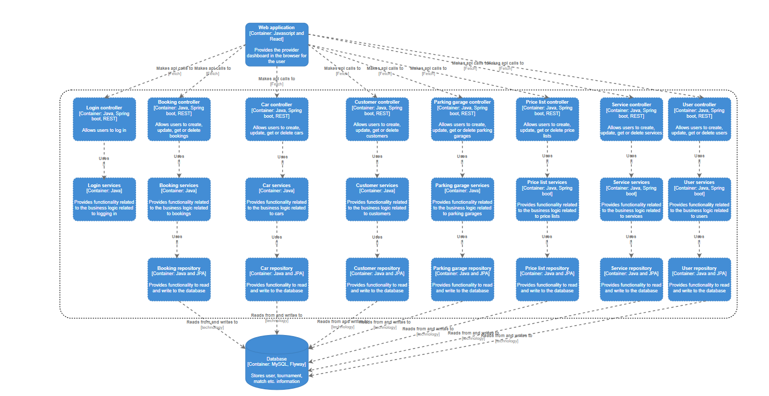

# Database Diagram:

