

Module code and name: | Network Operations - 5BUIS013C
Assessment: | CW
Student ID: | 00018919
Submission deadline: | 16 March, 2026
Wordcount
Results date and type of feedback
Result (Pass or Fail)
Feedback

Contents:

- Introduction
- Design Assumptions
- Equipment Selection
- Network Architecture and Diagram
- Network Security
- ISP Selection
- Cloud-Based Data Ingestion Solution
- IP Address Allocation (VLSM)
- Conclusion
- References

Introduction:
Elbonia National Oil Company (ENOC) operates a twelve-storey headquarters in Elbopolis. The building consists of a public retail floor (floor 1), five floors leased to external companies (floors 2–6), a dedicated technical floor for networking infrastructure (floor 7), and five upper floors (floors 8–12) occupied by ENOC departments.
Due to the diversity of users and operational requirements, the organisation requires a secure, scalable, and centrally managed network infrastructure. The design should ensure strict separation between ENOC departments, external tenant offices, and public Wi-Fi users, while providing reliable Internet connectivity for all floors.
This report proposes a complete network architecture for the headquarters. The design includes hierarchical network topology, structured cabling, centrally managed wireless infrastructure, secure Internet connectivity with VPN capability for branch communication, and appropriate logical segmentation to restrict inter-departmental and inter-tenant access.
Additionally, the report evaluates suitable Internet Service Providers, reviews managed cloud-based real-time data ingestion services, proposes an IP addressing scheme using Variable Length Subnet Masking (VLSM), and presents a proof-of-concept TCP-based client–server voting application developed in C#.
The objective of this report is to provide a technically justified network solution that meets performance, security, and scalability requirements for a multi-floor enterprise environment.

Design Assumptions

To develop a realistic and practical network design, several assumptions are made based on the case study requirements.

First, each ENOC department floor (floors 8–12) may accommodate up to 100 employees. This results in a maximum of approximately 500 internal users. Since wired connectivity is prioritised for security reasons, the design must support high-density wired access while also providing wireless coverage for mobility.

Second, each leased floor (floors 2–6) contains 15 separate offices. Each office requires at least one wired connection and access to wireless services. As every office belongs to a different company, strict network-level isolation is required to prevent communication between tenants and to block access to ENOC’s internal network. VLAN based logical segmentation and inter-VLAN routing will thus be applied.

Third, the first floor is used as a social place and should offer free Wi-Fi services to visitors. Having an area of around 1,000m2 and, possibly, a high load of users at the same time, several enterprise-level access points should be provided to guarantee both sufficient coverage, load balancing and performance during heavy traffic. Guest traffic must remain fully isolated from both ENOC and tenant networks.

All active networking equipment is assumed to be centrally located on the technical floor (floor 7), forming a collapsed core architecture. Fibre-optic cabling is used for vertical backbone connections between floors to provide high bandwidth and low latency, while Category 6 (Cat6) copper cabling is used for horizontal connections within each floor

For Internet connectivity, a 1000 Mbps business-grade connection is considered appropriate. Although the total number of users may reach approximately 600–700, including tenants and guests, not all users will generate high traffic simultaneously. The selected bandwidth provides sufficient capacity for web traffic, cloud services, VPN communication between branches, and future growth, while maintaining acceptable performance levels.

The IP addressing scheme will be designed using VLSM to ensure efficient address allocation, clear logical segmentation between departments and tenants, and scalability for future expansion.

These assumptions form the foundation for the equipment selection, segmentation strategy, and overall network architecture described in the following sections.

Equipment Selection

3.1 Edge Security Device (Firewall and VPN Gateway)

Specification | FortiGate 100F | FortiGate 400F
NGFW Throughput | 1.6 Gbps | 10 Gbps
Threat Protection | 1 Gbps | 9 Gbps
Concurrent Sessions | 1.5 million | 7.8 million
New Session/sec | 56 000 | 500 000
IPsec VPN Throughput | 11.5 Gbps | 55 Gbps
Recommended Scale | Branch / mid size | Enterprise HQ
Approximate Price (USD) | $1,998.54 | $9,382.78

The technical floor (floor 7) has been equipped with a next generation firewall (NGFW) as shown in the network diagram. It is positioned between the Internet connection and the core switch and acts as the main security control point for the entire headquarters network.
The firewall is responsible for:
• Traffic filtering
• Network Address Translation (NAT)
• Access control enforcement
• IPsec VPN termination
• External threat protection

Since the headquarters includes:
- Up to 500 ENOC employees
- Five tenant floors (15 offices per floor)
- Public Wi-Fi users on the first floor

The firewall must support high number of concurrrent sessions and encrypted VPN traffic without becoming a performance bottleneck.

Two devices were considered: FortiGate 100F and FortiGate 400F. The FortiGate 100F provides sufficient throughput for 500 MBps Internet connection and is suitable for branch or mid sized environments. However, its lower concurrent session capacity and reduced scalability make it less appropriate for multi-floor headquarters serving internal users, tenants, and public Wi-Fi clients simultaneously.

The FortiGate 400F offers significantly higher NGFW throughput, greater session handling capacity, and much higher IPsec VPN performance. This ensures:
- Stable performance during peak hours
- Reliable inter branch VPN connectivity
- Capacity for future Internet upgrades (e.g 1 Gbps)
- Long-term scalability without replacing the firewall
Because the firewall protects the entire building and processes all external traffic, selecting a higher capacity model reduces the risk of congestion and improves overall network reliability.

Therefore, the FortiGate 400F is selected as the edge security appliance for the ENOC headquarters.

The hardware cost (approximately USD 9,382.78) is included for capital expenditure estimation. Subscription and support services are considered operational expenses and are outside the scope of this design.

3.2 Core / Distribution Switch
The core layer is deployed on the technical floor (Floor 7), where all fibre backbone connections from the building floors terminate. This layer collects traffic of access switches and routes between various VLANs.

The design follows a collapsed core architecture where the core and distribution functions are combiined into single Layer 3 switch. This approach is appropriate because the network is located within single building and does not require a separate distribution layer. Combining these layers reduces hardware cost and complexity while stilll providing high performance and centralized routing control.

We selected Cisco Catalyst 9300 series Layer 3 switch (model C9300L-24T-4X-A) as the core device. This switch supports advanced Layer 3 routing features and include four 10-Gigabit SFP+ uplink ports which are used for high speed fibre connections betweeen the core and the access switches on each floor as illustrated in the network diagram.

The core switch performs inter-VLAN routing to maintain logical separation between:
- ENOC internal departments (Floors 8–12)
- Tenant networks (Floors 2–6)
- Public Wi-Fi users on the first floor

Since the core switch only communicates with floor access switches and the firewall, but not directly with end-user devices, a 24 port core switch is sufficient. It provides appropriate connectivity at an advantageous cost.

The Network Advantage license was selected in order to have complete Layer 3 routing and advanced policy control to separate VLANs and manage traffic. The switch costs about USD 2,397.00.

3.3 Access Layer Switches
The access layer provides wired connectivity for employee workstations, tenant office devices, printers, IP phones, and wireless infrastructure. The access switches typically operate at Layer 2 and forward the traffic to the core switch via high speed fibre links.

For ENOC floors (8–12), each floor may accommodate up to 100 employees. We installed three 48 port access switches per floor to manage the large number of devices and future expansion to provide 144 wired ports. These switches connect employee computers, printers, and other wired devices. In addition, a 24-port PoE+ switch is installed on each ENOC floor to provide power and network connectivity for wireless access points. Separating PoE infrastructure from user access switches simplifies power management and ensures reliable operation of the wireless network.

For tenant floors (2–6), each floor contains approximately 15 independent offices. One of the 48-port access switches provides sufficient wiring connections to tenant equipment, as well as additional ports to support future requirements. A 24-port PoE+ switch is also provided to each tenant floor to supply and distribute WiFi access points and also provide a good coverage of the offices.

Floor 1 is the public floor. It possesses guest Wifi, IP phones, and printers as well as admin computers. We installed a wired device 48 port access switch. A 24-port PoE+ switch is used to supply to multiple WiFi visitor access points. Security cameras can also be present in this floor. The new cameras can also connected wirelessly, or via PoE to the switches, although the network is also capable of supporting wired PoE cameras in case we require a better reliability or 24/7 video.

The access layer is selected to be Cisco Catalyst 9200L switches since they are consistent, have PoE+ and 10 Gb core switch uplinks. The Network Essentials license suffices since routing is performed by the core Layer 3 switch.

VLANs at the access layer are used to maintain separations between groups. There is a VLAN of each ENOC department, tenant network and public Wifi. This segregation devides broadcast spaces and accelerates the network.

Inter-VLAN routing is performed at the core Layer 3 switch, where access control policies restrict communication between networks. Tenant and guest networks are isolated from ENOC internal resources, ensuring secure operation of the headquarters network.

This design supports a collapsed core architecture, where the core switch performs both core and distribution functions while access switches provide connectivity for end devices across the building.

3.4 Wireless Access Points
Wireless connectivity is required across all floors to support employees, tenant offices, and public visitors. Enterprise-grade Wi-Fi 6 access points are selected to provide reliable performance, higher device capacity, and improved efficiency compared to older version of Wifi.

A centralized wireless architecture is assumed, where access points are centrally managed through a wireless controller. This allows consistent configuration, simplified monitoring, and uniform security policy enforcement across the entire building.

Cisco Catalyst 9120AXI access points are selected as they support the 802.11ax (Wi-Fi 6) standard and are suitable for high-density enterprise environments. These devices are powered using 802.3at PoE+ which aligns with the PoE switches deployed on each floor.

For ENOC floors (8–12), seven access points per floor are deployed. Since each floor may accommodate up to 100 employees, multiple access points are required to distribute wireless clients and prevent congestion. This results in 35 access points across the five ENOC floors.

For tenant floors (2–6), three access points per floor are considered sufficient. The office room count is normally low and the offices are fewer on these floors with 15 offices per floor. The number of access points used should be small as it provides great coverage and distributes clients to eliminate congestion. This results in a total of 15 access points across the tenant floors

The public ground floor (approximately 1000 m²) is expected to have higher guest traffic. To maintain stable wireless performance during peak usage, eight access points are deployed to provide adequate coverage and user capacity.

In total, 58 wireless access points are installed throughout the building. Each access point connects to the PoE switches on its respective floor.

Separate wireless SSIDs are configured for ENOC employees, tenant users, and public guests. These SSIDs are mapped to different VLANs to maintain logical separation between internal networks, tenant offices, and public Wi-Fi traffic.

The approximate hardware cost per access point is USD 1,132.67.

3.5 Cabling Infrastructure
The structured cabling system that we employ makes the network of the building reliable, scalable and manageable. This design is the common design that isolates the main vertical backbone cables and the horizontal floor cables.

Fibre-optic cabling is used for the vertical backbone connections between floors. Fibre links connect the access switches on each floor to the core switch located on the technical floor (Floor 7), as shown in the network diagram. Fiber is selected as it is capable of supporting 10-Gigabit Ethernet, the loss of signal is minimal in maintaining a long distance and it is also not affected by electromagnetic interference. These characteristics make it well suited for inter-floor backbone communication in multi-storey buildings.

For horizontal floor-level connections, Category 6 (Cat6) UTP cabling is used. Cat6 supports Gigabit Ethernet and PoE+ and provides reliable performance for cable runs up to 100 meters. This makes it suitable for connecting end devices such as workstations, printers, IP phones, access points, and security cameras to the access switches on each floor.

Patch cords are used to connect end devices to wall outlets and to connect patch panels to network switches within equipment racks. This structured approach improves cable organization and simplifies maintenance and troubleshooting.

Our estimation about the cable quantities is the number of devices per floor and a typical horizontal length of approximately 25 to 30 meters per device. The overall cost of cabling with these numbers and the existing market prices ranges to USD 25,000.
Item | Estimated Quantity | Unit Price (USD) | Total Cost (USD)
Cat6 UTP Bulk Cable | 20,000 m | $1.00 /m | $20,000
Cat6 Patch Cords | 1,400 units | $3.00 | $4,200
Fibre Optic Backbone Cable | 400 m | $2.00 /m | $800
Total Cabling Cost |  |  | $25,000

3.6 Cost Summary
Item | Quantity | Unit Price (USD) | Total Cost (USD)
FortiGate 400F | 1 | 9,382.78 | 9,382.78
Cisco Catalyst 9300 Core Switch | 1 | 2,397.00 | 2,397.00
Cisco Catalyst 9200L 48-port | 21 | 1,398.00 | 29,358.00
Cisco Catalyst 9200L 24-port PoE+ | 11 | 2,397.00 | 26,367.00
Cisco Catalyst 9120AXI AP | 58 | 1,132.67 | 67,694.86
Structured Cabling | - | - | 25,000
Total estimated infrastructure cost |  |  | 160,199.64 (approx.)

Network Architecture and Diagram
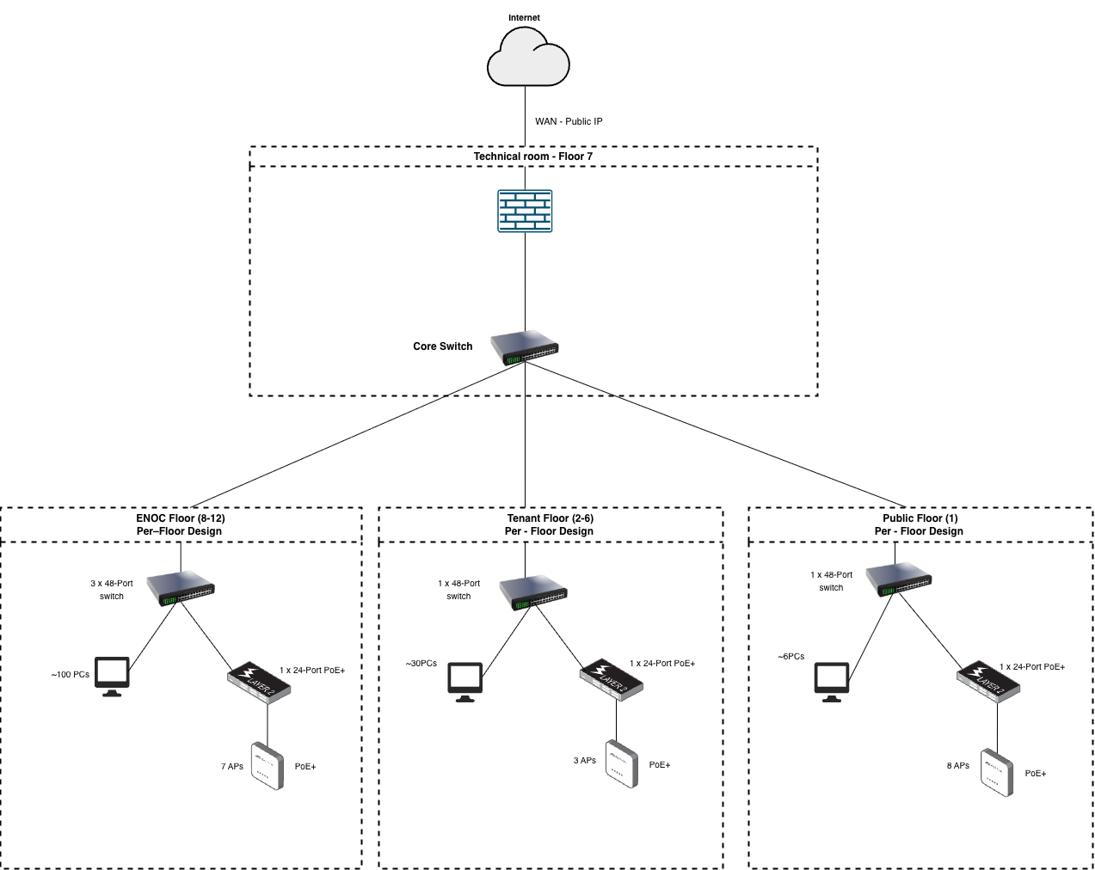
The proposed network architecture follows a hierarchical enterprise design consisting of an edge security layer, a collapsed core/distribution layer, and access layer switches deployed on each floor of the building. The firewall and core switch are located on the technical floor (Floor 7) where the connections of the backbone of the building end. This central placement allows all floor level networks to connect to the core switch through high-speed fibre links in order to guarantee an efficient forwarding of traffic and easier administration of the network.

The firewall protects the internal network from external threats and controls traffic between the internal network, tenant networks, public users, and the Internet. The core Layer 3 switch performs inter VLAN routing and links all access switches within the building.

ENOC Internal Floors (Floors 8–12)
Each ENOC floor has 100 employees each and thus needs a high density wired connection. To In order to support this need, three 48 port access switches are installed on every internal floor. This provides a total of 144 Ethernet ports per floor, ensuring sufficient capacity for employee workstations as well as additional office equipment.

There are about 100 ports where the computers of employees are connected and the rest of the ports are occupied by other devices like network printers, IP phones and wired security cameras, which need to be connected and functioning all the time. Some of the available ports are also kept to be expanded in the future so that the new employees or devices can be connected without necessarily new switching equipment.

Each ENOC floor has a separate 24-port switch (PoE+) that powers wireless access points. The switch provides power and network connectivity via the use of Ethernet cables; this means that separate power adapters do not have to be used at each access point. Seven wireless access points will be installed on each floor connected to the PoE switch to create consistent wireless coverage and distribute the wireless clients in the efficient way in the office.
Wired connections are better as compared to wireless connections despite the fact that some devices like cameras can be linked via the wireless networks. Wired connections are also better when dealing with important equipment that should always be in operation. Therefore, essential devices such as printers, phones, and some cameras are connected through the wired infrastructure whenever possible.

Tenant Floors (Floors 2–6)
Tenant floors contain approximately fifteen separate offices per floor with moderate device density. For this reason, a single 48-port access switch is sufficient to provide wired connectivity for tenant devices such as workstations, printers, and IP phones.

In order to facilitate wireless network connectivity in tenant offices, individual tenant floors have a 24-port PoE++ switch that serves as the power source to wireless access points. Each floor has three access points that will adequately cover wireless access in office spaces and will also spread the wireless traffic among several access points to evade congestion.

Tenant networks are logically separated from ENOC internal networks using VLAN segmentation. This prevents tenant devices from accessing corporate resources and ensures that each tenant operates within its own isolated network environment.

Public Floor (Floor 1)
The first floor consists of public and retail spaces where the visitors need to be connected with the Internet. Along with the guest access, this floor can have administrative systems like service workstations, printers, payment systems, and other working equipment by the staff.

These devices are wired to a 48 port access switch. Wired connections ensure reliable performance for administrative and business-critical systems that must remain stable during operation.

To support guest wireless access, a 24-port PoE+ switch powers eight wireless access points distributed across the approximately 1000 m² public area. By deploying a number of access points, the coverage is better, and the stability of performance is guaranteed when the density of users is at its peak.

Security cameras used for monitoring public areas may connect either through wired connections or through the PoE wireless network. While wireless connectivity can simplify installation in certain locations, wired connections are generally preferred for surveillance systems because they provide greater reliability and reduce the risk of signal interruptions.

Network Security

The headquarters network should protect company resources and also allow tenant networks and public Wi-Fi to use the same physical lines. Users are often sharing the same infrastructure, so we generally depend on network segmentation, firewall rules, and switch controls instead of application-level security. These mechanisms ensure that different user groups remain logically isolated while allowing controlled communication where necessary.

Network Segmentation using VLANs
VLANs isolate traffic between ENOC staff, tenant networks, and public Wi-Fi users. Every group has a VLAN, and therefore they cannot communicate with one another unless we specifically permit it.

The internal ENOC network operates within dedicated VLANs assigned to corporate departments. Tenant offices are placed in separate VLANs that isolate tenant traffic from ENOC internal systems. The public Wi-Fi network is deployed within a separate guest VLAN with restricted access policies.

Inter-VLAN routing is performed at the core Layer 3 switch, where access control rules can be applied to restrict communication between VLANs. This ensures that company information is secured without restricting Internet access to tenants and guests.

Firewall Security Policies

The enterprise firewall located at the network edge provides perimeter security between the internal network and the Internet. The firewall scans traffic, implements regulations, and serves as a VPN server.
Firewall rules are configured to allow internal users controlled access to Internet services while blocking unauthorized inbound connections from external networks. Internal ENOC resources are also not open to tenant networks or public Wi-Fi. The firewall is also used to monitor internal networks to internal networks traffic and prevent the entry of malware.

Guest Network Isolation
Public Wi-Fi users represent the least trusted group in the network. For this reason, the guest wireless network is fully isolated from internal corporate networks. Traffic from the guest VLAN is restricted to Internet access only and cannot communicate with internal devices or tenant networks.
This approach prevents unauthorized users from accessing sensitive corporate resources while still providing convenient Internet access for visitors.

Secure Remote Connectivity (VPN)
The firewall also operates as a VPN gateway, enabling secure connectivity between branch offices and the headquarters network. IPsec tunnels use encryption to keep the corporate data confidential across the public networks. The login of VPN and encryption prevents eavesdropping and unauthorized access.

Switch-Level Security
Access switches implement additional security features to protect the network from internal threats and misconfiguration. These include mechanisms such as Spanning Tree Protocol (STP) to prevent switching loops and maintain network stability. Switch rules can also prevent unauthorized devices and prevent attacks like the MAC flooding or rogue devices.

Port Security
Port security can be implemented on access layer switches to prevent unauthorized devices from connecting to the network. This feature allows the network administrator to limit the number of MAC addresses that can be learned on a switch port.

For example, employee workstation ports can be restricted to a single MAC address. If an unauthorized device is connected or if a user attempts to connect a small switch or hub to the network, the switch can automatically disable the port or block the new device.
This mechanism reduces the risk of unauthorized access to the internal corporate network and helps prevent attacks such as MAC flooding or rogue device connections.

ISP selection

Criteria | ISP1 – Sarkor Telecom | ISP2 – East Telecom | ISP3 – Comnet Telecom
Maximum speed | 1 Gbps | 1 Gbps | 1 Gbps
Symmetric connection | YES | YES | YES
SLA Uptime (%) | Not given | 98% | 99.9%
Static Public IP included | 1 static public IP included.  Additional IP addresses available depending on subnet allocation (≈110,000–330,000 UZS + monthly charge 37,000–880,000 UZS). | 1 static public IP included.  Additional IP addresses available (≈100,000 UZS setup + 6,400 UZS monthly). | 1 static public IP included.  Additional IP addresses available (≈50,000 UZS per IP).
Redundancy Option | Available depending on fibre infrastructure at the installation location | Available depending on fibre infrastructure at the installation location. | Available depending on fibre infrastructure at the installation location.
Monthly fee | 30,000,000 UZS | 43,000,000 UZS | 38,000,000 UZS
Contract Duration | Not limited | Not limited | Not Limited
24/7 Technical support | YES | YES | YES
Information about tariffs, SLA availability, and pricing was obtained through publicly available provider documentation and brief consultations with representatives of the selected ISPs operating in Tashkent.

After comparing the available Internet Service Providers, Comnet Telecom is selected as the most appropriate provider for the ENOC headquarters network.

All three providers offer a 1 Gbps symmetric connection, which satisfies the bandwidth requirements of the building. The headquarters network supports approximately 500 ENOC employees, tenant offices on five floors, and a public Wi-Fi zone. Assuming an average Internet consumption of 1–2 Mbps per active user, peak demand across employees, tenants, and public Wi-Fi users may reach approximately 700–800 Mbps.

Therefore, a 1 Gbps connection provides sufficient capacity to support normal business operations while leaving additional bandwidth available for peak traffic periods, cloud services, VPN connections, and future growth.

Sarkor Telecom offers a slightly lower monthly cost however, a confirmed SLA uptime percentage was not provided during the inquiry. In contrast, Comnet Telecom guarantees 99.9% service availability, making it a more reliable option for an enterprise environment where continuous Internet connectivity is essential.

Although Comnet’s monthly fee (38,000,000 UZS) is moderately higher than that of Sarkor Telecom, it remains significantly lower than the 43,000,000 UZS monthly fee offered by East Telecom while providing the highest service availability among the evaluated providers.

Higher service availability reduces the risk of network downtime, which could otherwise disrupt internal operations, tenant businesses, and public services within the building. Therefore, prioritizing reliability over minimal cost is considered the most appropriate decision for an enterprise environment.

Based on these factors, Comnet Telecom is selected as the primary Internet Service Provider for the ENOC headquarters network.

Cloud-Based Data Ingestion Solution

Even the custom data ingestion system of ENOC is becoming slow due to an increased workload. It would be more appropriate to have a cloud-based data ingestion platform that is operationally managed. Managed cloud services reduce operational overhead because infrastructure maintenance, scaling, and availability are handled by the cloud provider rather than the internal IT department.

The selected solution must support real-time ingestion of thousands of events, ensure that voting data is not lost if the application becomes temporarily unavailable, and require minimal operational management.

Three managed cloud services are considered: Amazon Kinesis Data Streams, Azure Event Hubs, and Google Cloud Pub/Sub.
Service | Cloud Provider | Managed | Real-Time Event Processing | Data persistence | Approx. cost
Amazon Kinesis Data Streams | AWS | Yes | Supports high-throughput real-time streaming ingestion | Data retained for processing by consumers | ~ $0.0495 per stream/hour + $0.10 per GB ingested  (Amazon Web Services, Inc, 2026)
Azure Event Hubs | Microsoft Azure | Yes | Supports large-scale event ingestion and streaming | Event retention supported for configurable periods | ~ $0.051 per throughput unit/hour  (Microsoft Azure, 2024)
Cloud Pub/Sub | Google Cloud | Yes | Real-time event ingestion with automatic scaling | Messages stored until successfully processed | First 10 GB free, then ~$40 per TB processed  (Google Cloud, 2026)

Amazon Kinesis Data Streams is a managed streaming platform designed for processing large volumes of real-time data. It allows applications to accept and process thousands of events per second and you can determine how long to store the data. This ensures that events remain available even if the consuming application temporarily fails (Amazon Web Services, Inc., 2026)

Azure Event Hubs is Microsoft’s event streaming service that enables large-scale event ingestion and real-time processing. It uses throughput units to scale performance and provides event retention features that allow events to be stored until they are processed (Microsoft, 2025).

Google Cloud Pub/Sub is an automatically-scaling, serverless messaging service that accepts real-time data. It stores messages until deliveries reach subscribers and delivers them reliably even in cases where the system of processing them is offline (Google Cloud, 2026).

Among the evaluated services, Amazon Kinesis Data Streams is selected as the most appropriate solution for ENOC.

Kinesis provides trustworthy real time data ingestion and has inbuilt data retention and therefore, voting events will not be lost in case the app goes down. The service is fully managed and automatically scalable, which reduces the burden of IT. These characteristics make it suitable for handling large volumes of committee voting events in a reliable and scalable manner. Compared with the other options, Kinesis integrates easily with AWS analytics and storage services, which allows ENOC to build future data processing pipelines if required.

IP Address Allocation (VLSM)

Base Network
The network address is determined from the student id 00018919.
Sum of digits: 0 + 0 + 0 + 1 + 8 + 9 + 1 + 9 = 28
Base network: 28.0.0.0 /8
This address space is subdivided using Variable Length Subnet Masking (VLSM).
Host Requirement Estimation
Network | Estimated Hosts
Public Wifi | ~550
ENOC floor | ~100
Tenant floor | ~40

VLSM Calculation
Public Wi-Fi Network
Required hosts: ~500
Calculation: 2^9 = 514
514 − 2 = 512 usable hosts
Subnet required: /23

ENOC Floors
Required hosts: 100
Calculation: 2^7 = 128
128 − 2 = 126 usable hosts
Subnet required: /25

Tenant Floors
Required hosts: ~30–40
Calculation: 2^6= 64
64 − 2 = 62 usable hosts
Subnet required: /26
Network segment | Network address | Hosts
Public Wi-Fi | 28.0.0.0/23 | 500
ENOC floor 8 | 28.0.2.0/25 | 100
ENOC floor 9 | 28.0.2.128/25 | 100
ENOC floor 10 | 28.0.3.0/25 | 100
ENOC floor 11 | 28.0.3.128/25 | 100
ENOC floor 12 | 28.0.4.0/25 | 100
Tenant floor 2 | 28.0.4.128/26 | 40
Tenant floor 3 | 28.0.4.192/26 | 40
Tenant floor 4 | 28.0.5.0/26 | 40
Tenant floor 5 | 28.0.5.64/26 | 40
Tenant floor 6 | 28.0.5.128/26 | 40
The subnet sizes are selected to provide additional address capacity for future growth of devices within each network segment.
The subnet allocation was verified using an online VLSM calculator to confirm network ranges, broadcast addresses, and usable host ranges. (see Appendix A).

Conclusion

The proposed solution provides a scalable and secure network design for the ENOC headquarters. Enterprise networking equipment, structured cabling, and a hierarchical architecture were selected to support employees, tenant offices, and public Wi-Fi users. Comnet Telecom was chosen as the Internet Service Provider due to its higher service availability, while Amazon Kinesis Data Streams was selected as the most suitable cloud-based data ingestion platform. A VLSM addressing scheme was also developed to ensure efficient IP allocation and allow future network growth. Overall, the design meets the organization’s operational, performance, and security requirements.

Reference list
Amazon Web Services, Inc. (2026). Managed Streaming Data Service - Amazon Kinesis Data Streams Features - Amazon Web Services. Amazon Web Services, Inc. Available from https://aws.amazon.com/kinesis/data-streams/features/?nc=sn&loc=2 [Accessed 11 March 2026].
Amazon Web Services, Inc. (2026). Amazon Kinesis Data Streams Pricing. Amazon Web Services, Inc. Available from https://aws.amazon.com/kinesis/data-streams/pricing/?nc=sn&loc=3 [Accessed 11 March 2026].
C9200L-24P-4X-A, Cisco Catalyst 9200L Switch, 24xPoE+ Ports/4x10G Uplink/Network Advantage. (2020). Router-switch.com. Available from https://www.router-switch.com/c9200l-24p-4x-a.html [Accessed 18 February 2026].
C9200L-48P-4X-E. (2020). Router-switch.com. Available from https://www.router-switch.com/c9200l-48t-4x-e.html [Accessed 19 February 2026].
C9300L-24T-4X-A. (2020). Router-switch.com. Available from https://www.router-switch.com/c9300l-24t-4x-a.html [Accessed 18 February 2026].
Cisco. (2023). Cisco Catalyst 9120AX Series Access Points Data Sheet Cisco Public D. Available from https://www.cisco.com/c/en/us/products/collateral/wireless/catalyst-9120ax-series-access-points/datasheet-c78-742115.pdf [Accessed 18 February 2026].
Comnet. (2026). Корпоративные Тарифы На Интернет Для Бизнеса От Comnet | Comnet UZ. comnet.uz. Available from https://comnet.uz/business/internet [Accessed 24 February 2026].
Fortinet FortiGate 100F Series | AVFirewalls.com. (2026). www.avfirewalls.com. Available from https://www.avfirewalls.com/FortiGate-100F.asp.
Fortinet FortiGate 400F | AVFirewalls.com. (2025). Avfirewalls.com. Available from https://www.avfirewalls.com/fortigate-400f.asp [Accessed 18 February 2026].
Fortinet, Inc. (2026a). FortiGate 100F Series IPS NGFW Threat Protection Interfaces 2.6 Gbps 1.6 Gbps 1 Gbps Multiple GE RJ45, GE SFP and 10 GE SFP+ Slots. Available from https://www.fortinet.com/content/dam/fortinet/assets/data-sheets/pdf/fortigate-100f-series.pdf [Accessed 17 February 2026].
Fortinet, Inc. (2026b). FortiGate 400F Series IPS NGFW Threat Protection Interfaces 12 Gbps 10 Gbps 9 Gbps Multiple GE RJ45, 10GE SFP+ Slots, GE SFP Slots. Available from https://www.fortinet.com/content/dam/fortinet/assets/data-sheets/pdf/fortigate-400f-series.pdf [Accessed 17 February 2026].
FS. (2024). C6UTPPVC. FS.com. Available from https://www.fs.com/eu-en/products/69075.html [Accessed 18 February 2026].
FS. (2026). Ethernet Patch Cables/Leads: Cat5e, Cat6/6a, Cat7, Cat8 - FS Europe. FS.com. Available from https://www.fs.com/eu-en/c/patch-cords-960 [Accessed 18 February 2026].
Google Cloud. (2026). Cloud Pub/Sub. Google Cloud. Available from https://cloud.google.com/pubsub [Accessed 11 March 2026].
Microsoft. (2025). Architecture Best Practices for Azure Event Hubs - Microsoft Azure Well-Architected Framework. Microsoft.com. Available from https://learn.microsoft.com/en-us/azure/well-architected/service-guides/azure-event-hubs [Accessed 11 March 2026].
Microsoft Azure. (2024). Pricing - Event Hubs | Microsoft Azure. Microsoft.com. Available from https://azure.microsoft.com/en-us/pricing/details/event-hubs/ [Accessed 11 March 2026].

Appendix A – VLSM Calculation Tool
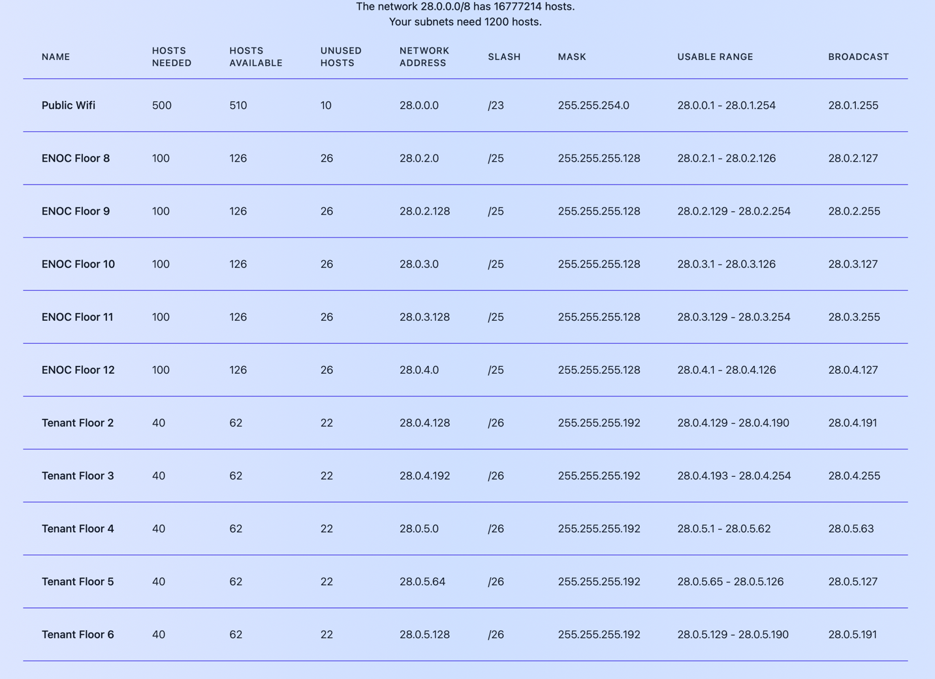
Figure 1: VLSM subnet calculation generated using an online subnet calculator.

