Integers **Z**={ − 2, −1, 0, 1, 2。。}整数

Real **R**实数集（有理数&无理数，包括0）

**N** 自然数集{0，1，2，3...}

**Q** 有理数集

Positive Integers **P**正整数

P⊂N⊂Z⊂Q⊂R 1

例：66789−(123−1)=66667

and the number of integers that are divided by 3 between 123 and 66789

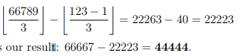

‘m|n’n能被m整除

**Prime**，质数gcd(m,n)=1 are said to be relatively prime

**Fact**:gcd(m,n)·lcm(m,n)=|m|·|n|

if m>n then gcd(m,n)=**gcd(m−n,n)**

Union**并**A**∪**B ⇔ a or b

intersection**交** A**∩**B ⇔ a and b

**Power set**幂集（包含所有子集，**全集**和**空集**也包括）**S ⊆ T**,S是T的子集

S ⊂ T 真子集（**proper subset**) S⊆T and S ！= T

12

**Cardinality基数**card(X)

|∅|=0 Pow(∅)={∅} |Pow(∅)|=1

Pow(Pow(∅))={∅,{∅}}，|{a}| = 1

Pow({a}) = {∅,{a}}

**|[m,n]| = n−m+1**,for n≥m

n+1 def=n∪{n} symbol def =（left is defined by the formula(公式）/expression（表达式） on right）

**disjoint**不相交A∩B = ∅

A\B-**difference （**a but not b**）**

A ⊕ B — **symmetric difference**

A ⊕ B def = (A \ B) ∪ (B \ A)

**1** ‘not a’

Commutativity交换性

Associativity关联性

**1**

**1**

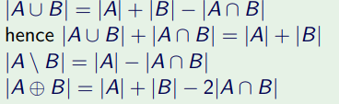

Σ-alphabet,a **finite, nonempty** set

**empty word — λ** length(aaa) = 3, length(λ) = 0. ***λω=ω=ωλ***

**length(νω) = length(ν) + length(ω)**

**1**

**1**

**2**

f:S→T，f assigns to every element s ∈ S a unique element t ∈ T

f : x 1 y, which means the same as f (x) = y，S-**domain** of f，T -**codomain** of f

{f(x):x∈Dom(f)}-image of f , symbol: Im(f)，Im(f ) ⊆ Codom(f )

every function maps its domain **into** its codomain, but only **onto** its image. **Onto**：值域中的每个元素都被定义域中的至少一个x映射。(满射)

**1**The former means that x is **mapped to** y; the latter means that B is the **image** of A under f .

**1**

**1**

此函数定义域上任一元素代入都是它本身

**Logic**

**1**

A unless B can be approximated as ¬B ⇒ A

A ⇔ B=(A ⇒ B) ∧ (B ⇒ A)

logically equivalent,denoted φ≡ψ if they have the same truth value for all values of their basic propositions(所有基本命题的值都有相同的真值）

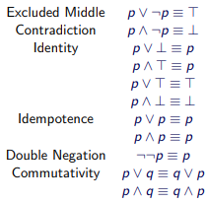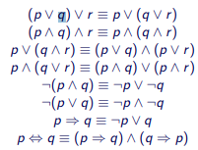

p⇒(q⇒r)≡(p⇒q)⇒(p⇒r)

(p ⇒ q) ⇒ r ≡ p ⇒ (q ⇒ r)

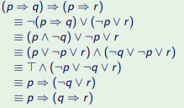

|=永真式/重言式**tautology** φis valid,or a tautology, denoted |= φ

∀ means “for all” and ∃ means “there exist(s)”

√ 2 is **irrational（无理数）**

A Boolean function of one variable（变量）is also called **unary**.一元

A function of two variables is called **binary**.二元

A function of n input variables is called n-ary. n元

**join**:a+b,**meet**:a·b

**1**

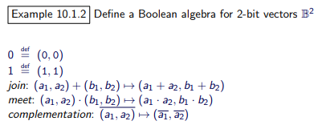

**1CNF:合取范式**使用**∧**

**DNF:析取范式**使用**∨，如下**

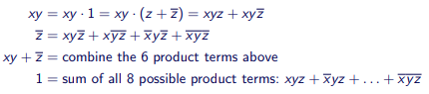

Karnaugh maps卡诺图

Rectangles must have sides of 1, 2 or 4 squares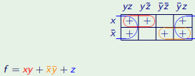

join: A ∪ B, meet: A ∩ B, complement: Ac = S \ A

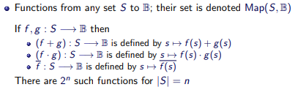

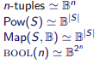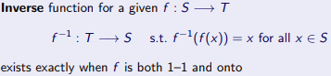

1

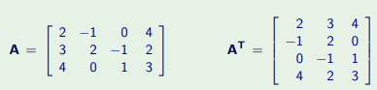

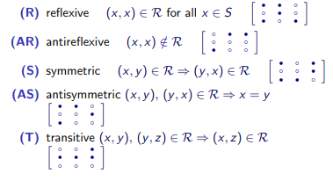

**reflexive**等于自己 **antireflexive**自反

**symmetric**对称 **antisymmetric** 不对称

**transitive**传递性