Z5141180

Yizheng Ying

27/3/2018

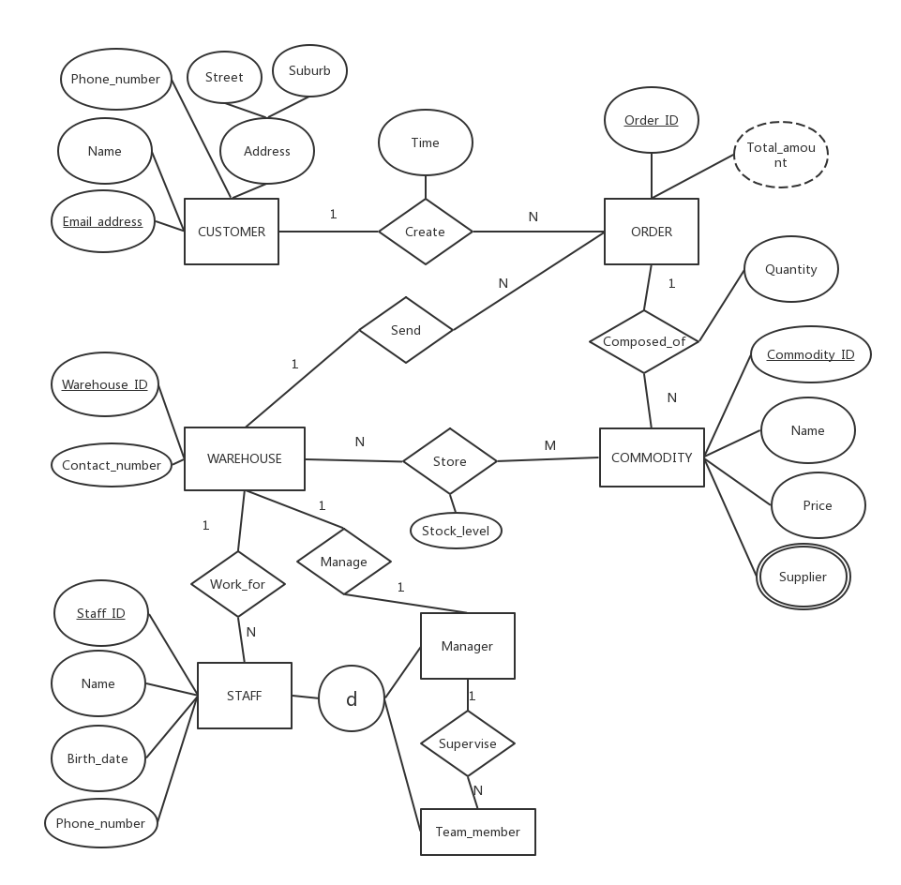

M

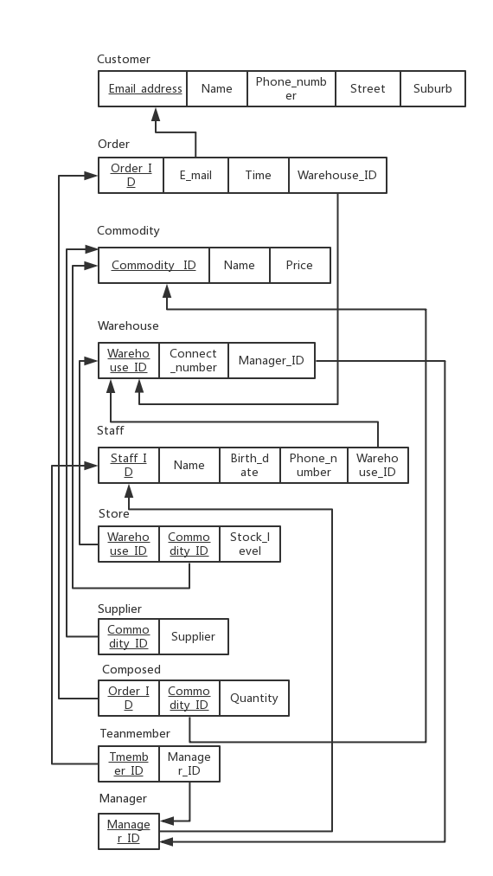

(1)

Step by step:

A←πstudentID((σjob=designer(JobRequirement))**⋈**courseID=courseID(Enrolment))

B←πstudentID(Student)

πname(σgender=female((B∩A)**⋈**studentID=studentID(Student)))

Total:

πname(σgender=female((πstudentID(Student)∩πstudentID((σjob=designer(JobRequirement))**⋈**courseID=courseID(Enrolment)))**⋈**studentID=studentID(Student)))

Explanation:get data from JobRequirement where job=designer and join Enrolment by courseID=courseID ,select studentID from it as A and select studentID from Student as B then use intersection to get the unique studentID ,using (B∩A) join Student by studentID=studentID ,then get the data from it where gender=female and then select name.

(2)

Step by step:

A←πcourseID(σjob=designer(JobRequirement))

B←πstudentID(σfaculty=law(Course)**⋈**courseID=courseID(Enrolment))

πname(((Enrolment÷A)-B)**⋈**studentID=studentID(Student))

Total:

πname(((Enrolment÷πcourseID(σjob=designer(JobRequirement)))-πstudentID(σfaculty=law(Course)**⋈**courseID=courseID(Enrolment)))**⋈**studentID=studentID(Student))

(3)

Step by step:

A←πcourseID(σgender=male(Student)**⋈**studentID=studentID(Enrolment))

B←πcourseID(σgender=female(Student)**⋈**studentID=studentID(Enrolment))

πcourseName((A-B)∪(B-A)**⋈**courseID=courseID(Course))

Total:

πcourseName(

(πcourseID(σgender=male(Student)**⋈**studentID=studentID(Enrolment))-πcourseID(σgender=female(Student)**⋈**studentID=studentID(Enrolment)))∪

(πcourseID(σgender=female(Student)**⋈**studentID=studentID(Enrolment))-πcourseID(σgender=male(Student)**⋈**studentID=studentID(Enrolment)))

)**⋈**courseID=courseID(Course))