# Assignment 5 Name_______________________________

1. Your target for this assignment is to create a simple unit conversion calculator that lets the user perform unit conversion of length. The interface of your calculator should be similar to the following screenshot.

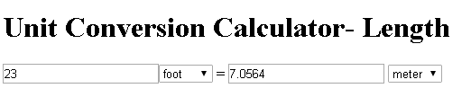

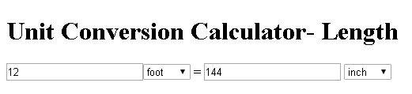

1. Here are grading rubrics/specifications for this assignment.

* Name your file conversion.html
* In the assignment section of your index.html document, create a link which links to this document “conversion.html”.
* Text box and label for input value.
* Drop down list (Select Tag) for length units of the input such as ( Foot, Inch , Meter, and so on).
* Text box and label for converted output value.
* Drop down list (Select Tag) for units of the output.
* (Optional) Button “Convert” .
* JavaScript Event in your calculator is ______________________
* JavaScript function that read inputs and calculate the conversion
  + Read Input
  + Convert input to float type
  + Perform the calculation
    - You calculator should be able to convert between foot and Inch, foot and meter, inch and meter.
  + Display the output
* Before you submit your file, be sure to check this checklist.
* To submit:
  + Push your files to GitHub
  + Please make sure your program is syntax, running time error free. Points will be taken for bugs in the program.
  + Please turn in this page with items checked to instructor on due date.