**Second announcement**

We invite you to take part in

**II International Conference**

**"DIFFERENTIAL EQUATIONS AND MATHEMATICAL MODELING" (DEMM - 22)**

**dedicated to the 90th anniversary of BSPI – BSUAugust 22-25, 2022, Ulan-Ude, Republic of Buryatia, with a trip to the Lake Baikal**

Buryat State University named after Dorzhi Banzarov in cooperation with Novosibirsk State University, Sobolev Institute of Mathematics SB RAS, East Siberian State University of Technology and Management, Buryat State Agricultural Academy named after V.R. Filippov is organizing the II International Conference “Differential Equations and Mathematical Modeling” in the city of Ulan-Ude (Lake Baikal, Maksimikha village, recreation center “Kolos”) from August 22 to 25, 2022 (in-person or online participation).

**PROGRAM COMMITTEE**

**Chairman:**

Kozhanov A.I. –professor (Russia, Novosibirsk)

**Members of the program committee:**

Demidenko G.V. – professor (Russia, Novosibirsk),

Dzhenaliev M.T. – professor (Kazakhstan, Almaty),

Egorov I.E. – professor (Russia, Yakutsk),

Zhukov V.T. –professor(Russia, Moscow),

Zikirov O.S. – professor(Uzbekistan, Tashkent),

KalmenovT.Sh. – professor(Kazakhstan, Almaty),

Mizhidon A.D. – professor (Russia, Ulan-Ude),

Plekhanova M.V. –professor (Russia, Chelyabinsk),

Popivanov N.I. – professor(Bulgaria, Sofia),

Popov S.V. – professor (Russia, Yakutsk),

Pyatkov S.G. – professor (Russia, Khanty-Mansiysk),

Soldatov A.P. – professor (Russia, Moscow),

Fedorov V.E. –professor (Russia, Chelyabinsk),

ShirapovD.Sh. – professor(Russia, Ulan-Ude).

**ORGANIZING COMMITTEE**

**Chairman:**

Tsyrenzhapov N.B. (associate professor, head of the department AMDE, BSU).

**Vice Chairmen:**

AntonovaL.V.(associate professor, director of the IMI, BSU)

Darmaev T.G. (associate professor, BSU),

Yumov I.B. (associate professor, BSU).

**Scientific Secretary:**

Telesheva L.A. (senior lecturer).

**Members of the organizing committee:**

Abiduev P.L. (associate Professor, BSAA)

Burzalova T.V. (associate professor, BSU),

Guseva I.S. (senior lecturer, BSU),

Dumnov V.A. (BSU),

Zhigmytov B.V. (BSU),

Zhigzhitzhapov B.V. (BSU),

Zayatuev B.V. (associate professor, BSU),

NikolaevO.Yu. (senior lecturer, BSU),

Trunin D.O. (associate professor, BSU),

Urbakhanov A.V. (associate professor, BSU),

Khankhasaev V.N. (associate professor, ESSTUM),

Tsybikov A.S. (associate professor, BSU),

Sharankhaev I.K. (associate professor, BSU),

Namsaraeva G.V. (senior lecturer, ESSTUM).

**Secretariat of the Organizing Committee:**

Khovalyg R.R., Tugdumova E.B., Zhamtsaev N.S., Seveen A.

**IMPORTANT DATES**

* Registration of participants ~~until June 30~~ until July 15, 2022
* Submission of abstracts ~~until June 30~~ until July 15, 2022
* Report Inclusion Notification to the

conference program ~~until July 10~~ until July 20, 2022

* Confirmation of participation ~~by July 15~~ by July 20, 2022
* Arrival of participants August 21 – 22, 2022
* Conference opening August 22, 2022
* Closing of the conference August 25, 2022
* Departure of participants August 25 – 26, 2022

**PROGRAM OF THE CONFERENCE**

The conference will be dedicated to the following areas: partial differential equations, equations of mathematical physics, ordinary differential equations, dynamical systems, operator theory, spectral theory, mathematical modeling.

The conference program will include presentations by invited scientists (30 minutes), plenary presentations (30 minutes), brief presentations (15 minutes) and poster presentations.

**MAIN SECTIONS OF THE CONFERENCE:**

1. Non-classical problems of mathematical physics.
2. Degenerate equations and equations of mixed type.
3. Spectral theory of differential operators.
4. Dynamical systems, optimal controls and the theory of

differential games.

1. Mathematical modeling and computational mathematics.

The working languages of the conference are Russian and English.

**ACCEPTANCE OF THE REGISTRATION FORMS AND THEABSTRACTS OF REPORTS**

Please, fill the Registration Formand send it to us at your earliest convenience but no later than **~~June 30~~ July 15, 2022.**

**Registration form of the participant of the International conference**

**“Differential Equations and Mathematical Modeling”**

* Surname
* Name
* Second name*
* Scientific degree
* Place of work or study
* Position
* Post address
* Phone no:
* E-mail:
* Section
* Title of the report
* Form of participation (in-person event, online):
* Type of report (plenary, sectional, poster[1]*)
* Do you need a viza?

Those colleagues who want to take part in the conference should send the abstracts of the report by e-mail to the Organizing Committee.

Abstracts are accepted in Russian and English. The volume of abstracts should be no more than 2 (two) pages.The deadline for receiving abstracts is **~~June 30~~ July 15, 2022.**

Registration forms and abstracts are sent by e-mail: [pmduconf@yandex.ru](mailto:pmduconf@yandex.ru) – (registration on the conference website: demm.bsu.ru). Publication of the collection of abstracts is not planned. Full reports, recommended by the Program Committee, will be published in rating journals (Mathematical notes of NEFU, Bulletin of BSU, etc.)

Invitations and additional information will be sent after consideration of the submitted abstracts.

**ABSTRACT REQUIREMENTS**

**to the international conference"Differential Equations and Mathematical Modeling"(DEMM - 2022)**

Abstracts up to 2 pages in A4 format are submitted in Russian or English as a tex-file prepared in the LaTeX editor (template is attached). \textwidth=16 cm, \textheight=24 cm, main font size 12 pt. Book orientation.

The name of the file indicates the name of the first author.

Abstracts are provided as a .zip-archive, which contains a folder named after the first author, containing the original abstract tex-file, all used drawing files (png, jpg, bmp), as well as the corresponding compiled pdf file.

At the beginning, the UDC index is indicated according to the UDC classifier.

This is followed by the title of the abstract (no more than 10 words, the use of letters of alphabets other than Russian and Latin, Roman numerals, abbreviations and formulas is not allowed).

The following is information about the authors (last name, first name, second name in full, academic degree, academic title (before the academic title, you must clearly indicate the phrase "academic title", for example, "academic title professor", "academic title associate professor"), position, place of work (full official names of organizations, address with postal code, e-mail are indicated).

Further, on a new line after the word “Acknowledgements”, information is given about gratitude (if any) to organizations or institutions, supervisors and other persons, including links to grants.

The following is the text of the theses.

At the end of the abstract, immediately before the list of references, key words are given in the amount of at least 10 and no more than 25 words.

For sources, the list of references should indicate the number / number of pages and DOI (if available). For all electronic resources, it is obligatory to indicate the date of circulation. The list of references includes only those sources, references to which are in the text of the abstract.

The list of references should indicate only published works in the original language (Russian or English).

The list of references does not include any materials that do not have a specific author (laws, standards (including GOSTs), articles from dictionaries and encyclopedias, website pages), where a specific author is not indicated, references to them are made only as footnotes in the text of the theses.

The program committee will consider all received abstracts. The Program Committee reserves the right to reject abstracts that do not correspond to the subject of the conference or are issued in violation of the requirements.

**REGISTRATION FEE AND ACCOMMODATION**

The registration fee for the conference participants is approximately 3000 rubles – in-person participation, 1000 rubles –online participation and is carried out after receiving notification of the inclusion of the report in the program. The registration fee does not include accommodation and meals for the participants during the conference.

Accommodation on the shore of Lake Baikal (Barguzinsky Bay), in the village of Maksimikha there is a recreation center "Kolos". The nearest large settlement is Ulan-Ude, the distance is 234 kilometers.

Accommodation of the recreation center involves living in wooden 1 and 2-storey cottages with partial amenities.

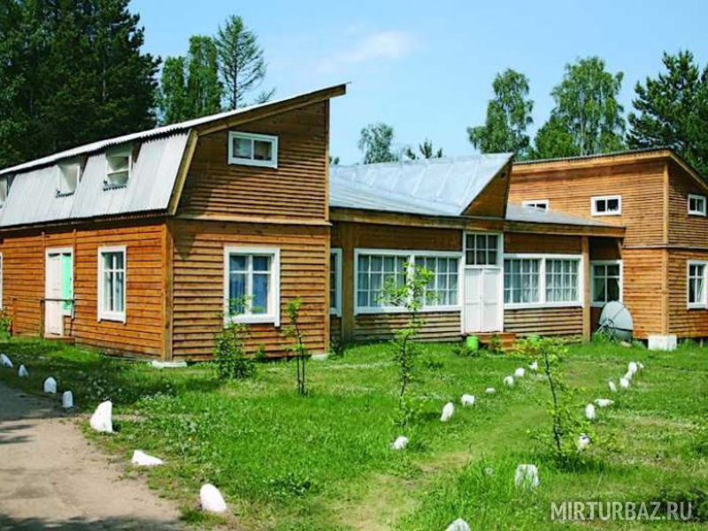

To make a reservation, please call +79085999666 – Aleksandr Valerievich Urbakhanov.

The procedure for paying the registration fee will be announced later.

The cost of accommodation with meals per one vacationer at the recreation center "Kolos" (Maksimikha village) for third-party employers for the summer period (June - September) 2022

|  |  |  |
| --- | --- | --- |
| **No** | **Roomname** | **Price, RUB (per night)** |
| **Building No. 1** | | |
| 1 | Rooms No. 1, 2, 5, 6 (two-room, double) | 2600 |
| 2 | Rooms No. 3, 4 (double) | 2400 |
| **Building No. 2, Block No. 1** | | |
| 1 | Rooms No. 1, 2 (double, triple) | 2200 |
| 2 | Rooms No. 3, 4 (double) | 2400 |
| **Building No. 2, Block No. 2** | | |
| 1 | Rooms No. 1, 2 (double, triple) | 2000 |
| 2 | Rooms No. 5, 6 (quadruple) | 1900 |
| **Building No. 7 (comfortable rooms)** | | |
| 1 | Rooms No. 1, 2, 3 (double) | 2600 |
| 2 | Room №4 (double) | 2400 |
| 3 | Room No. 5 (double, shower, toilet, TV) | 2900 |
| 4 | Rooms No. 6, 7 (double) | 2600 |
| 5 | Rooms No. 8, 9, 10 (double) | 2400 |
| 6 | Rooms No. 11, 12 (double) | 2500 |
| **Unfurnished buildings** | | |
| **Building No.4** | | |
| 1 | Rooms No. 1, 2, 3, 4 (triple) | 1900 |
| **Building No.5** | | |
| 1 | Rooms No. 1, 2, 3, 4, 5 (double) | 1900 |
| **Building No.6** | | |
| 1 | Rooms No. 3, 4, 5, 6 (double) | 1900 |

**CONTACT INFORMATION OF THE ORGANIZING COMMITTEE**

670000, Ulan-Ude, Smolina st. 24a, Buryat State University, Institute of Mathematics and Informatics, Department of Applied Mathematics and Differential Equations.

Phone: +7 (3012) 21-97-57; +7(3012)29-71-60 (ext. 310),

+79246553941(Lyubov Aleksandrovna Telesheva),

+79025620620(Nima Bulatovich Tsyrenzhapov)

1. * for in-person event.