CryptoGuard AI – Blockchain Wallet Fraud Detection & Risk Scoring System
Technical Document



Group - 2
Tirth Rakeshkumar Doshi – 200609650
Chang Liu – 200652377
Darshit Manojkumar Limbachiya – 200611012
Kusuma Sree Addageethala – 200600636
Project Requestor: Adil khan (Town of Innisfil – Development Engineering)
Client: Town of Innisfil – Development Engineering Dept.
Author: Vishnuraj Radhakrishnan | Yashkumar Jayendra Patel | Kirtankumar Patel| Victor Adekola
Date: 27-March-2025

Table of Contents
1. System Architecture Overview 2
Components 2
Architecture Flow 2
2. Technology Stack 3
Languages & Libraries 3
Tools 3
3. Data Collection Process 3
API Used 3
Data Fields Extracted 3
4. Feature Engineering 4
5. ML Model Design (IsolationForest) 4
Why IsolationForest? 4
Training Process 4
Risk Scoring Logic: 4
Risk Categories 5
6. Streamlit Application Design 5
User Workflow 5
Pages 5
7. Data Flow Diagram 5
8. Target Audience / Users 5
9. Use Case Example 6
10. Key Features 6
11. Business Value 6
12. Why ML? Why Blockchain? 7

System Architecture Overview

Components
- Frontend: Streamlit-based web interface
- Backend:
  - Data ingestion from Etherscan V2
  - Feature engineering
  - ML model
- ML Model: IsolationForest
- Data Storage: Local CSVs for repeated analysis
- Dashboard: Power BI

Architecture Flow
- User enters Ethereum wallet
- App requests wallet transactions from Etherscan
- Raw JSON is transformed into a clean DataFrame
- Feature engineering extracts behavioral indicators
- IsolationForest calculates anomaly score
- Score converted to 0–100 risk
- Results displayed through Streamlit charts
- Optional CSV exported for Power BI dashboard

Technology Stack

Languages & Libraries
- Python
- Pandas
- NumPy
- Streamlit
- scikit-learn
- Joblib
- Requests
- Etherscan V2 API

Tools
- VS Code
- Conda Virtual Environment
- Windows OS
- Power BI Desktop

Data Collection Process

API Used
- Etherscan V2 (https://etherscan.io/apidashboard)
- Actions: txlist
- Parameters:
  - address (wallet)
  - startblock
  - endblock
  - offset (number of tx)
  - sort=desc
  - chainid=1
  - apikey=<yourkey>

Data Fields Extracted
- tx_hash
- timestamp
- value (ETH)
- gas fees
- from / to addresses
- error flag

Feature Engineering
For each wallet, we compute:
- tx_count
- total_volume_btc (ETH)
- avg_tx_value_btc
- std_tx_value_btc
- max_tx_value_btc
- min_tx_value_btc
- avg_fee_btc
- burstiness_tx_per_hour
- avg_time_between_tx_sec
- avg_inputs
- avg_outputs
Features saved to:
data/processed/features_<wallet>.csv

ML Model Design (IsolationForest)

Why IsolationForest?
- Works with unlabeled data
- Detects anomalies in high-dimensional data
- Ideal for fraud detection
- Fast and robust

Training Process
- Collect features for multiple wallets
- Concatenate into all_wallet_features.csv
- Fit IsolationForest model
- Save model to:
app/model/isolation_forest_model.pkl

Risk Scoring Logic:
raw_score = model.decision_function(X)
risk_score = (1 - raw_score) * 50 # scaled to 0–100

Risk Categories
- 0–40 → Low Risk
- 40–70 → Medium Risk
- 70–100 → High Risk

Streamlit Application Design

User Workflow
- Enter wallet address
- View transaction chart
- View hourly tx distribution
- View feature values
- Get risk score
- Download CSV

Pages
- Home/Overview
- Wallet Analysis
- Results

Data Flow Diagram

Target Audience / Users
- Retail investors
- Crypto traders
- Crypto exchanges (KYC/AML pre-screening)
- Compliance & risk teams
- VCs and investors analyzing project treasury wallets
- General public interested in wallet safety

Use Case Example
A user wants to send ETH to an unfamiliar address. Before sending funds, they paste the wallet into CryptoGuard AI.
The system:
- Fetches 150 recent transactions
- Analyzes behaviors (volume, frequency, burst patterns)
- Detects anomalies using IsolationForest
- Outputs a risk score + risk category
The user avoids sending funds if the wallet is labeled High Risk.

Key Features
- Live Blockchain Data Ingestion via Etherscan V2
- IsolationForest ML Model for anomaly detection
- Streamlit Web App for real-time user interaction
- Charts & Analytics (transaction patterns, volume trends)
- CSV Export for Power BI
- Risk Scoring (0–100) + Low/Medium/High classification
- Clear explanations and transparency

Business Value
- Reduces financial losses for users
- Helps exchanges act faster on AML checks
- Provides low-cost risk intelligence
- Can be scaled into a SaaS product
- Strong potential for future integrations (Telegram bot, API service, alerts)

Why ML? Why Blockchain?
Blockchain provides transparent, public data, and ML can detect hidden patterns that traditional rules cannot catch. Together, they provide high-value fraud detection without needing private data.

Product prototype:
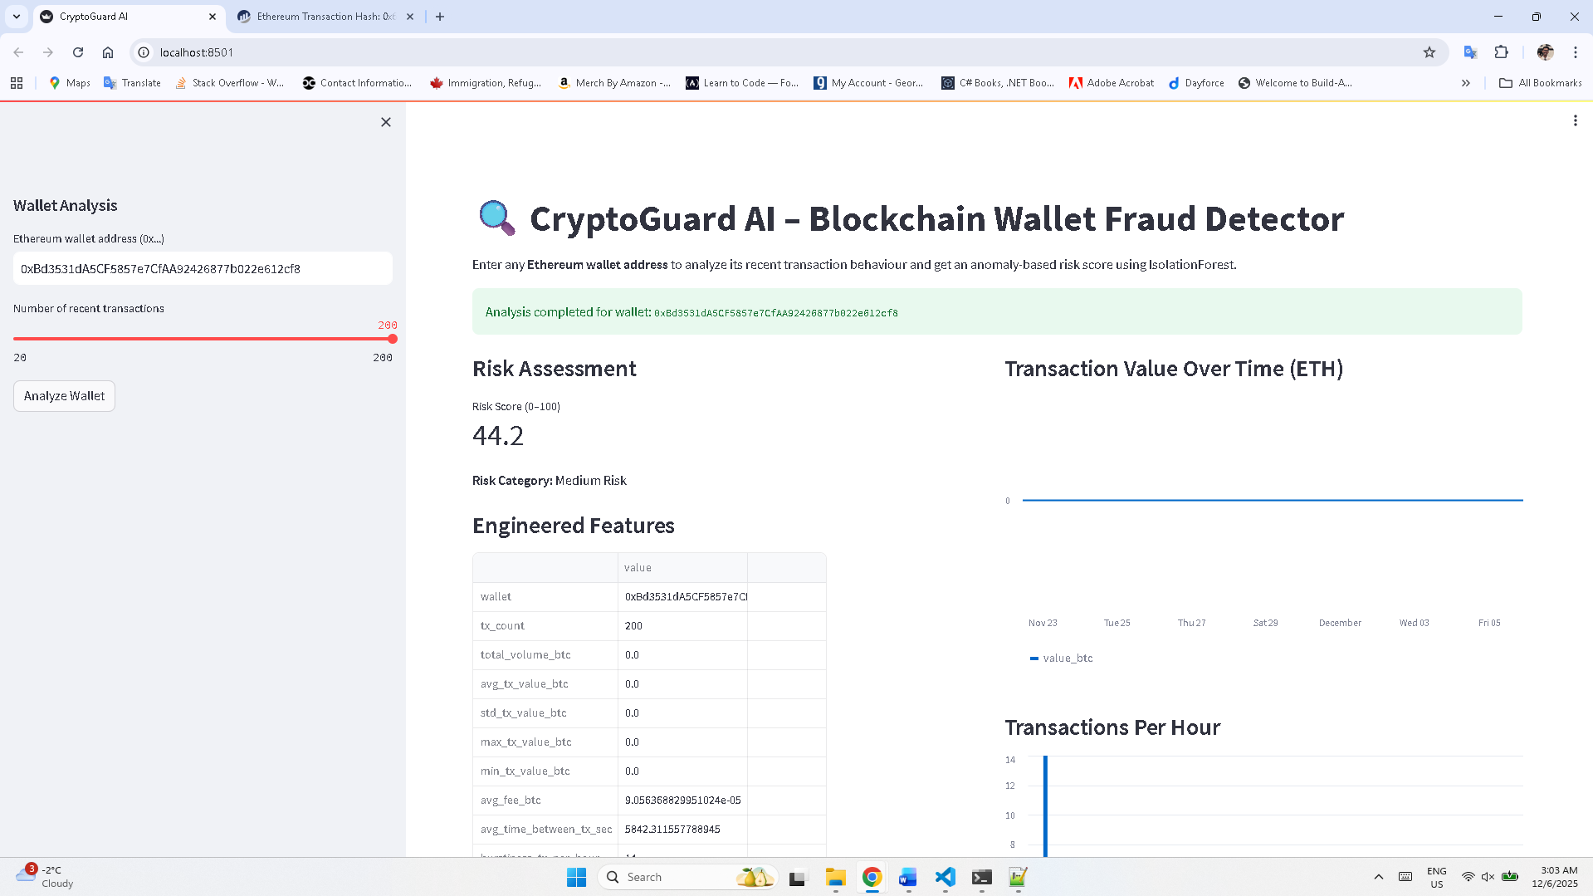
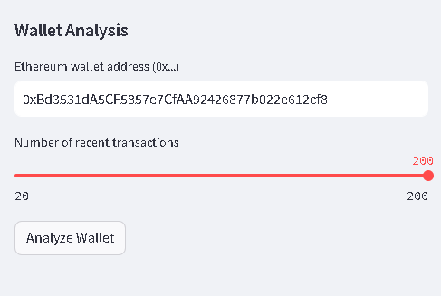
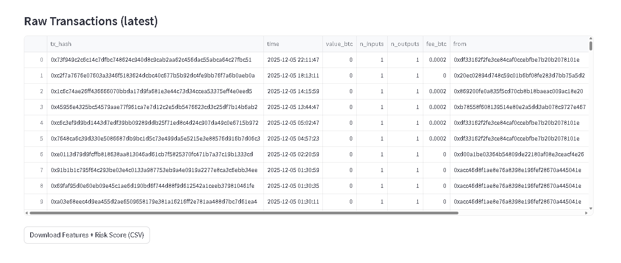
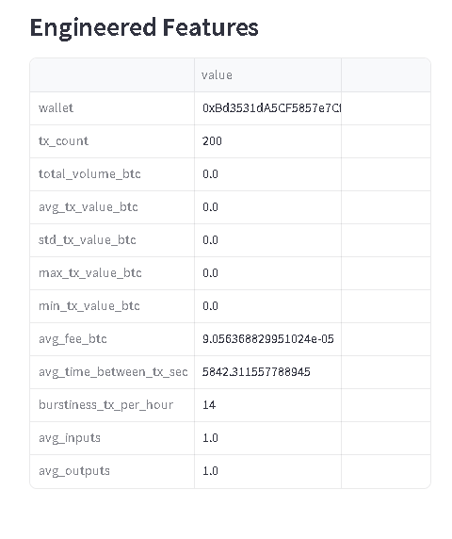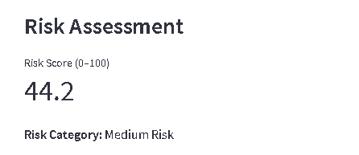
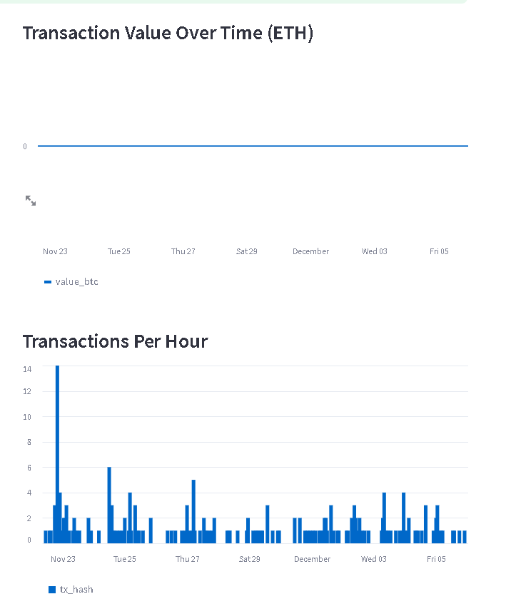

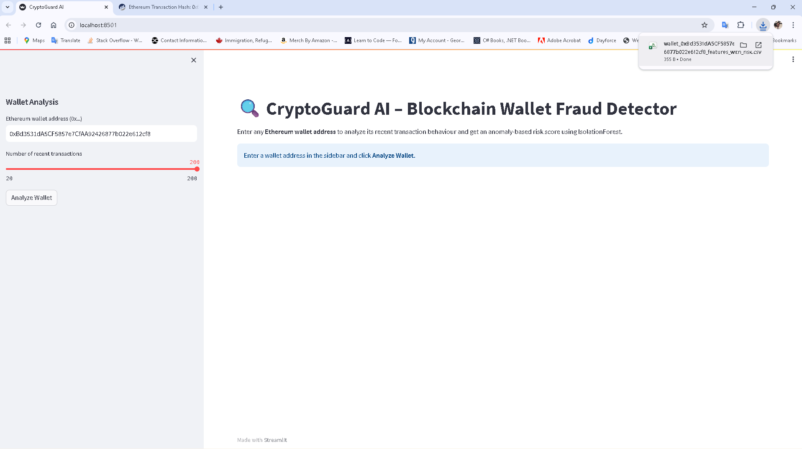

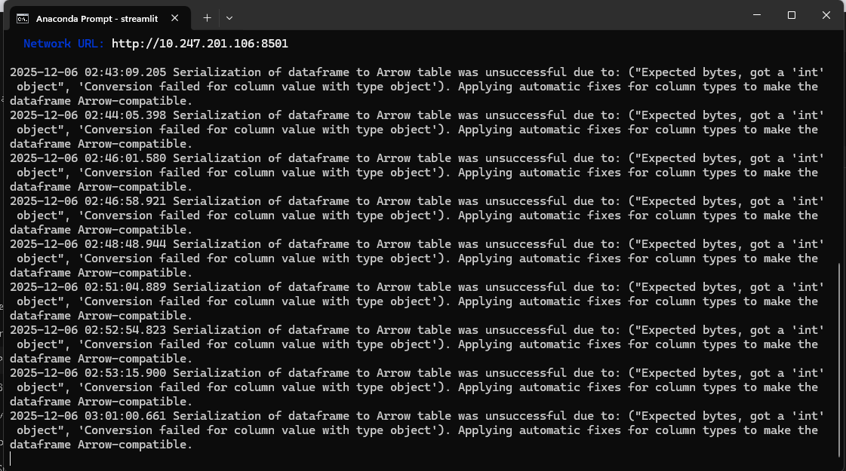

Project Structure:
