Financial Econometrics Group Work Project 1

Problem 1: Omitted-Variable Bias
(1) Y_i = α + β x_i + γ w_i + δ z_i + ε_i
(2) Y_i = α + β x_i + γ w_i + μ_i, μ_i = δ z_i + ε_i
1a) No. Once z_i is omitted, its effect enters the composite disturbance μ_i = δ z_i + ε_i. If z_i is correlated with x_i or w_i, then E(μ_i | x_i, w_i) ≠ 0, so the zero-conditional-mean assumption fails. Stoker treats omitted-variable bias as exactly this problem: a relevant influence is left out of the specification and the resulting restricted regression becomes misspecified rather than merely less precise. [Stoker]
1b) The restricted-model estimates of β and γ are generally biased because the included regressors absorb part of z_i's effect. The direction and magnitude of the bias depend on δ and on how z_i covaries with x_i and w_i. In Stoker's framing, coefficients from regressions with different regressor sets cannot be given the same economic interpretation unless the exclusion is innocuous. [Stoker]
1c) The slope estimates from model (2) coincide with those from model (1) only under an orthogonality condition such as Cov(z_i, x_i) = 0 and Cov(z_i, w_i) = 0. In that special case, omitting z_i may weaken explanatory power, but it does not induce systematic correlation between the included regressors and the composite disturbance. [Stoker]
1d) The notebook sets the true coefficient on X equal to 1 and the theoretical omitted-model coefficient equal to 1.6. In the full model, the estimated X-coefficient moves from 0.925568 at n = 200 to 1.002342 at n = 10,000, which is close to the true parameter. In contrast, the omitted model moves from 1.481238 to 1.583250, converging toward the biased value rather than toward the truth. The simulation therefore illustrates the core omitted-variable-bias result: larger samples reduce sampling noise, but they do not repair misspecification. [Stoker; P1d Notebook]
Quantity | Value
True coefficient on X | 1.000000
Theoretical omitted-model coefficient on X | 1.600000
Estimated X coefficient (full model, n=200) | 0.925568
Estimated X coefficient (omitted model, n=200) | 1.481238
Estimated X coefficient (full model, n=10000) | 1.002342
Estimated X coefficient (omitted model, n=10000) | 1.583250
Table 1. Problem 1d simulation summary from the notebook output [P1d Notebook]. 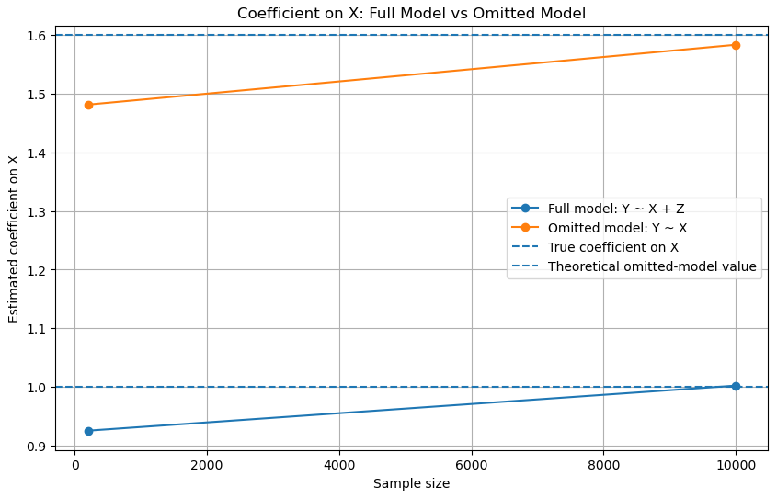

Figure 1. Estimated coefficient on X under the full and omitted models as sample size increases [P1d Notebook].
How to read Figure 1: read left to right as sample size increases; compare each solid line to its dashed benchmark, and note that the omitted-model estimate converges toward 1.6 rather than the true value of 1.0.
Conclusion for Problem 1. The restricted regression is valid only under a strict orthogonality condition. Once a relevant correlated regressor is omitted, the disturbance becomes endogenous, the included coefficients are biased, and consistency fails; more data only sharpen convergence toward the wrong parameter. [Stoker; P1d Notebook]

Problem 2: Sensitivity to Outliers
Y_i = α + β X_i + ε_i
2a) OLS is sensitive to outliers because it minimizes the sum of squared residuals, Σ e_i^2, so unusually large deviations receive disproportionate weight. The most dangerous observations are influential points that combine unusual X-values with a large departure from the prevailing trend. In practice, this is why leverage, studentized residuals, and Cook's distance are central diagnostics rather than optional add-ons. [P2b Notebook]
2b) The notebook begins from a clean sample generated by Y_i = α + β X_i + ε_i with α = 1, β = 3, X_i ~ Uniform(0, 5), and Gaussian noise, then adds one extreme observation. The clean-sample intercept and slope are 1.1961 and 2.9705, close to the true values 1 and 3. After contamination, the intercept rises to 3.8740 and the slope falls to 1.8497. The added observation also has leverage 0.3151, studentized residual -20.2008, and Cook's distance 6.2418, so the change in the fitted line is economically and statistically material rather than incidental. [P2b Notebook]
Quantity | Value
True intercept | 1.0000
Clean intercept | 1.1961
Contaminated intercept | 3.8740
True slope | 3.0000
Clean slope | 2.9705
Contaminated slope | 1.8497
Table 2. Clean-versus-contaminated parameter estimates [P2b Notebook].
Diagnostic | Influential point value
Leverage (hat value) | 0.315070
Studentized residual | -20.200750
Cook’s distance | 6.241774
Table 3. Diagnostics for the most influential observation [P2b Notebook]. 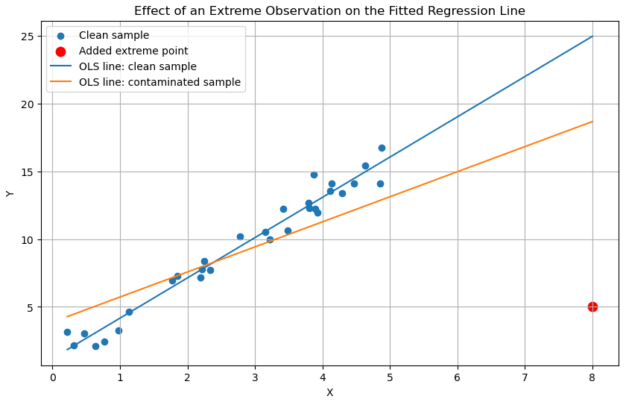

Figure 2. Clean and contaminated fitted lines after adding one extreme point [P2b Notebook].
How to read Figure 2: compare the clean blue fit with the contaminated orange fit; the red point at high X and low Y pulls the contaminated line downward, showing how one influential observation changes the slope and intercept.
Conclusion for Problem 2. The simulation shows that OLS can become highly unstable when one observation combines leverage with a large vertical deviation from the underlying pattern. In this case, a single point materially alters both the slope and intercept, so regression conclusions are not robust unless such observations are diagnosed and justified. [P2b Notebook]
Problem 3: Model Selection
Y_i = β_0 + β_1 X1_i + β_2 X2_i + β_3 X3_i + β_4 X4_i + β_5 X5_i + ε_i
AIC = n ln(RSS / n) + 2k, BIC = n ln(RSS / n) + k ln(n)
3a) Model selection should be framed as a tradeoff between fit and parsimony, not as a search for the highest raw R². Pham notes that R² mechanically rises with model size, while adjusted R², AIC, BIC, and related penalized criteria are designed to account for over-parameterization, with stronger penalties becoming especially important when samples are limited. Consistent with that logic, the notebook evaluates all candidate subsets using adjusted R², AIC, and BIC and then checks robustness with forward selection by AIC and backward selection by BIC. Every formal criterion selects the same specification, (X2, X3, X4, X5), so the recommendation does not depend on one arbitrary search rule. [Pham; P3a Notebook]
Relative to the full model, the selected model improves adjusted R² from 0.630170 to 0.633974, lowers AIC from 262.592528 to 260.616684, and lowers BIC from 278.223549 to 273.642535. The final coefficient table reports const = 1.189339, X2 = -0.586083, X3 = 0.559157, X4 = 0.710541, and X5 = -0.196639, with all retained predictors statistically significant. Figure 3 also shows that fitted values track actual values reasonably well. The agreement across multiple penalized criteria is stronger evidence than a single winning metric on its own. [Pham; P3a Notebook]
Criterion | Best model | Value
Adjusted R^2 | (X2, X3, X4, X5) | 0.633974
AIC | (X2, X3, X4, X5) | 260.616684
BIC | (X2, X3, X4, X5) | 273.642535
Table 4. Best model under each selection criterion [P3a Notebook].
Model | Predictors | Adjusted R^2 | AIC | BIC
Selected model | (X2, X3, X4, X5) | 0.633974 | 260.616684 | 273.642535
Full model | (X1, X2, X3, X4, X5) | 0.630170 | 262.592528 | 278.223549
Table 5. Selected-model versus full-model comparison [P3a Notebook].
Variable | Coef. | P>|t|
const | 1.189339 | 1.75e-23
X2 | -0.586083 | 4.87e-09
X3 | 0.559157 | 2.05e-08
X4 | 0.710541 | 1.13e-13
X5 | -0.196639 | 2.06e-02
Table 6. Final selected-model coefficients and p-values [P3a Notebook].
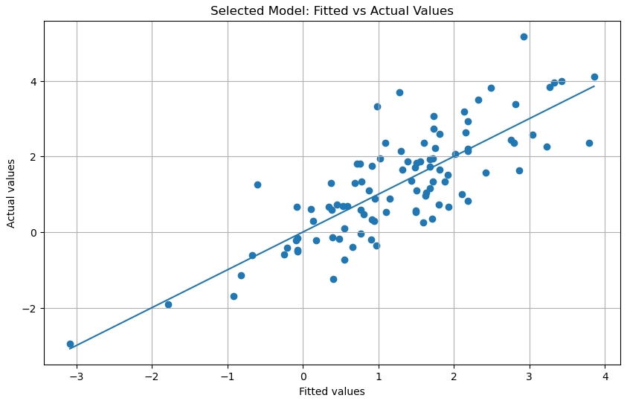
Figure 3. Fitted-versus-actual check for the selected model [P3a Notebook].
How to read Figure 3: the horizontal axis gives fitted values and the vertical axis gives actual values; tighter clustering around the fitted relationship indicates smaller residual error and therefore a better in-sample fit.
Conclusion for Problem 3. The model (X2, X3, X4, X5) is preferred because it dominates the full model on all three penalized-fit criteria used in the notebook. That is the right comparison: as Pham stresses, raw fit improves automatically as regressors are added, whereas adjusted R², AIC, and BIC better balance explanatory power against unnecessary complexity. [Pham; P3a Notebook]

Problem 4: Elasticity
4a) We start from the elasticity definition below and then apply it to each functional form. The resulting expressions are summarized in Table 7 and written explicitly in the formulas that follow.
E = (dy / dx) (x / y)
For y = 2 + 0.8x: E = 0.8x / (2 + 0.8x)
For ln(y) = 0.1 + 0.4x: E = 0.4x
For ln(y) = 0.1 + 0.25 ln(x): E = 0.25
For y = 0.15 + 1.2 ln(x): E = 1.2 / (0.15 + 1.2 ln(x))
4b) The correct model for direct elasticity interpretation is the log-log specification, ln(y) = 0.1 + 0.25 ln(x), because the coefficient on ln(x) is itself the constant elasticity of y with respect to x. Therefore, the elasticity is 0.25.
Model | Elasticity
y = 2 + 0.8x | 0.8x / (2 + 0.8x)
ln(y) = 0.1 + 0.4x | 0.4x
ln(y) = 0.1 + 0.25ln(x) | 0.25
y = 0.15 + 1.2ln(x) | 1.2 / (0.15 + 1.2ln(x))
Table 7. Elasticity expressions derived from the four candidate models.
Conclusion for Problem 4. Only the log-log model produces a constant elasticity that is immediately interpretable from the estimated coefficient. The other specifications imply elasticities that vary with x and/or y.

Problem 5: Stationarity and Unit Roots
Δ y_t = y_t - y_(t-1)
ADF null: unit root, KPSS null: stationarity
Simulations: y_t = y_(t-1) + ε_t and y_t = 1.5 y_(t-1) + ε_t
5a) Stationarity matters because many time-series tools assume a stable probabilistic structure over time. The MIT lecture notes distinguish stationary processes from nonstationary ones by whether moments such as the mean, variance, and autocovariance remain invariant with time, and they use the random walk as a canonical unit-root example. The notebook uses two complementary tests: the ADF test, which takes a unit root as the null, and the KPSS test, which takes stationarity as the null. When both point in the same direction, the classification is stronger. If levels look nonstationary but first differences do not, the series is treated as I(1) and differencing is the appropriate transformation before further modelling. [Lecture 1; P5 Notebook]
5b) For the real-data illustration, the notebook uses the normalized GOOG price series from the bundled stock data. In logs, the level series has ADF statistic -2.266209 with p-value 0.452723 and KPSS statistic 0.166474 with p-value 0.032938, so the evidence does not support stationarity in levels. After first differencing, the ADF statistic becomes -12.498111 with p-value 2.84619e-23 and the KPSS p-value rises to 0.1, which is consistent with treating log prices as I(1) and log returns as stationary. This is the same broad pattern as the lecture's random-walk example: the level behaves as a unit-root-type series, while differencing restores stability. [Lecture 1; P5 Notebook]
5c) The notebook also simulates two processes using the same shock sequence: a unit-root process y_t = y_(t-1) + ε_t and an explosive process y_t = 1.5 y_(t-1) + ε_t. The summary table shows why the distinction matters. The explosive process has a standard deviation on the order of 10^33 and a maximum absolute value on the order of 10^34, whereas the unit-root process remains large but economically plausible. The key applied boundary is therefore the unit root at 1: shocks are persistent and non-mean-reverting, but the process is not explosively diverging in the obvious way seen when φ = 1.5. [P5 Notebook]
Series | ADF Statistic | ADF p-value | KPSS Statistic | KPSS p-value
log_price | -2.266209 | 0.452723 | 0.166474 | 0.032938
dlog_price | -12.498111 | 2.84619e-23 | 0.094716 | 0.1
Table 8. Unit-root test summary for GOOG log prices and first differences [P5 Notebook].
Process | Standard deviation | Maximum absolute value
phi = 1 | 4.862e+00 | 1.260e+01
phi = 1.5 | 6.584e+33 | 7.028e+34
Table 9. Simulation summary for the unit-root and explosive processes [P5 Notebook].
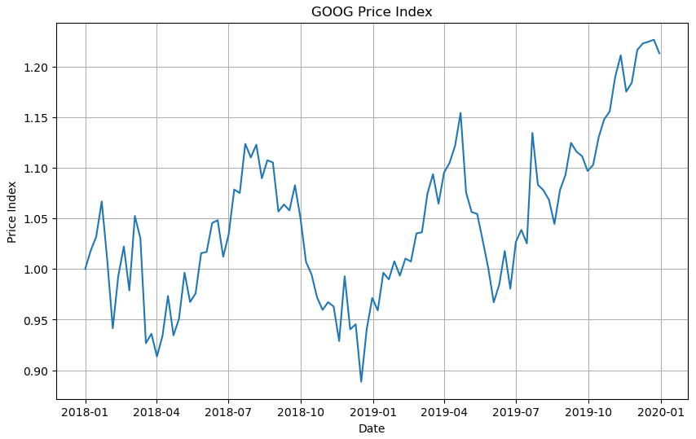
Figure 4. Normalized GOOG price path used for the real-data illustration [P5 Notebook].
How to read Figure 4: move left to right through calendar time and read the vertical axis as a normalized price index; values above 1.0 are above the starting level, while values below 1.0 are below it.
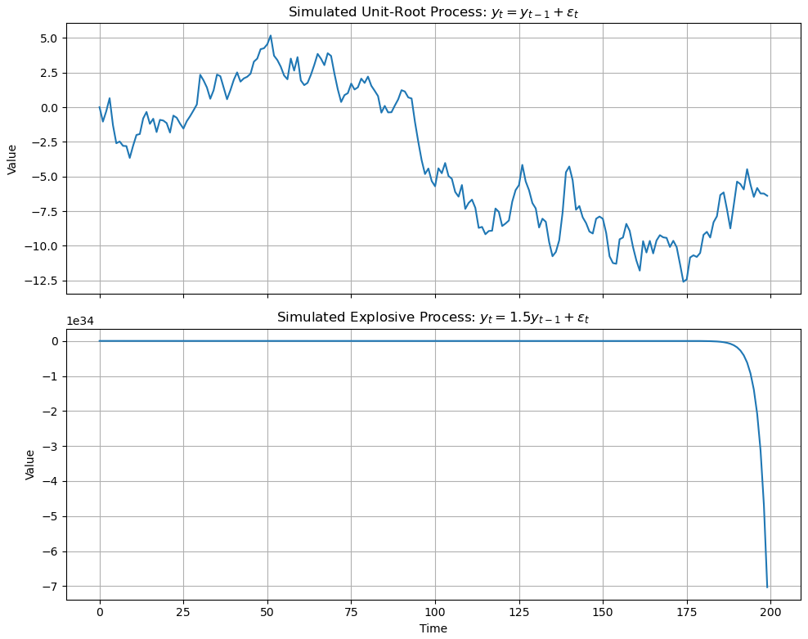
Figure 5. Simulated unit-root and explosive processes using the same shock sequence [P5 Notebook].
How to read Figure 5: both panels share the same time progression from left to right; compare the vertical scales carefully, because the lower explosive process operates on a vastly larger magnitude than the upper unit-root process.
Conclusion for Problem 5. The notebook evidence supports classifying the GOOG log-price series as nonstationary in levels and stationary after first differencing. Read alongside the lecture notes, the results show why random-walk-type behavior is the economically important case: shocks persist, so inference should proceed on transformed data rather than on the raw level series. [Lecture 1; P5 Notebook]

Problem 6: Structural Break in the Slope
D_t = 0 for t ≤ 10, D_t = 1 for t ≥ 11
Y_t = α + β X_t + λ (D_t X_t) + ε_t
H_0: λ = 0, H_1: λ ≠ 0
6a) To test for a slope break at t = 10 using one regression, we define a dummy D_t equal to 0 for t ≤ 10 and 1 for t ≥ 11, then create the interaction DX_t = D_t X_t. The single regression is Y_t = α + β X_t + λ DX_t + ε_t. In this parameterization, β is the slope before the break and β + λ is the slope after the break, so the structural-break null is H_0: λ = 0. This one-equation setup is a clean way to evaluate coefficient instability, which matters because undetected structural breaks can leave OLS estimates biased and inefficient. [Conniffe-Kelly; P6a Notebook]
The illustrative notebook implementation estimates α = 2.1823, β = 0.8954, and λ = 1.5957, with the interaction term highly significant (p-value reported as 0.000). The implied post-break slope is 2.4911, very close to the true slope after the break of 2.5. The simulation therefore gives direct evidence of coefficient instability across subperiods. [P6a Notebook]
Quantity | Value
True slope before break | 1.000000
True slope after break | 2.500000
Estimated slope before break | 0.895415
Estimated slope after break | 2.491102
Estimated slope change | 1.595687
Table 10. Structural-break slope summary from the notebook output [P6a Notebook].
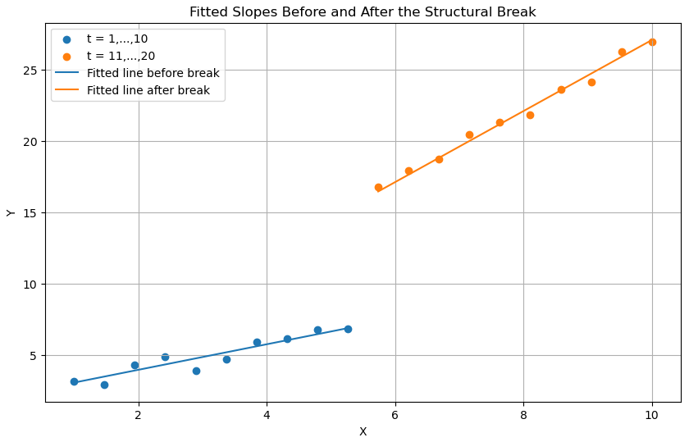
Figure 6. Fitted slopes before and after the structural break [P6a Notebook].
How to read Figure 6: compare the fitted line for t = 1 to 10 with the fitted line for t = 11 to 20; the steeper post-break line shows the increase in slope after the structural break.
Conclusion for Problem 6. The dummy-interaction regression provides a clean one-equation test for coefficient instability. In the illustrative data, the interaction term is large and statistically significant, so the hypothesis of a common slope across the full sample is rejected; this is exactly why structural-break testing matters in applied econometrics. [Conniffe-Kelly; P6a Notebook]

References
[Stoker] Stoker, Thomas M. Omitted Variable Bias and Cross Section Regression. Working Paper #1460-83, July 1983.
[Pham] Pham, Hoang. A New Criterion for Model Selection. Mathematics, 7(12), 1215, 2019.
[Lecture 1] Mikusheva, Anna, and Paul Schrimpf. Lecture 1: Stationarity, Lag Operator, ARMA, and Covariance Structure. MIT OpenCourseWare 14.384 Time Series Analysis, Sept. 2007.
[Conniffe-Kelly] Conniffe, Denis, and Robert Kelly. Structural Breaks: An Instrumental Variable Approach. Research Technical Paper 04/RT/11.
[P1d Notebook] Problem_1d_omitted_variable_bias_professional_math.html. Uploaded notebook export, 5 Apr. 2026.
[P2b Notebook] Problem_2b_outlier_sensitivity_professional_math.html. Uploaded notebook export, 5 Apr. 2026.
[P3a Notebook] Problem_3a_model_selection_enhanced.html. Uploaded notebook export, 5 Apr. 2026.
[P5 Notebook] Problem_5_stationarity_unit_root.html. Uploaded notebook export, 5 Apr. 2026.
[P6a Notebook] Problem_6a_structural_break.html. Uploaded notebook export, 5 Apr. 2026.

