|  |  |
| --- | --- |
|  |  |
|  |
|  |

**High Impact Skills Development Program for Gilgit Baltistan**

**Computer Vision Module Project**

**Title Expression Classification from Facial Images**

Name: Dostdar Ali, Email Address: [dostdar.cui@gmail.com](mailto:dostdar.cui@gmail.com)

GitHub Link: <https://github.com/DostdarDost>

**Summary**

The focus is on understanding and quantifying fine grained and high-level interpersonal traits in between individuals and face images. The deep network architecture that the research suggest is capable of reliable facial expression recognition. Their multitask network integrates auxiliary parameters like gender, age, and head posture in addition to facial expression labels, unlike standard models that simply learn from facial expression labels, for increased learning. They employ the expression recognition network as branches for a Siamese model to forecast the relationship accurately and finely between persons to anticipate interpersonal ties. Numerous tests show that their approach is good in extracting mutual context from face.

1. **Problem Overview**

The era very goes to the visual analysis for many applications domain in various sectors like healthcare, system antennation, and many more. Our problem related to recognition, while the reconstruction of information after some processed and identifiable to be a challenging task. In this mini project, we are going through facial recognition using a family deep neural network and fine tuning to overcome this misleading identification.

1. **Literature Review**

The researchers proposed a deep network architecture that robustly recognizes facial expressions. Unlike conventional models that only learn from facial expression labels, their multitask network also incorporates auxiliary attributes like gender, age, and head pose for improved learning [1]. They introduce a novel attribute propagation method that relaxes the need for complete attribute labels in the training dataset. This allows the network to leverage the inherent relationships between different attribute sources despite their differing distributions [2]. The proposed approach achieves state-of-the-art results on facial expression recognition benchmarks. For predicting interpersonal relations, they use the expression recognition network as branches for a Siamese model, enabling accurate and fine-grained prediction of the association between individuals. Extensive experiments demonstrate the effectiveness of their model in mining mutual context from face images to predict interpersonal relations with high accuracy. In this research, the focus is on understanding and quantifying fine-grained and high-level interpersonal traits between individuals using face images.

1. **Methods and material**

To address the problem objective, we are adopting basic machine and deep learning general steps as follow:

* Dataset

For this computer vision task, we are going to used dataset is for facial expression recognition and contains 91,793 faces manually labeled with expressions. Each of the face images is annotated as one of the seven basic expression categories: “angry”, “disgust”, “fear”, “happy”, “sad”, “surprise”, or “neutral”.

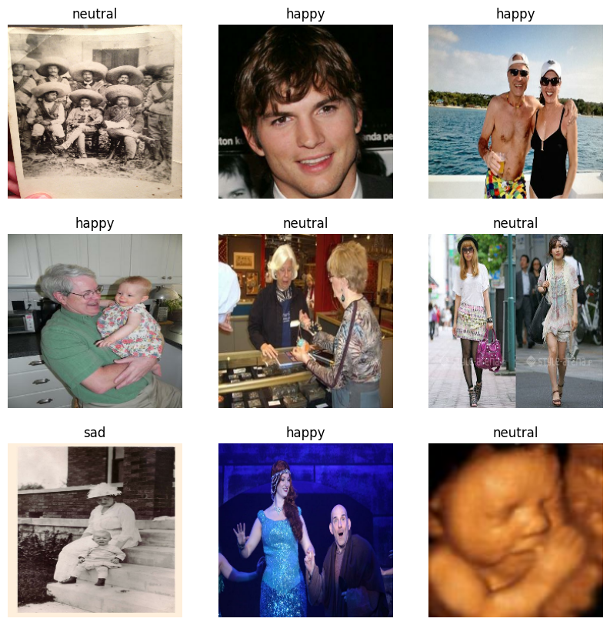

* Preprocessed

The Images are preprocessed for some basic operation to overcome the computation time and best learning, like rescaling, augmentation, and normalization.

* Split method

In this step the whole dataset divided into three parts, train, validation, and test. With the ratio 70%, 15% and 15%.

* Madel architecture

The convolution neural network with three covnet layers are used the model with the activation relu function for muilt-classification.

* Training

To apply this above architecture on the train ratio with validation test for seek we have three epochs to use train model. And last test the training learning on the test ratio.

* Model performance

This is last step of general process of ML and DL; this tells us about the model accuracy for classification as confusion matrix.

1. **Results and Evaluations**

As I share my GitHub repository, I get fifty-five plus accuracy in the first three epochs. Due to lass capability of my system unable to ran higher than 5 epochs,

1. **Future Recommendations**

Our recommendations are the facial classification task to fine tuning hypermeters, using another architecture, like Resnet, Vgg16,19 and so on and last doing trails to analysis terms like accuracy, overfitting and underfitting.

1. **Reference**

* Karnati, M., Seal, A., Bhattacharjee, D., Yazidi, A., & Krejcar, O. (2023). Understanding deep learning techniques for recognition of human emotions using facial expressions: a comprehensive survey. IEEE Transactions on Instrumentation and Measurement.
* Marlow, C., Naaman, M., Boyd, D., & Davis, M. (2006, August). HT06, tagging paper, taxonomy, Flickr, academic article, to read. In *Proceedings of the seventeenth conference on Hypertext and hypermedia* (pp. 31-40).

1. **GitHub project Link**

[**https://github.com/DostdarDost/DATA-SCIENCE-AND-ARTIFICIAL-INTELLIGENCE-DSAI-GILGIT/blob/main/CV_moduls_project.ipynb**](https://github.com/DostdarDost/DATA-SCIENCE-AND-ARTIFICIAL-INTELLIGENCE-DSAI-GILGIT/blob/main/CV_moduls_project.ipynb)