
Module code and name: | 7BDIN014C - Data Warehousing and OLAP
Module leader | Dmitriy Pochitayev
Assessment: | CW 1
Student ID: | 002595
Submission deadline: | 30/03/2026 Monday
Wordcount
Results date and type of feedback
Result (Pass or Fail)
Feedback

Executive Summary

This project focuses on the design, implementation, and analysis of a data warehouse for parking transactions in Austin, Texas, within the domain of transportation and logistics. The primary objective of the system is to analyze parking usage patterns across multiple dimensions, including time, location, payment methods, and weather conditions, to support data-driven decision-making for urban parking management.
A Kimball-based data warehouse architecture was developed using a star schema design. The central fact table captures parking transactions, while multiple dimension tables such as date, time, location, payment, and weather provide contextual information for multidimensional analysis. This structure enables efficient querying and supports Online Analytical Processing (OLAP).
The system integrates data from three heterogeneous sources: a CSV dataset containing parking transactions, a weather API providing environmental data, and a relational database storing structured dimension tables. An ETL pipeline was implemented using Python, pandas, and SQLAlchemy to extract, clean, transform, and load the data into a PostgreSQL database. Data transformation included handling missing values, standardizing formats, and enriching datasets through integration.
To support analytical exploration, several OLAP operations were implemented, including roll-up, slice, dice, and pivot. These operations enabled the analysis of revenue trends over time, comparison of payment methods, spatial distribution of parking activity, and temporal patterns of usage. Additionally, the integration of weather data allowed for further analysis of how environmental factors, such as temperature and precipitation, influence parking behavior.
A web-based interactive dashboard was developed using Dash and Plotly to visualize the results. The dashboard includes filtering options, key performance indicators (KPIs), and multiple visualizations, allowing users to explore the data dynamically.
The results demonstrate that the proposed data warehouse architecture and ETL pipeline effectively support multidimensional analysis. The system provides valuable insights into parking usage patterns and highlights the importance of integrating diverse data sources for enhanced decision-making.
Overall, this project successfully meets the objectives of designing a scalable data warehouse, implementing an ETL pipeline, and applying OLAP techniques to support analytical and decision-making processes.

Case study rationale

The selected case study focuses on parking transaction analysis within the transportation and logistics domain, specifically using data from Austin, Texas. Parking systems represent a critical component of urban infrastructure, and effective management of parking resources is essential for improving overall city efficiency.
Firstly, parking data plays a significant role in reducing traffic congestion. By analyzing parking usage patterns across different times and locations, it is possible to identify peak demand periods and areas with high occupancy. This enables city authorities to implement targeted strategies, such as dynamic pricing or traffic redirection, to alleviate congestion.
Secondly, the analysis of parking data supports informed urban planning and transportation management. Understanding how parking demand varies spatially and temporally allows planners to optimize infrastructure, improve accessibility, and enhance the overall efficiency of transportation systems.
Finally, data-driven insights enable better decision-making regarding the allocation and expansion of parking resources. Instead of relying on assumptions, authorities can use historical and real-time data to determine where additional parking capacity is required or where existing resources are underutilized.
Given the increasing complexity of modern cities, the integration of diverse data sources and the use of data warehousing techniques provide a powerful approach for managing and analyzing parking systems. Therefore, this case study is highly relevant for demonstrating the practical application of data warehousing and OLAP technologies in supporting urban decision-making.

Architecture design

The data warehouse was designed using the Kimball dimensional modeling approach, implementing a star schema. This design was selected due to its simplicity, high query performance, and suitability for OLAP operations.
The central fact table, fact_parking_transaction, stores measurable data such as duration and amount, with each record representing a single parking transaction. It is surrounded by dimension tables including dim_date, dim_time, dim_location, dim_payment, dim_source, and dim_weather, which provide contextual information for multidimensional analysis.
This structure allows efficient querying by reducing join complexity and supports OLAP operations such as roll-up, slice, dice, and pivot. At the conceptual level, the model focuses on parking transactions, while at the logical and physical levels it is implemented in PostgreSQL using primary and foreign key relationships.
In addition, a separate database (weather_db) was used to store raw weather data from an external API. This acts as a staging layer, ensuring data integrity and enabling reprocessing. Relevant data is transformed and loaded into dim_weather within the main warehouse (parking_dwh).
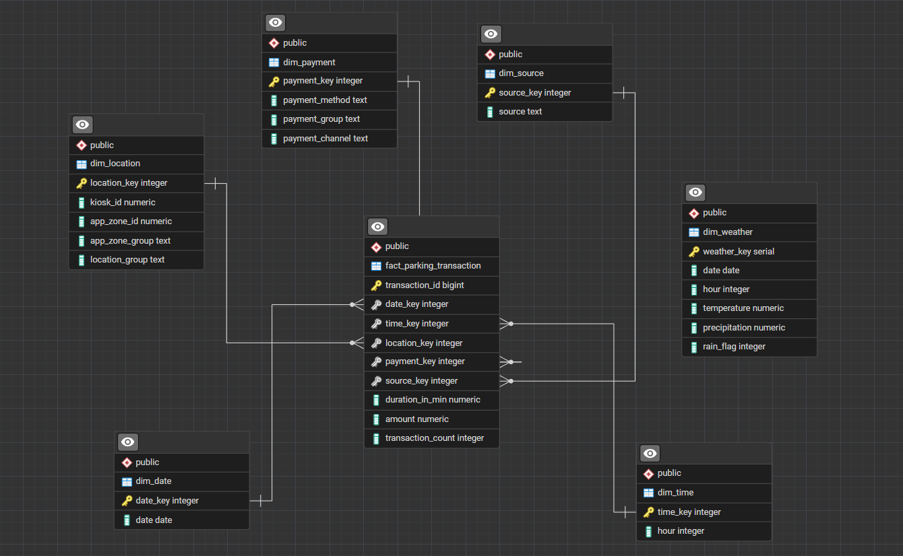
This separation improves scalability, supports integration of multiple data sources, and follows best practices in data warehousing architecture.

ETL pipeline explanation

The ETL (Extract, Transform, Load) pipeline was implemented using Python, Pandas, and SQLAlchemy to integrate data from multiple heterogeneous sources, including a CSV file (parking transactions), an external weather API, and relational database tables.
During the extraction phase, parking transaction data was loaded from CSV files, while weather data was retrieved from an external API and stored in a separate staging database (weather_db). This ensured that raw data remained unchanged and could be reused if necessary.
In the transformation phase, several data cleaning and preprocessing steps were applied. Invalid or missing datetime values were handled by converting timestamps and removing inconsistent records. Text fields such as payment method and source were standardized using lowercasing and trimming to ensure consistency. Missing values in location-related fields were replaced with default values to maintain data integrity.
Furthermore, new attributes were derived to support dimensional modeling. Surrogate keys such as date_id and time_id were generated from timestamp fields. Dimension tables (date, time, location, payment, and source) were created by extracting unique values, while payment methods were grouped into higher-level categories such as Mobile, Cash, and Card to support business-level analysis.
Surrogate keys such as date_id and time_id were generated from timestamp fields to improve query performance, ensure consistency, and support dimensional modeling within the star schema.
Separate dim_date and dim_time tables were created to enable flexible and efficient OLAP analysis at different levels of granularity.
Weather data was transformed and filtered to ensure consistency with the date dimension, ensuring referential integrity between datasets. This step enabled the integration of external environmental data into the warehouse.
Finally, in the loading phase, the transformed data was inserted into a PostgreSQL data warehouse (parking_dwh) using a star schema design. Fact and dimension tables were populated with appropriate relationships, enabling efficient analytical querying.
Overall, the ETL pipeline ensured data quality, consistency, and integration, forming a reliable foundation for subsequent OLAP analysis and visualization.
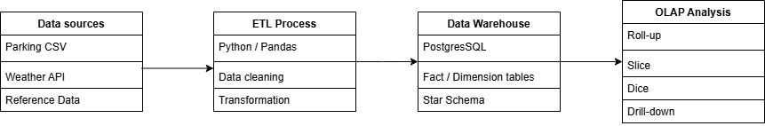

OLAP operations and results

To support multidimensional analysis, several OLAP operations were applied to the data warehouse using Python (Pandas) and SQL queries. These operations enabled the exploration of parking data across multiple dimensions, including time, location, payment methods, and environmental conditions.
The roll-up operation was used to aggregate data at a higher level of granularity. Parking revenue was summarized by month and year, allowing the identification of long-term trends and seasonal patterns in parking usage. This operation demonstrates how detailed transactional data can be generalized for strategic analysis.
The slice operation was applied by filtering data based on a single dimension, such as payment method. This allowed comparison of total revenue generated by different payment types (e.g., Mobile, Cash, Card), providing insights into customer preferences and behavior.
The dice operation involved selecting data across multiple dimensions simultaneously. For example, revenue was analyzed by both location group and payment method, enabling a deeper understanding of how payment behavior varies across different areas.
The pivot operation was used to reorganize the data for comparative analysis. A heatmap visualization was created to show the relationship between time (hour of the day) and location, highlighting peak parking activity periods and spatial usage patterns.
In addition to standard OLAP operations, further analysis was conducted by integrating weather data. Parking revenue was analyzed based on different levels of precipitation (e.g., no rain, light rain, moderate rain, heavy rain). The results indicated variations in parking activity depending on weather conditions, demonstrating the value of integrating external data sources.
Overall, these OLAP operations enabled comprehensive multidimensional analysis and provided meaningful insights into parking usage patterns, supporting the decision-making objectives of the system.

Conclusion

In conclusion, this project successfully demonstrated the design and implementation of a data warehouse for parking transaction analysis within the transportation and logistics domain. A Kimball-based star schema was developed to support efficient storage and querying of multidimensional data, integrating various perspectives such as time, location, payment methods, and weather conditions.
The ETL pipeline effectively combined data from multiple heterogeneous sources, including a CSV dataset, a relational database, and an external weather API. Data cleaning, transformation, and integration ensured consistency, accuracy, and reliability of the data, while the use of a separate staging database for weather data reflected real-world data engineering practices.
Furthermore, the application of OLAP operations, including roll-up, slice, dice, and pivot, enabled comprehensive analysis of parking usage patterns. The results provided valuable insights into temporal trends, spatial distribution, payment behavior, and the impact of weather conditions on parking activity.
The interactive dashboard developed using Dash and Plotly enhanced the usability of the system by allowing dynamic exploration of the data through filters and visualizations. This supports data-driven decision-making for urban parking management.
Overall, the project demonstrates how data warehousing and OLAP techniques can be effectively applied to real-world scenarios, providing a scalable and efficient solution for analytical processing. Future improvements could include the integration of additional data sources, real-time data processing, and predictive analytics to further enhance decision-making capabilities.

