**[Does better coffee make a better company?](http://blog.codejobs.io/post/95672351561/does-better-coffee-make-a-better-company)**

You may have seen Matt Holford’s article [Don’t Skimp on Coffee](http://www.fastcompany.com/3034469/coffee-week/dont-skimp-on-coffee-a-ctos-plea) last week which posits that technology companies that offer high quality coffee as a perk are better companies to work for.

Could it be true that a strong coffee culture is an indicator of a strong company culture? Are employees at these companies really happier? And is the K-cup is a sign of a company’s cultural death spiral?

As self proclaimed coffee nerds, we decided to dig into the data support’s Holford’s hypothesis. A pot of coffee later and we had collected a sample of 428 companies hiring for a “Software Engineer”.

We compared employee reviews between companies that explicitly listed coffee as a perk in their job descriptions vs companies that did not. Here were the results:

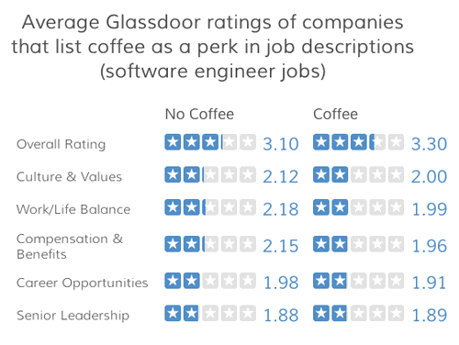

Overall, it looks like companies that have a stronger coffee culture (or strong enough to list it in a job description at least) have slightly higher overall ratings from employees. The correlation between coffee and overall company rating is pretty weak however (~.14).