# TABLE OF CONTENTS

TABLE OF CONTENTS 1

CHAPTER 1 INTRODUCTION 2

1.1. PROBLEM BACKGROUND 2

1.2. PROJECT GOALS AND OBJECTIVES 3

1.3. SIGNIFICANCE OF THE STUDY 4

1.4. THEORETICAL BACKGROUND 5

1.5. REVIEW OF RELATED LITERATURE 13

1.6. DEFINITION OF TERMS 18

# CHAPTER 1 INTRODUCTION

## PROBLEM BACKGROUND

PHIVOLCS, or commonly known as Philippine Institute of Volcanology and Seismology, needs an affordable digitizer equipment for their sensors. Currently, each said equipment will not cost less than a million and it would be a problem for them to buy several pieces of it. As a response for problem, they requested some schools, including CIT University, to create and design an affordable device that will digitize their sensors.

As a response for their request, this project is created to solve the compelling problem on their digitizer equipment. We will design an amplifier for their specified sensor. The amplifier will meet the minimum and maximum frequency response and signal voltage. The signal will be feed to a digitizer circuit which is responsible for converting analog signals to digital signal. The data from the digitizer will be converted to a standard CSV file.

## 

## PROJECT GOALS AND OBJECTIVES

* This project aims to create a cheap digitizer system as an alternative to the digitizer system used by PHIVOLCS.
* The digitizer will convert the 3-axis (x, y, and z axis) analog signal from their sensors into a 24-bit digital resolution. A file will be generated to contain primarily with digitized data, compass, time information, location, and output data speed.
* The project uses an android phone to display the digitized data while it manages the transferring of data to the cloud.
* An online database will be created to be used as a storage for all files generated by the digitizer system.
* An API will be created to be used as interface for the data stored in the cloud.
* An earthquake analyzer software will be created to serve as a backend software for analyzing data from the local database.

## 

## SIGNIFICANCE OF THE STUDY

As a solution to the compelling problem on PHIVOLCS digitizer, this project can become a good foundation for their goal to mass produce an affordable digitizer equipment. This can be beneficial in such a way that it will lower down the Philippine budget for buying seismic equipment. In the future when the digitizer will be completed, there will be a building code specifically for commercial and government buildings near the fault line requiring the said buildings to have a seismic sensors to be installed. This project can be used as an alternative equipment for the digitizer used by PHIVOLCS and also the sensor used by PHIVOLCS can be also be used as sensor to this project.

## 

## THEORETICAL BACKGROUND

The ADC (Analog to Digital Converters) in this system is composed of 224 comparators and 224 resistors. The Op-amp comparator compares one analog voltage level with another analog voltage level, or some preset reference voltage, VREF and produces an output signal based on this voltage comparison. In other words, the op-amp voltage comparator compares the magnitudes of two voltage inputs and determines which is the larger of the two. If the input analog voltage is much higher than the reference voltage, the comparator will output a logic high voltage. The resistors that are part of the ADC acts as a voltage divider for the reference voltage. The least significant bit comparator of the ADC module will have a low reference voltage. The higher the order of the comparator will have higher reference voltage than its lower order comparator/s. The output of the 224 comparators will be send to the microcontroller.

The project uses online database which is the central and main repository of data in this system. In this set-up, the database is hosted by a local computer. The DBMS that will be used in this set-up is MySQL which is the Relational Database Management System (RDBMS) based on Structured Query Language (SQL). SQL Commands will be used to interact with database.

The effect of an earthquake on the Earth's surface is called the intensity. The intensity scale consists of a series of certain key responses such as people awakening, movement of furniture, damage to chimneys, and finally - total destruction. Although numerous intensity scales have been developed over the last several hundred years to evaluate the effects of earthquakes, the one currently used in the United States is the Modified Mercalli (MM) Intensity Scale. This scale, composed of increasing levels of intensity that range from imperceptible shaking to catastrophic destruction, is designated by Roman numerals. It does not have a mathematical basis; instead it is an arbitrary ranking based on observed effects.

The Modified Mercalli Intensity value assigned to a specific site after an earthquake has a more meaningful measure of severity to the nonscientist than the magnitude because intensity refers to the effects actually experienced at that place.

The **lower** numbers of the intensity scale generally deal with the manner in which the earthquake is felt by people. The **higher** numbers of the scale are based on observed structural damage. Structural engineers usually contribute information for assigning intensity values of VIII or above. There are more ways in getting the magnitude. In our case, we use the value of accelerometer in g with correlation to Modified Mercalli Intensity Scale.

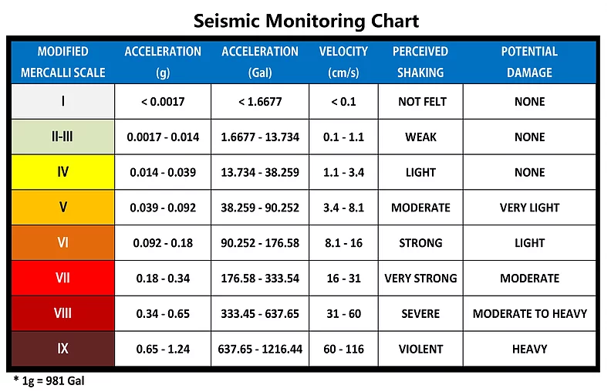

**Figure 1.4.1 Seismic Monitoring Chart**

The magnitude of an earthquakes can be estimated by using the formula in figure 1.4.2.

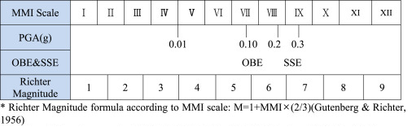

**Figure 1.4.2 Richter Magnitude**

In getting the direction of epicenter, it uses the concept of summing up the resultant vectors of forces using Component Method. The value of x and y will only be used. The resultant vector can be solved by first getting the sum of x and y value of digitized data by using Pythagorean Theorem. The resulting value will be then a single vector with angle in respect of x-y plane. The resulting vector of the x and y value will have a corresponding angle and magnitude. The angle of that vector will be compared with positive y plane since the three axis sensors will be positioned with respect with the poles of the Earth. The direction of the epicenter can be calculated by getting the difference of the degree of the compass of positive y-plane and the angle of the resultant vector. The angle of the resultant vector will be the subtrahend while the other one will be the minuend. 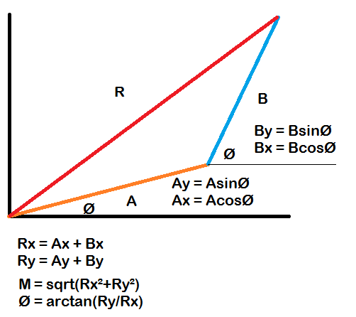

**Figure 1.4.3 Resultant Vector**

where:

Rx = is the resultant vector of the X-plane

Ry = is the resultant vector of the Y- plane

M = magnitude

Ø = angle

Primary waves or P waves are made up of compression waves, also known as push-pull waves. The individual waves, therefore, push against one another, causing a constant parallel, straight motion. S waves are transverse waves, which means they vibrate up and down, perpendicular to the motion of the wave as they travel. In an S wave, particles travel up and down and the wave moves forward, like the image of a sine wave. S waves are generally larger than P waves, causing much of the damage in an earthquake. Since the particles in an S wave move up and down, they move the earth around them with greater force, shaking the surface of the Earth. P waves, though easier to record, are significantly smaller and do not cause as much damage because they compress particles in only one direction.

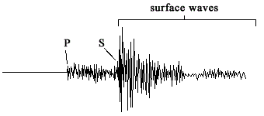

**Figure 1.4.4 P and S wave**

In determining the distance of hypocenter from the device, it measures the time it takes between the P – wave and the S – wave. As stated in the functional requirements of SRS, the speed of the wave to be used is 8 km/sec which is the standard speed PHIVOLCS used.

An accelerometer is an electromechanical device used to measure acceleration forces. Such forces may be static, like the continuous force of gravity (g) or, as is the case with many mobile devices, dynamic to sense movement or vibrations.

**1g = 9.81 m/s2**

Single- and multi-axis models of accelerometer are available to detect magnitude and direction of the proper acceleration, as a [vector](https://en.wikipedia.org/wiki/Euclidean_vector) quantity, and can be used to sense orientation , coordinate acceleration, vibration, [shock](https://en.wikipedia.org/wiki/Shock_indicator), and falling in a resistive medium. Micromachined [microelectromechanical systems](https://en.wikipedia.org/wiki/Microelectromechanical_systems) (MEMS) accelerometers are increasingly present in portable electronic devices and video game controllers, to detect the position of the device or provide for game input.

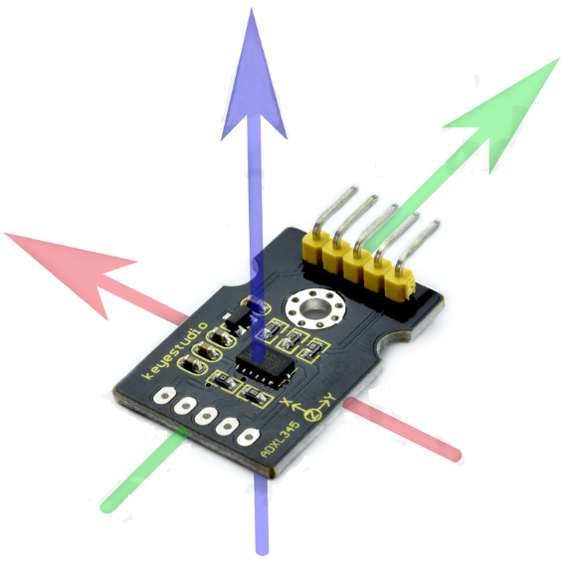

**Figure 1.4.5 Accelerometer**

The system has a dynamic gain control. It uses a digital potentiometer to increase the gain of the system. A potentiometer has 3 pins, namely, Vin, Vout, and GND. In order to get a variable resistance using potentiometer, the connection must be in series with potentiometer. The input pin must be in Vin and output will be in Vout. With this set-up, the digital potentiometer can be used to increase the gain by incorporating it with the instrumentation amplifier. The instrumentation amplifier has a two input pins, namely, RG- and RG+. RG means resistor gain for the instrumentation amplifier. This pins will be used to control the gain of the instrumentation amplifier. Thus using the digital potentiometer, the gain of the system can be controlled.

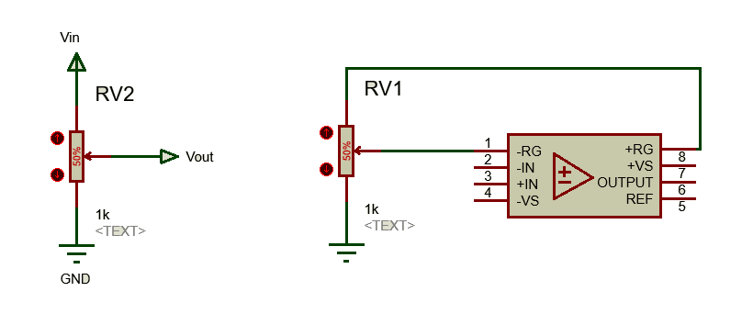

**Figure 1.4.6 Digital Potentiometer and Instrumentation Amplifier Set-up**

The figure above fundamentally shows the connection of digital potentiometer and operational amplifier. The circuit on the left side shows the basic pins of a potentiometer. The circuit on the right side shows the usage of potentiometer to the instrumentation amplifier.

## REVIEW OF RELATED LITERATURE

In the project of Zhang J, et. al. entitled the Real-time earthquake monitoring using search engine method, they used a different approach of determining and analyzing earthquakes rather than the common way of using recorded seismograms to infer its location, magnitude and source-focal mechanism as quickly as possible. Here, the researchers used an earthquake search engine, similar to a web search engine, that the researchers developed by applying a computer fast search method to a large seismogram database to find waveforms that best fit the input data. The researchers’ method is several thousand times faster than an exact search. For an Mw 5.9 earthquake on 8 March 2012 in Xinjiang, China, the search engine can infer the earthquake's parameters in less than a second after receiving the long-period surface wave data.

The challenge lies in the automatic and rapid estimation of the earthquake source mechanism in a few seconds after receiving the seismic data from a few stations. The researchers developed an image-based earthquake search engine, similar to web search engines, to estimate earthquake parameters within 1 second by searching for similar seismograms from a large database on a single AMD Opteron processor 6136. Significant advances in computer search technology have helped the search industry to retrieve words, images, videos and voices from Internet-sized data sets. Similar to voice recording or a one-dimensional (1D) image, a seismogram is a graph record of the ground motion at a recording station as a function of time. It contains information about both the earthquake source and the earth medium through which the waves propagated. By assuming that the earth velocity model is known, the researchers applied a forward modelling approach to build a database of waveforms for scenario earthquakes over possible source mechanisms and locations on a discretized grid. The researchers’ objective was to find the best matches to any new earthquake record from the database. This approach is fully automatic and requires no parameter input or human interference. Therefore, it could be applied for routinely reporting earthquake parameters.

After some test in their test area of 5° by 5° in Southern Xinjiang, China, where three permanent seismic stations that can record earthquakes from the area within a range of ~5° to 15°, the researchers’ methods were proved correct after an earthquake hit Xinjiang, China back in 2015. On the other hand, our project is more focused on finding the general direction and maximum amplitude generated on the sensor using our own data collected at real time. Basically, the two project’s goals were the same but the methods to achieve it was different because the Earthquake Analyzer Project uses the traditional method of detecting the P-wave and the S-wave first by depending on a certain threshold, then calculating the magnitude of the earthquake through a formula, then finding the direction through summing up the resultant vectors of forces using Component Method.

Another project related to the Earthquake analyzer project is the project of Martin Pavelek, entitled Digitizer firmware for fast Phenomena. It is related to the Earthquake analyzer project because both of them are digitizer devices. In various applications, it may be required to detect and measure phenomena occurring on a timescale in the order of mere milliseconds or even nanoseconds. One such application may be a device for seismologist where the device reads seismic behaviors of the earth’s crust or another one may be a system for nuclear spectrometry in mixed radiation fields, where it is necessary to determine the type of each particle as it is detected. A suitable scintillation detector may be used for this application, producing a slightly different response in collisions with different types of particles. The signal from a scintillation detector typically lasts less than 100 ns, requiring appropriate equipment capable of sampling and processing such signals with reasonable precision to be used. There is already an existing device capable of achieving the needed requirements mentioned above. It is the FD-11 ŠOHAJ is a digital spectrometric system that uses a fast and precise A/D converter with a sample rate up to 2 GHz, 12 bit resolution and implements the particle characterization procedure in VHDL, using a Virtex-6 FPGA. The goals of this work are to improve its original FPGA firmware in order to increase its maintainability and to implement new features that are required to allow two A/D converters to be used simultaneously.

The digitizer device in question is first introduced in the context of the spectrometric system and the basic building blocks are described. Before designing a new data processor structure, obsolete development code was removed and changes towards better code clarity and dual - ADC support were made in the top-level entity. Various modules were modified or newly implemented in order to improve the performance or add new features to the digitizer. Both the configuration and the output interfaces were modified to support the new features and data outputs available.

The finalized firmware is ready to work with both A/D converters, supports online processing and due to improved trigger sensitivity allows to capture pulses with lower amplitude than previously possible.

In one of the process of the output, one of the trouble the project has encountered was that particles present in the measured field may cover a very wide range of energies. In case the detector assembly is set to high sensitivity, particles with low energy will produce a relatively strong signal that is easy to measure with a decent precision. In order to measure particles with higher energy, the sensitivity must be lowered, otherwise the signal could exceed the range of A/D converter and become saturated. Lowering the sensitivity makes it possible to measure particles with much higher energy, but it also means that the signal produced by low energy particles becomes much smaller. This weak signal will be in turn more susceptible to noise and only a relatively small part of the full ADC range can be used for its representation, leading to lower measurement precision of low-energy particles as the detector sensitivity decreases. Thankfully the signal received from the sensor is typically available in two channels with different amplification levels: one suitable for high energy particles and the other to preserve the precision of weak signals. By combining these two signals, a new signal can be created that helps to achieve higher dynamic range without negatively impacting the measurement precision in the region of low energies.

In the case of the Earthquake analyzer project, the accelerometer with the scale of ±3g, the output will be amplified by a PGA or programmable gain amplifier. So, if ever the output voltage of the accelerometer will be too high, the gain will be reduced to protect the ADC from over voltage and if it’s too low, the output will be amplified.

The offline data processing of Martin’s project does not actually involve any additional processing except for reassembling the raw data samples in a form that is suitable for later network transfer where as in the Earthquake analyzer project, as the name itself, after the analog data is converted into digital, it is sent into an online database and there is a C# program that will analyze its result.

In conclusion, the purpose of Martin’s project was solely an analog to digital converter and send it to a local database where as the Earthquake Analyzer Project also has analog to digital converter but it analyzes the data that it receives from the sensors it is connected to.

## DEFINITION OF TERMS

**ADC (Analog to Digital Converter)** - is a component used for this project to convert analog signals from the sensor to its digital form.

**UART (Universal Asynchronous Receiver-Transmitter)** - is an interface that uses asynchronous serial communication between peripherals.

**SPI (Serial Peripheral Interface)** - is an interface that uses synchronous serial communication between peripherals.

**RTC (Real Time Clock)** - is a module used for getting time or date information.

**GPS (Global Positioning System)** - is a satellite-based radionavigation system owned by the US government and operated by the United States Air Force.

**USB VCOM (Universal Serial Bus Virtual Communication Port)** - is a composite Universal Serial Bus device class. The class may include more than one interface, such as a custom control interface, data interface, audio, or mass storage related interfaces. USB VCOM is one of the common communication protocol used for communicating Android devices with other devices.