4.1 In the main user interface, the real time reading of the seismometer, the x, y and z axis, is displayed at the center of the screen with the analysis of the peak magnitude and the direction. A drop down menu is displayed in the upper left corner of the screen. When the drop down menu is pressed, it will display the other controls like load data, real time, and orientation buttons.

4.2 There are 4 controls that can be interacted in the system namely the menu, load data, real time and orientation button.

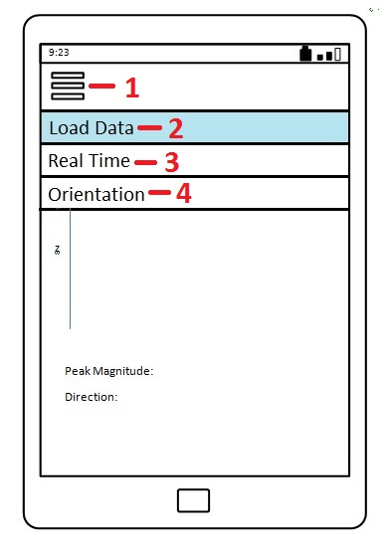

1. Menu – A drop down button which displays the other controls
2. Load Data – A button which redirects the user to the manual loading of the csv file for viewing. It has the Open button to open the selected file and Cancel button to return to the last display the user was..
3. Real Time – A button which will return to the Real Time reading screen.
4. Orientation – A button which will display the orientation screen.

