Digital Seismometer with Earthquake Analyzer

Marvin Joshua P. Chewchut¹, Clark Jay R. Cortezano¹, Keith Joseph B. Damandaman¹, Rafran De Villa¹
¹Department of Computer Engineering
College of Engineering and Architecture
marvin.chewchut@gmail.com

Abstract—PHIVOLCS, or called as Philippine Institute of Volcanology and Seismology, needs an affordable digitizer device. This device has the capability of converting the signal from their sensors into understandable form of data. The data will be in a range of numbers from 0 - 65535 and the value will base on the produce signal from their sensors. This paper pertains on creating such device along with database center for centralized data storage of data, Android application for live monitoring and data handling, and Computer Application for accessing data from database and analyzing.
Index Terms—Digitizer, Database, Android, Seismometer

Introduction
This paper pertains the creation of three major components, namely, digital seismometer, database center, and earthquake analyzer. Digital seismometer is a subsystem that performs conversion of analog signal from seismic sensors, handling of data over the database, and displaying of data for the user to monitor. Database center is an online storage of data where all the results of data conversion process by are gathered in this storage. Lastly, earthquake analyzer software is a C# application software that uses the data gathered in the Database center and analyzes it to check the earth movement.

Block diagram
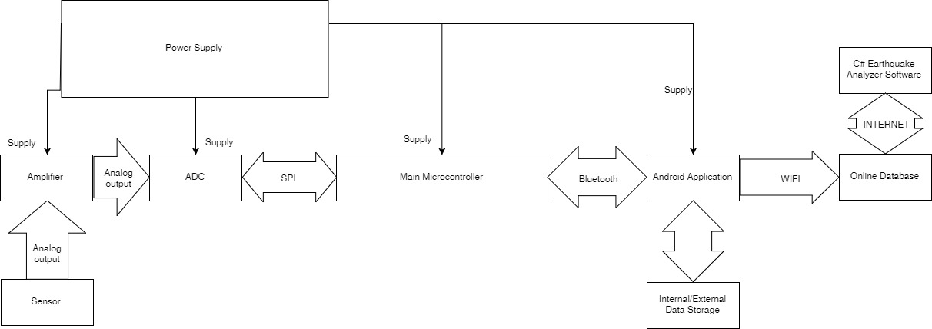
Fig 1 Block Diagram

The figure above shows the entire proposed system in this research. Digital seismometer composed of seismic sensor, amplifier, ADC, main microcontroller, and Android device. There will be three ADC and amplifier as relative to three analog outputs of seismic sensors, namely, x, y, and z. The main microcontroller will act as a link between the ADCs and Android device and pass the data through Bluetooth. The Android device is responsible for data management where all the data are temporary stored here before passing it to the database and at the same time displaying the data in a form of graph for live monitoring.

Data flow
To fully comprehend the flow of data, the figure below shows the route that the data passed through.

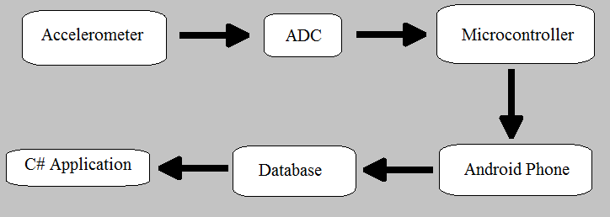
Fig 2 Data Flow

First, an Accelerometer, an instrument for measuring acceleration, produces analog signal with different values along three axis namely X, Y, and Z axis. These three different data will be sent to ADC, Analog to Digital Converter, for conversion. X, Y, and Z axis digitized data will be sent to microcontroller that act as a buffer that will be sent to the Android phone. The three axis data from the microcontroller will be gathered through Bluetooth to the android phone. An Android phone act as to manage data from the delivered data to a file with an extension of “.csv”. The file that was saved in a .csv format, appending with the orientation of the phone aligning with the accelerometer and the location of the device, is ready for compression. The compressed csv will be turned into .csv.gz. “.gz” is an extension for GZIP that is a lossless compression. The compressed file is ready for sending to the database. The zip file has been stored in the database and is ready to be used for analysis. The C# application requests a file to database for analysis. Using API that act as a medium for communication between C# and Database. C# will request a file that will manage for decompression of the compressed file and open the .csv extension for further analysis.

Result and Discussion
In analyzing an earthquake, an actual output, a seismic file in csv format, was provided by PHIVOLCS, the researches then will make a program to read the seismic file and analyze the give seismic activity. The relevant contents of the seismic file is the site name, date and time it is recorded, sampling rate of the device, and the XYZ values. For a basic knowledge about earthquake, first, what is an earthquake? An earthquake is a sudden and violent shaking of the ground, sometimes causing great destruction, as a result of movements within the earth's crust or volcanic action. An earthquake consists of 2 waves, the primary wave (p-wave), and the secondary wave(s-wave). The primary wave is the first wave generated by an earthquake and is the fastest kind of seismic wave. This wave is the first one to arrive or to be recorded by any seismic instruments. Then there’s the secondary wave, it is slower than the primary wave but significantly has greater motion. Meaning it is stronger than the primary wave and the wave that really causes damage to any structure.
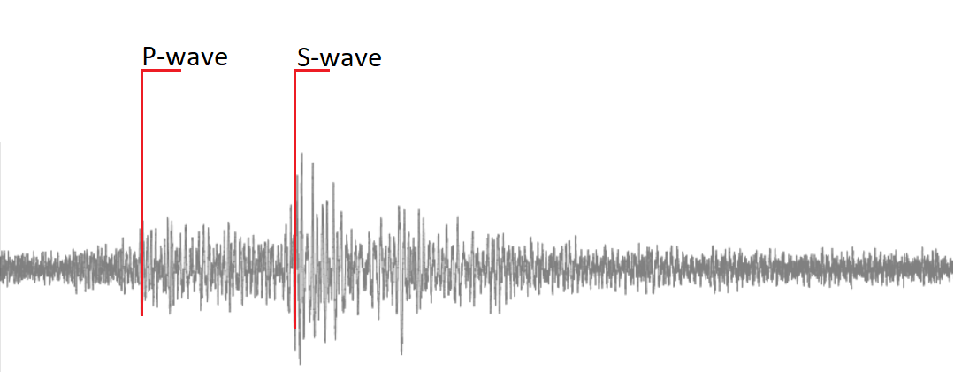
Fig 3 Seismic Wave

A sample recorded seismic wave is shown. The P-wave is show to be greater than the normal amplitude and the S-wave is shown after the P-wave and has greater amplitude than the P-wave. To analyze the seismic file, the user must first choose the P-wave and S-wave. Then the program will find the highest amplitude to calculate for the magnitude. The formula for calculation is:
Where A is the measured ground motion (in micrometers) and D is the distance from the event (in km).
This is how this table was formed:
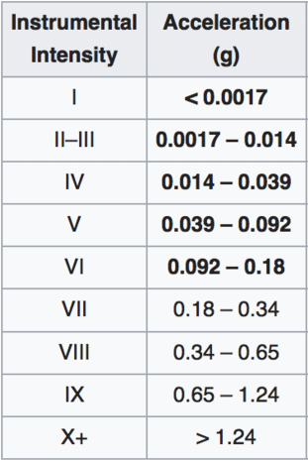
Table 1. Intensity Scale

To measure the distance between the device and the event, this formula is used:

Where P-wave is the time P-wave arrives, and S-wave is the time when S-wave arrives. 8 is a constant.
To compute the direction, the first value of the P-wave is computed. This formula is used:
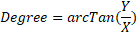
After the degree is taken, the actual direction will be decided by the Z value if it is positive or negative. If the value of the Z axis of the P-wave is positive, then it is push, meaning the direction stays as it is, but if the value of the Z axis of the P-wave is negative, then it is pull. Meaning the direction is actually going to the opposite.
To avoid reading spikes like man made noises that the seismic device reads, the method STA/LTA is used. First, the STA, or short-term averaging is the moving average of absolute amplitude of an axis on a short time and the period is usually 2 seconds. The LTA, or long-term averaging is moving average of the absolute amplitude of an axis for a long time. And usually the period is over 10 – 20 seconds. Then the ratio of the two is taken and plotted.
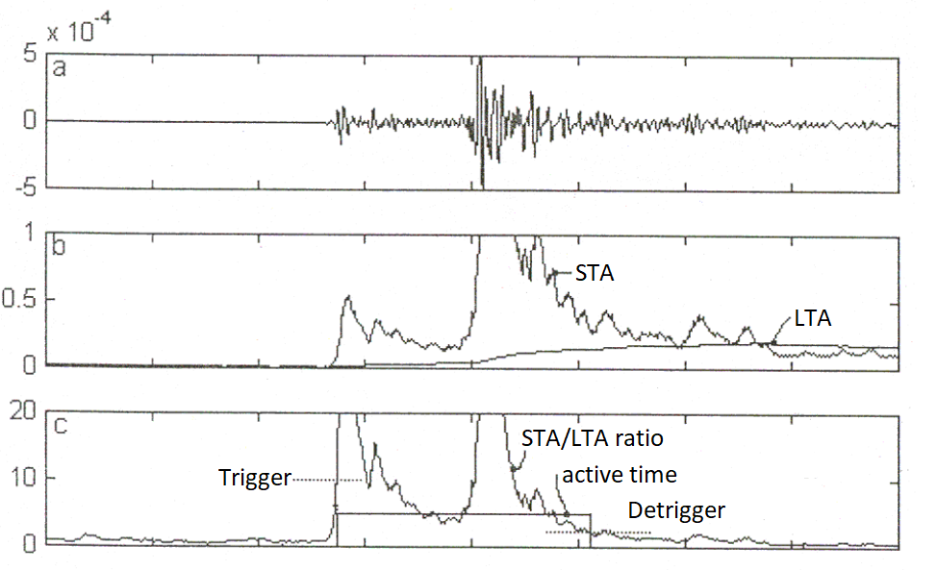
Fig 4. STA/LTA Guide
First, the value of the STA/LTA ratio must exceed the trigger value set by the user, then after the event, the value will return to normal thus arriving at the detrigger value. Then the active time is calculated by subtracting the time the detrigger was achieved and the time the trigger was exceeded. If the active time is greater than or equal to the inputted active time, usually the time how long an earthquake last, the data is considered to be an earthquake. Else, it is not an earthquake.
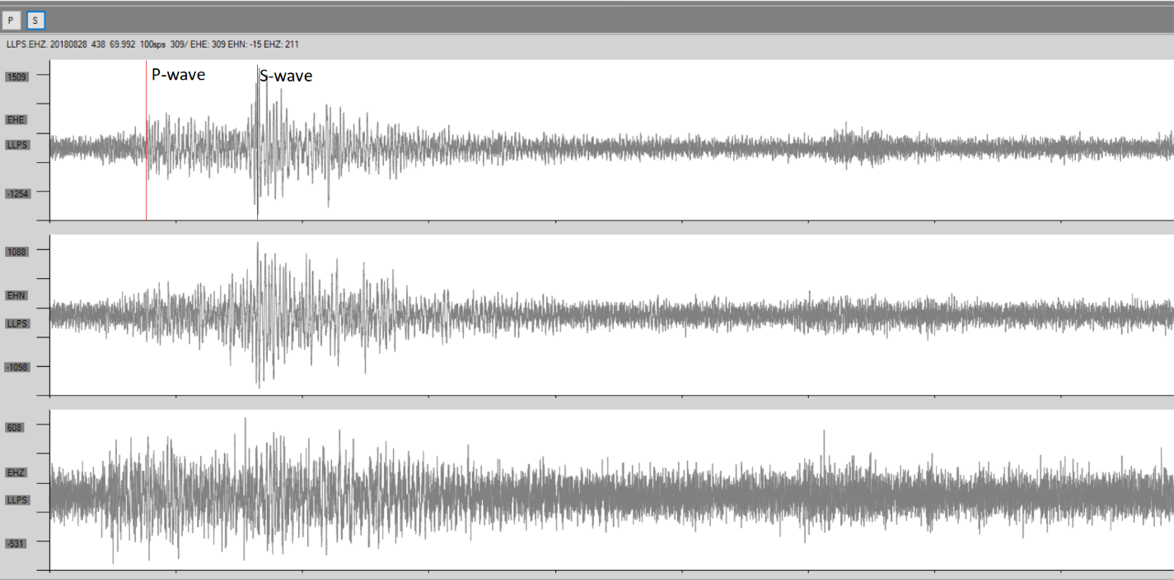
Fig 5

Now to apply what was discussed above, first we choose the p-wave at 4:38:30.87 then s-wave at 4:38:55.27. Then we check it if there was an earthquake using the methods discussed above.
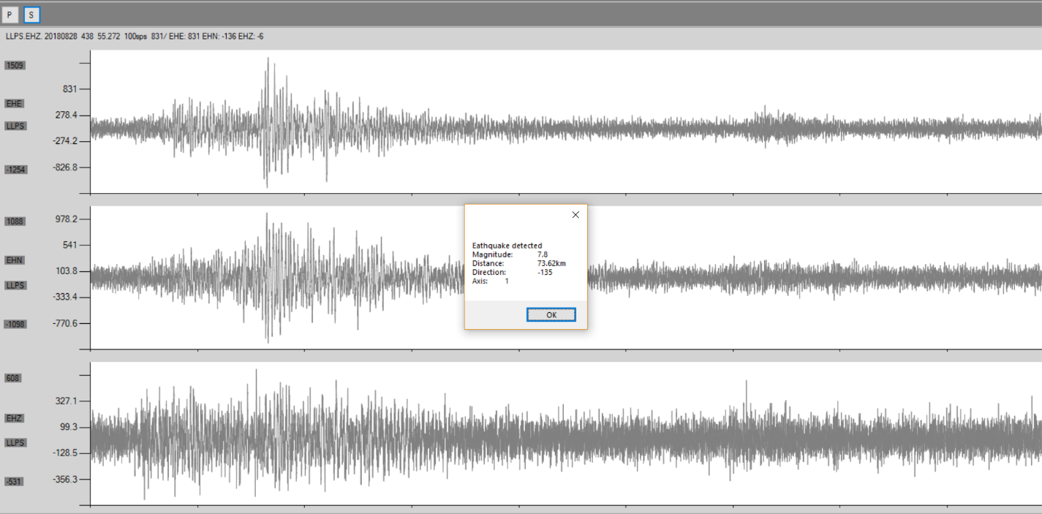
Fig 6
Then we get the result. The program was triggered at the X axis.
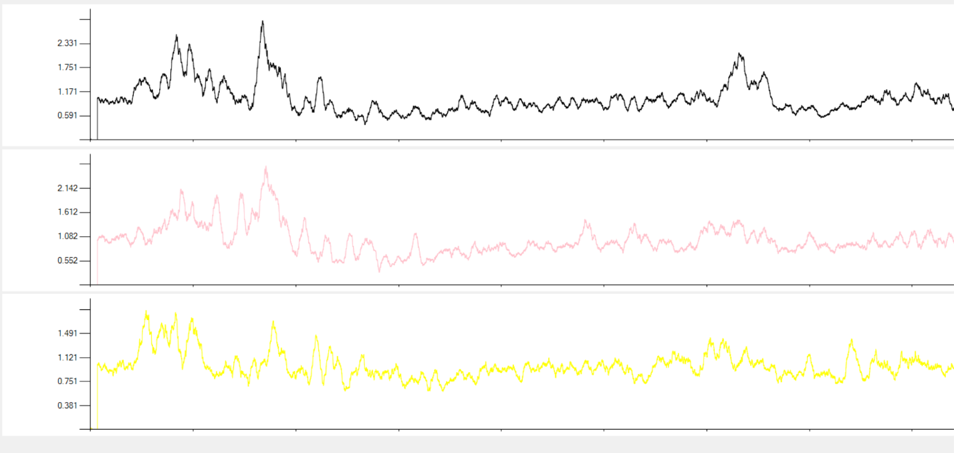
Fig 7
This is the STA/LTA result of the program. The set triggered value was 2.5 and the detrigger was 0.5 and the minimum active time was 10 seconds.
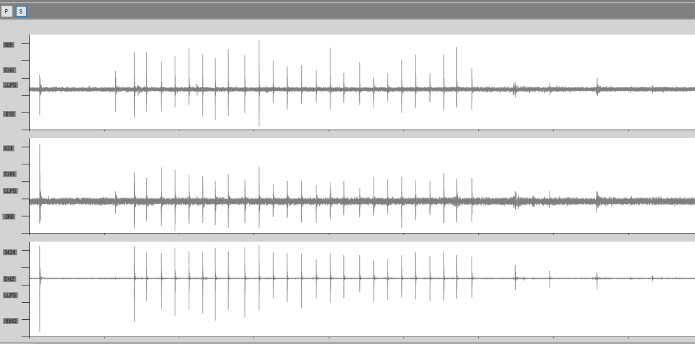
Fig 9
Here we have a sample full of manmade seismic noise. After the P-wave and S-wave, here is the output.
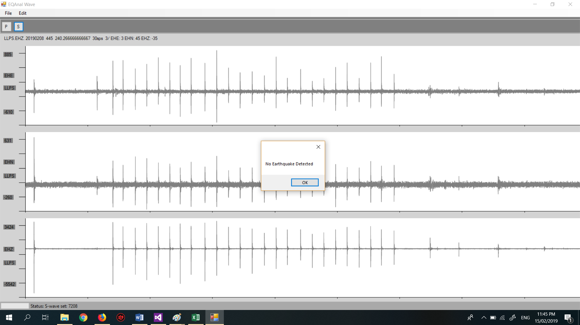
Fig 10
It is because of the STA/LTA ratio which did not meet the required trigger and detrigger.
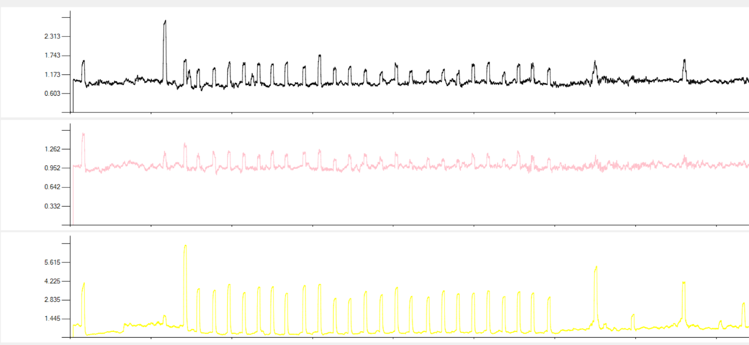

Fig 11

Acknowledgment
The researchers would like to thank the people along with the journey in this project:

Our adviser, Engr. Rafran de Villa for his patience and for teaching and guiding us.

Our families and friends for their constant support
And of course to Almighty God for the blessings and the strength.

References
- https://www.researchgate.net/post/Is_there_a_graph_relating_the_peak_ground_acceleration_of_an_earthquake_to_the_magnitude_in_Richter_scale
- https://www.bgs.ac.uk/discoveringGeology/hazards/earthquakes/magnitudeScaleCalculations.html

