
CEBU INSTITUTE OF TECHNOLOGY UNIVERSITY

N. Bacalso Avenue, Cebu City

ROBOTIC ARM (6DOF)
using inverse kinematics with object/distance detection on grip

REQUIREMENTS SPECIFICATIONS

August 10, 2018

LABISTE, Aubrey Joyce
ALTERADO, Jundith
NILLAS, Lhoyd

Chapter 1 Introduction

  - Purpose

The main idea behind the creation of this robotic arm is to imitate simple actions of the human hand, such as picking and placing an object. The purpose of this project is to be able to design and create a Robotic Arm with at least six degrees of freedom, and would utilize the concept of Vision Guided Robotics and operate using inverse kinematics. The project also involves the development of an interface that would provide control over the robotic arm with minimal or reduced human assistance. The project is devised to minimize, if not provide solutions to common production problems such as low productivity or efficiency, unintentional human errors, large number of product rejects, long production time (takt time), and varying product quality. The robotic arm would be able to automatically adjust its position to accurately pinpoint and perform a pick-and-place function to the target object as long as it is within the arm’s range of motion.

  - Scope

The project to be developed is under the field of Vision Guided Robotics and PIC-Based Control System. Robotics involves the design, construction, operation and the use of robots, as well as computer systems for their control, sensory feedback, and information processing. The project is not only using sensors as the hardware interface but also utilizes the use of a vision system to perform desired functions. Cameras are used as one of the I/O devices for data gathering such as pinpointing the target location and mapping the spatial reach of the arm to determine its minimum and maximum range of motion. The software interface would be PIC-Based which is responsible for the main control of the robotic arm’s movements and operations. The PIC is the device that would control the motors used.
The first function of the project would be the gathering of data done by the Vision System. As per stated above, this involves the task of mapping the spatial reach of the arm, object configuration , which is collecting the target’s data such as shape, size and distinctive attribute.
The second function, Distance Detection, would also make use of the vision system. It will be responsible in finding the location of the target and determining the distance between the target and the robot base.
The third one would be the major function of the project, which is the automatic pick-and-place function. This function would make use of the data collected by the vision system and the distance detection function. This function would enable the robotic arm to automatically compute for the robotic arm joints’ angles in order to reach the target, pick it and place it to the next container with minimal human assistance.
Another function would be the speed control function. This function would be able to limit the acceleration of the arm depending on the target’s fragility and distance. It would use ultrasonic sensors to detect the proximity of the target, it would then reduce the speed of approach of the arm the moment the target enters the limit range set by the user, thus avoiding collision and possible damage due to the excess force applied by the gripper. This function would also be responsible in determining the gripper’s amount of opening and hold.
The fifth function would be the Auto-Homing function, which would enable the Robotic Arm to return to its original or starting position. This function would be automatically triggered every time the robot is turned on or restarted.

  - Project Constraints and Limitations

- The software needs data for pre-configuration, i.e. object to be picked up, location and object orientation.
- The robotic arm is only applicable for desktop usage, thus unable to carry heavy weight and had a smaller spatial reach than a typical industrial arm..
- The robotic arm is immovable if in use, but can easily be transferred if needed be.
- The robotic arm would possess a maximum of 6 degrees of freedom for the movement..
- The robotic arm base’s first motor (base joint) can rotate only up to 180 degrees, bidirectional. The second would be able to rotate up to 180 degrees in an up down motion. The elbow motor (elbow joint) can rotate only up to 180 degrees in an up down motion. The wrist joint’s first motor can rotate only up to 180 degrees, bidirectional while the second motor can only rotate up to 180 degrees. The last motor (gripper) can rotate a maximum of 180 degrees.
- The robotic arm should be placed in a specific area for it to function precisely.
- The robot would not be able to accurately judge the object’s fragility without external input of data.
- The software to be developed doesn’t involved self-object identification and recognition. It will only able to identify the target or object that was pre-configured beforehand.
  - Hardware Requirements

- At least six (6) degrees of freedom
- Six (6) Servo Motors
- PIC18f455
- Vision system (Raspberry pi and 2 camera)
- Chassis
- Ultrasonic Sensors

  - Software Requirements

- Qt Creator
- PIC* based programming (mikroC) for controlling the motors

  - Definitions of Terms

- Degree of Freedom
  - In mechanics context, are specific, defined mode in which a mechanical device or system can move. The number of degrees of freedom is equal to the total number of independent displacements or aspects of motion.

- Vision System in Robotics
  - Robotic vision is similar to human vision – it provides valuable information to the robot that the robot can use to interact with the world around it.

- End Effector
  - It is the body connected to the last joint of the hover which is used for the purpose of gripping or handling objects, It can be an analogy to the arm of a human being.

- Actuators
  - They are the drivers of the robot. It actually actuates the robot. It can be any motor, stepper motor or pneumatic or hydraulic cylinders.

- Sensors
  - They are used to sense the internal as well as the external state of to make sure the robot functions smoothly as a whole, Sensors involve pressure sensor, ultrasonic sensor, etc.

- VGR (Vision Guided Robotics)
  - Using a machine vision camera would enable the robot to identify and track products, automatically orienting to successfully pick.

- Servo Motor
  - A servo motor is a rotary actuator or motor that allows for a precise control in terms of angular position, acceleration and velocity, capabilities that regular motor does not have.

- PIC (Peripheral Interface Controller)
  - A compact microcomputer designed to govern the operation of embedded systems in motor vehicles, robots, office machines, medical devices, mobile radios, vending machines, home appliances, and various other devices. A typical microcontroller includes a processor, memory, and peripherals.

- Takt Time
  - It is the average time between the start of production of one unit and the start of production of the next unit.

  - References

- https://whatis.techtarget.com/definition/PIC-microcontrollers
- https://www.techopedia.com/definition/13274/servo-motor
- https://www.bastiansolutions.com/solutions/technology/industrial-robotics/industrial-robotic-solutions/vision-guided-robotics
- https://www.azosensors.com/article.aspx?ArticleID=632
- https://whatis.techtarget.com/definition/degrees-of-freedom

Chapter 2 System Analysis

  - System or Software Architecture
This diagram describes how our system works. Before the operation can be started, the user would have to capture the image of the target object first, the image would processed and saved as the object to be picked. First, to begin the sequence, the camera (camera 1) must capture an image of the spatial boundary or environment on where the object would be picked and displays it. The image would be sent to the PC interface (RaspberryPi) where it would be processed and used as reference in order to compute for the estimated posture of the robot. The data collected would be sent to the microcontroller. The arm would then move accordingly to the sent data and proceed to pick the object. The object’s destination for the Place function would already be configured beforehand and is fixed.
This diagram describes the system within our PC interface. Camera 1 and Camera 2 would send a live feed to the RaspberryPi to be displayed to the monitor. Upon the user’s command, the sequence would start the moment camera 1 captures an image of the spatial location of where the object to be picked is located. The image would then be processed using Qt Creator (C Language) in order to identify if the target object’s location and send the data to the next function where inverse kinematics would be used to compute for the estimated posture (motor angles) of the robot arm. The result would then be sent out by the RaspberryPi to the microcontroller as well as displaying it to the monitor.
This diagram describes the system within the servo motor control.
  - Flowcharts
    - Main Flowchart
The Main Flowchart describes the main sequence of operation on the system. It prompt the user to choose between Manual or Automatic Operation.
      - Automatic Operation Flowchart
The Automatic Flowchart describes the sequence of operation that would take place if the user chose the Automatic Operation. It would perform the programmed sequence automatically, step by step.
        - Pick and Place
The Pick-And-Place function is a sub-function of the Automatic function that would control and perform the pick and place action of robot arm.
          - Speed Control
This is a sub-function of the Pick-And-Place function and is responsible in controlling the speed of the motors.
          - Gripper Control
This sub-function of the Pick-And-Place would control the operation of the gripper.
        - Image Processing

          - Image Filtering
          - Target Object Identification

          - Motion Planning

          - Distance Detection

      - Manual Flowchart
      - Target Object Data Configuration and Calibration
  - Data Flow Diagram
  - Entity-Relationship Diagram

Chapter 3 Functional Requirements

  - Main Function
This would be the main function of the software which would enable the user to be able to choose between Automatic or Manual Operation. This would also be responsible in asking the user for the target object’s data.
    - Automatic Operation Function
This function enables automatic operation of the robot arm. A set sequence of actions would be programmed and would be followed by the robot arm. It would call the following sub-functions:
      - Pick and Place Function
This function contains the sequence of actions that the robot arm would perform. The function starts when the data of the estimated posture (motor angles) of the robot arm is received. The data would be sent to the micro-controller which would then move the motors accordingly and the operation mode would be set to ‘pick’ mode. It will also simultaneously call the sub-function Speed Control in order to control the speed and movements of the motors (more about this function below). The moment the end-effector (the gripper) of the arm reach the object, it will call the function Gripper Control and the mode will be changed to ‘place’ mode. Once it was in ‘place’ operation, the robot arm would then move towards the available destination in the placing area and situate the object there.
      - Speed Control
This function is responsible for the speed control of the motors. This function will enable to robot arm to assess the object’s proximity and would respond accordingly with the appropriate motor speed. It’s goal is to avoid accidental collision with the object due to unintended data deviation that can lead to damage to the target object. The function starts simultaneously with the Pick and Place function. It would trigger the ultrasonic sensors to send signals in order to compute for the distance of the object from the gripper. If the object enters within a set range of distance from the gripper, the speed of the motor would then be decreased and if the object is inside the max limit range of the sensor, it would then stop all motors, thus concluding that the object is reached.
      - Gripper Control
This function is responsible for the operation of the gripper (gripper motor). Once the gripper is within a certain range from the object, camera 2 would capture an image of the object to be picked. The image will be processed in order to get the object’s orientation. The data will be sent to the micro-controller in order to control the angle/posture of the wrist motor in order to pick the object correctly. It would also be equipped with force feedback sensors that would determine if the gripping force applied to the object is enough. The gripper speed in closing and opening would be set in constant.
      - Image Processing Function
This function will process the images captured by the cameras in order to gather the needed date for the Distance Detection and Motion planning or posture computation of the robot arm. This function will call the sub-functions Image Filtering and Object Identification. It will then compare the data of the object/s found to the data of the configured target object. If it is equal, it will be marked as a ‘target object to be picked’ if it is not, then it would be ignored.
        - Image Filtering Function
In this function, the image will undergo various process in order to detect the edges and to be able to easily identify the object later on. The image would first be converted to a grayscale image, then applied with the Gaussian Filter. Sobel X and Sobel Y will be computed as well as G and teta using a set formula. It will then undergo non-maximum suppression, Hysteresis and edge map. The function would return a filtered image that can be used in distance detection, object-orientation correction, and object identification.
        - Target Object Identification
This function is responsible in identifying the number of blobs or objects that can be found in the processed image. It would count the number of blobs, get each of the blobs’ coordinates and return them.

      - Distance Detection
This function would be responsible in computing the distance between the end-effector (gripper) and the object. The distance between the gripper and each object marked as ‘target object to be picked’ would be calculated using a process called Triangle Similarity and return them to used for the Motion Planning function.
      - Motion Planning
This function would be responsible in computing the angles of the motors in order to reach the target object. This function will receive the computed distance of the Distance Detection Function and would proceed to compute the corresponding angles that the motors should have in order to reach the target. This function would utilize inverse kinematics in order to come up with a posture estimate.
    - Manual Operation Function
This function is responsible for the Manual operation of the robot arm. The Pick, Place, Open Gripper, and Close Gripper will all be separate operations. This function does not include sequences.
    - Target Object Data Configuration
This function will enable the user to configure the target object’s dimension, shape, and identifying attribute. It would first process the image and get the blobs’ edges. This would return the data of the target object which would then be used as comparison for the other functions’ operations.
Chapter 4 User Interface

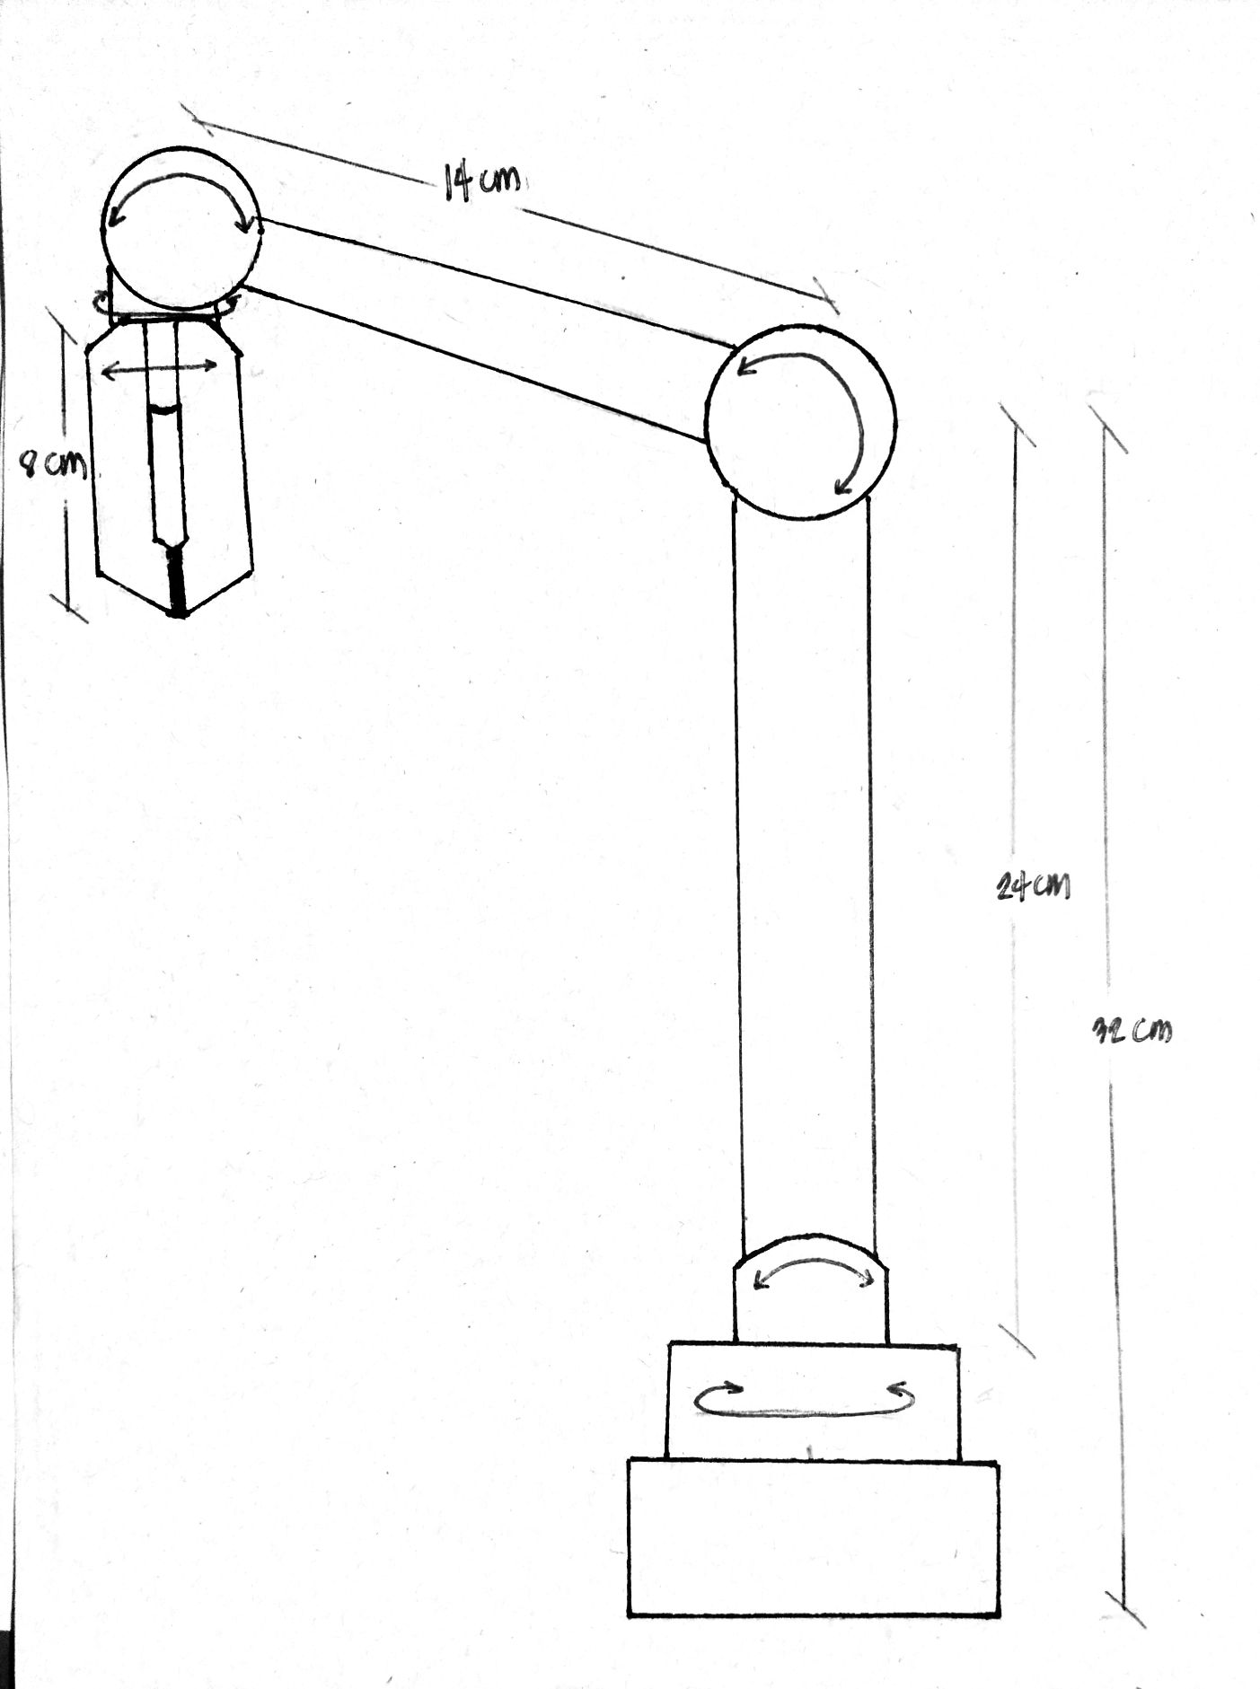
Physical Layout

  - Main User Interface
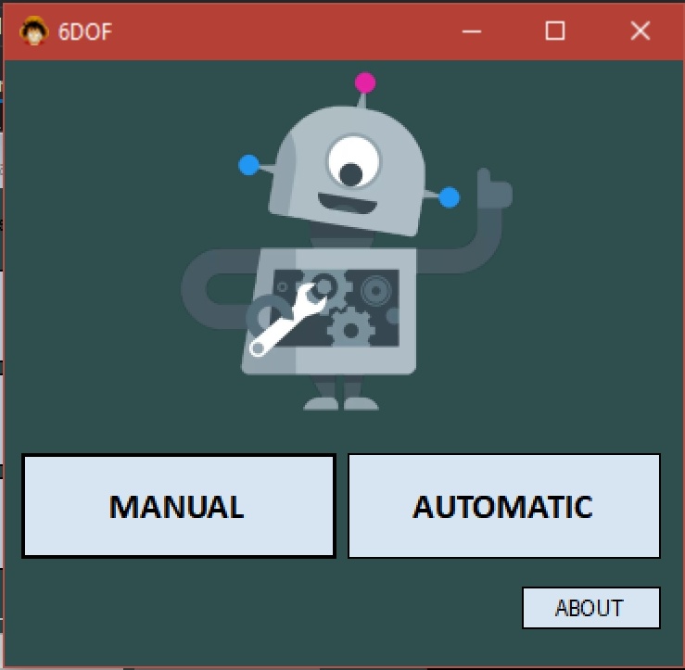
Main User Interface
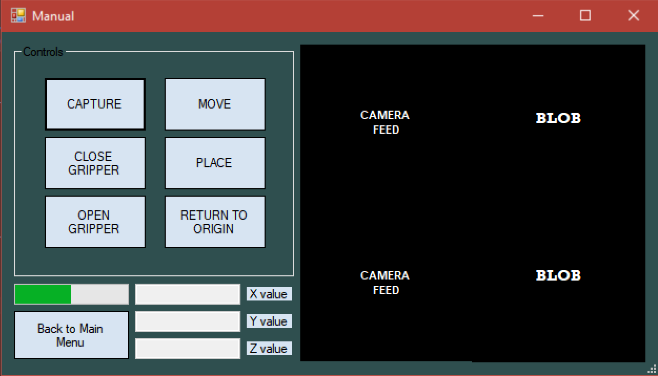
Manual Screen Interface
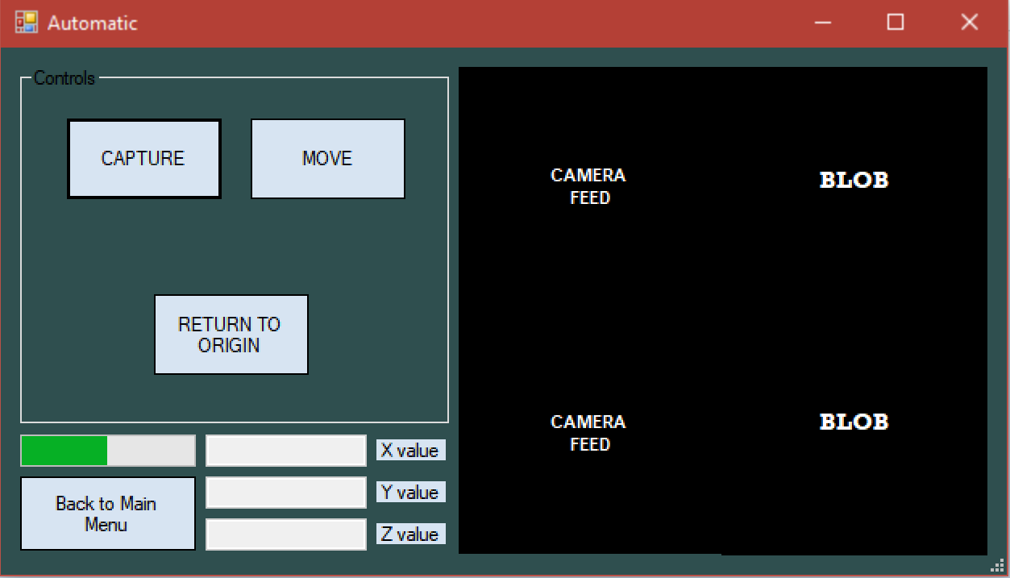
Automatic Screen Interface

  - Manual Control
The Manual Button would redirect the user to the Manual Screen while the Automatic Button would redirect the user to the Automatic Screen. The About Button would then display the project summary and the group members’ contact information.
    - Capture
This sub-control would trigger the camera to capture the current image shown on the live feed. It would then call the Image Processing function to process the image, the Distance Detection function would then compute the location of the target object. This location would then be used in the Motion Planning function in order to compute for the estimated posture of the Robot arm to reach reach the target object.
    - Move
This sub-control would perform the pick operation and would move the robot arm accordingly to the computed arm posture.
    - Open Gripper
This would control the gripper motor. The function enable the gripper to open.

    - Close Gripper
This would control the gripper motor. The function enable the gripper to close.
    - Place
This sub-control would move the robot arm from the picking position to the destination where it would be placed.
    - Return to Origin
This would return all the motor angles of the robot arm to it’s original or initial position.
    - Back to Main Menu
This would redirect the user to the Main screen.
  - Automatic Control (the sectioning depends on the controls you are using. It is your discretion what control to discuss in each section.)
    - Capture
This sub-control would trigger the camera to capture the current image shown on the live feed. It would then call the Image Processing function to process the image, the Distance Detection function would then compute the location of the target object. This location would then be used in the Motion Planning function in order to compute for the estimated posture of the Robot arm to reach reach the target object.

    - Move
Unlike in the Manual Operation, the move control would trigger the programmed sequence for the automatic operation. It would first move the robot accordingly to the computed posture. While simultaneously calling the Speed Control function for speed regulation of the motors. Then signal for the Gripper function to operate the gripper operations. After that it would again call for the Motion Planning function again to compute for the fitting posture of the robot arm to be able to place the picked object to its designated destination.
    - Back to Main Menu
This would redirect the user to the Main screen.

