Abstract

Acknowledgements

TABLE OF CONTENTS
ABSTRACT 1
ACKNOWLEDGMENTS 2
TABLE OF CONTENTS 3
CHAPTER 1 INTRODUCTION 4
1.1. PROBLEM BACKGROUND 4
1.2. PROJECT GOALS AND OBJECTIVES 5
1.3. SIGNIFICANCE OF THE STUDY 6
1.4. THEORETICAL BACKGROUND 7
1.5. REVIEW OF RELATED LITERATURE 8
1.6. DEFINITION OF TERMS 9

CHAPTER 1
INTRODUCTION

PROBLEM BACKGROUND
Production is a scientific process which involves transformation of raw materials into desired product or service by adding economic value. The most important points in production and operation management are production or operation strategy, total quality management, time reduction and lean production. Tremendous emphasis is usually placed on the production strategy that can incur the best yield with least amount of loss. The TQM (Total Quality Management) approach assert to high quality production with less rejects as possible. Balance between quality and quantity is what drives the success of a production line. Yet, with repetitive cycle, and pressure to meet the quota, mistakes made by operators are unavoidable. They are, after all, still human beings despite the training and experience they had. But with these man-made mistakes, also comes rejects, which, in a sense, are the most avoided results of a production line. Unnecessary actions or movements also pose quite a problem as it can increase the amount of time consumed by a process, while reducing the possible number of products that can be produced during that time. The team came up with this idea to possibly reduce, if not erase, the problem stated above.
Robotic systems are synthesized from a number of interrelated and interacting subsystems which characterize the entire facility with respect to its flexibility and applicability to certain task. Robots are very common nowadays in our lives. The time where everything had to be done manually, are rapidly shifting towards a world where everything can be programmed or managed automatically. And of course, these developments had already found their way to the industrial industry. But these industrial robots are usually massive, expensive, and can only be used for performing heavy tasks. They also came with a constraint; they couldn’t see. But with the development of vision system for robots, this all changed. That is why the group decided to pursue a project that would utilize a vision system to help manipulate the robotic arm’s operations.

PROJECT GOALS AND OBJECTIVES
Project Goals:
- To be able to increase production efficiency as much as possible.
- To be able to reduce production time while increasing the production yield as much as possible.
- To be able to lessen the labor cost.
- To be able to develop a robotic arm that is capable of grabbing and placing an object successfully in the desired location.
- To be able to operate the robotic arm with as little human assistance as possible.
- To be able to identify the object to be picked.
Objectives:
In order to successfully develop the Robotic Arm, we have come up with objectives to guide us throughout the semester.
- Two cameras would be used as the robotic arm’s vision system.
- To control the robot using Graphical User Interface (GUI).
- To utilize the concept of Inverse Kinematics for estimating the robotic arm posture.

SIGNIFICANCE OF THE STUDY
The industrial world is facing many technological changes which increased the demand for premium quality products and services that can only be supplied by a high level of productivity. Hence, automation would play a vital role in solving the requirements of companies. With this concept in mind, “Work smarter, faster and proficiently.” This idea would be able to contribute on tackling the task of increasing the productivity, with regards to cost, time and quality.
With this Robotic Arm, human assistance regarding certain functions in production lines can be minimized or reduced, thus the decline in possible man-made errors.

THEORETICAL BACKGROUND

Robotics
Robotics is a branch of engineering that involves the conception, design, manufacture and operation if robots. The field overlaps with electronics, computer science, artificial intelligence, mechatronics, nanotechnology, and bioengineering. Science-fiction author Isaac Asimov is often given the credit for being the first person to use the term robotics in a short story he composed in 1940’s. He was also the one who coined the Three Laws of Robotics, which have survived up to the present. They are:
- Robots must never harm humans.
- Robots must follow instructions from humans without violating rule 1.
- Robots must protect themselves without violating other rules.
Over the next 10 years, the work of 110 Million to 140 Million knowledge workers around the globe may be handled by cognitive robotic automation systems. That’s according to KMPG’s Cliff Justice, citing research from McKinsey’s Global Institution last week at the World BPO/ITO Forum’s Global Sourcing and Cloud Summit in New York. Robotic Process Automation (RPA) is the digitization of labor through the use of advanced machine intelligence, engagement, analysis, big data, social media, modern technologies and cloud computing. RPA is expected to ultimately expand the job market according to some economists and researchers.

Vision guided robotics
First of all, what is a vision system? A Vision System or a Machine Vision System is a type of technology that enables a computing device to inspect, evaluate and identify still or moving images. It is a field in computer vision and is quite similar to surveillance camera, but provides automatic image capturing, evaluation and processing capabilities. A machine vision system works through enabling a computer to recognize and evaluate images, it is similar to voice recognition technology, but uses images instead. This system is typically consists of digital cameras and back-end image processing hardware and software. The camera at the front end captures images from the environment or from a focused object and then sends them to the processing system. Depending on the design or need of the machine vision system, the captured images are either stored or processed accordingly. As per mentioned earlier, machine vision system also involves image processing. It is a method to perform some operations on an image, in order to get an enhanced image or to extract some useful information from it. It is a type of signal processing in which input is an image and output may be image or characteristics/features associated with that image. Nowadays, image processing is among rapidly growing technologies. It forms core research area within engineering and computer science disciplines too.
Image processing basically includes the following three steps:
- Importing the image via image acquisition tools;
- Analyzing and manipulating the image;
- Output in which result can be altered image or report that is based on image analysis.
With the rise of vision system for robots, a robot connected to a camera or a smart viewer can now detect objects and perform different tasks based on those objects. Vision Guided Robotics (VGR) is basically a robot fitted with one or more camera used as sensors to provide secondary feedback signal to the robot controller to more accurately move to a variable target position. VGR is rapidly transforming production processes by enabling robots to be highly adaptable and more easily implemented, while dramatically reducing cost and complexity of fixed tooling previously associated with the design and set of robotic cells, whether for material handling, automated assembly, agricultural applications, life sciences, and more.
SOBEL OPERATOR
Detecting edges is one of the fundamental operations you can do in image processing. It helps you reduce the amount of data (pixels) to process and maintains the “structural” aspect of the image. There are two known methods in detecting edges, the gradient based edge detector and laplacian based edge detector. The project would use a gradient based edge detector, but how does it really works? Take a look at this:

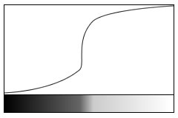
The curve representing intensity
The lower part is the 1-D image. The upper part is the intensity of each pixel of the 1-D image plotted as a graph. Blacks have a low intensity, so the graph curve is low. It reaches full height at the white end of the image. Note that the center of the curve has a steep slope - meaning you've got an edge!
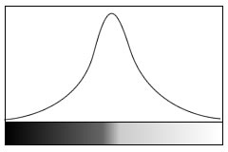
The first derivative of the curve above
Looking for these peaks is exactly what gradient based edge detection methods do. You're not interested in what the actual colors are. If the change is steep enough, you mark it as an edge pixel. Though these methods work well, there's one drawback - how do you decide what is a peak and what isn't? There has to be a certain threshold above which an edge is classified as a peak else it must be considered part of noise.
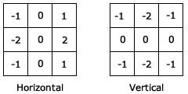
The Sobel edge detector is a gradient based method. It works with first order derivatives. It calculates the first derivatives of the image separately for the X and Y axes. The derivatives are only approximations (because the images are not continuous). To approximate them, the following kernels are used for convolution:

Kernels used in the Sobel edge detection
The kernel on the left approximates the derivative along the X axis. The one on the right is for the Y axis. Using this information, you can calculate the following:
- Magnitude or "strength" of the edge: 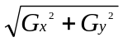
- Approximate strength: 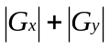
- The orientation of the edge: 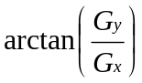

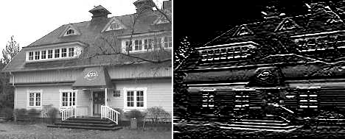
Result of the horizontal Sobel operator
Above, the horizontal peaks were detected. You can clearly see the horizontal edges highlighted. The result can then be threshold to get rid of the grey areas and get solid edges.
INVERSE KINEMATICS
Inverse Kinematics (IK) is the inverse of Forward Kinematics. The Forward Kinematics function/algorithm takes a pose as the input, and calculates the position of the end effector as the output. While in Inverse Kinematics, you do not need to define the whole pose of an articulated body - this gets calculated for you by the IK algorithm. With IK, you only need to define a position as the input. This means you know the end effector position but you don’t know what the pose of the articulated body needs to be for the end effector to reach this target position.
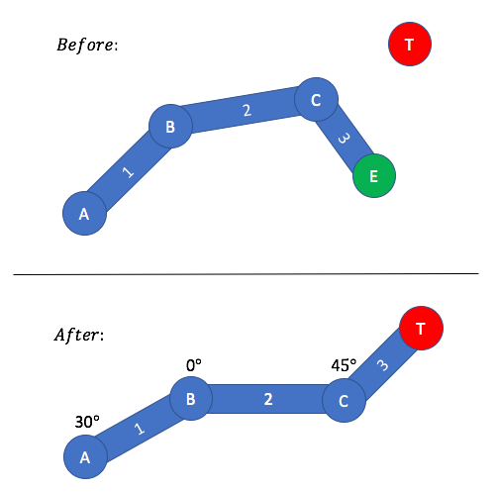
The target position is represented by a red circle. The target position is defined as the input, and the resulting pose required for the end effector to reach the target position is the output.

REVIEW OF RELATED LITERATURE
As the rise of automated machines and smart processing systems usher us into the fourth Industrial Revolution (industry 4.0), the tasks being performed by robots on the production line are becoming more complex. Using vision guided robotics (VGR) helps streamline the routine tasks performed by machines with high mobility in their movement without compromising precision and accuracy operations. But the use of robotic arms in industry processes was already observed even before the addition of a vision system.
The very first Industrial robot was the Unimate. Conceived from a design for a mechanical arm patented in 1954(granted in 1961) by American inventor George Devol, the Unimate was developed as a result of the foresight and business acumen of Joseph Engelberger - the Father of Robotics. Engelbeger focused on employing robots in tasks harmful to humans, highly motivated by Asimov’s Three Law of Robotics that relates a “first do no harm” philosophy similar to the Hippocratic Oath. In 1959, the 2700 pound Unimate #001 prototype was installed on an assembly line for the first time at a General Motors die-casting plant in Trenton, New Jersey. By 1961, the Unimate 1900 series became the first mass produced robotic arm for factory automation. In a very short period of time, approximately 450 Unimate robot arms were employed in die-casting. From a two-dimensional drawing to industrial societal revolution, the Unimate robot remains one of the most significant contributions in the past one hundred years not only to manufacturing but to civilization. It has left a living legacy in the industry to which it gave birth. As a result of the Unimate, the field robotics continues to expand beyond manufacturing to virtually every facet of human life and service. After the development of the Unimate, the development of robotics was slow for a while, with many of the most useful applications being involved with space exploration, until the late 1970s when several big Japanese conglomerates began producing similar industrial robots. In 1969, Victor Scheinman at Stanford University invented the Stanford arm, an all-electric, 6-axis articulated robot designed to permit an arm solution. This allowed it accurately to follow arbitrary paths in space and widened the potential use of the robot to more sophisticated applications such as assembly and welding. Robotics (formerly known as ASEA) introduced IRB 6, among the world’s first commercially available all electric micro-processor controlled robot.
Interest in robotics increased in 1970s and many US companies entered companies entered the field, including large firms like General Electric, and General Motors. Only a few non-Japanese companies ultimately managed to survive in the market.
But the use of robots to aid in industrialization weren’t fully realized until late 1980s, when robotic arms began to be integrated in automobile assembly lines. Robots were initially retained to perform precise welding chores and other repetitive tasks that humans had long found boring, monotonous and injurious. By using robots to weld, handle dangerous objects and place items, auto manufacturers were able to ensure a consistent product with a minimum of worker injury. Currently, 50 percent of all robots in use today are used in automobile manufacture.
In the study of Faravar entitled Design, Implementation and Control of a Robotic Arm Using PIC 16F877A Microcontroller, it was found out that the first step of designing a robot is to decide the dimension and workspace configuration according to the requirements. The next step is to decide the specification of each actuator. The arm is attached to a base which is the most bottom part of the robot. It is important to mention that the base ought to have considerably heavy weight in order to maintain the general balance of the robot in case of grabbing an object. Although the idea of using stepper and gear motors is brilliant, but physical movement of the robot is done by using servo motors. The advantage of the servos is that they can be programmed to return to their initial position. Since the servo motors operate using the signals received from the microcontroller, they could be programmed according to the requirements. However, this characteristic of the servo motors is actually a disadvantage, because the chance of sending and receiving a wrong signal is high which causes the servo to operate incorrectly.
The study mentioned above gives good advices on how to build a better robotic arm. The biggest difference there is, instead of using PIC18F4550 they used PIC16F877A, which has a comparable lesser amount of pins the PIC18 series has. Another thing to take note of is the robotic arm being built is only capable of up to five degrees of freedom.
In another study spearheaded by Nie and Huang entitled Inverse Kinematics for 6-DOF Manipulator by the Method of Sequential Retrieval, it is said that there are three types of a 6DOF general purpose robotic arms.
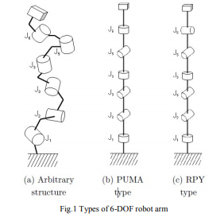

Fig.1 (a) shows that the general structure of a 6DOF arm allows arbitrary length of each link and direction of joints to move such a robot arm to do tasks of some kinds, it is necessary to obtain, from target values of hand tips, the angles of each joint corresponding to them, i.e. to solve so-called inverse kinematics. However, no analytical solution of the inverse kinematics applicable to arbitrary structure is available at present. Therefore, with most that are currently used for industrial applications, no analytical solution of the inverse kinematics has been found yet. Inverse kinematics can be solved analytically if all adjoining joint axes are parallel or orthogonal. Of those, the structure designated as PUMA-type as shown in Fig.1 (b). It is used extensively at present. As described, one condition for practical application is that inverse kinematics must be solved, which imposes restrictions on selectable structures. In this study, for an RPY-type arm (Fig.1(c) ) which is one structure of inverse kinematics that has not been solved yet, we propose the Method of Sequential Retrieval, for which the modification weight is added to an efficient solution of the inverse kinematics to obtain a solution.
Solving inverse kinematics of an RPY-type arm analytically is difficult. For such a structure, Newton–Raphson method and numerical solutions designated as efficient solution of the inverse kinematics (hereinafter designated as efficient solution) have been proposed. The efficient solution has features such as rapid convergence and that eight or fewer solutions are obtained. Additionally, it is considered that the efficient solution is characteristic in that solutions of a particular pattern can be selected. This feature plays an important role when the hand tip target positions and posture trajectories are converted to joint angle trajectories. However, a problem area of this efficient solution is that no convergence occurs depending on the target values. In this study, an improvement of the efficient solution, which is termed as the Method of Sequential Retrieval, is proposed.
This is very important in solving the impending problem regarding on how to implement Inverse Kinematics with robotic arms. This robot however, did not mention any use of cameras for a vision guided robotic arm.

Definition of terms
- Articulated Body - An articulated body can represent most animated bodies such as humans and animals with skeletons. Simply put, an articulated body is a tree linked chains. The linked chains are made up of joints and links, where link is a rigid cylinder.
- Articulations and Poses - An articulation is a rotation/translation of a joint which moves a connected link. A Pose is a combination of all the articulations of each joint.
- Assembly Lines - Assembly line is invented by Henry Ford. It is a series of workers and machines in a factory by which a succession of identical items is progressively assembled.
- End Effector - An End Effector is the position at the most outboard position of the most outboard link. It is the free end of the chain of alternating joints and links. The end effector is not a joint but is merely a position at the end of an articulated body.
- Graphical User Interface (GUI) - A visual way of interacting with a computer using items such as windows, icons, and menus, used by most modern operating systems.
- Image Intensity - An image is a two dimensional function f(x,y) the amplitude of f at any pair of coordinates (x,y) is called intensity or gray level of the image at that point.
- Inboard link/joint - It is a link/joint that is closer to the root joint within the tree hierarchy of the articulated body.
- Outboard link/joint - It is a link/joint that is further away from the root joint within the tree hierarchy.
- Prismatic Joint - It is a joint such that the connected link translates from the joint to extend/ shorten the link. It much acts like the extending or retracting length of the handle of your luggage.
- Revolute Joint - It is the first type of joint. It is connected to a link that rotates around it. A revolute joint is much like the center pin of a clock - with a clock hand as a link.
- Root Joint - It is the base of the structure, for humanoids, it is usually the center of the hips.
- Threshold - It is the magnitude or intensity that must be exceeded for certain reaction, phenomenon, result, or condition to occur or be manifested.
- Total Quality Management (TQM) - It is a management approach to long-term success through customer satisfaction.

